Lab Protocol Nº 3
Ramachandran Plots

Biostructure Modeling – Q3009

Abstract

Interpreting Ramachandran plots and their application to protein structural analysis.

1. Recall Lab Protocol Nº1 and the definition of the dihedrals Φ(phi) e Ψ(psi):
Φ = ∠( ) Ψ = ∠( )

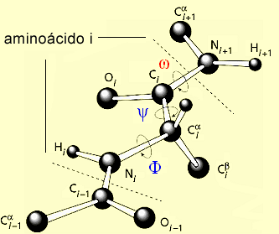
amino acid i

- Ramachandran Plots in VMD
General Procedure

1. Launch the VMD program and open the file of a protein (e.g., PDB ID: 1ERT).
Note: To download a structure directly from the Protein Data Bank (PDB) into VMD, select PDB Database Query from the Extensions menu. Then enter the PDB ID and click Load into new molecule in VMD. Alternatively, the structure can be loaded via the File menu.

2. To display the Ramachandran plot, select Analysis from the Extensions menu. In this submenu, choose Ramachandran Plot.

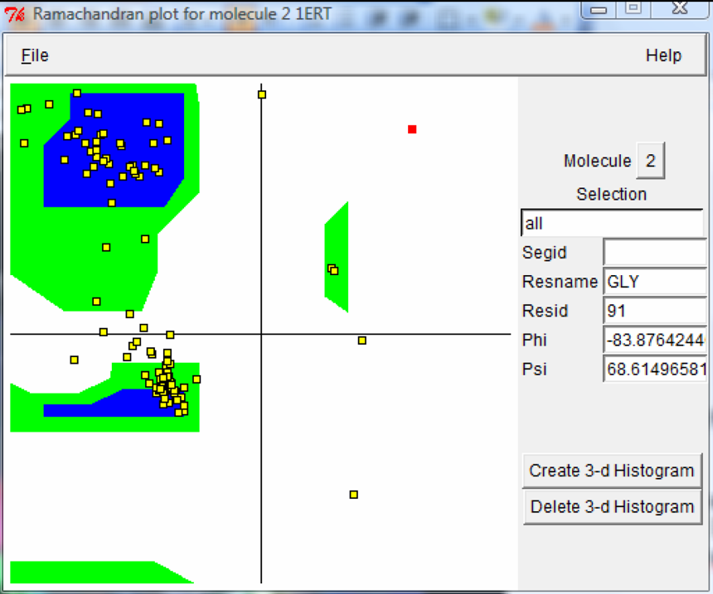

3. A new window will appear showing the Ramachandran plot. This plot is presented in a square format, with the φ (phi) and ψ (psi) dihedral angles plotted along the x- and y-axes, respectively. Each angle can vary between −180° and +180°.
Three main regions can be identified in the plot, typically highlighted in blue and green in the figure below. These regions correspond to stereo chemically favorable conformations:
Blue regions represent highly favorable conformations
Green regions represent moderately favorable conformations
White regions correspond to conformations that are less favorable or sterically hindered.
4. To visualize the φ and ψ angles associated with the amino acids of the protein displayed in the VMD visualization window, it is first necessary to select the corresponding molecule in the Molecule menu. As a result, the Ramachandran plot will be populated with multiple yellow points representing the φ and ψ angle values for each amino acid in the protein.
By clicking on any of these points, it is possible to identify the corresponding amino acid and obtain the associated φ and ψ values. This information is displayed in the text boxes located on the right-hand side of the Ramachandran plot.
5. It is also possible to display information corresponding only to a specific region of the protein. To do this, use the Selection text field. In this field, the same keywords commonly used in the main VMD interface can be applied (e.g., all, resid, resname, etc.).

- Exercises

1. The Ramachandran plot provides a simple and effective way to evaluate the φ and ψ dihedral angles of a polypeptide chain. This information is highly useful, as it allows the identification of the types of secondary structures present, as well as an assessment of their quality.
i. Using the crystallographic structure with PDB code 7ODC, select all proline and glycine residues and identify the regions of the protein (secondary structure elements) in which they are located.
ii. Use the Ramachandran plot to determine the φ and ψ values associated with the different amino acids and discuss, from stereochemical and energetic perspectives, their influence on the structure of the polypeptide chain.
iii. Discuss the importance of folding in the secondary and tertiary structure of proteins.

2. The enzyme ribonucleotide reductase is responsible for the reduction of ribonucleotides to deoxyribonucleotides. This enzyme plays a crucial role in DNA replication and synthesis and is therefore an important biological target in cancer therapy.
In 1997 and 2002, two structures of the R2 subunit of this enzyme were crystallized, with PDB codes 1AV8 and 1MXR, respectively.
i. Based on this information, compare the Ramachandran plots of the crystallographic structures and discuss the overall quality of each structure (relating your analysis to the resolution of the crystallographic data).
ii. Using the information obtained from the Ramachandran plots, discuss whether conformational changes influence the three-dimensional structure of the protein.
Note: To align the two structures, use the RMSD Calculator option in the Analysis submenu of the Extensions menu. In the new window, select both structures (All in memory) and click Align. The same module can be used to calculate the RMSD (root mean square deviation) between the two structures.

3. The structures of collagen (PDB code 1CAG) and the polyproline helix (PDB code 1COR) adopt helical conformations that differ significantly from a conventional α-helix. Interestingly, when represented on a Ramachandran plot, their φ and ψ angles are found to be very similar to those of a β-sheet.
i. For each crystallographic structure, locate the proline residues within the three-dimensional structure of the polypeptide chain. Also visualize hydroxyproline residues, which can be selected using the command resname HYP.
ii. Use the Ramachandran plot to identify the region in which the polyproline helix and collagen helix are located and discuss the reasons for their positioning.
iii. Compare the distribution of glycine residues in the two polypeptide chains and analyze their influence on the adopted three-dimensional structure.
iv. Which of the two types of helices is more rigid? Explain your answer.

