Lab Protocol Nº4
Use of PDBe as an Introductory Tool for the Study of New Biological Systems

Biostructure Modeling – Q3009

Abstract

This work aims to introduce the Protein Data Bank in Europe (PDBe), a bioinformatics resource within the Worldwide Protein Data Bank (wwPDB) that provides structural, functional, and experimental information on proteins, nucleic acids, and macromolecular complexes.
In addition to complementing the data available through the Protein Data Bank (PDB), PDBe offers a variety of online visualization and analysis tools that facilitate the exploration and interpretation of structural data. The platform represents a valuable resource for the initial investigation of novel biological systems, particularly when used in conjunction with Visual Molecular Dynamics (VMD), a molecular visualization program.
By integrating accessible structural data with advanced visualization capabilities, PDBe and VMD provide an effective framework for the study of biomolecular structure and function in both educational and research settings.

- Introduction

The Protein Data Bank in Europe (PDBe) provides a highly intuitive user interface that allows users to access predominantly graphical information on the biomacromolecular structures deposited in the well-established Protein Data Bank (PDB).
For each PDB entry, PDBe presents key information regarding the constituent molecular components. Available features include three-dimensional structural representations, graphical depictions of the secondary-structure elements associated with individual polypeptide chains, schematic diagrams of protein-ligand and protein-DNA interactions, molecular surface characterizations, and analyses of residue conservation across the corresponding amino acid sequences, among other informative annotations.
To obtain the greatest benefit from this tutorial, readers are encouraged to explore the various resources provided by PDBe while simultaneously examining the PDB structure 1JCR in Visual Molecular Dynamics (VMD). This combined approach facilitates the direct correlation of information available through the database with the three-dimensional representation of the molecular structure.
The PDBe database can be accessed at:
https://www.ebi.ac.uk/pdbe/

First Steps

For this tutorial, we will consider the structure of the enzyme farnesyltransferase (FTase) from rat. FTase is a zinc-dependent enzyme composed of two distinct subunits (each containing approximately 400 amino acid residues), and its inhibition has been the focus of considerable interest in cancer research.
This enzyme catalyzes the addition of a farnesyl group (an isoprenoid composed of 15 carbon atoms) to peptides or proteins that contain the characteristic CAAX motif at the carboxyl terminus. In this motif, C represents the cysteine residue that undergoes farnesylation, A represents a generic aliphatic residue, and X corresponds to the terminal amino acid, which is typically methionine, serine, alanine, or glutamine.
The general procedure illustrated in this tutorial can, in principle, be applied to any biological system. FTase has been selected as an example because it combines several structurally interesting features within a single system. In this tutorial, we will analyze the PDB structure 1JCR, which corresponds to a complex of FTase with the substrate FPP (farnesyl pyrophosphate) and a substrate-analog tetrapeptide CVFM.
Task nº 1:

- Access the PDBe database at:

https://www.ebi.ac.uk/pdbe/

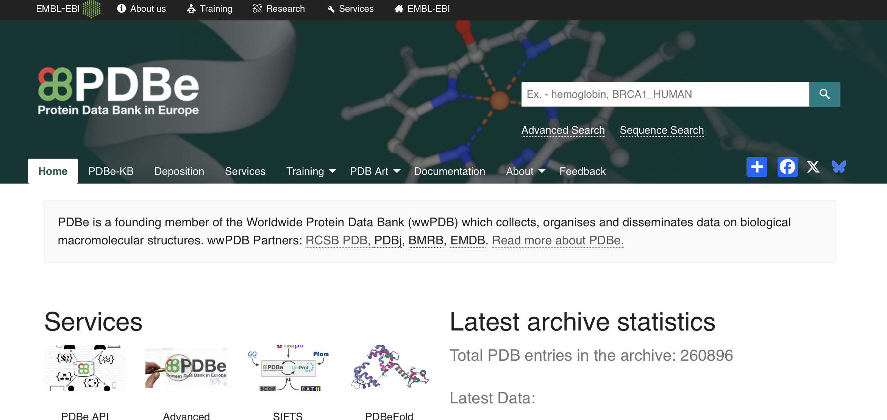

Figure 1: Homepage of the PDBe website.

Task nº 2:

- Enter the PDB code of the crystallographic structure to be analyzed in the search field. In this tutorial, use 1JCR as the search term. The resulting page provides an overview of the corresponding protein.
- Next, select the link to the structure to access additional information and carefully examine the data and annotations provided.

Next, select the link to the structure to access additional information and carefully examine the data and annotations provided.

Explore the information provided for this structure using the Model Quality, Complexes, Macromolecules, Ligands and Environments, and Domains tabs.
As you examine the available data, identify key features of the structure, including its molecular components, the source organism, the enzyme's EC number, the cofactors involved in its activity (in this case, Zn²⁺ and/or Mg²⁺), the structural resolution, the authors of the associated scientific publication, and the deposition date of the structure in the Protein Data Bank (PDB). Carefully review the structural, functional, and experimental annotations provided in each section and consider how these contribute to the biological characterization of the macromolecule.
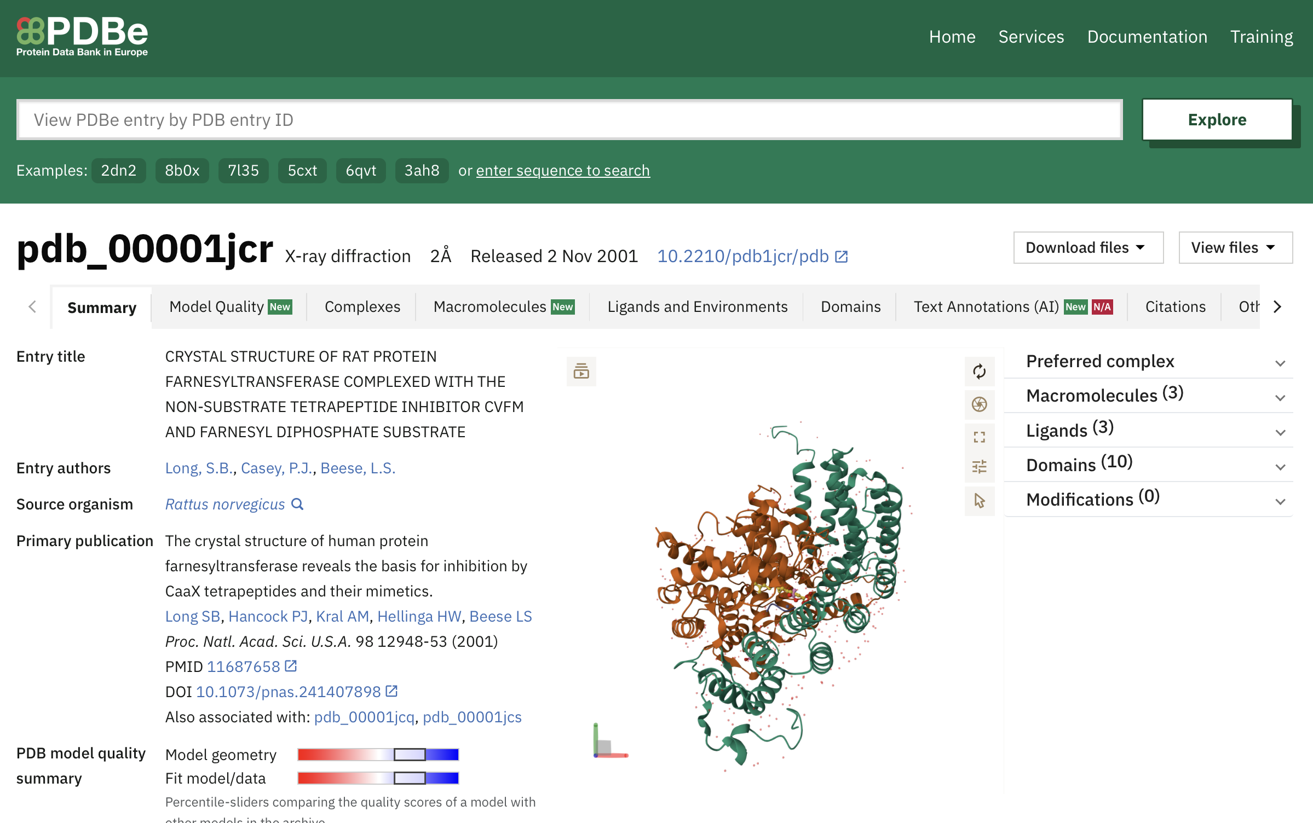
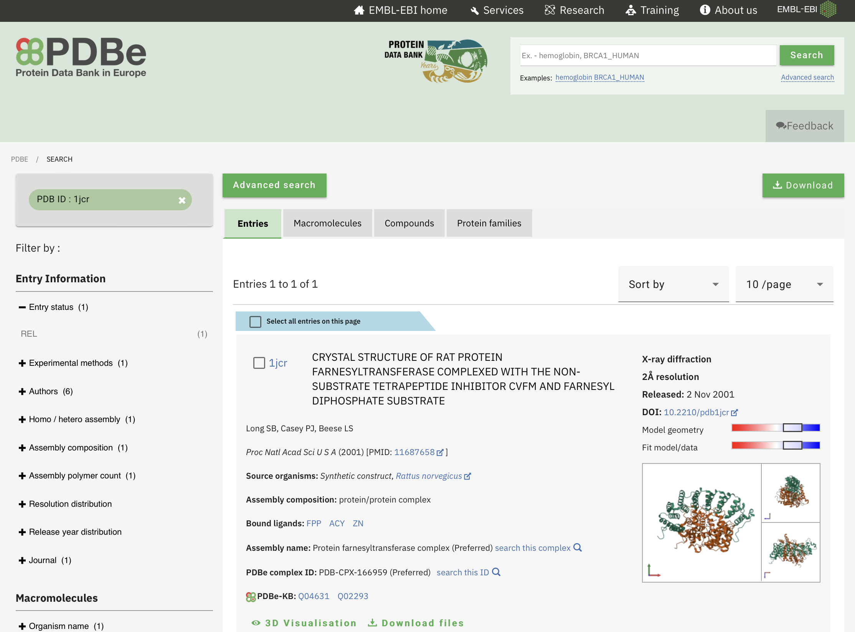

Figure 2: PDBe data base. Summary tab corresponding to 1JCR structure.

Polypeptide chains

The structure consists of two polypeptide chains, A and B, comprising 377 and 423 amino acid residues, respectively.
Task nº 3:

- Select the Macromolecules tab and examine the information provided for chain A.

- Identify the regions of the amino acid sequence that were not resolved in the X-ray crystallographic structure. Confirm the presence of these missing regions by direct inspection of the corresponding PDB file.

- Visualize the locations of the longest α-helices within the overall structure by clicking on the corresponding elements in the Secondary Structure diagram.

- Explore the intermolecular interactions involving chain A.

- Using VMD, reproduce and visualize the most significant structural features and interactions identified through the PDBe interface.

- Repeat the above procedure for chain B and for the tetrapeptide CVFM.

The ligands

As indicated in the left-hand side of the Ligands and Environments tab, the structure contains, in addition to the two polypeptide chains described in the previous section, several ligands, namely the tetrapeptide CVFM, the substrate FPP, and two acetic acid (ACY) molecules. The acetic acid molecules are not biologically relevant and are present solely because of the experimental conditions used during structure determination, a common occurrence in crystallographic studies.
We will therefore focus our analysis on the other two ligands and examine them in greater detail.

- Navigate to the Ligands and Environments tab and select the FPP ligand for further analysis.
Task nº 4:

The resulting page (Figure 3) displays the position of the ligand within the structure as well as all interactions involving the ligand. Hover the cursor over individual interactions to obtain additional information, including the interaction type and the corresponding interatomic distances.

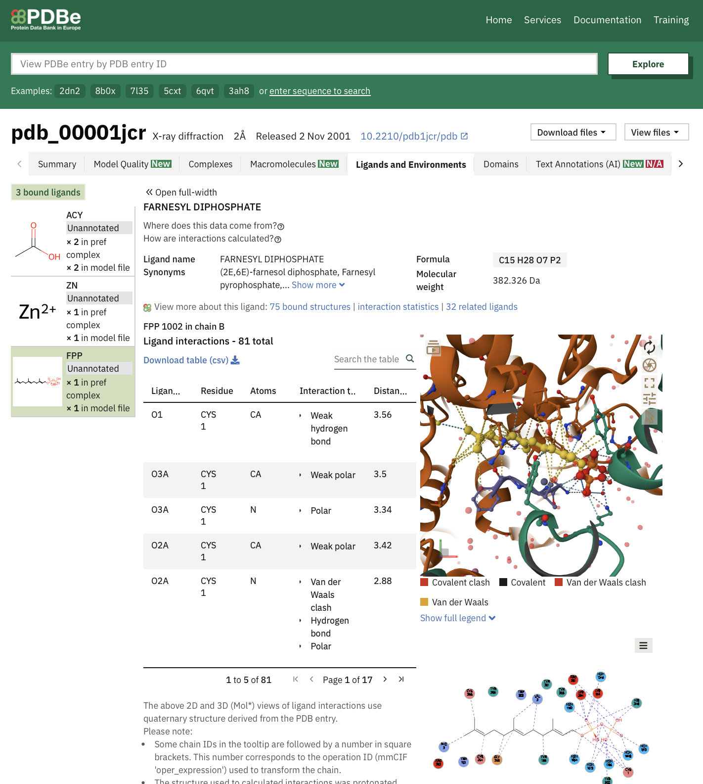

Figure 3: The FPP ligand in the 1JCR structure: graphical representations of its molecular structure and key intermolecular interactions.

Task nº 5:

- Repeat the procedure for the tetrapeptide (chain C) and for the Zn(II) metal ion.

- Using VMD, attempt to reproduce and visualize the most important features of these interactions.

Note: To display all atoms located within x Å of a selected reference atom or molecular entity, use the following VMD command: all within x of ... or same residue as within x of ... .

Analysis of residue conservation

In this section, we will examine the degree of conservation of the amino acid residues that constitute FTase in the 1JCR structure. Through integration with the ConSurf-HSSP database (available at http://consurf.tau.ac.il), PDBe provides a set of precomputed sequence alignments that compare each PDB structure with a collection of homologous protein sequences.

Based on these alignments, the database employs a conservation analysis algorithm to estimate the evolutionary conservation of each position in the original amino acid sequence with respect to the corresponding family of homologous proteins.
Conservation scores can provide valuable insights into the structural and functional roles of individual residues, as highly conserved positions are often associated with catalytic activity, ligand binding, structural stability, or other biologically important functions.

Task nº 6:

- Select the chain A in the Macromolecules tab.

- In the map below select the option Conservation.

- Select two residues that exhibit markedly different degrees of conservation, for example, Trp134 (conservation score = 5) and Lys146 (conservation score = 0).

- Examine the relative positions of these residues within the overall structure of the protein complex and relate their locations to their respective conservation scores.

