Lab Protocol Nº 5
Introduction To Molecular Dynamics
Study of the enzyme HIV-1 Protease

Biostructure Modeling – Q3009

Abstract
This work focuses on the study of the three-dimensional structure of HIV-1 protease in complex with the inhibitor Nelfinavir, using selected molecular dynamics (MD) analysis techniques. The analysis includes the evaluation of root-mean-square deviation (RMSD) and employs the VMD visualization software.

1. Introduction
1.1. HIV-1 Protease in Complex with the Inhibitor Nelfinavir
HIV-1 protease is an enzyme of the human immunodeficiency virus (HIV). As an aspartyl protease, it utilizes aspartic acid residues to cleave the viral polyproteins Gag and Gag-Pol in a highly specific manner, a process that is essential for the HIV replication cycle.
The three-dimensional structure of HIV-1 protease has been extensively studied and characterized. Crystallographic studies have shown that:
- It exists as a homodimer that, in its unbound form, possesses a C2 symmetry axis, which is disrupted upon binding to an asymmetric substrate or inhibitor.
- The N- and C-terminal regions of the monomers are responsible for stabilizing the dimeric structure.These regions adopt β-sheet conformations that intertwine in an antiparallel arrangement.
- Each subunit of the dimer contains 99 amino acid residues.
- The two subunits interact to form a hydrophobic core, a cylindrical catalytic cavity with approximate dimensions of 24 Å in length and 6–8 Å in diameter, and two flexible “flaps”.
- These two flaps can move by approximately 700 pm relative to their initial position, allowing substrate or inhibitor entry and binding.
- At the center of the hydrophobic active site are two symmetrically arranged residues, Asp25 and Asp25′, which are directly involved in peptide bond hydrolysis.

The proposed mechanism of hydrolysis catalyzed by HIV-1 protease suggests that both Asp25 and Asp25′ play crucial roles in the reaction, with one residue in the protonated form and the other in the ionized form.¹
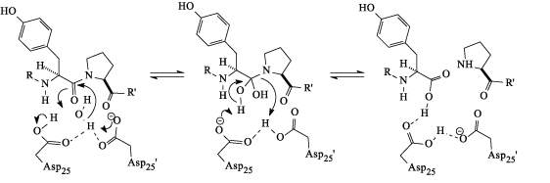
Figure 1. Proposed mechanism of hydrolysis catalyzed by HIV-1 protease.¹

The characterization of the transition state, the role of the water molecule located between the two aspartate residues, protease–substrate interactions, viral resistance, oral efficacy, susceptibility to enzymatic degradation, and other pharmacological factors are considered in the design of more effective HIV-1 protease inhibitors.
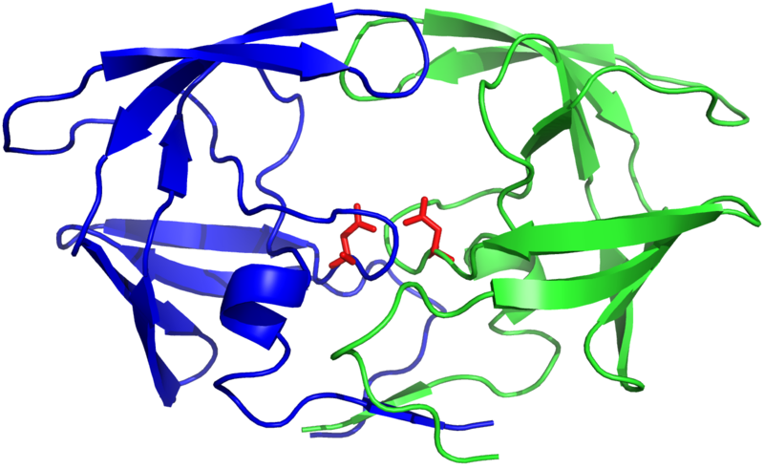
Catalytic aspartates
Active site

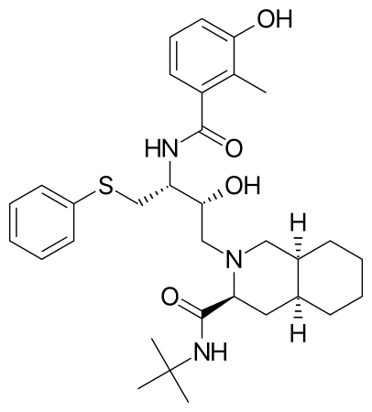

Nelfinavir
Flaps

Figure 2. Structures of HIV-1 Protease and the Nelfinavir inhibitor.
Several HIV-1 protease inhibitors are currently available and are used as therapeutic agents in the treatment of AIDS (Acquired Immunodeficiency Syndrome). In this work, the interaction between the enzyme and the inhibitor nelfinavir will be examined, whose structure is shown in Figure 2 (PDB code 1OHR).
1.2. Molecular Dynamics
In classical molecular dynamics simulations, atoms are modeled as rigid particles interacting through suitably parameterized potential energy functions. The time evolution of the system, positions and velocities of all particles, is obtained by numerically integrating Newton’s equations of motion.
In this study, no molecular dynamics simulation is performed; instead, the analysis focuses on results obtained from a previously completed simulation. The starting structure corresponds to a complex in which nelfinavir is already bound at the enzyme’s active site.

2. Visualization of the 3D Structure and Trajectory Using VMD

1. Copy the files prot_nelf.prmtop, prot_nelf.mdcrd, and prot_nelf.out to your workspace. These files can be found in: /home/users/profs/almagalh/Mod_Bio_files_prot6.
2. Launch the VMD program and, from the File menu, select the New Molecule option.
3. Select first the parameter and topology file (prot_nelf.prmtop) corresponding to the simulation you wish to visualize.
4. Choose the file type AMBER7 Parm and click Load.
5. Next, select the trajectory file (prot_nelf.mdcrd) corresponding to the simulation.
6. Change the file type to AMBER Coordinates with Periodic Box and click Load. Wait while the trajectory file is loaded.
7. Click PLAY to view the simulation.
8. Generate separate representations for each component of the system (chain A, chain B, inhibitor, counterions, and solvent). Analyze the secondary structure of the enzyme. Examine the structure of the inhibitor and observe how the catalytic aspartates and the inhibitor evolve over the course of the simulation.
9. Display the Ramachandran plot and analyze its evolution throughout the molecular dynamics trajectory.
Questions
Based on the analysis of the three-dimensional structure, answer the following questions:
Q1. What is the total simulation time (consult the prot_nelf.out file)?
Q2. What is the total number of atoms?
Q3. Which of the catalytic aspartate residues is protonated: the one in chain A or the one in chain B?
(Note: Asp25 in chain A corresponds to residue 25, whereas Asp25 in chain B corresponds to residue 124, since each chain contains 99 amino acids; thus, Chain A: residues 1–99; Chain B: residues 100–198; the inhibitor corresponds to residue 199.)
Q4. Measure the key distances between the aspartate residues and the inhibitor, and evaluate how these distances vary throughout the simulation.
Q5. This enzyme has an overall charge of +5 at physiological pH. Determine the number of charged residues (ASP, GLU, ARG, LYS, and HIS) and explain this overall charge. To neutralize the system, counterions were added; in this case, five chloride ions. Represent these ions and discuss their locations within the structure.

3. RMSD
3.1. General concept
The Root Mean Square Deviation (RMSD) is a widely used measure in the analysis of the three-dimensional geometry of molecules, allowing the quantitative evaluation of the geometric difference between two conformations of a given set of points, in this case atomic nuclei. For a set of n atoms in structures ν e ω, the RMSD is defined as:
$$RMSD\left(υ,ω\right)=\sqrt{\frac{1}{n}\sum_{i=1}^{n}{\left({\left(υ_{ix}-ω_{ix}\right)}^{2}+{\left(υ_{iy}-ω_{iy}\right)}^{2}+{\left(υ_{iz}-ω_{iz}\right)}^{2}\right)}}$$
RMSD is generally expressed in units of length, typically angstroms (Å, equivalent to 10⁻¹⁰ m), and provides a quantitative measure of the positional deviation of corresponding atoms between two structures. It is also commonly used to evaluate whether a macromolecular structure generated during a molecular dynamics simulation has reached equilibrium, taking the initial configuration of the system as a reference.
3.2. RMSD Analysis
1. In VMD select Extensions >> Analysis >> RMSD Visualizer Tool
Define both chains as:
resid 1 to 99 and click RMSD
resid 100 to 198 and click RMSD
Select the two options listed below and click Plot result.
2. Repeat the procedure to calculate the RMSD of the inhibitor (residue 199) and of the chloride counterions (residues 200–204).
Compare and comment on the average RMSD values of these different components of the system.

4. Hydrogen Bond Analysis
- To evaluate hydrogen bonding, select: Extensions >> Analysis >> Hydrogen Bonds
For Selection1 (Required): choose all , the define the relevant criteria (donor–acceptor distance and angle), and finally click Find hydrogen bonds.
Repeat the procedure for the catalytic aspartates and nelfinavir:
Selection1 (Required): resid 25 124 199.

References
- Krzeminska, A.; Moliner, V. ; Swiderek, K., Dynamic and Electrostatic Effects on the Reaction Catalyzed by HIV-1 Protease, JACS 2016; 138(50), 16283-16298. DOI: 10.1021/jacs.6b06856.

