INDIA’S AGRICULTURAL CROP PRODUCTION AND ANALYSIS

INTRODUCTION

Crop production is a common agricultural practice followed by worldwide farmers to grow and produce crops to use as food and fibre. This practice includes all the feed sources that are required to maintain and produce crops.

Crop yield prediction analysis requires a model of how crops respond to soil factors. Crop productivity is the quantitative measure of crop yield in given measured area of field.

AREA Vs PRODUCTION

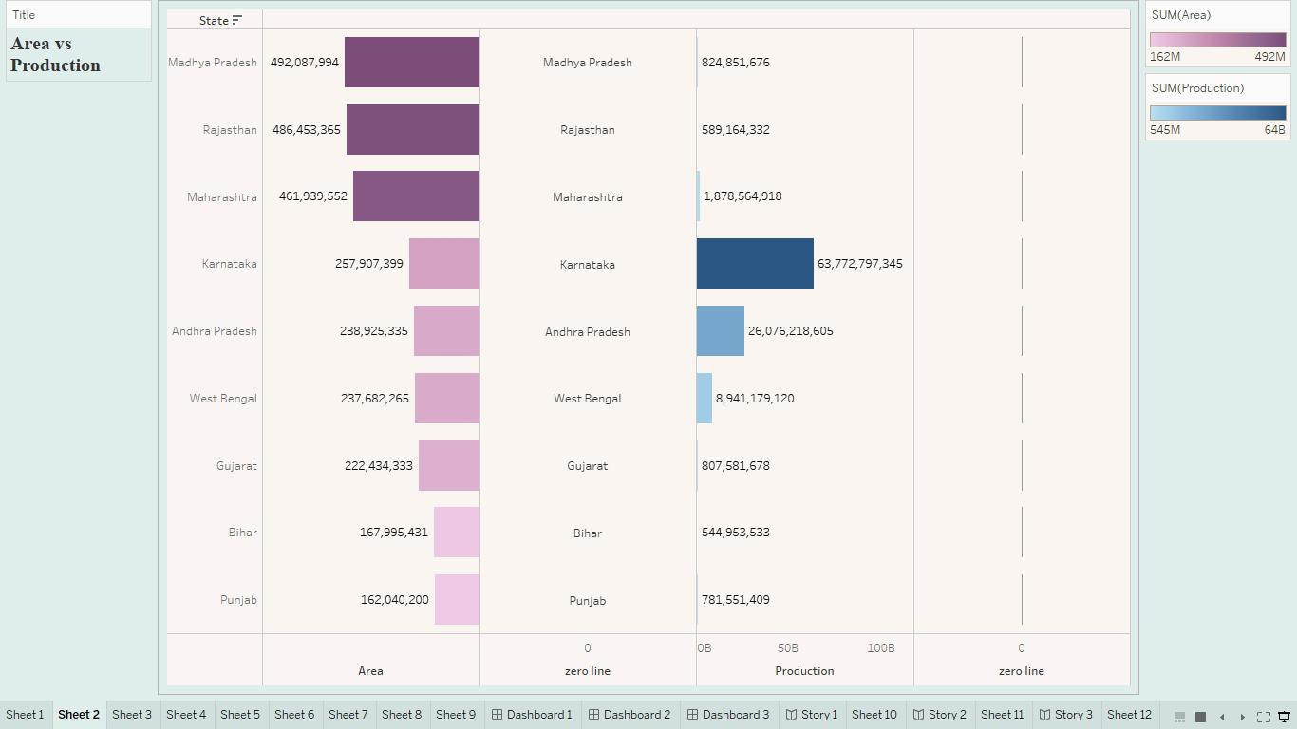As per Second Advance Estimates for 2022-23, Total Foodgrain production in the country is estimated at record 3235.54 lakh tonnes which is higher by 79.38 LMT as compared to previous year 2021-22. Total production of Rice during 2022-23 is estimated at (record) 1308.37 lakh tonnes.

SEASON BASED CULTIVATION AREA

There are three distinct crop seasons in India, namely Kharif, Rabi and Zaid. The Kharif season started with Southwest Monsoon under which the cultivation of tropical crops such as rice, cotton, jute, jowar, bajra and tur are cultivated.

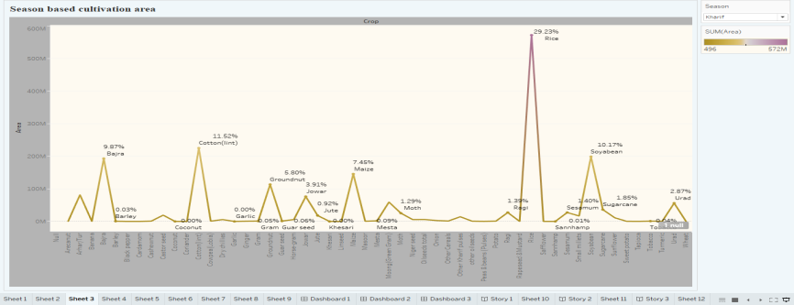

YIELD BY SEASON

Agriculture in India is an important topic in Indian geography. 49% of the population in India is dependent on agriculture. In the total geographical area in India, 141 million hectares is the net sown area while 195 million hectares is the gross cropped area.

Agriculture in India contributes to 14% of the GDP and the distribution of income and wealth. It provides essential amenities like food for the people and fodder for the animals. It also provides a major source of raw materials to the agro-based industries in India.

The vast relief of the country, varied climate, and soil conditions cause the provision of a variety of crops.  All tropical, subtropical and temperate crops are grown in India but predominantly food crops are cultivated in 2/3rd of the total cropped area.

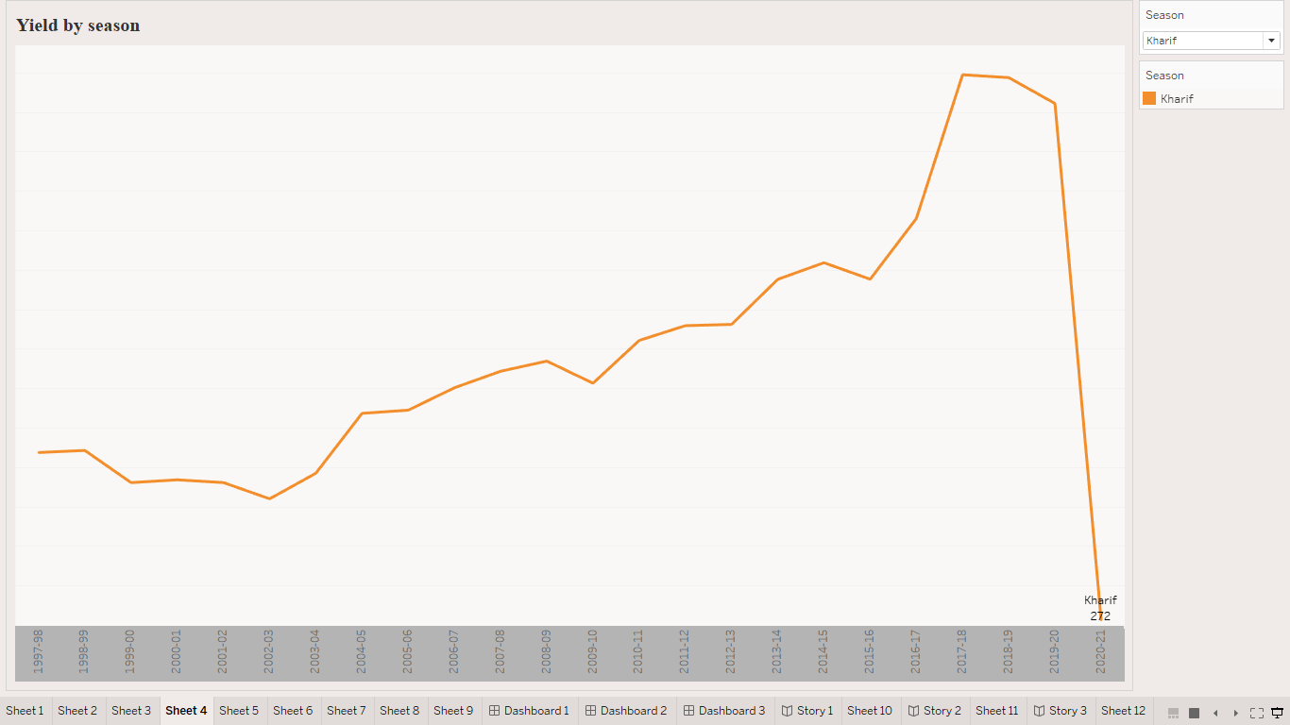

CROP PLANTATION BY AREA

As per Second Advance Estimates for 2022-23, Total Foodgrain production in the country is estimated at record 3235.54 lakh tonnes which is higher by 79.38 LMT as compared to previous year 2021-22. Total production of Rice during 2022-23 is estimated at (record) 1308.37 lakh tonnes.

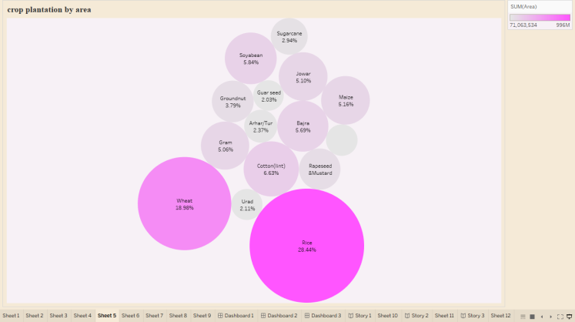

MAJOR CROPS

Major crops grown in India are rice, wheat, millets, pulses, tea, coffee, sugarcane, oil seeds, cotton and jute, etc. of canal irrigation and tubewells have made it possible to grow rice in areas of less rainfall such as Punjab, Haryana and western Uttar Pradesh and parts of Rajasthan.

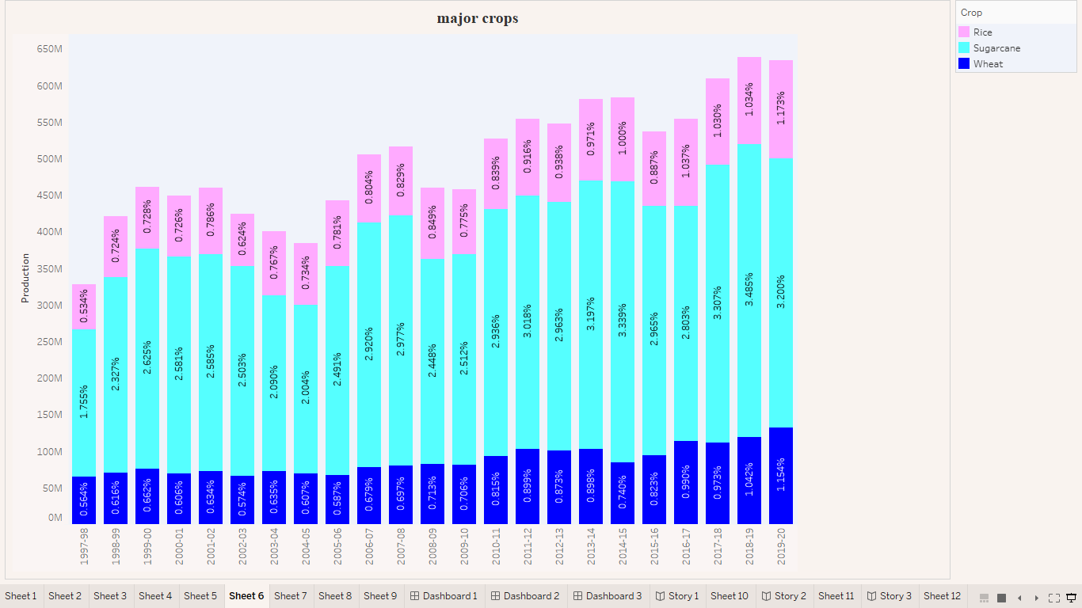

CROPS PLANTATON BY COUNT

Production of Plantation Crops has increased from 16.12 Million Tonne in 2019-20 to 16.63 Million Tonne in 2020-21. Production of Spices has increased by 9.7%, from 10.14 Million Tonne in 2019-20 to 11.12 Million Tonne in 2020-21.

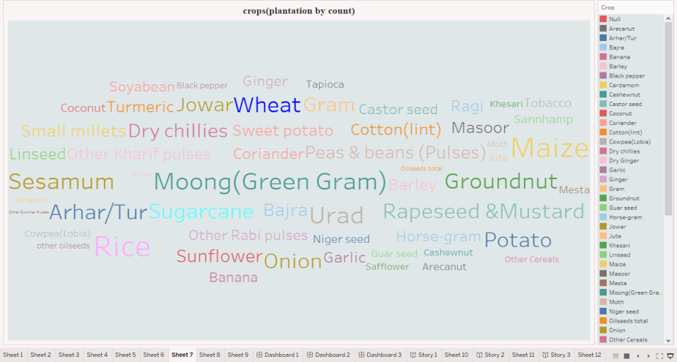

SEASONWISE PRODUCTION

Every crop has unique planting, harvesting, and processing procedures. However, each crop can be distinguished genetically based on the crop season. There are three main Cropping Seasons in India:

* Kharif
* Rabi
* Zaid

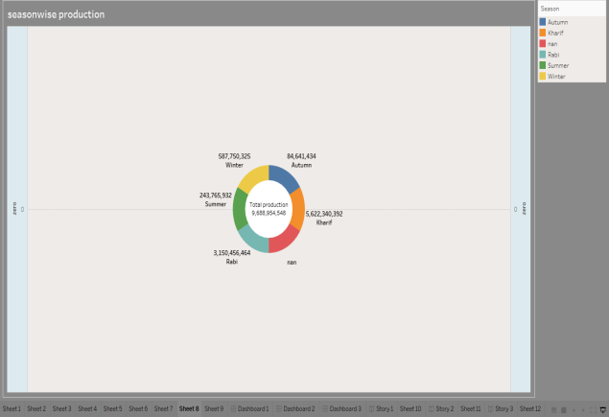

DASHBOARD

AREAS CULTIVATION AND PRODUCTION

**Two-thirds of India’s population** is engaged in agricultural activities. It is a primary activity, which produces food grains and raw materials for industries. India is geographically a vast country so it has various food and non-food crops which are cultivated in three main cropping seasons which are rabi, kharif and zaid.

Major crops can be classified into-

* **Food crops-** Rice, Wheat, Millets, Maize and Pulses.
* **Cash crops-** Sugarcane, Oilseeds, Horticulture crops, Tea, Coffee, Rubber, Cotton and Jute.
* **Top Wheat Producing States: Uttar Pradesh > Punjab > Madhya Pradesh > Haryana > Rajasthan.**
* India is the **second largest producer** after China.
* This is the **second most important cereal crop and the main food crop, in north and north-western** India.
* Success of **Green Revolution** contributed to the growth of Rabi crops especially wheat.
* **Macro Management Mode of Agriculture, National Food Security Mission and Rashtriya Krishi Vikas Yojana** are few government initiatives to support wheat cultivation.

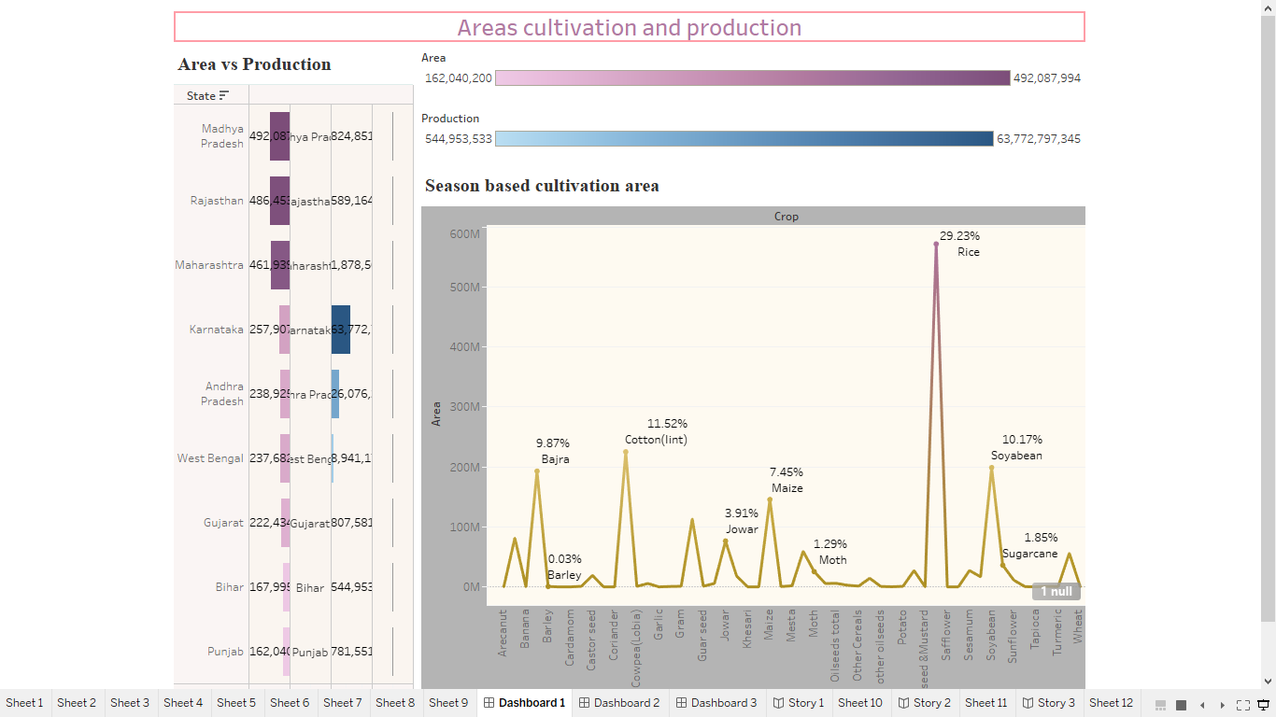

CULTIVATION IN SEASON

The agricultural activities begin with the onset of monsoon in the month of June. India has three major cropping seasons in a year.  
1. Kharif-June-Early days of November-Paddy, Maize, Jute, Sugarcane, Cotton, Millet.  
2. Rabi-November-March-Wheat, Tobacco.  
3. Zaid-March-June-Fruits, Vegetables.

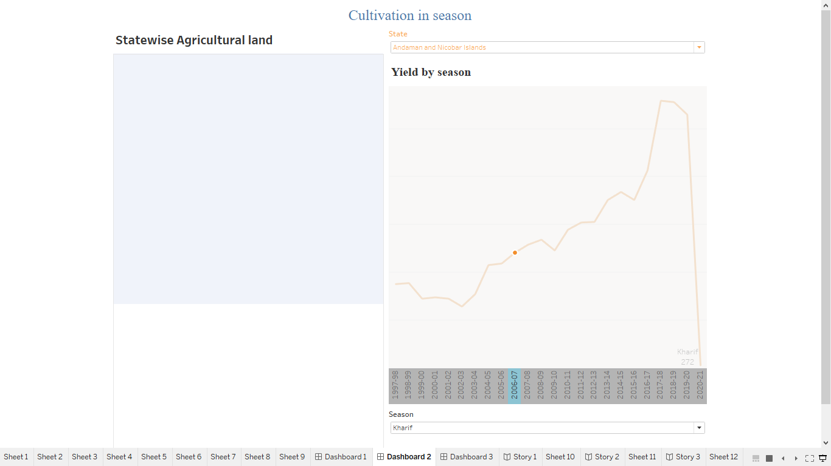

GROUPS OF PLANTATION

A plantation is a large-scale farm or estate, typically situated in tropical or subtropical climates, where a single commercial crop is grown. The term "plantation" is often associated with the production of cash crops like coffee, rubber, tea, cocoa, bananas, sugar, and various forms of palm.

1. **Monoculture** - Plantation crops are typically grown as monocultures, meaning a single crop is grown on a large scale over a wide area. This uniformity can simplify management and increase yield but also makes the crop more susceptible to diseases and pests.
2. **High-Value Cash Crops** - Plantation crops are generally high-value cash crops. They are commercially grown primarily for sale, not for local consumption.
3. **Specific Climate Requirement** - Plantation crops often require specific climatic conditions. Most are grown in tropical or subtropical regions, as these crops usually require a warm and humid climate.
4. **Labour Intensive** - Plantation crops are labor-intensive. They often require a significant amount of manual labor for planting, caring for the crops, and harvesting. This labor need often provides employment opportunities for many people, especially in developing regions.
5. **Capital Intensive** - The cultivation of plantation crops requires substantial investment. This is due to the need for large land areas, high-quality seeds, fertilizers, pesticides, and in many cases, advanced machinery for planting and harvesting.
6. **Long Gestation Period** - Many plantation crops have a long gestation period. For instance, a rubber tree, after being planted, may take up to seven years to mature and become ready for latex tapping.
7. **Processing Requirement** - Most plantation crops need to be processed before they can be used or consumed. For example, coffee beans must be dried, roasted, and ground before being used to make coffee.
8. **Large Scale Production** - As the term 'plantation' suggests, these crops are usually grown on a large scale. This large-scale production is often associated with the commercial purpose of these crops.

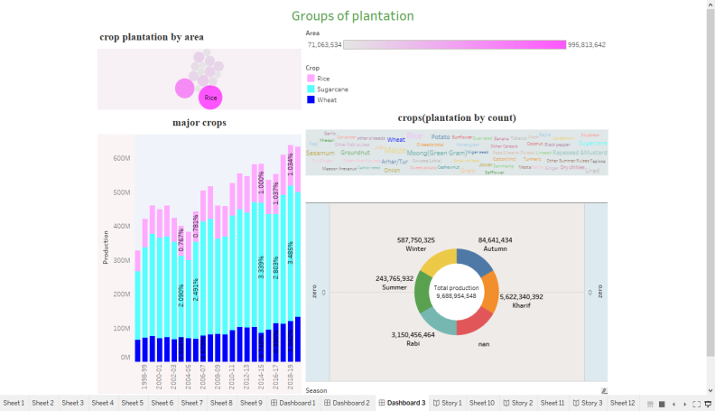

STORY

* In **2014** India ranked as the **world’s largest producer of fruits**like Banana mango guava lemon papaya and vegetables like chickpea and okra, major spices like Ginger chili pepper, fibrous crops such as jute, and staples such as millet and castor oil seed.
* India ranks as the **second-largest producer of wheat and rice**. The major reason for the success of India in agriculture is the **irrigation network of India**.
* The irrigation network includes major and minor canals from rivers rainwater harvesting and groundwater systems. From all of these the **groundwater system** is the largest irrigation network in India.
* The improvement in the irrigation network over the last 50 years has helped India to improve food security and reduce its dependence on monsoon. One of the major roles in irrigation networks is played by dams.
* Dams provide drinking water and control and prevent drought-related damage to agriculture. 60% of the water which comes from all the water channels is consumed by rice and sugar crops.
* India is among the top 3 global producers of the major crops including wheat, rice, cotton, fruits, vegetables, and pulses. The**irrigated crop area of India is 8.26 million hectares** which is the largest in the world and the **arable land is 159.7 million hectares** which is the second largest in the world.

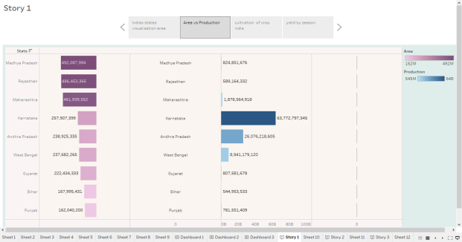 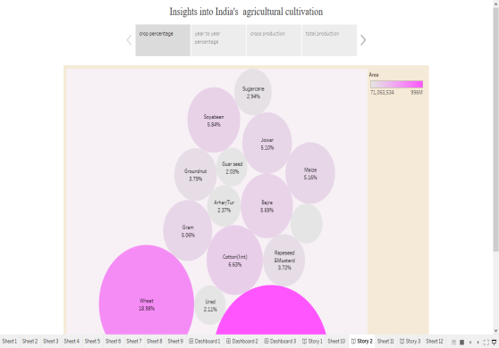

CONCLUSION

The agricultural sector is of vital importance for the region. It is undergoing a process of transition to a market economy, with substantial changes in the social, legal, structural, productive and supply set-ups, as is the case with all other sectors of the economy.

Crop rotation is a fundamental practice that offers a multitude of benefits for sustainable agriculture.