AN INTERNSHIP PROJECT REPORT
ON

“MATHME 3D STUDIO”
Generative 3D Art & Object Studio

Submitted in partial fulfilment of the requirements for the award of the degree of
BACHELOR OF COMPUTER APPLICATIONS (BCA)
Semester III

Submitted by
SULAIMAAN
Register Number: ____________________


MATHME

Under the guidance of
________________________________
Designation: ____________________

DEPARTMENT OF COMPUTER APPLICATIONS
[Name of the College] ________________________
[Affiliated University] ________________________
Academic Year 2026 – 2027

INTERNSHIP CERTIFICATE

This is to certify that SULAIMAAN, Register Number ____________________, a student of the Third Semester of the Bachelor of Computer Applications (BCA) programme, has successfully completed the internship project titled “MATHME 3D STUDIO: Generative 3D Art & Object Studio” as an independent internship project.
The internship was carried out on a part-time basis for a total of 90 hours over 10 weeks, from ____________ to ____________. During this period the student analysed, designed, developed, tested and documented the MathMe web application described in this report.
The work presented in this report is a record of the work done by the student, and the conduct of the student during the internship was found to be satisfactory.

Place: ____________
Date: ____________

Signature of the Internship Guide / Mentor  Name: ____________ | Seal

[NAME OF THE COLLEGE]
[Address of the College] ____________
DEPARTMENT OF COMPUTER APPLICATIONS

CERTIFICATE

This is to certify that the internship project report entitled “MATHME 3D STUDIO: Generative 3D Art & Object Studio” is a bonafide record of the internship work carried out by SULAIMAAN, Register Number ____________________, in partial fulfilment of the requirements for the Third Semester of the Bachelor of Computer Applications (BCA) degree of ________________________________ during the academic year 2026 – 2027.
It is certified that all corrections and suggestions indicated during the internal assessment have been incorporated in the report. The report satisfies the academic requirements prescribed for the internship.

Signature of the Guide  Name: ____________ | Signature of the Head of the Department  Name: ____________

Signature of the Principal
Name: ____________

Examiners

1. Examiner  Name: ____________ | 2. Examiner  Name: ____________

STUDENT DECLARATION

I, SULAIMAAN, Register Number ____________________, a student of the Third Semester of the Bachelor of Computer Applications (BCA) programme, hereby declare that the internship project report entitled “MATHME 3D STUDIO: Generative 3D Art & Object Studio” is an original record of the work carried out by me as an independent internship project, under the guidance of ________________________________.
I further declare that this report is based on my own work, that it has not been submitted earlier to any other university or institution for the award of any degree, diploma or certificate, and that all sources of information used in this report have been duly acknowledged in the bibliography.

Place: ____________
Date: ____________

(SULAIMAAN)

ACKNOWLEDGEMENT

The successful completion of this internship project would not have been possible without the guidance, support and encouragement of many people. I take this opportunity to express my sincere gratitude to all of them.
I express my deep sense of gratitude to ____________________, Principal, ____________________, for providing the necessary facilities and an encouraging environment to carry out this internship.
I am thankful to ____________________, Head of the Department of Computer Applications, for the constant support and for giving me the opportunity to take up this internship project.
I owe my sincere thanks to my internship guide, ____________________, for the valuable guidance, timely suggestions and patient reviews at every stage of this work, from the first idea to the final report.
I also thank all the teaching and non-teaching staff of the Department of Computer Applications for their help and cooperation throughout the internship period.
I am grateful to the open-source communities behind React, Three.js, Mantine, FastAPI, trimesh and manifold3d, whose tools and documentation made this project possible, and to the HuBMAP consortium for making the Human Reference Atlas heart model freely available for education.
Finally, I thank my parents, family members and friends for their love, patience and constant encouragement, which kept me motivated throughout this internship.

(SULAIMAAN)

TABLE OF CONTENTS
Page
EXECUTIVE SUMMARY 1
CHAPTER I: INTRODUCTION 3
1.1 Background of the Internship Project 3
1.2 Problem Statement 3
1.3 Existing System and Proposed System 4
1.4 Objectives of the Project 5
1.5 Scope of the Project 5
1.6 Methodology 6
1.7 Internship Details 7
1.8 Tools and Technologies Used 7
1.9 Organisation of the Report 8
CHAPTER II: DESCRIPTION OF THE ORGANISATION / PROJECT 9
2.1 About MathMe 9
2.2 Vision and Mission 10
2.3 Target Users 10
2.4 Products and Services 10
2.5 Business Model and Plans 11
2.6 Project Team and Roles 12
2.7 Working Environment and Practices 13
CHAPTER III: EXPERIENTIAL LEARNING 14
3.1 Weekly Work Log 14
3.2 Requirement Analysis 15
3.2.1 Functional Requirements 15
3.2.2 Non-functional Requirements 16
3.2.3 Hardware and Software Requirements 16
3.3 System Design 16
3.3.1 System Architecture 16
3.3.2 Data Flow Diagrams 17
3.3.3 Database Design (E-R Diagram) 19
3.3.4 Use Case Diagram 21
3.3.5 Module Structure 21
3.4 Implementation 22
3.4.1 Home Page and Project Management 22
3.4.2 Maths Engine and Patterns 23
3.4.3 Learn and Measure Panels 25
3.4.4 Recipes, Ideas and the Assistant 26
3.4.5 Custom Shapes 28
3.4.6 Exports 29
3.4.7 Geometry Service (Python) 30
3.4.8 Human Heart Slice Atlas 31
3.4.9 Pencil Drawing 31
3.4.10 2D Sketch Board 32
3.4.11 User Interface and Settings 33
3.4.12 Accounts, Plans and Limits 34
3.4.13 Checkout, GST and Invoices 36
3.4.14 Campus Licences and the Class Page 38
3.4.15 Owner Dashboard 39
3.4.16 Landing Page, Enquiries and Policy Pages 41
3.5 Testing 42
3.5.1 Testing Strategy 42
3.5.2 Test Cases 42
3.5.3 Test Results 43
3.6 Deployment Plan 43
3.7 Security Measures 44
3.8 Learning During the Internship 45
CHAPTER IV: INTERNSHIP OUTCOMES AND CONCLUSION 46
4.1 Internship Outcomes 46
4.2 Achievements in Numbers 46
4.3 Skills Gained 47
4.4 Challenges Faced and Solutions 47
4.5 Educational and Social Impact 48
4.6 Limitations 48
4.7 Future Enhancements 49
4.8 Conclusion 49
BIBLIOGRAPHY 50

LIST OF FIGURES
Page
Figure 2.1: The MathMe landing page 9
Figure 2.2: The pricing section of the landing page 12
Figure 3.1: System architecture of MathMe 17
Figure 3.2: Context diagram (Level 0 DFD) 18
Figure 3.3: Level 1 data flow diagram 19
Figure 3.4: Entity-relationship diagram of the account database 20
Figure 3.5: Use case diagram 21
Figure 3.6: Module structure of the MathMe repository 22
Figure 3.7: Home page with the chat box, project cards and ideas 23
Figure 3.8: The 3D studio showing the brief’s example: 100 spheres in a spiral 24
Figure 3.9: The Pattern panel with plain-language controls 25
Figure 3.10: The Learn panel with the spiral formulas and a worked example 26
Figure 3.11: The Measure panel with step-by-step working 26
Figure 3.12: The ideas gallery 28
Figure 3.13: The “Wave field” idea: 625 cubes rising and falling as y = A sin(distance) 28
Figure 3.14: A spun (lathe) shape and its editable side outline 29
Figure 3.15: The export dialog 30
Figure 3.16: The heart model cut along the four-chamber view 31
Figure 3.17: Drawing a solid and a 3D pen tube with the pencil 32
Figure 3.18: The 2D sketch board: a 3-4-5 triangle (area 6 cm²) and a circle of radius 2 33
Figure 3.19: The Settings page 34
Figure 3.20: The Help window with the glossary of maths words 34
Figure 3.21: Upgrade prompt shown when a Free user chooses the STL export 35
Figure 3.22: The plans window 35
Figure 3.23: Checkout with the GST split (Karnataka: CGST + SGST) 36
Figure 3.24: Settings → Account: plan, usage meters and the GST invoice 37
Figure 3.25: Sequence diagram of a Plus checkout 37
Figure 3.26: The teacher’s class page with shared projects and the class list 39
Figure 3.27: The owner dashboard 40
Figure 3.28: Campus licences in the owner dashboard 40
Figure 3.29: The revenue scenario calculator 41

LIST OF TABLES
Page
Table 1.1: Existing systems compared with the proposed system 4
Table 1.2: Internship details 7
Table 1.3: Tools and technologies used 7
Table 2.1: MathMe modules and services 10
Table 2.2: MathMe plans (prices before 18% GST) 11
Table 2.3: Roles in the internship project 12
Table 3.1: Weekly work log 14
Table 3.2: Functional requirements 15
Table 3.3: Non-functional requirements 16
Table 3.4: Hardware and software requirements 16
Table 3.5: Main database tables 20
Table 3.6: Patterns and their formulas 23
Table 3.12: Example recipes and the mathematics they show 27
Table 3.7: Export formats 29
Table 3.8: Prices with 18% GST 36
Table 3.9: Selected test cases 42
Table 3.10: Summary of automated test results 43
Table 3.11: Deployment steps 43
Table 4.1: The project in numbers 46
Table 4.2: Skills gained during the internship 47
Table 4.3: Challenges and how they were solved 47

EXECUTIVE SUMMARY
This report presents the internship project “MathMe 3D Studio: Generative 3D Art & Object Studio”, carried out as an independent internship project during the Third Semester of the Bachelor of Computer Applications (BCA) programme. The internship comprised 90 hours of part-time work spread over 10 weeks.
Traditional 3D modelling software asks the user to create, move, rotate and resize every object by hand. Placing two hundred spheres in a spiral can take hours, and beginners must learn a large number of tools before they make anything. At the same time, school students often see mathematics (angles, sine and cosine, sequences, areas and volumes) as abstract formulas with no visible use. MathMe was built to connect these two problems: the student writes one mathematical rule, and the computer places every object.
MathMe is a web application that runs in any modern browser. The user picks a shape by its width, height and radius, chooses one of seven patterns (spiral, grid, circle, wave, radial rings, sphere and random scatter) and sees hundreds or thousands of copies appear instantly in a 3D view. A “Learn” panel shows the formula behind every pattern with the user’s own numbers filled in, and a “Measure” panel works out volume and surface area step by step. Finished work can be exported as GLB, STL, OBJ, PNG or PDF files for 3D printing, games, posters and class reports.
During the internship the application grew into a complete product with the following parts:
- a maths engine written in TypeScript (shapes, patterns, formulas, a plain-language recipe parser and a 2D constraint solver);
- a 3D studio built with React, Three.js (react-three-fiber) and the Mantine component library, including a pencil tool, a 2D sketch board and an ideas gallery;
- a geometry service written in Python with FastAPI, trimesh and manifold3d for exact measurements, joining and cutting solids, print-ready files and a real human-heart slice atlas;
- an account service in Python for Cloudflare Workers that adds Google sign-in, cloud saves, subscription plans in Indian rupees with 18% GST, Cashfree payments, school (Campus) licences and an owner dashboard.
The work followed an iterative method: small milestones, each one designed, built, tested and committed before the next. The finished system is covered by 147 unit tests and 35 browser tests for the web application and 91 automated tests for the two Python services, all of which pass, and a continuous-integration pipeline runs them on every change.
The internship provided practical experience of the full software development life cycle: requirement analysis, system design (architecture, data-flow and entity-relationship diagrams), front-end and back-end programming, database design, payment integration, security, automated testing and technical documentation. This report describes the project setting (Chapter II), the work done and the knowledge gained week by week (Chapter III), and the outcomes, limitations and future scope of the work (Chapter IV).

CHAPTER I
INTRODUCTION

1.1 Background of the Internship Project
Computer graphics and 3D printing are becoming part of school and college laboratories, and students are increasingly asked to design models, posters and simulations. Most 3D tools, however, are built for professional artists. They expose hundreds of buttons, and they treat every object as a separate item to be placed by hand.
Mathematics offers a better way to describe many designs. A sunflower, a spiral staircase, a DNA double helix, a snowflake or a field of waves can each be described by a short rule: how many objects, which pattern, how far apart, and how much each one turns or grows. If a computer program understands such rules, a student can create a complex artwork in seconds and, at the same time, see exactly how angles, trigonometry and sequences produce the shapes in front of them.
The project brief, titled “Generative 3D Art & Object Studio”, asked for exactly this kind of tool. Its example rule, “100 objects → Spiral → Radius 20 → Rotation 30° → Scale 0.5–2”, became the guiding test case of the internship. MathMe 3D Studio is the result: a browser-based studio, written with 10th-grade students in mind, where mathematics is the main design tool.

1.2 Problem Statement
The internship set out to address the following problems:
- Repetitive manual modelling. Creating patterned 3D artwork in traditional software means creating, moving, rotating and resizing each object separately, which is slow and error-prone.
- Steep learning curve. Beginners must learn a large set of tools and technical vocabulary (vertices, modifiers, transforms) before they can make anything.
- Mathematics without context. Students learn formulas such as x = r cos θ or the volume of a sphere, but rarely see them used to build something real.
- Hard-to-share results. Many tools produce files that only the same tool can open, which makes printing, presenting and sharing difficult in a classroom.
- Sustainability. A free educational tool also needs a fair, legal way to cover its hosting costs in India (plans, GST invoices and school licences).
The aim was therefore to build a tool in which one mathematical rule creates every object, every formula is visible and explained, and the result can be exported to standard file formats, while keeping the interface simple enough for a school student.

1.3 Existing System and Proposed System
Before designing MathMe, the tools that students and teachers already use were studied. Each is good at its own job, but none of them combines pattern-based 3D modelling, visible mathematics and classroom-friendly exports in one simple tool.
- Professional 3D software (for example Blender) is very powerful and can make repeated patterns with array modifiers or node systems, but it is designed for trained artists. A beginner must learn many concepts before making a simple pattern, and the mathematics stays hidden inside the tool.
- Beginner 3D design tools (for example Tinkercad) are easy to start with and export files for 3D printing, but objects are still placed one at a time, and the tools do not explain the mathematics behind a design.
- Mathematics software (for example GeoGebra 3D) shows graphs, surfaces and formulas very well, but it is not built for making artwork from hundreds of objects or for producing posters and project sheets.
Table 1.1: Existing systems compared with the proposed system
Feature | Professional 3D tools | Beginner 3D tools | Maths software | MathMe (proposed)
Easy for a 10th-grade student | No | Yes | Partly | Yes
One rule places many objects | Yes, with advanced tools | No | Partly | Yes, 7 patterns
Shows the formula for every object | No | No | Yes | Yes, with worked examples
Volume and area with working | No | No | Partly | Yes
Plain-language recipe | No | No | No | Yes
3D-print and game exports | Yes | Yes | Partly | Yes
Runs in a browser, no installation | No | Yes | Yes | Yes
Class page for teachers | No | Yes | Yes | Yes

The proposed system, MathMe, keeps the ease of beginner tools and the clear formulas of mathematics software, and adds the pattern power of professional tools: the user writes one rule, sees every object placed by it, reads the formula behind it, and exports real files.

1.4 Objectives of the Project
The main objectives of the internship project were:
- To design and develop a web-based 3D studio in which shapes are described by simple measurements (width, height, depth, radius).
- To implement a generation engine with seven mathematical patterns that place hundreds or thousands of copies of a shape automatically.
- To show the formula behind every pattern and shape, worked out with the user’s own numbers, so that the tool also teaches mathematics.
- To support a plain-language “recipe” such as “100 spheres → spiral → radius 20”, so that a model can be described in one line.
- To export the result as GLB, STL, OBJ, PNG and PDF files for games, 3D printing, posters and reports.
- To build a Python geometry service for exact measurements, joining and cutting of solids, and an educational human-heart slice atlas.
- To add a 2D sketch board with points, lines, circles, measurements and geometric rules, and to turn sketches into 3D solids.
- To add user accounts, cloud saves, subscription plans with GST-compliant invoices, school licences and an owner dashboard, so that the product can be offered sustainably.
- To test every part automatically and document the system for future maintenance and deployment.

1.5 Scope of the Project
In scope. The project covers:
- the complete web application (home page, 3D studio, 2D sketch board, exports, settings and help);
- the geometry service and the account service;
- the landing page with pricing, and draft policy pages;
- automated tests and the deployment guide.
The application works fully without an account: projects are saved in the browser, and every feature can be used. Signing in adds cloud saves, paid plans and school features.
Out of scope. The following were deliberately left for later phases:
- native mobile applications;
- real-time collaborative editing;
- class assignments and grading;
- a marketplace for shared designs;
- a public developer API.
The heart atlas is for education only: it shows one reference heart and is not a medical record.

1.6 Methodology
The internship followed an iterative and incremental development method, similar to the agile practice of short sprints. The work was divided into milestones; each milestone was planned, implemented, tested and committed to the version-control repository before the next one began. This kept the application working at every stage and made it easy to show progress to the guide.
Every milestone followed the same cycle:
- Plan: write down what the milestone must achieve and how it will be tested.
- Design: sketch the data model, the user interface and the interfaces between parts.
- Implement: write the code in small, readable steps.
- Test: write unit tests for the logic and browser tests for the user flows; run lint, formatting and type checks.
- Review and commit: read the change again, fix problems, and commit it with a clear message.
The milestones were: project set-up; the maths engine and 3D view; custom shapes; recipes and project files; exports; the geometry service; the heart atlas; interface design and the home page; the pencil and the 2D sketch board; and finally accounts, plans, payments, school licences and the owner dashboard. Table 3.1 in Chapter III maps them to the ten weeks of the internship.

1.7 Internship Details
Table 1.2: Internship details
Particular | Details
Name of the student | Sulaimaan
Register number | ____________________
Programme and semester | Bachelor of Computer Applications (BCA), Semester III
Title of the internship project | MathMe 3D Studio: Generative 3D Art & Object Studio
Type of internship | Independent internship project (software development)
Mode | Part-time, during the semester
Duration | 90 hours over 10 weeks
Period | From ____________ to ____________
Internal guide | ____________________
Domain | Educational technology, 3D graphics, web development

1.8 Tools and Technologies Used
The project uses free and open-source tools throughout. Table 1.3 lists the main technologies and the purpose of each one.
Table 1.3: Tools and technologies used
Area | Technology | Purpose in MathMe
Front-end language | TypeScript 5 | Type-safe code for the whole web application
User interface | React 19, Mantine 9 | Components, panels, dialogs and forms
3D graphics | Three.js, react-three-fiber, drei | 3D view, instanced rendering, cameras and gizmos
State | zustand, immer, zundo | Application state with undo and redo
Build tool | Vite 8 | Fast development server and production build
Back-end language | Python 3.11+ | Geometry service and account service
Web framework | FastAPI, Pydantic | REST APIs with validated input
Geometry | trimesh, manifold3d | Exact volumes, joining and cutting solids
Hosting (planned) | Cloudflare Workers, D1, R2 | Serverless API, SQLite database, file storage
Payments | Cashfree Payments | UPI AutoPay subscriptions, orders, payment links
Email | Resend | Receipts and renewal reminders
Sign-in | Google OAuth 2.0 | Secure sign-in without passwords
Documents | jsPDF | PDF project sheets and GST invoices in the browser
Testing | Vitest, Playwright, pytest | Unit tests, browser tests, service tests
Quality | ESLint, Prettier, ruff | Linting and consistent formatting
Version control | Git, GitHub Actions | History, branches and continuous integration
Editor | Visual Studio Code | Writing and debugging code

1.9 Organisation of the Report
The rest of this report is organised as follows:
- Chapter II describes the project setting: MathMe’s vision and mission, its users, its products, its business model and the way the work was organised.
- Chapter III describes the experiential learning: the weekly work log, the requirements, the system design with diagrams, the implementation of every module with screenshots, the testing, and what was learnt.
- Chapter IV summarises the outcomes, skills gained, challenges and solutions, limitations and future enhancements, and concludes the report.
- The Bibliography lists the books and documentation referred to during the internship.

CHAPTER II
DESCRIPTION OF THE ORGANISATION / PROJECT
This internship was carried out as an independent internship project and not inside an outside company. In place of a company profile, this chapter describes the project itself as the organisation in which the work was done: its vision and mission, its users, the products it offers, its business model, and the way the work was planned and managed.

2.1 About MathMe
MathMe 3D Studio is a generative 3D art and object studio for students, teachers and makers. Its name combines “Math” and “Me”: mathematics made personal, visible and creative. The product runs entirely in a web browser, so it needs no installation and works on school computers, laptops and tablets.
The central idea of MathMe is that one rule creates every object. Instead of placing two hundred spheres by hand, the user writes a rule (how many, which pattern, which sizes) and the studio calculates every position, rotation and scale. Changing one number updates the whole artwork. Every rule explains itself in a Learn panel, so the same tool is both a creative studio and a mathematics lesson.
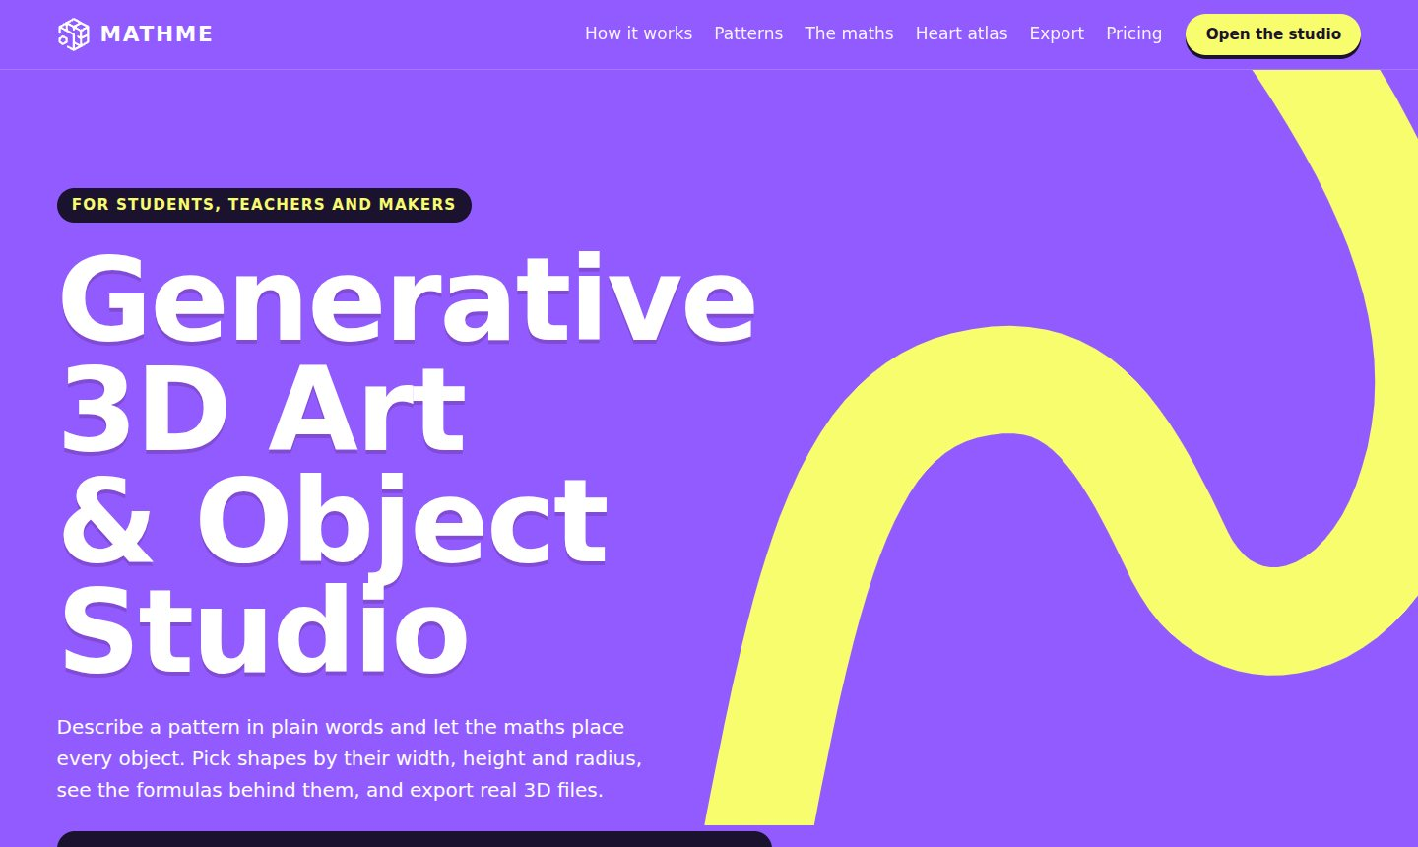
Figure 2.1: The MathMe landing page

2.2 Vision and Mission
Vision. To make mathematics the most creative subject in school by letting every student build real 3D art and objects from simple rules.
Mission.
- To give students a free, friendly studio in which every formula is visible and every shape is described in plain words.
- To let teachers use the same tool for lessons on geometry, trigonometry, sequences, area and volume, and for science topics such as human anatomy.
- To produce real files (3D prints, models for games, posters and reports) so that students can take their work beyond the screen.
- To keep the product sustainable through fair, transparent pricing in Indian rupees and affordable school licences.

2.3 Target Users
- School students (Classes 8–12): learn geometry and trigonometry by building artwork; the interface was written with 10th-grade students in mind.
- College students: use MathMe for design, engineering-drawing and computer-graphics coursework, and for 3D printing.
- Teachers: demonstrate formulas live, set creative tasks and see their students’ shared work on a class page.
- Makers and designers: create patterned objects, print-ready models and posters quickly.
- Schools and colleges: buy a Campus licence for a whole class with teacher and student accounts.

2.4 Products and Services
MathMe is organised as a set of modules that work together. Table 2.1 summarises each module and what it offers to the user.
Table 2.1: MathMe modules and services
Module | What it offers
Home page | Project list with pictures, an AI-assisted chat box (“describe what to make”), an ideas gallery
3D studio | 21 shape types, 7 patterns, variation, symmetry, colours, undo/redo, a plain-language recipe box
Learn and Measure | The formula behind every pattern with a worked example; volume and surface area with full working
Pencil | Draw closed outlines that become solids, or 3D pen lines that become tubes, directly in the 3D view
2D sketch board | Points, lines and circles by radius, snapping, measurements, geometric rules, 2D-to-3D
Exports | GLB, STL, OBJ, PNG (HD, 4K, square, see-through), PDF project sheet, SVG, DXF, project file
Geometry service | Exact volume of the whole model, join / cut / overlap of solids, print-ready joined STL
Heart atlas | A real human heart (Human Reference Atlas) with 51 structures, cut along 21 standard planes or any angle
Accounts and cloud | Google sign-in, cloud saves, plans and limits, GST invoices
Campus | School licences, join codes, class page with shared student projects
Owner dashboard | Sign-ups, active users, paying users, MRR, churn, enquiries, licences, revenue calculator

2.5 Business Model and Plans
MathMe follows a “freemium” business model. Everything can be tried for free, and paid plans add more capacity, more export formats and commercial-use rights. All prices and limits are stored in one file (shared/plans.json), which is read by the web application, the server and the tests, so that the prices shown can never disagree with the prices charged. Prices are in Indian rupees and 18% GST is added at checkout: CGST and SGST (9% each) within the seller’s state, or IGST (18%) for other states.
Table 2.2: MathMe plans (prices before 18% GST)
Plan | Price | Main features
Free (Explorer) | ₹0 | 3 patterns, 2,000 objects per scene, 3 cloud projects, 15 exports a month (PNG HD, project file), 5 AI messages and 5 geometry jobs a day
Plus (Creator) | ₹299 a month or ₹2,499 a year | All 7 patterns, 20,000 objects, 2D-to-3D, GLB/STL/OBJ/SVG/DXF/PDF, 200 exports a month, 50 cloud projects, 50 AI messages and 50 geometry jobs a day
Pro (Professional) | ₹799 a month or ₹6,999 a year | 4K and see-through PNG, print-ready STL, 1,000 exports a month, 500 cloud projects, 300 geometry jobs a day processed first, commercial use, priority support
Campus | ₹14,999 a year | 100 student accounts (Plus) and 5 teacher accounts (Pro), class page and join codes; starts with a free pilot
Enterprise | By quotation | Volume licences and custom workflows for universities, laboratories and studios

For example, the Plus plan costs ₹299 + ₹53.82 GST = ₹352.82 a month, and the Campus licence costs ₹14,999 + ₹2,699.82 GST = ₹17,698.82 a year. Monthly plans renew through a UPI AutoPay or card mandate; yearly plans are a single payment with reminder emails before they end.
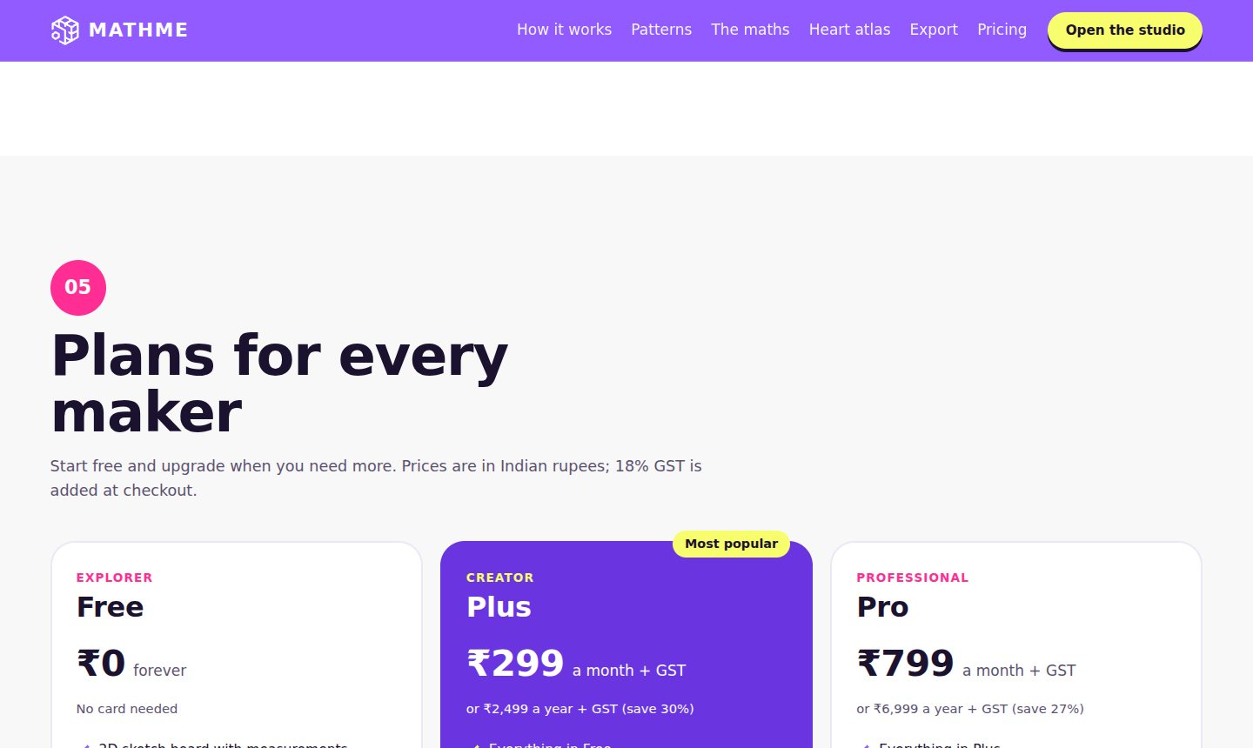
Figure 2.2: The pricing section of the landing page

2.6 Project Team and Roles
Because this was an independent internship project, the student carried out every role in the project, under the supervision of the internal guide. Table 2.3 lists the roles.
Table 2.3: Roles in the internship project
Role | Person | Responsibilities
Developer and designer | Sulaimaan | Requirements, design, front-end and back-end programming, user interface, diagrams
Tester | Sulaimaan | Unit tests, browser tests, service tests, manual checks on desktop and phone sizes
Documentation | Sulaimaan | Plan, README, deployment guide, policy drafts and this report
Internal guide | ____________________ | Reviews, suggestions and evaluation of the internship

2.7 Working Environment and Practices
The internship used a professional software engineering environment, so that the project could be maintained and extended after the internship:
- Version control: all code lives in a Git repository on GitHub. Work is done on a feature branch, and every milestone is a separate commit with a descriptive message.
- Monorepo structure: the web application (web/), the geometry service (geometry-service/), the account service (account-service/), shared data (shared/) and documentation (docs/) are kept in one repository.
- Continuous integration: a GitHub Actions pipeline runs linting, formatting checks, type checking, unit tests, the production build, browser tests and the Python tests on every push.
- Code quality: ESLint and Prettier for TypeScript, ruff for Python; strict TypeScript settings; small, readable functions with comments where the reason is not obvious.
- Documentation: a project plan (docs/PLAN.md), a README with setup and checks, and a step-by-step deployment guide (docs/DEPLOY.md).
- Working hours: about nine hours a week on a part-time basis, with a short written log of the work done each week (Table 3.1).

CHAPTER III
EXPERIENTIAL LEARNING
This chapter describes the work carried out during the internship and the learning gained from it. It begins with the weekly work log, then follows the stages of the software development life cycle: requirement analysis, system design, implementation of each module, and testing. It ends with the security measures taken and a summary of what was learnt.

3.1 Weekly Work Log
The internship was planned as ten weeks of part-time work, about nine hours a week, for a total of 90 hours. Table 3.1 lists the work done in each week. The dates and the hours actually spent are filled in by hand and signed off by the guide.
Table 3.1: Weekly work log
Week | Dates | Work done | Hours
1 |  | Studied the project brief; wrote the plan; set up the repository, React + TypeScript + Vite, Python service, linting, tests and continuous integration
2 |  | Built the maths engine: shapes described by width, height and radius; the seven patterns; variation and symmetry; formulas for the Learn panel
3 |  | Built the 3D view with instanced rendering, selection and the move/turn/stretch gizmo; the editor panels; undo and redo
4 |  | Added custom shapes (spun and extruded outlines, 3D text, graph surfaces), the plain-language recipe box, the ideas gallery, autosave and project files
5 |  | Implemented exports: GLB, STL, OBJ, PNG and the PDF project sheet; started the Python geometry service (measure, join, cut)
6 |  | Finished the geometry service and print-ready exports; built the human-heart slice atlas and the any-angle cut tool
7 |  | Redesigned the interface in the brand colours; sidebar, settings page and logo; home page with project list and chat box; landing page
8 |  | Added the pencil tool and the 2D sketch board (points, lines, circles, measurements, rules, SVG/PNG/PDF/DXF export, 2D-to-3D)
9 |  | Built the account service: Google sign-in, cloud saves, plans and limits, Cashfree checkout, GST invoices, Campus licences and the owner dashboard
10 |  | Security review and fixes; browser tests for every flow; deployment guide, policy drafts, landing pricing; this report
 |  | Total | 90

3.2 Requirement Analysis
The requirements were collected from the project brief, from the needs of the target users described in Chapter II, and from the business plan. They are divided into functional requirements (what the system must do) and non-functional requirements (how well it must do it).

3.2.1 Functional Requirements
Table 3.2: Functional requirements
ID | Requirement
FR1 | The user can create, open, rename, duplicate and delete projects; projects save automatically.
FR2 | The user can add shapes described by plain measurements (width, height, depth, radius).
FR3 | The user can copy a shape into a spiral, grid, circle, wave, radial rings, sphere or random-scatter pattern.
FR4 | The system shows the formula of each pattern and a worked example for any chosen object.
FR5 | The system works out the volume and surface area of shapes and of the whole model, with working.
FR6 | The user can type a recipe such as “100 spheres → spiral → radius 20” to build a scene.
FR7 | The user can draw shapes with a pencil and sketch in 2D with lines, circles and rules.
FR8 | The user can export GLB, STL, OBJ, PNG, PDF, SVG and DXF files and a project file.
FR9 | The user can open a real human-heart model and cut it along standard or custom planes.
FR10 | The user can sign in with Google and save projects in the cloud.
FR11 | The system enforces the limits of each plan and explains which plan unlocks a feature.
FR12 | The user can buy a plan; the system adds GST, takes payment through Cashfree and issues an invoice.
FR13 | Teachers and students can join a class with a code; students can share projects with their class.
FR14 | The owner can see sign-ups, revenue and churn, answer enquiries and manage school licences.

3.2.2 Non-functional Requirements
Table 3.3: Non-functional requirements
Quality | Requirement
Usability | Plain words instead of technical terms; every control has a short help text; works for a 10th-grade student
Performance | Smooth 3D view with thousands of objects (instanced rendering); first screen loads quickly
Portability | Runs in any modern browser on Windows, macOS, Linux, Chromebooks and tablets; no installation
Reliability | Autosave, undo/redo, version checks on cloud saves; payments processed exactly once
Security | Secure sign-in, signed payment webhooks, protection against cross-site requests
Maintainability | Typed code, small modules, one source of truth for prices, automated tests
Compliance | GST invoices numbered per financial year; refund, privacy and terms pages
Accessibility | Keyboard support, labelled controls, readable colours, layouts that fit a phone screen

3.2.3 Hardware and Software Requirements
Table 3.4: Hardware and software requirements
Item | For using MathMe | For developing MathMe
Processor | Any dual-core processor | Quad-core processor
Memory | 4 GB RAM | 8 GB RAM or more
Graphics | WebGL-capable graphics | WebGL-capable graphics
Operating system | Any (Windows, macOS, Linux, ChromeOS) | Windows, macOS or Linux
Software | Chrome, Edge, Firefox or Safari | Node.js 22, Python 3.11+, Git, VS Code
Network | Internet for the first load; cloud features need a connection | Internet for packages and deployment

3.3 System Design

3.3.1 System Architecture
MathMe follows a three-tier, service-based architecture (Figure 3.1). The presentation tier is the web application running in the browser. It contains the whole maths engine, so the studio works even without a server, and it keeps device projects in browser storage.
The application tier has two services, each with a narrow job:
- the account service, a FastAPI application designed to run as a Cloudflare Python Worker, which handles sign-in, cloud projects, plans, payments and school licences;
- the geometry service, a FastAPI application in a Docker container, which performs heavy and exact geometry work with trimesh and manifold3d.
The data tier is Cloudflare D1 (an SQLite database) for records and R2 for project files. External services are Google (sign-in), Cashfree (payments) and Resend (email).
The browser talks only to the account service, under the same web address (/api/*). The account service checks the user’s plan and daily quota before passing a geometry job to the geometry service with a shared secret, so the quotas cannot be bypassed.
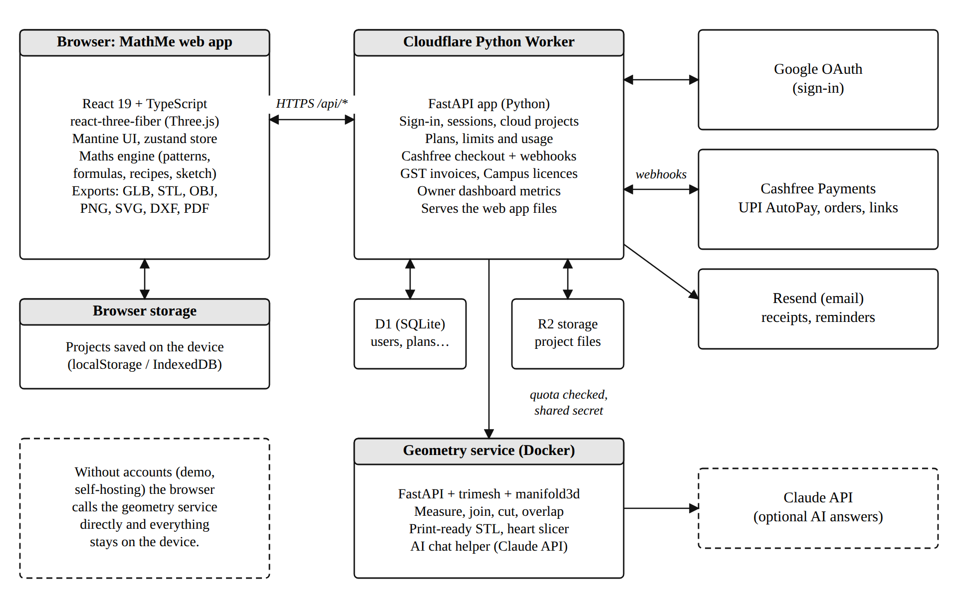
Figure 3.1: System architecture of MathMe

3.3.2 Data Flow Diagrams
The context diagram (Level 0 DFD) in Figure 3.2 shows MathMe as a single process and its five external entities: the student or maker, the teacher, the owner, Google, and Cashfree/Resend. Students send shapes, patterns, recipes and sketches, and receive the 3D view, formulas and exported files. Teachers send join codes and receive the class page. The owner manages licences and receives metrics. Google confirms identity, and Cashfree reports payment events.
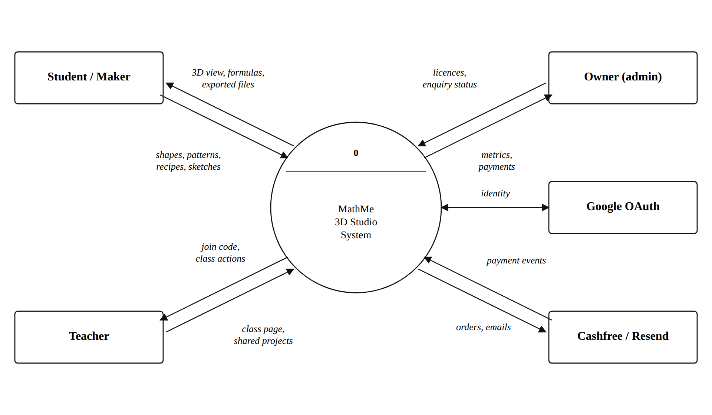
Figure 3.2: Context diagram (Level 0 DFD)
The Level 1 DFD in Figure 3.3 breaks the system into seven processes:
- 1.0 build the scene;
- 2.0 export files;
- 3.0 run geometry jobs;
- 4.0 sign in and save to the cloud;
- 5.0 billing and GST;
- 6.0 the Campus class;
- 7.0 the owner dashboard.
It also shows four data stores:
- D1: device projects in the browser;
- D2: users and cloud projects;
- D3: payments and invoices;
- D4: organisations and their members.
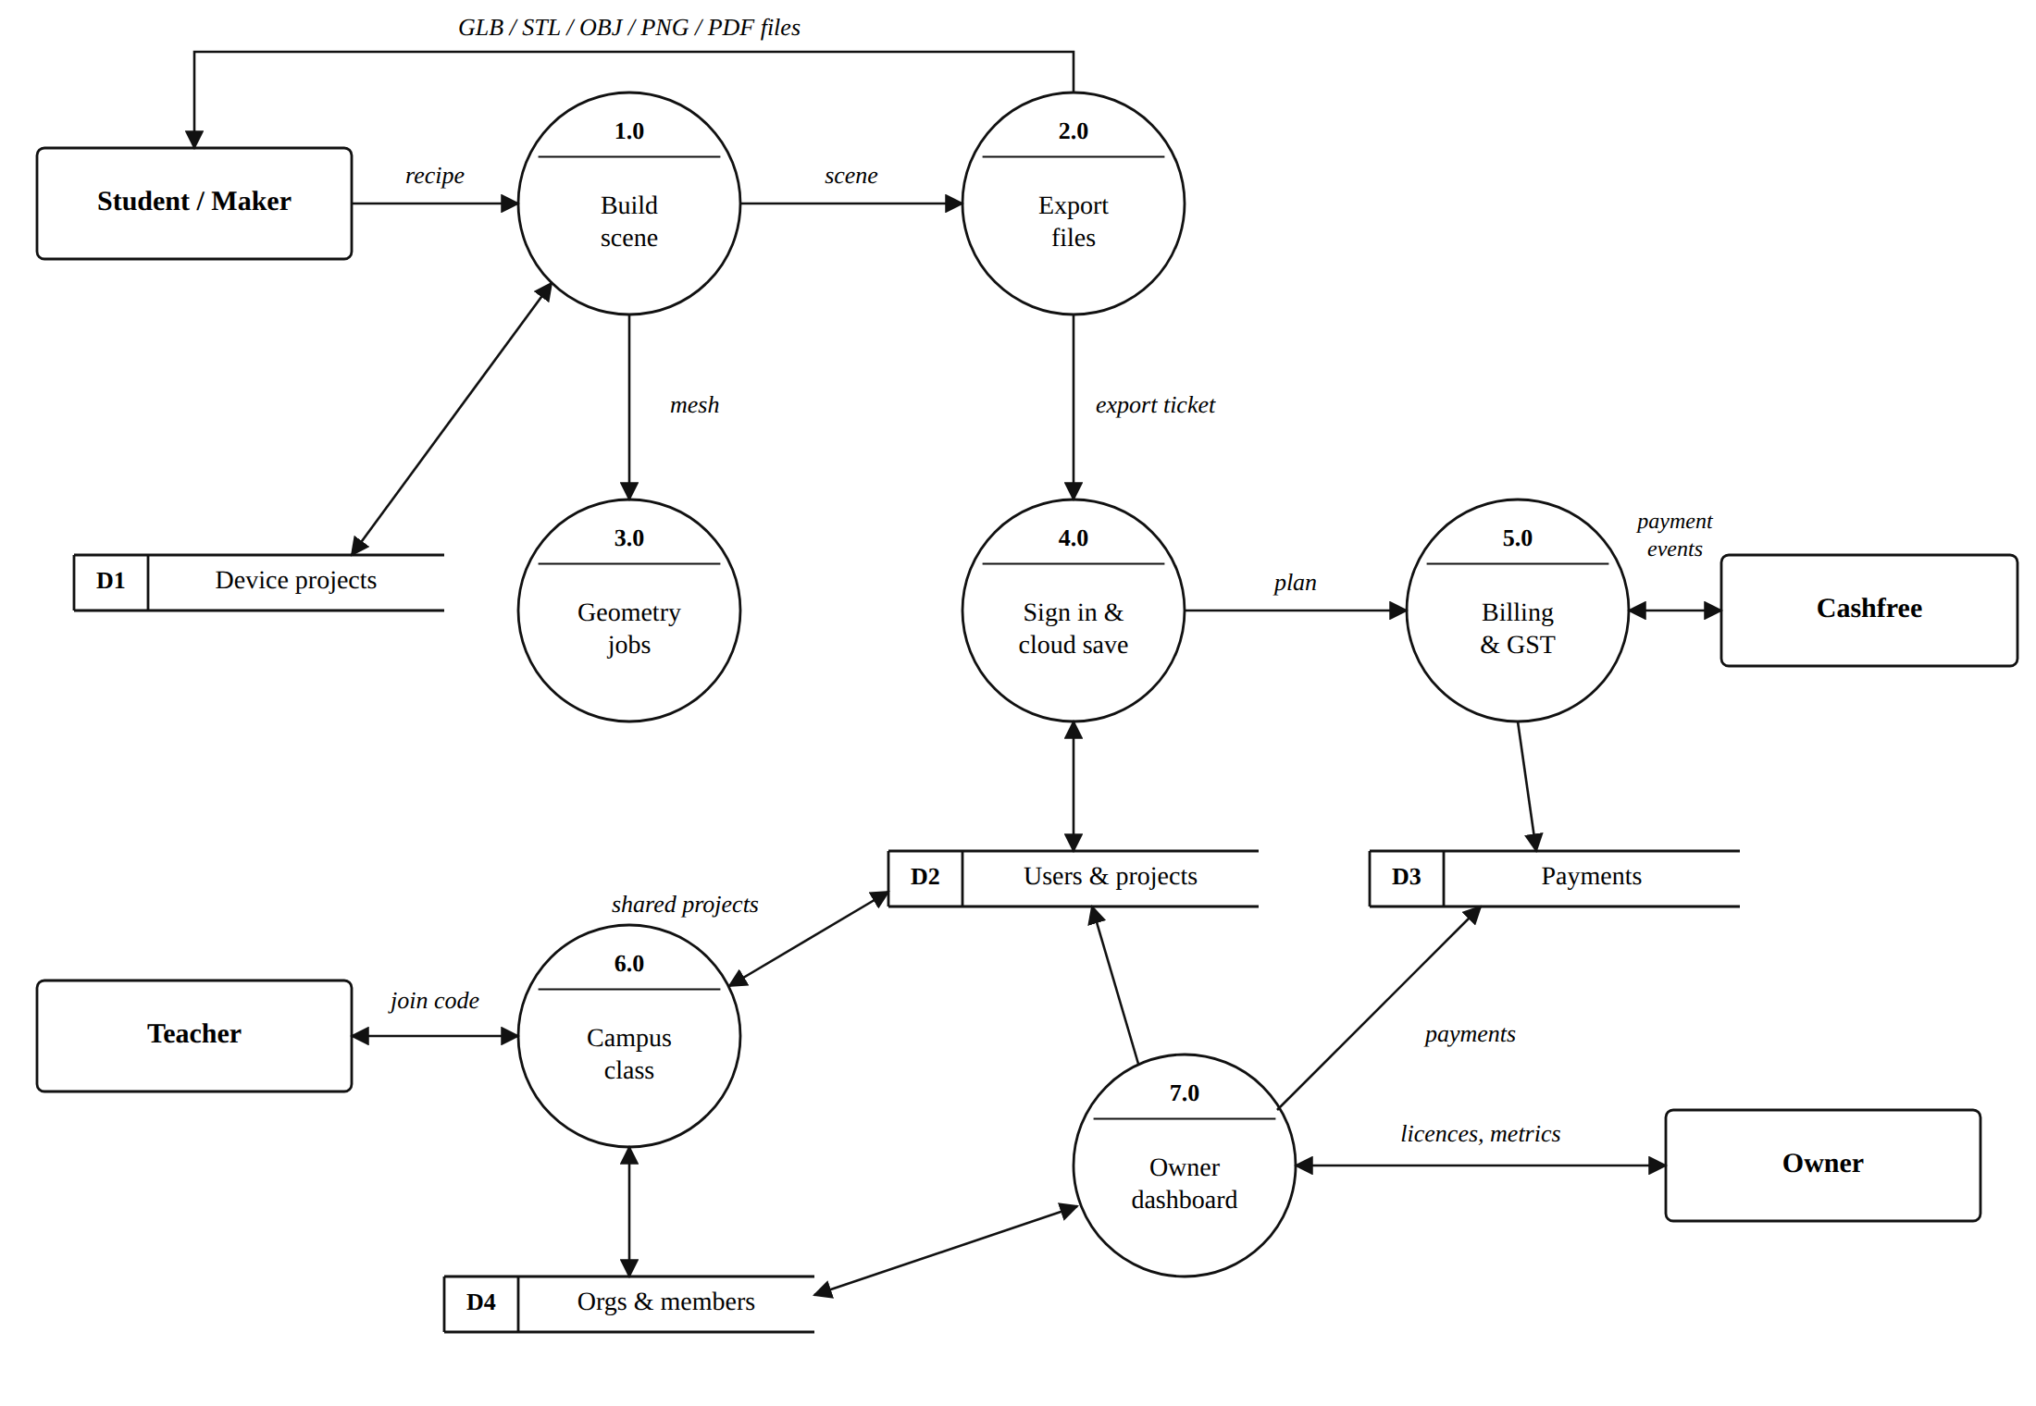
Figure 3.3: Level 1 data flow diagram

3.3.3 Database Design (E-R Diagram)
The account service stores its data in a relational database (SQLite, run as Cloudflare D1 in production). The same SQL migration file creates the tables in both places. Figure 3.4 shows the entity-relationship diagram of the main tables:
- A user has many sessions, projects, subscriptions, payments and usage counters.
- A payment has exactly one GST invoice.
- An organisation (a Campus licence) has many members, through the ORG_MEMBERS table, and can make payments.
- A project can be shared with one organisation.
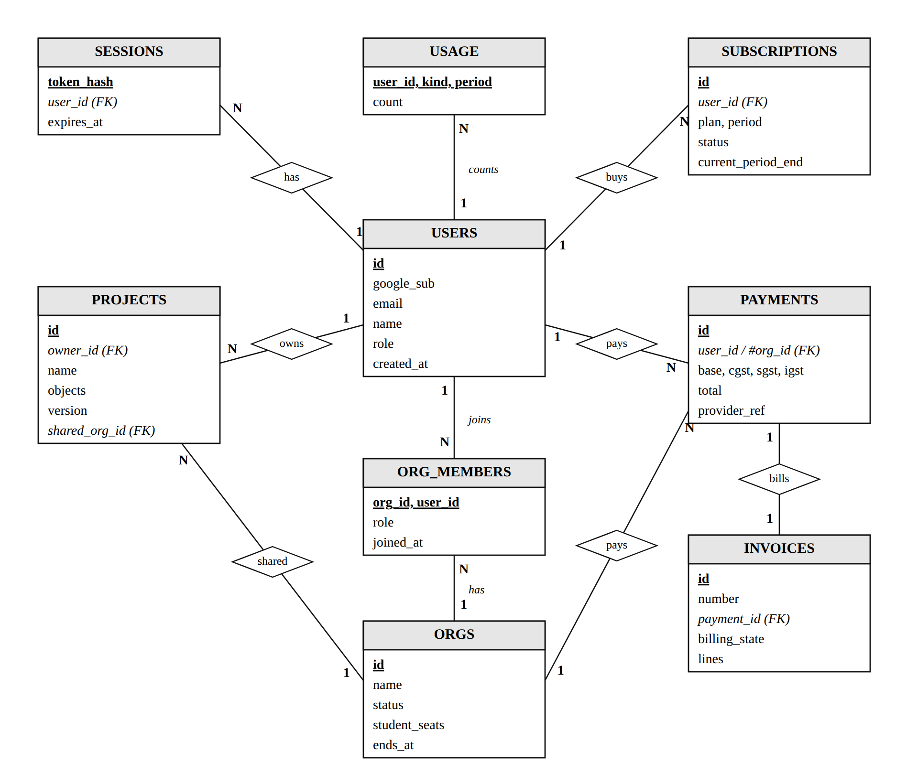
Figure 3.4: Entity-relationship diagram of the account database
Table 3.5: Main database tables
Table | Purpose | Key fields
users | People who signed in with Google | id, google_sub, email, role
sessions | Signed-in browsers (stored as a hash of the token) | token_hash, user_id, expires_at
projects | Cloud projects (the file itself is in R2) | id, owner_id, version, shared_org_id
subscriptions | Paid plans and their state | plan, period, status, current_period_end
payments | Every rupee received, with the GST split | base, cgst, sgst, igst, total
invoices | GST invoices numbered per financial year | number, payment_id, billing_state
usage | Daily and monthly counters for plan limits | user_id, kind, period, count
orgs, org_members, org_codes | Campus licences, members and join codes | seats, ends_at, role, code
enquiries, webhook_events | School leads; payment events already handled | status; event id

3.3.4 Use Case Diagram
Figure 3.5 shows the three kinds of users and what each one can do. The student creates and explores; the teacher can do everything a student can and also manages a class; the owner manages licences, enquiries and the business numbers.
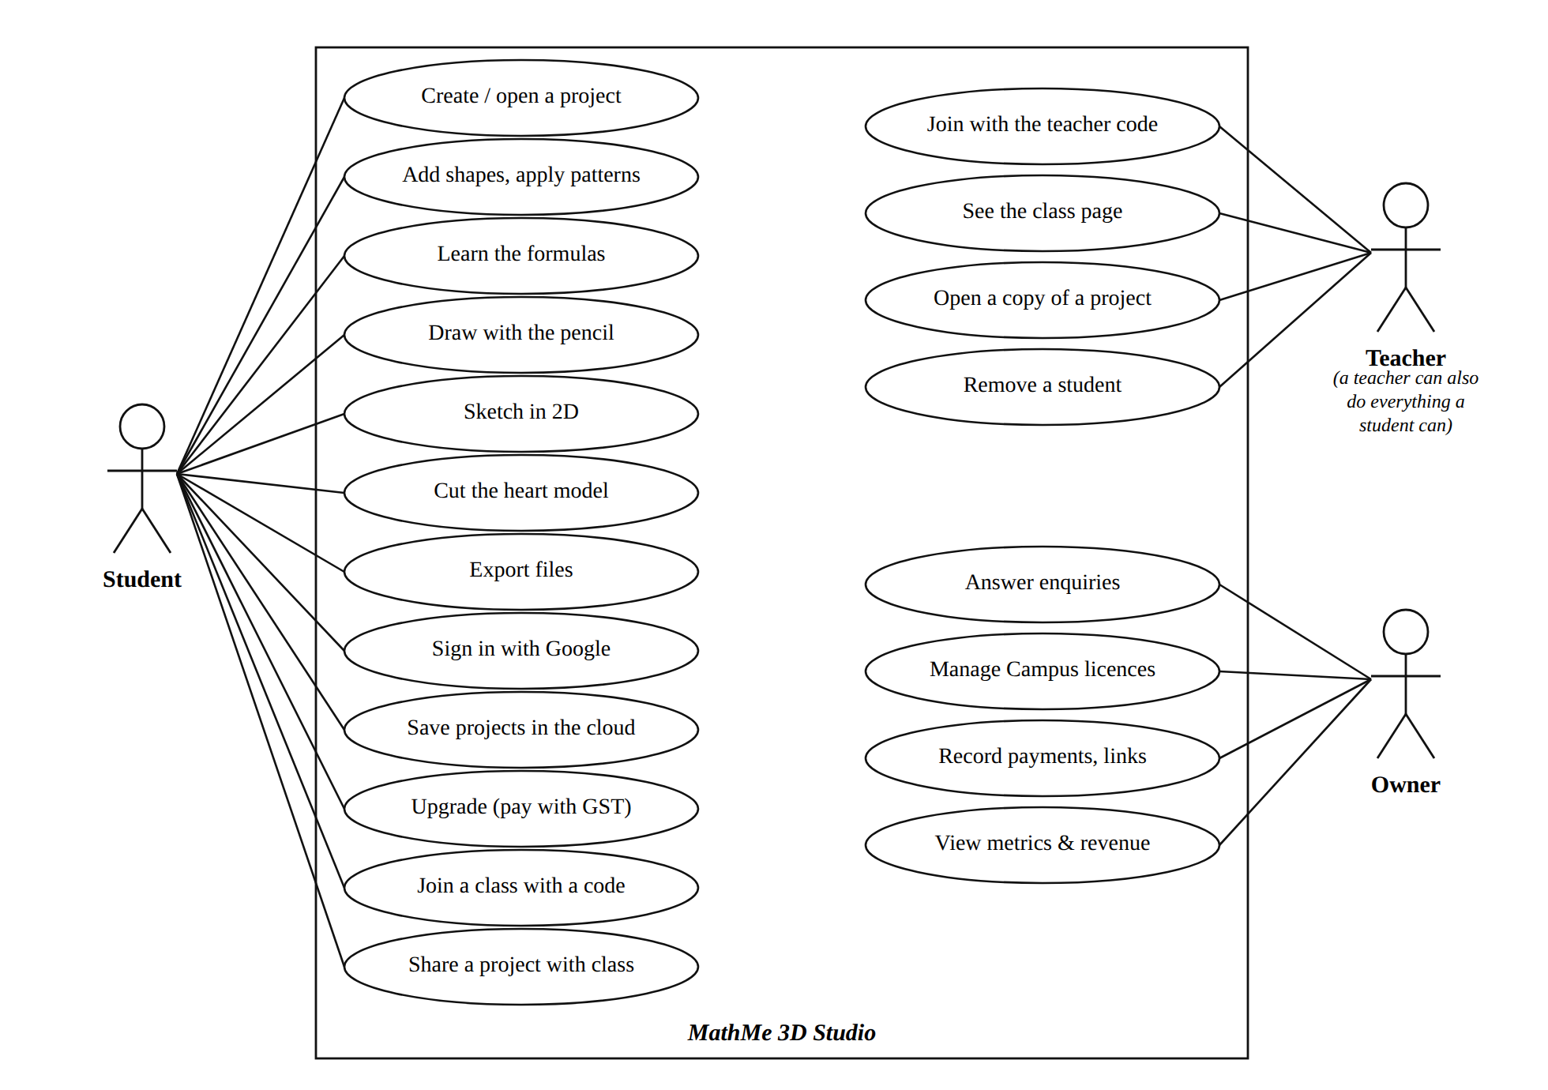
Figure 3.5: Use case diagram

3.3.5 Module Structure
The source code is organised as a monorepo (Figure 3.6). The maths engine (web/src/engine) has no user-interface code, so it can be tested quickly and reused. The application code is split into the 3D viewport, the user interface, the state stores and the exporters. The two Python services each have their own routes, logic and tests. One shared file (shared/plans.json) holds every price and limit.
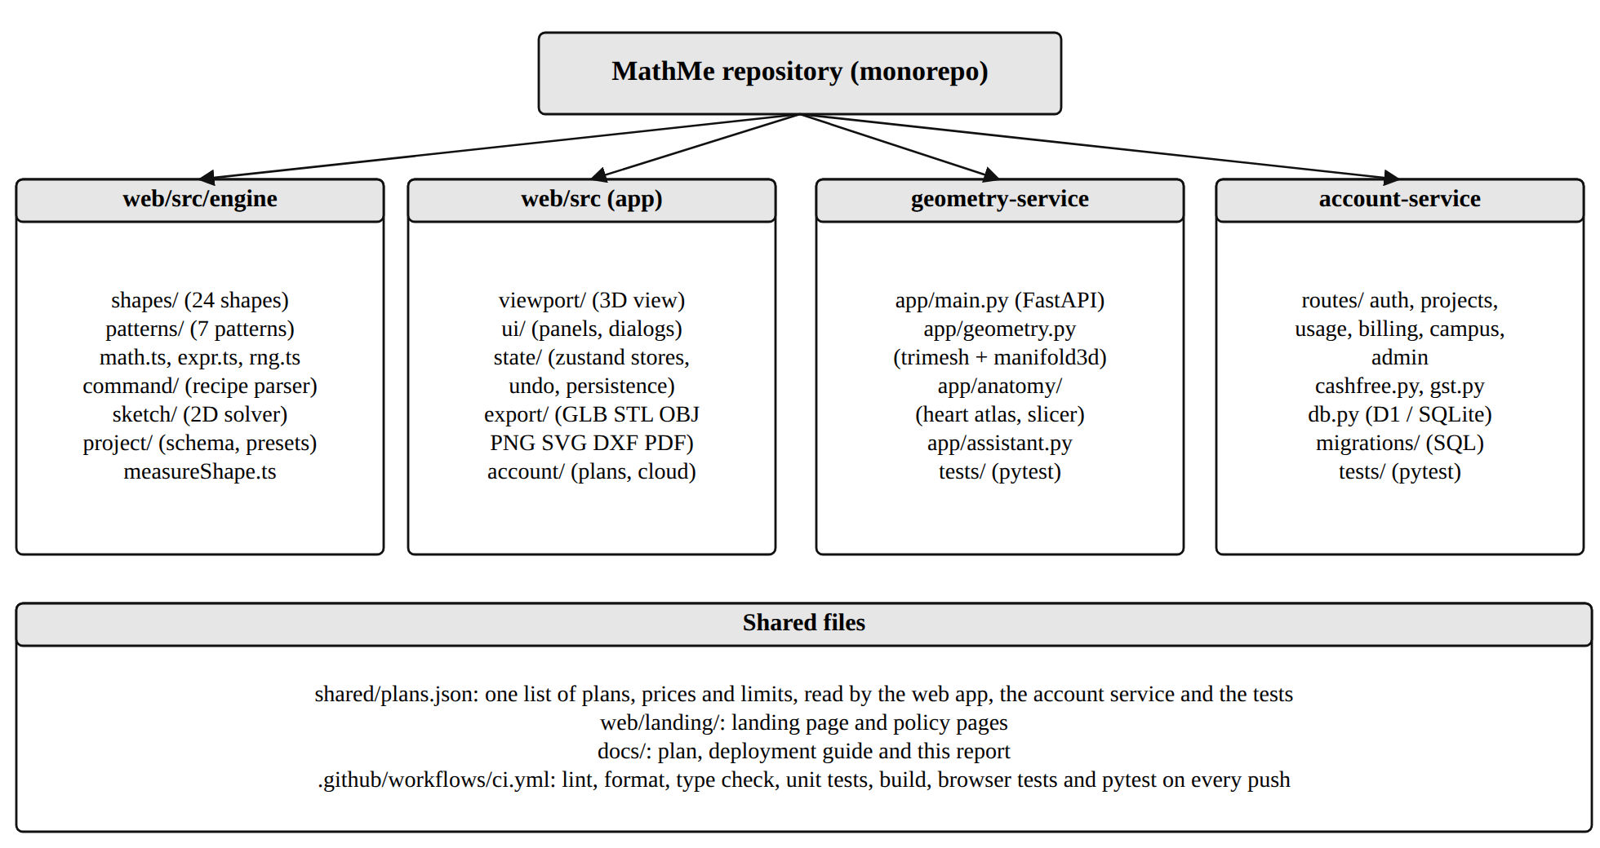
Figure 3.6: Module structure of the MathMe repository

3.4 Implementation
This section describes how each module was implemented, with screenshots of the working application and short extracts from the source code.

3.4.1 Home Page and Project Management
The home page (Figure 3.7) is the first screen after the landing page. A chat box asks “What shall we make today?”: the user can describe an artwork in words, start drawing with the pencil, or choose a recipe. Below it, the user’s projects appear as cards with a small picture of each scene, and a gallery offers ready-made ideas such as a sunflower, a DNA double helix, an atom, a snowflake and the human heart.
Each project is stored as a JSON document that follows a versioned schema, checked with the Zod validation library when it is opened. Projects save automatically a moment after every change, and the picture on each card is captured from the 3D view.
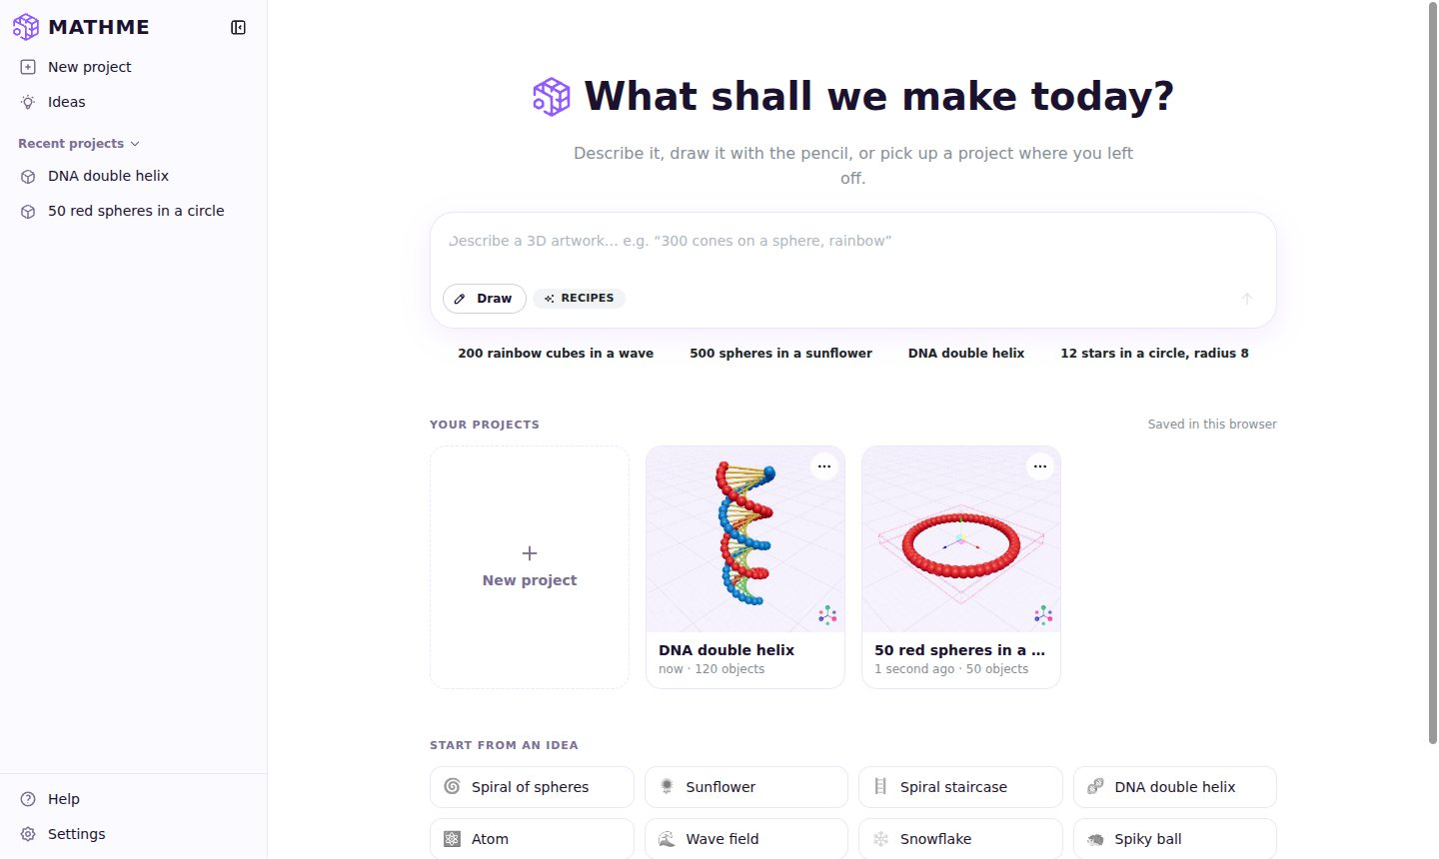
Figure 3.7: Home page with the chat box, project cards and ideas

3.4.2 Maths Engine and Patterns
The maths engine is the heart of MathMe. A pattern node combines a source shape, a pattern type, a count and the pattern’s parameters. When any value changes, the engine calls the pattern’s generate function, which returns a position and an orientation for every copy. Variation rules then change the size, rotation and colour of each copy (for example “scale 0.5–2” or a rainbow of colours), and the symmetry modifier can mirror or rotate the whole result.
Every pattern is a small, self-contained definition with its own fields, help texts, default values and an explain function that produces the formulas for the Learn panel. Table 3.6 lists the seven patterns and their core formulas.
Table 3.6: Patterns and their formulas
Pattern | Rule for object number i
Spiral | θ = start + i × step; r = R × i ÷ (n − 1); x = r cos θ, z = r sin θ, y = i × rise
Sunflower spiral | θ = i × 137.5° (golden angle); r = R × √(i ÷ (n − 1))
Grid | column = i mod columns, row = ⌊i ÷ columns⌋; x = column × gap, z = row × gap (centred)
Circle | θ = i × 360° ÷ n; x = R cos θ, z = R sin θ
Wave | y = A × sin(k × distance from the centre) on a grid of points
Radial rings | ring k has (first ring) × k objects at radius r = k × gap; θ = 360° × j ÷ (objects in ring)
Sphere (Fibonacci) | h = 1 − 2(i + 0.5) ÷ n; ring = √(1 − h²) (Pythagoras); θ = i × 137.5°
Random scatter | positions from a seeded random generator, so the same seed gives the same result

The extract below is the generate function of the spiral pattern. For each object it works out the angle θ and the distance r, and then uses x = r cos θ and z = r sin θ, exactly the formulas a student learns in trigonometry.
Extract from web/src/engine/patterns/spiral.ts
generate(p, n) {
const out: BasePlacement[] = [];
for (let i = 0; i < n; i++) {
const { r, thetaDeg, y } = spiralPoint(p, i, n);
const th = thetaDeg * DEG; // degrees → radians
out.push({ position: [r * Math.cos(th), y, r * Math.sin(th)],
align: yaw(-th) }); // face along the spiral
}
return out;
}

Figure 3.8 shows the example from the project brief, “100 spheres → spiral → radius 20 → rotation 30 → scale 0.5–2”, typed into the recipe box. Figure 3.9 shows the Pattern panel, where every value can be changed with a slider or by typing a number.
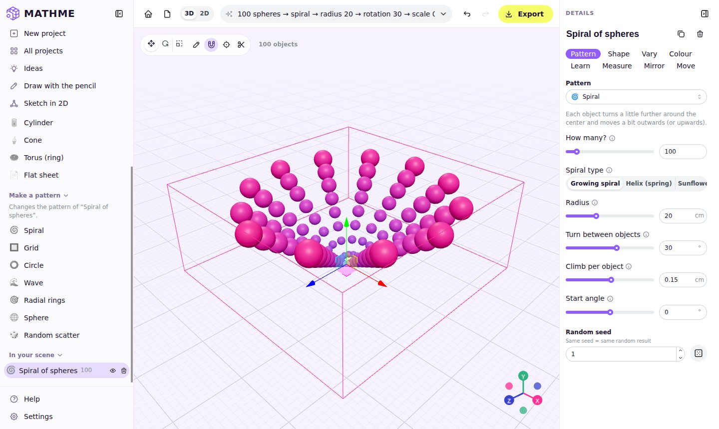
Figure 3.8: The 3D studio showing the brief’s example: 100 spheres in a spiral
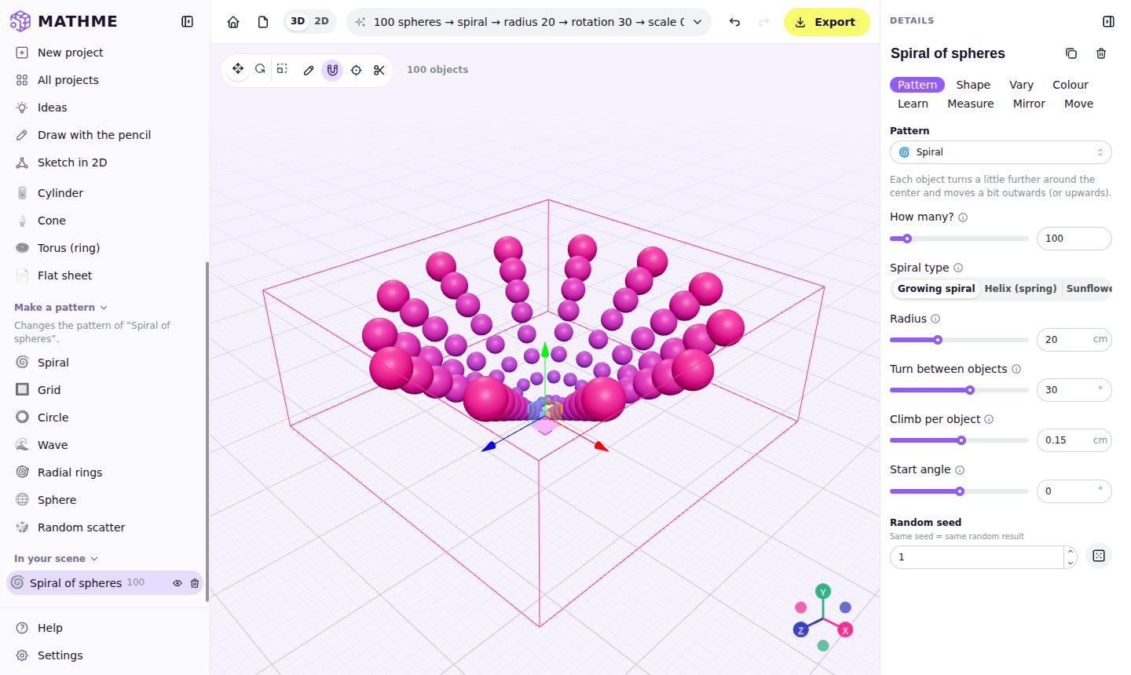
Figure 3.9: The Pattern panel with plain-language controls
To keep the view smooth with thousands of objects, all copies of the same shape are drawn with instanced rendering: the graphics card receives one shape and a list of positions, instead of thousands of separate objects. A scene of 20,000 objects still turns smoothly on an ordinary laptop.

3.4.3 Learn and Measure Panels
The Learn panel (Figure 3.10) explains the idea behind the selected pattern in one or two sentences, lists its formulas, and works them out for any object the user chooses. For example, it shows θ = 10 × 30° = 300° and x = 2.02 × cos 300° = 1.01 for object number 10. The aim is that students see the same formulas from their textbook producing the artwork in front of them.
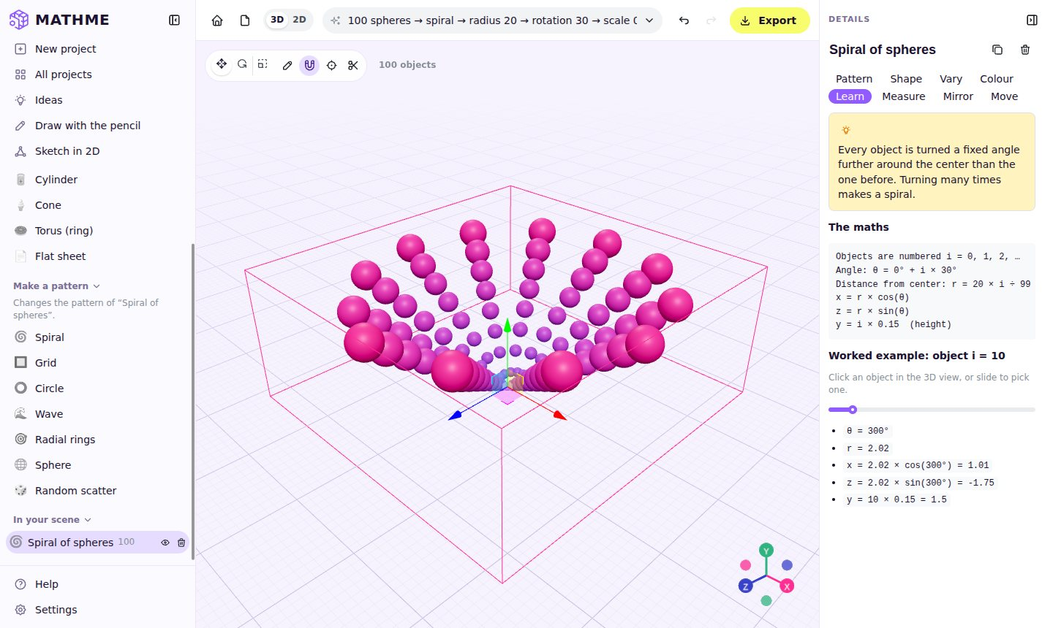
Figure 3.10: The Learn panel with the spiral formulas and a worked example
The Measure panel (Figure 3.11) gives the volume and surface area of one object with full working (for a sphere, V = 4/3 × π × r³). It then explains how scaling by k changes the area by k² and the volume by k³, so it can add up the whole pattern. For the exact volume of overlapping objects, the panel calls the geometry service, which joins all the shapes into one solid first.
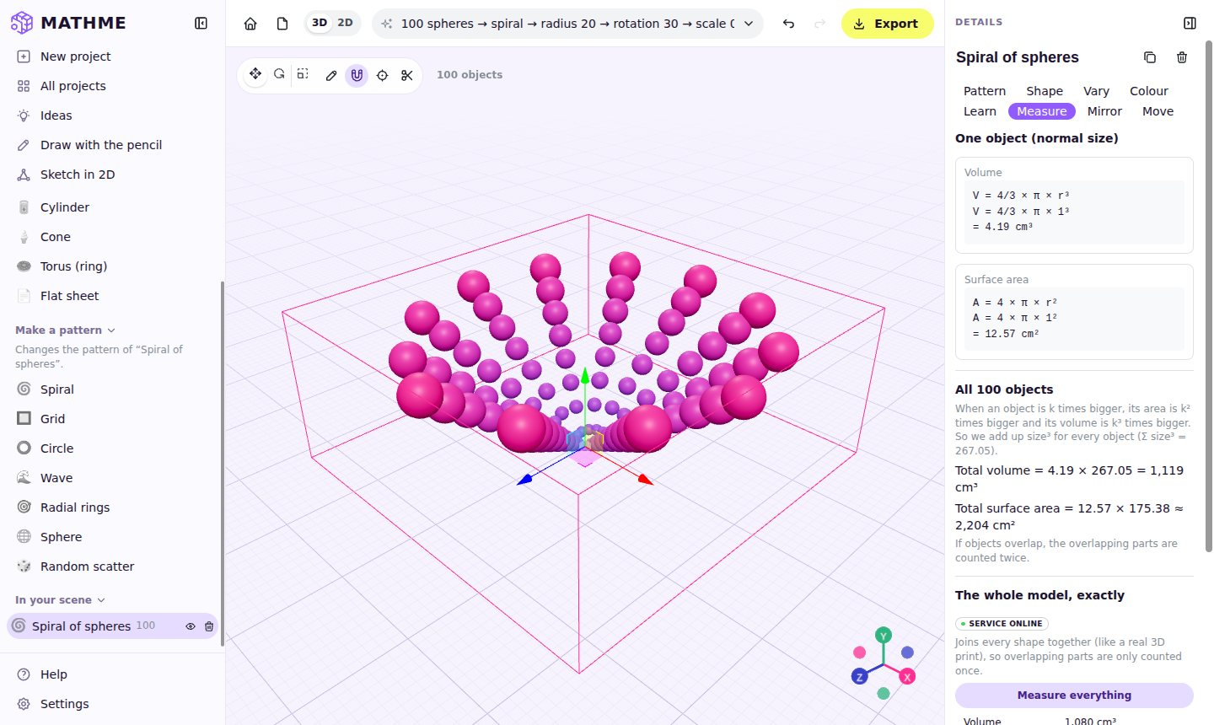
Figure 3.11: The Measure panel with step-by-step working

3.4.4 Recipes, Ideas and the Assistant
The recipe box at the top of the studio accepts one-line descriptions such as “300 cones → sphere → radius 10” or “12 stars in a circle, radius 8”. A small parser written for this project splits the text into tokens, recognises numbers, shapes, patterns and settings (including synonyms such as “rotation” for the turn between objects), and reports a clear message if something is not understood.
The ideas gallery (Figure 3.12) opens ready-made scenes such as the wave field in Figure 3.13, which students can study and change. On the home page, the chat box sends the user’s request to an optional AI helper through the geometry service; when the AI is not available, a built-in local matcher still turns common requests into recipes.
Table 3.12 shows examples of what a student can type and the mathematics each one demonstrates.
Table 3.12: Example recipes and the mathematics they show
What the student types | What MathMe makes | Mathematics shown
100 spheres → spiral → radius 20 → rotation 30 → scale 0.5–2 | A growing spiral of spheres of different sizes | Angles, x = r cos θ, linear growth of r
500 spheres in a sunflower | Seeds packed like a sunflower head | Golden angle 137.5°, r ∝ √i
200 rainbow cubes in a wave | A field of cubes rising and falling | y = A sin(distance), periodic functions
12 stars in a circle, radius 8 | Twelve stars evenly around a circle | 360° ÷ 12 = 30° steps
300 cones on a sphere, rainbow | A spiky ball of evenly spread cones | Fibonacci sphere, Pythagoras
50 red spheres in a circle | A ring of fifty spheres | Circle equation, equal angles

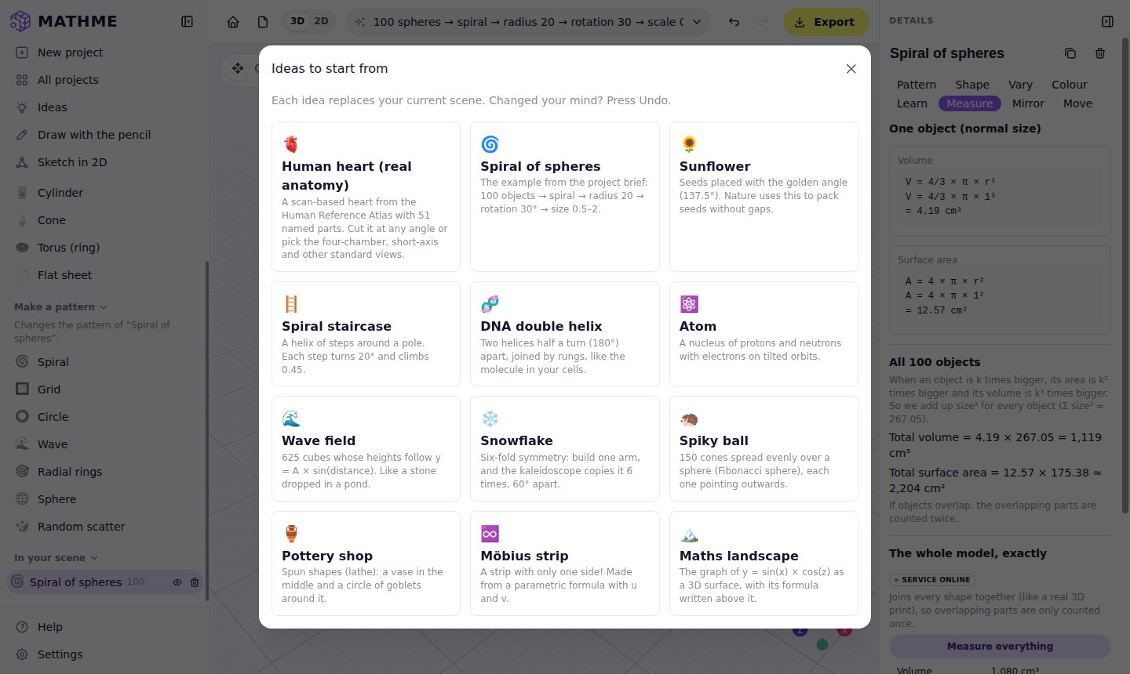
Figure 3.12: The ideas gallery
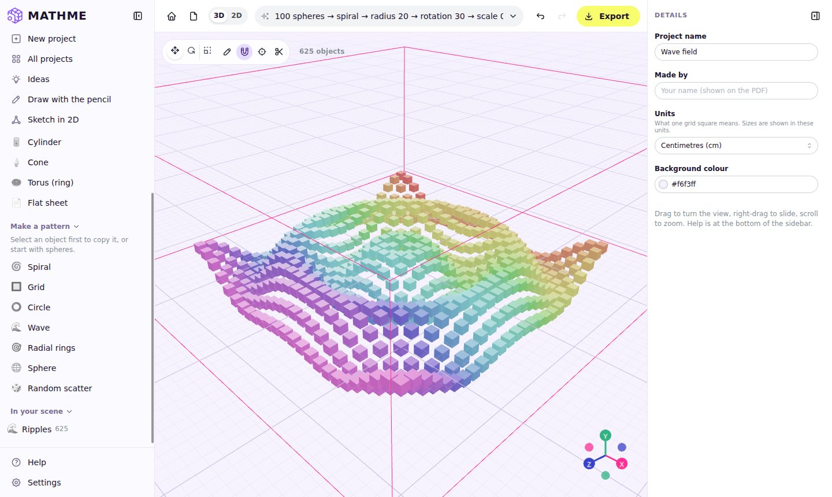
Figure 3.13: The “Wave field” idea: 625 cubes rising and falling as y = A sin(distance)

3.4.5 Custom Shapes
Besides the 21 built-in shape types (cuboid, sphere, cylinder, cone, torus, prism, pyramid, the five Platonic solids, torus knot, capsule and more), MathMe lets the user make their own shapes. A spun shape (Figure 3.14) is drawn as half an outline and spun around an axis, like clay on a potter’s wheel, to make vases, bowls and goblets. An extruded shape pushes a flat outline up into a solid. There are also 3D text, graph surfaces of the form y = f(x, z) and parametric surfaces. Groups of shapes can be saved under “Mine” and used as the source of a pattern.
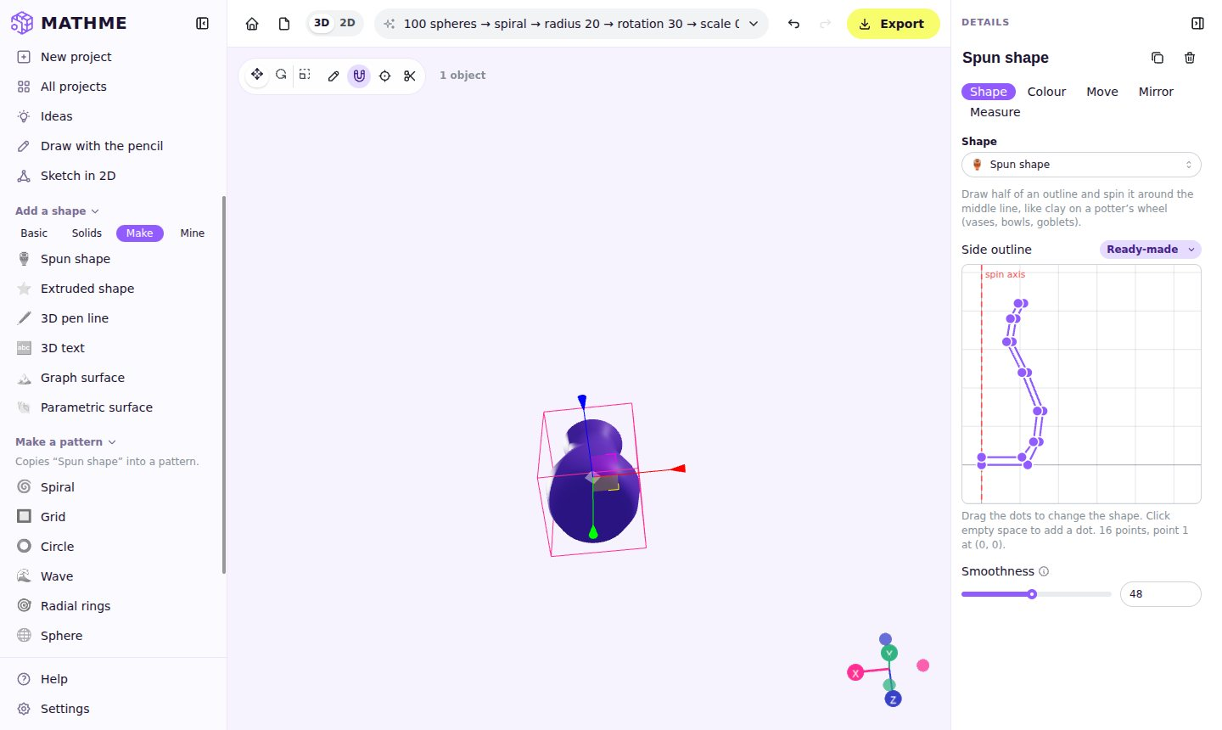
Figure 3.14: A spun (lathe) shape and its editable side outline

3.4.6 Exports
All exports are made inside the browser, so they work without a server (Figure 3.15). Table 3.7 lists the formats. Each exporter converts the instanced scene into ordinary meshes, applies the right units (metres for GLB, millimetres for STL) and names every part so that it can be found again in other programs.
Table 3.7: Export formats
Format | Used for | Notes
GLB (glTF 2.0) | Blender, Unity, Unreal, web pages | One mesh per object, in metres
STL | 3D printers (slicer software) | In millimetres; print-ready joined solid via the geometry service
OBJ | Almost every 3D program | Simple text format
PNG | Posters and slides | HD, 4K or square; optional see-through background
PDF | Class reports | Project sheet with views, settings and the maths
SVG, DXF, PDF | 2D sketches | Vector drawings for CAD and laser cutting
.mathme.json | Saving and sharing projects | Opens again in MathMe with File → Open

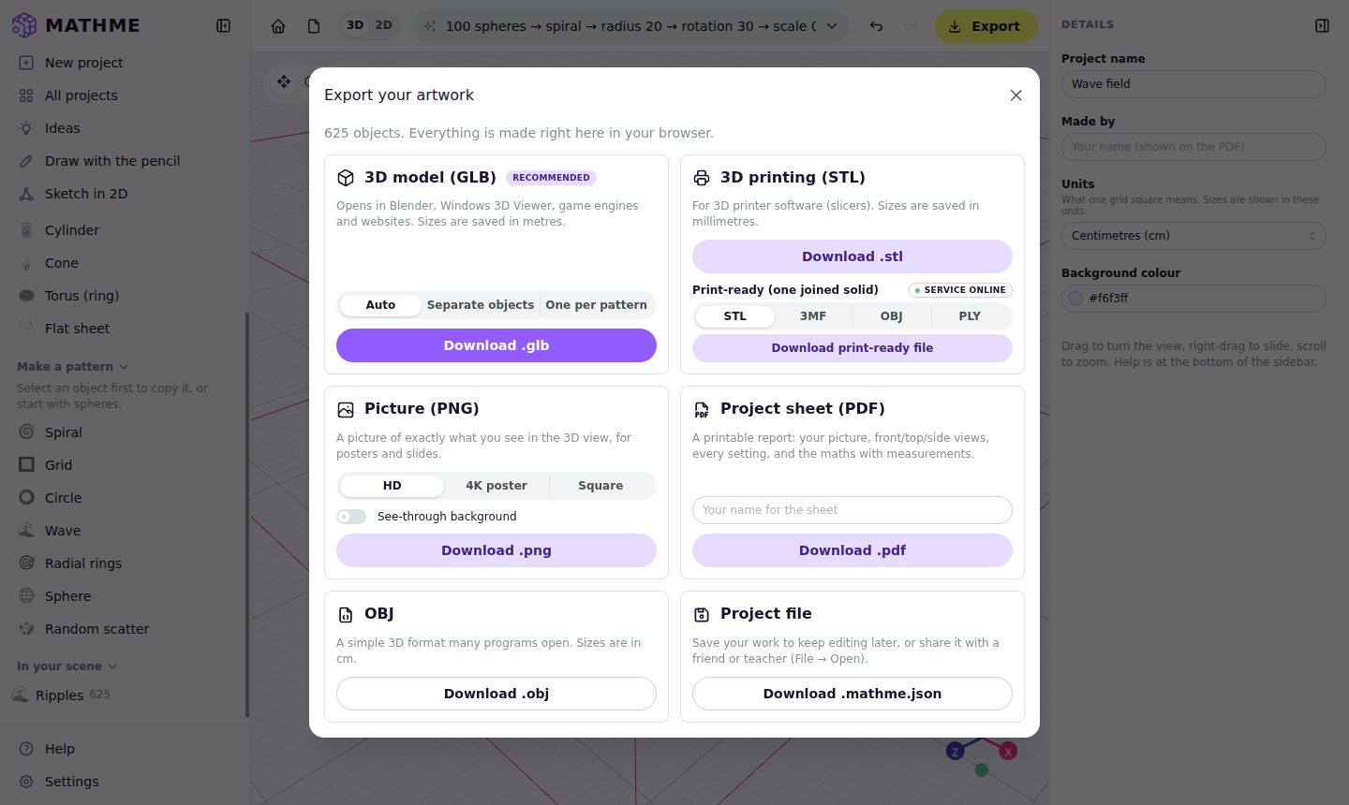
Figure 3.15: The export dialog

3.4.7 Geometry Service (Python)
Some tasks need exact geometry that is too heavy or too complex for the browser. These run in the geometry service, a FastAPI application with the following endpoints:
- /analyze: volume, surface area and bounds of the whole model.
- /boolean: join, cut or overlap two shapes.
- /export: print-ready files.
- /slice: cut the heart model.
- /assist: the AI helper.
The browser sends the scene as a GLB file, and the service loads it with the trimesh library and uses the manifold3d engine for robust boolean operations. Inputs are limited in size, triangle count and running time, so that one request cannot overload the server.
Extract from geometry-service/app/geometry.py
def boolean(a, b, operation, settings):
first = union_all(solid_parts(a, "The first shape"), settings)
second = union_all(solid_parts(b, "The second shape"), settings)
op = {"union": trimesh.boolean.union,
"difference": trimesh.boolean.difference,
"intersection": trimesh.boolean.intersection}[operation]
result = op([first, second], engine="manifold")
if result is None or len(result.faces) == 0:
raise GeometryError("Nothing is left after cutting.")
return result

3.4.8 Human Heart Slice Atlas
To show how the same tools serve science teaching, MathMe includes a real, scan-based human heart from the Human Reference Atlas of the HuBMAP consortium (licensed CC BY 4.0), with 51 named structures. The cut tool (Figure 3.16) slices the model along 21 standard planes used in anatomy and cardiac imaging, such as the four-chamber, three-chamber, two-chamber and short-axis views, or along any angle chosen with the sliders. The plane is shown as an equation n · x = d, again linking the anatomy to the mathematics of planes. The Python side also produces a labelled PDF slice atlas of about 50 pages.
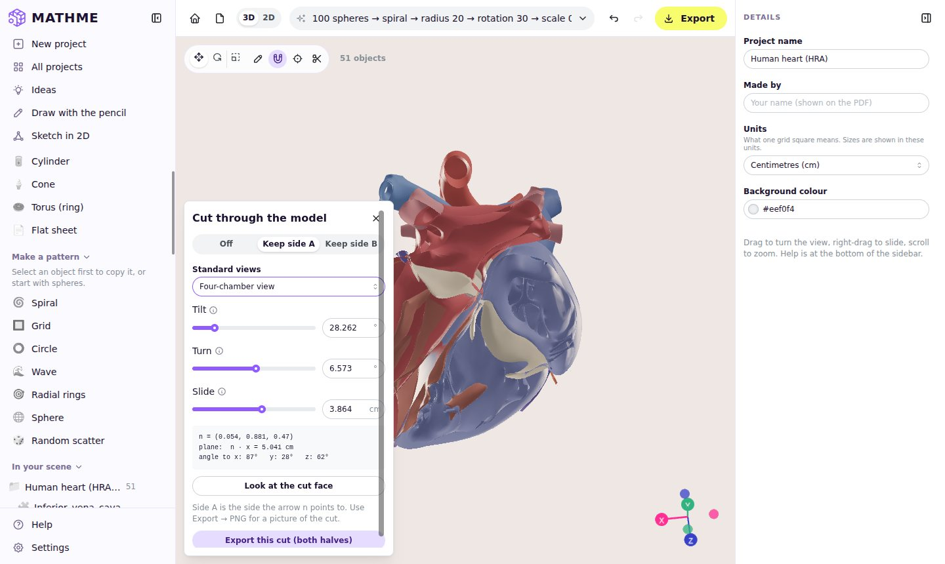
Figure 3.16: The heart model cut along the four-chamber view

3.4.9 Pencil Drawing
The pencil (Figure 3.17) lets beginners draw directly in the 3D view. A closed loop drawn on the floor becomes a solid that can be pushed up; an open line becomes a 3D pen “tube”; and a “lines” mode lets the user click corner points to make straight-edged shapes. The drawn points are simplified and smoothed before the solid is built, so freehand drawings still give clean shapes.
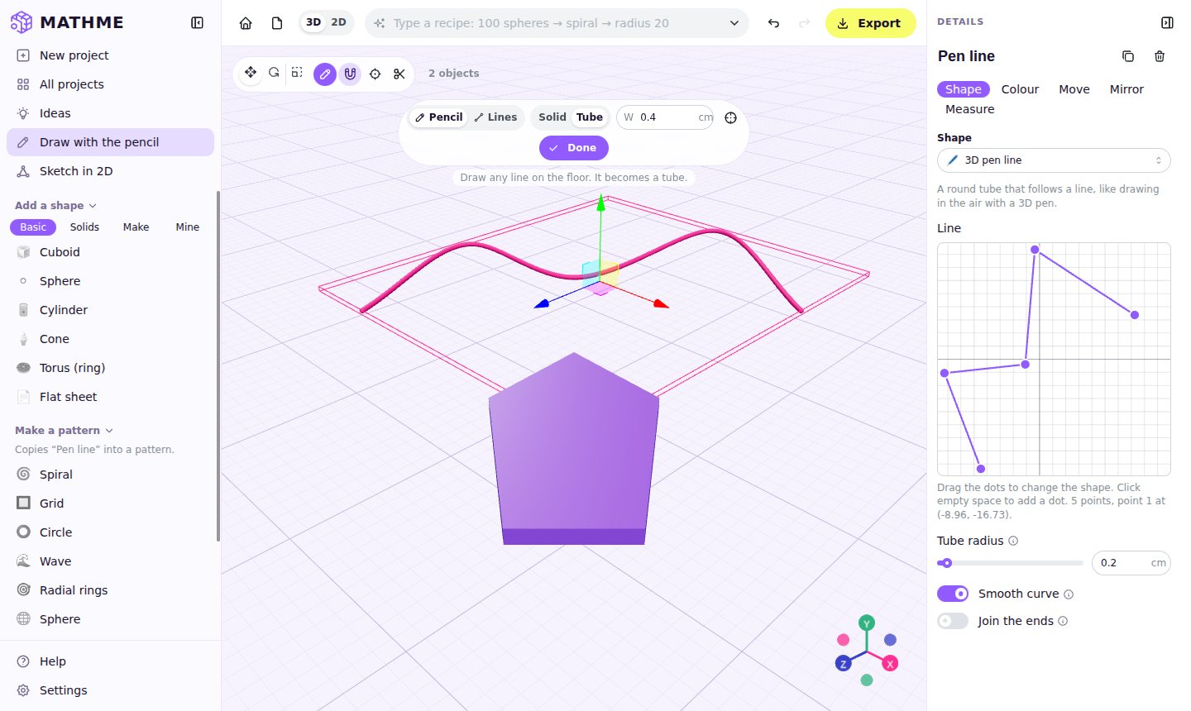
Figure 3.17: Drawing a solid and a 3D pen tube with the pencil

3.4.10 2D Sketch Board
The 2D sketch board (Figure 3.18) is a geometry board in the style of a school notebook. The user places node points, joins them with lines, and draws circles by radius. Points snap to the grid, to other points and to the middle of lines. Selecting a closed shape shows its area and perimeter; selecting a line shows its length and angle; selecting two lines shows the angle between them.
The user can add geometric rules: horizontal, vertical, fixed length, parallel, perpendicular, equal and fixed radius. A small constraint solver, written for this project, nudges the points again and again, like a network of springs, until every rule holds, and it reports any rules that conflict. Sketches can be exported as SVG, PNG, PDF and DXF, or turned into 3D solids by pushing them up (extrusion) or spinning them (lathe).
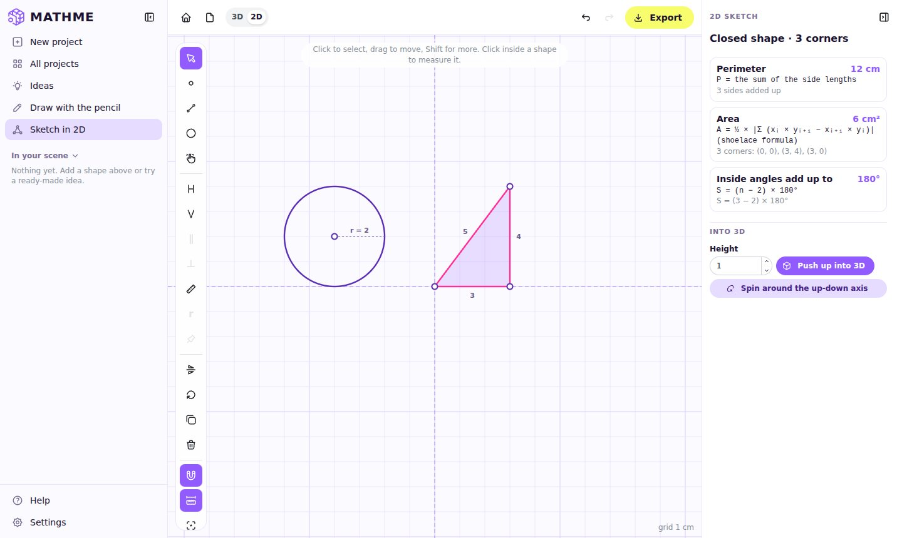
Figure 3.18: The 2D sketch board: a 3-4-5 triangle (area 6 cm²) and a circle of radius 2

3.4.11 User Interface and Settings
The interface was redesigned during the internship to be minimal and friendly:
- a collapsible sidebar in the style of modern chat applications;
- a details panel that can be hidden;
- consistent brand colours taken from the MathMe presentation;
- a welcome tour and a help window with a glossary of maths words.
The Settings page (Figure 3.19) groups the project options (name, author, units and background), appearance (light or dark theme), 3D-view options, data management and an About section.
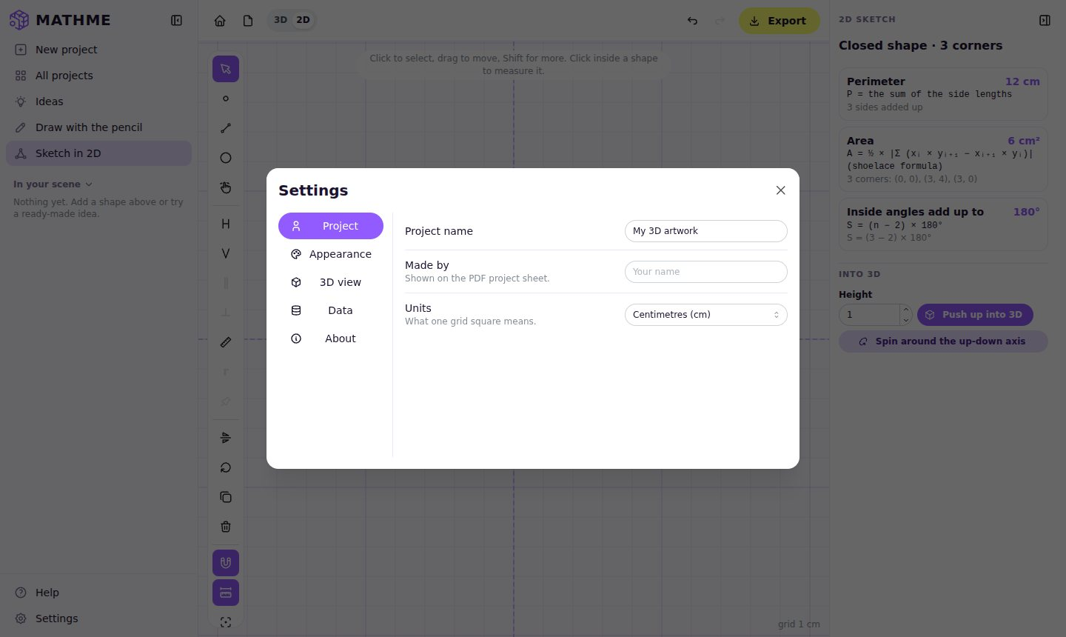
Figure 3.19: The Settings page
The Help window (Figure 3.20) explains every tool in short sentences, lists the keyboard shortcuts and includes a glossary of “maths words” (such as radius, angle, sine, volume and symmetry) in simple language, so that students can look up a term without leaving the studio.
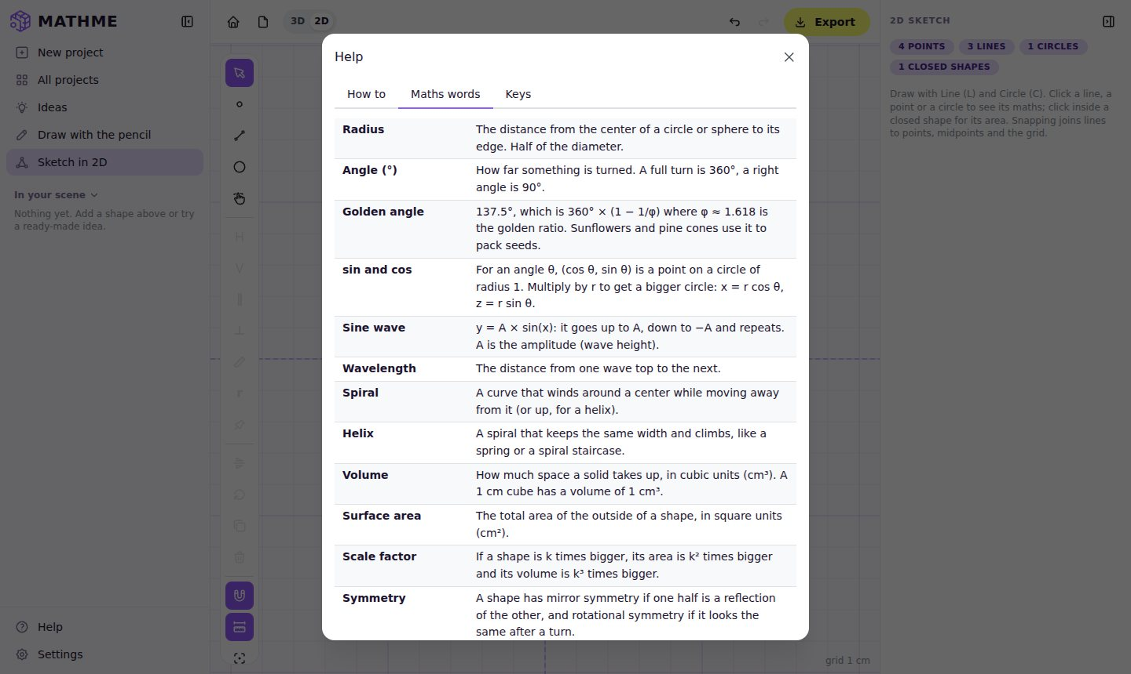
Figure 3.20: The Help window with the glossary of maths words

3.4.12 Accounts, Plans and Limits
Accounts are switched on by a build setting (VITE_ACCOUNTS), so the free demo and self-hosted copies keep working without a server. When accounts are on, users sign in with Google using the secure authorisation-code flow: the browser never sees Google’s tokens. The server creates a session stored in an HttpOnly cookie, and only a hash of the session token is kept in the database.
Each plan’s limits come from the shared plans file. Before an export, a geometry job or an AI message, the app asks the server for a “ticket”, and the server counts the use with an atomic database update. When a limit is reached, or a feature belongs to a higher plan, the user sees a friendly prompt that names the feature and the plan that unlocks it (Figure 3.21). The plans window (Figure 3.22) compares Free, Plus and Pro with monthly and yearly prices.
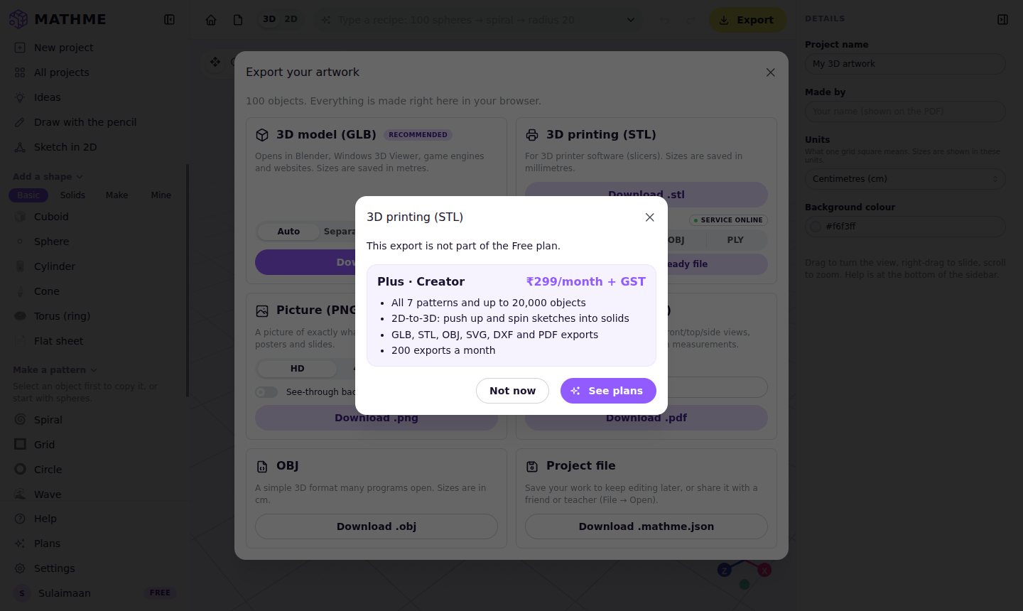
Figure 3.21: Upgrade prompt shown when a Free user chooses the STL export
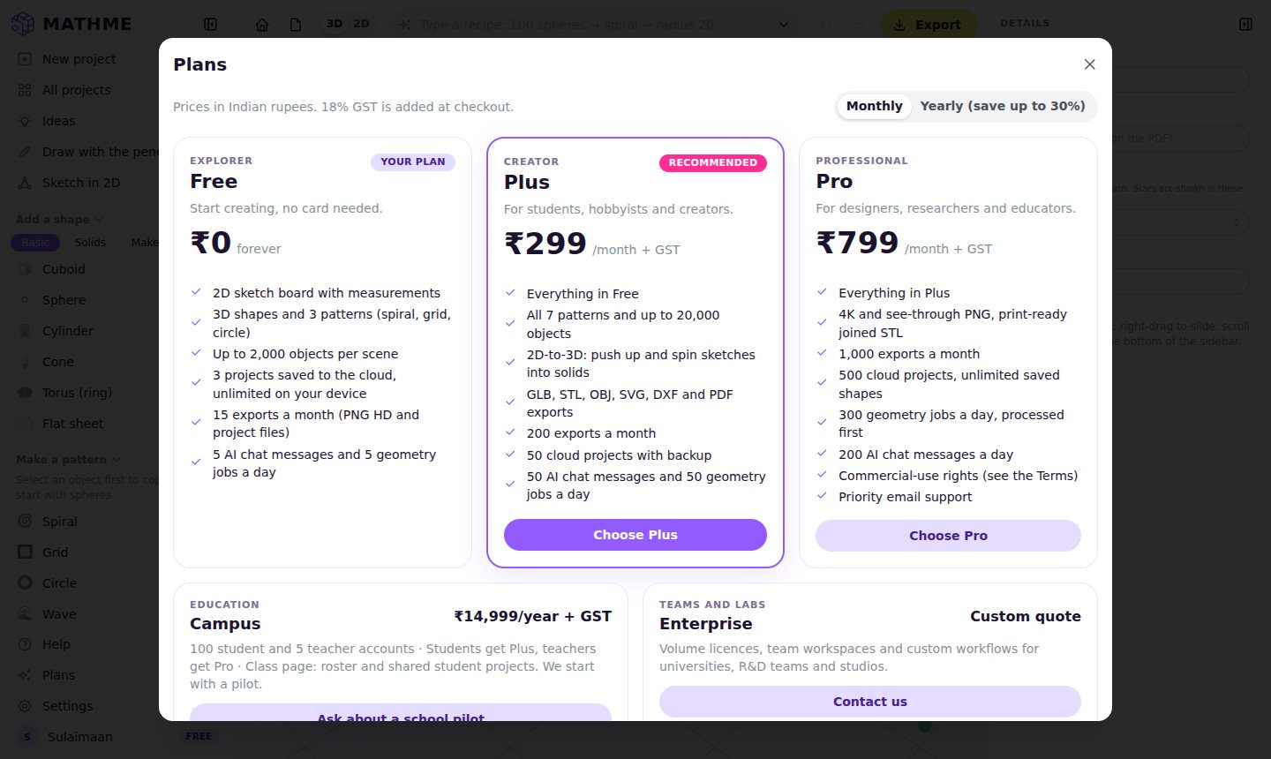
Figure 3.22: The plans window

3.4.13 Checkout, GST and Invoices
Checkout asks for the details needed for a GST invoice: name, mobile number, state and an optional GSTIN for businesses (Figure 3.23). The buyer’s state decides the tax lines: within the seller’s state, 9% CGST and 9% SGST; otherwise, 18% IGST. All amounts are handled in paise (whole numbers), so there are no rounding errors from decimal fractions. Table 3.8 shows the prices with GST.
Table 3.8: Prices with 18% GST
Plan | Price before GST | GST (18%) | Total charged
Plus, monthly | ₹299.00 | ₹53.82 | ₹352.82
Plus, yearly | ₹2,499.00 | ₹449.82 | ₹2,948.82
Pro, monthly | ₹799.00 | ₹143.82 | ₹942.82
Pro, yearly | ₹6,999.00 | ₹1,259.82 | ₹8,258.82
Campus, yearly | ₹14,999.00 | ₹2,699.82 | ₹17,698.82

Extract from account-service/src/account_service/gst.py
def add_gst(base: int, seller_state: str, buyer_state: str) -> Tax:
"""Base price (paise, before GST) → the tax lines and the total."""
tax = (base * RATE_PERCENT + 50) // 100 # 18%, rounded half up to the paisa
if seller_state.strip().lower() == buyer_state.strip().lower():
cgst = tax // 2
return Tax(base, cgst, tax - cgst, 0, base + tax) # CGST + SGST
return Tax(base, 0, 0, tax, base + tax) # IGST

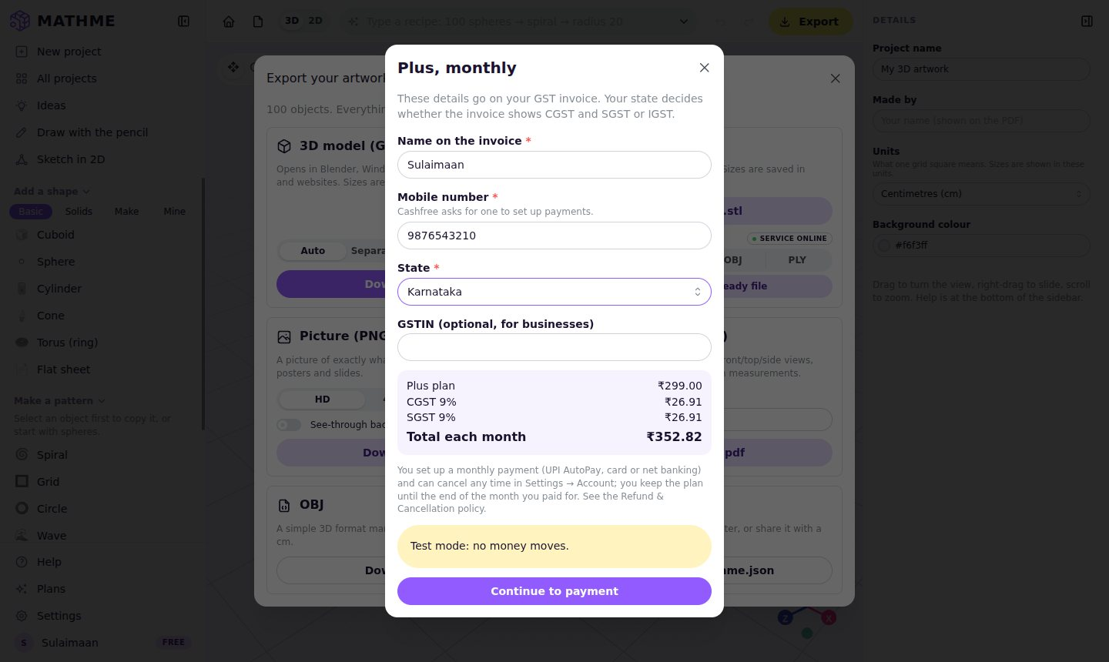
Figure 3.23: Checkout with the GST split (Karnataka: CGST + SGST)
Payments use Cashfree Payments. Monthly plans are set up as a subscription mandate (UPI AutoPay, card or e-mandate), and yearly plans as a one-time order. Cashfree informs MathMe of every payment through a webhook. The flow is shown in Figure 3.25:
- The server first checks the webhook’s signature, a Base64 HMAC-SHA256 of the timestamp and the body, keyed with a secret.
- It rejects messages that are more than five minutes old.
- It records each event id, so that a repeated message is processed only once.
- It then records the payment and issues an invoice numbered per financial year (for example MM/2026-27/000001).
- It emails a receipt. The invoice can be downloaded as a PDF from Settings → Account (Figure 3.24).
Extract from account-service/src/account_service/cashfree.py
def sign(secret: str, timestamp: str, raw_body: bytes) -> str:
"""Cashfree's webhook signature: Base64(HMAC-SHA256(secret, timestamp + body))."""
mac = hmac.new(secret.encode(), timestamp.encode() + raw_body, hashlib.sha256)
return base64.b64encode(mac.digest()).decode()

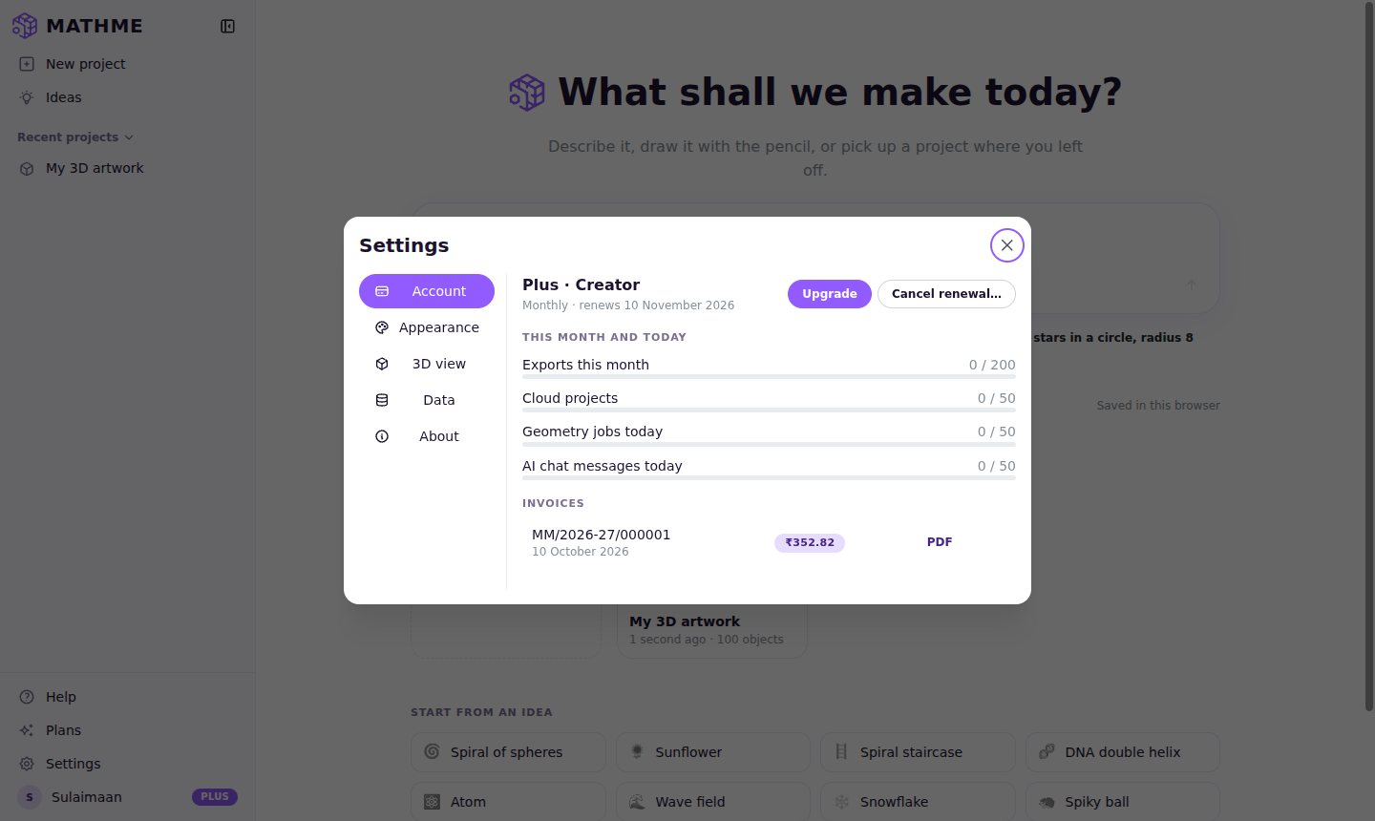
Figure 3.24: Settings → Account: plan, usage meters and the GST invoice
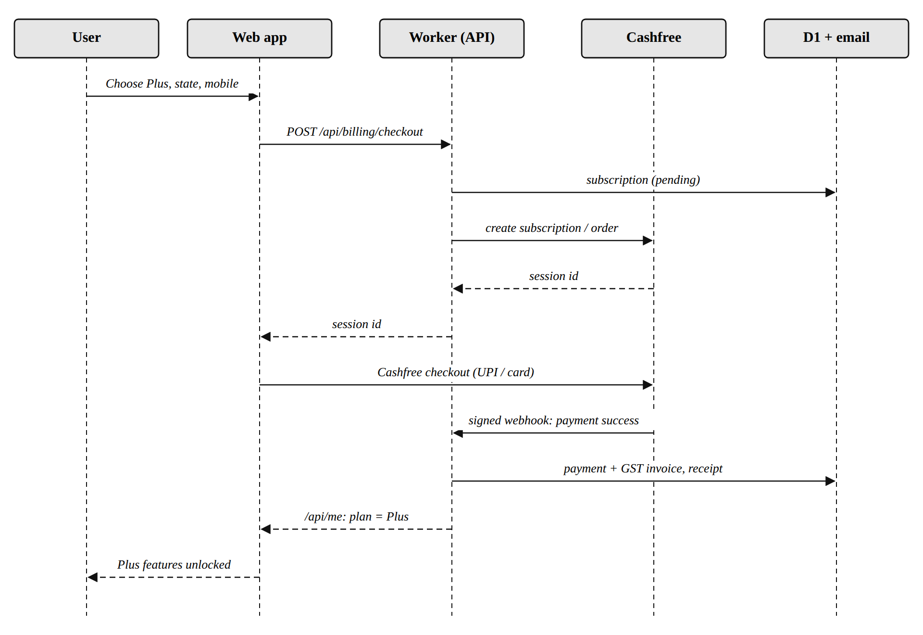
Figure 3.25: Sequence diagram of a Plus checkout

3.4.14 Campus Licences and the Class Page
A school or college starts with an enquiry form on the landing page. The owner turns the enquiry into a Campus licence for 100 students and 5 teachers, which creates two join codes, one for teachers and one for students. When a member signs in and types a code, the server checks the seat limits and adds them to the class. Teachers then get Pro features and students get Plus features while the licence is valid.
Students can share a cloud project with their class. The teacher’s class page (Figure 3.26) shows the licence, the codes, the shared projects (which the teacher can open as a copy) and the class list, from which a student can be removed.
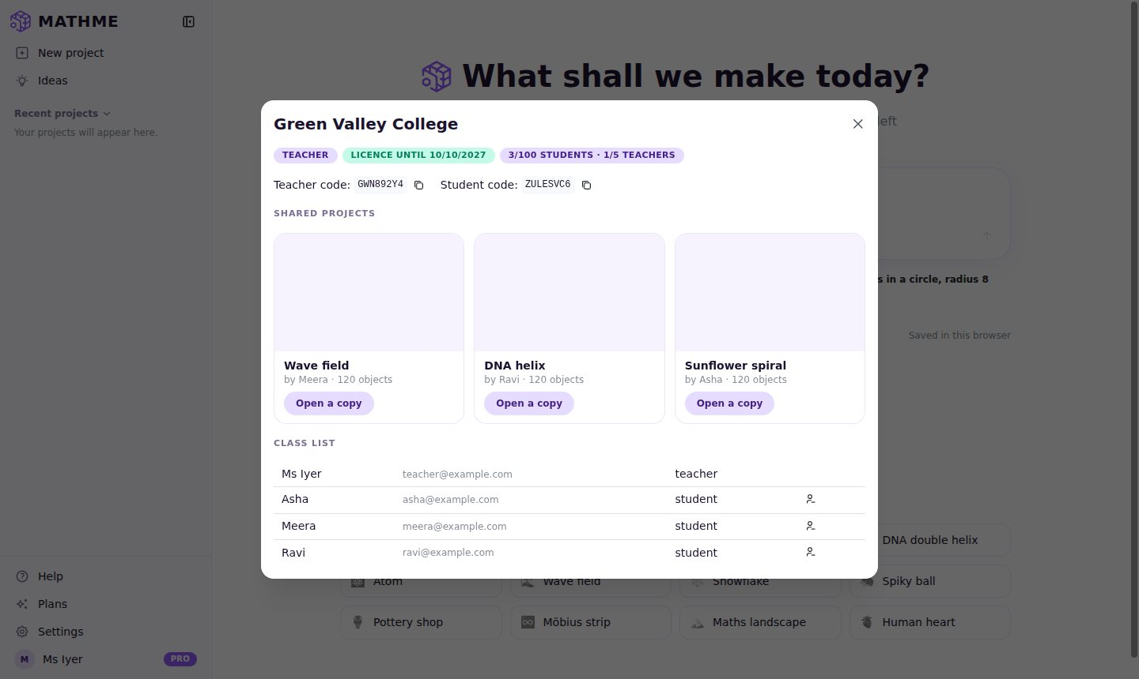
Figure 3.26: The teacher’s class page with shared projects and the class list

3.4.15 Owner Dashboard
The owner dashboard (Figure 3.27) is visible only to the accounts listed as owners. It shows:
- sign-ups and weekly active users;
- paying users by plan and the free-to-paid conversion rate;
- monthly recurring revenue (MRR) and 30-day churn;
- revenue before GST;
- Campus pilots and paid licences.
Separate tabs list enquiries, Campus licences (Figure 3.28), with actions to extend a licence, mark it paid or send a payment link, and recent payments. A revenue calculator (Figure 3.29) reproduces the scenario from the business plan, ₹86,125 a month or ₹10,33,495 a year, and lets the owner try other numbers of Plus, Pro, Campus and Enterprise customers.
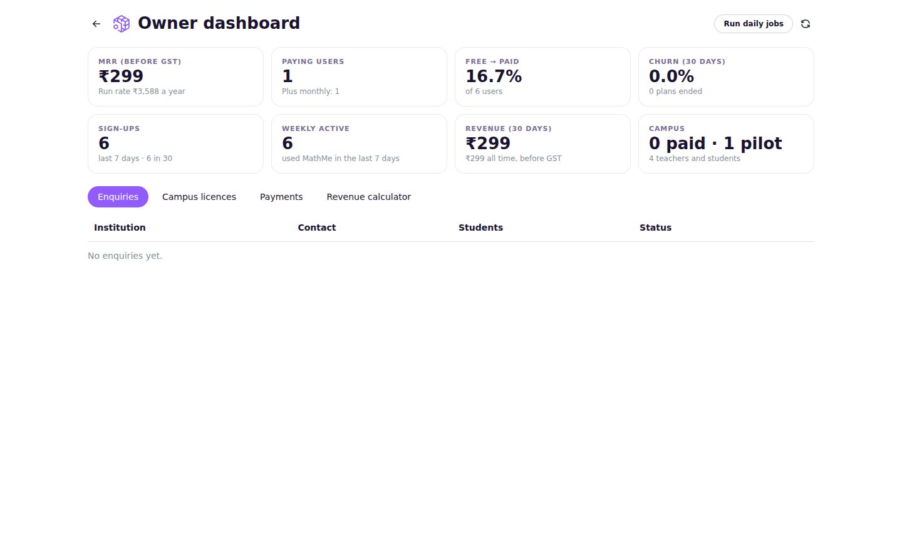
Figure 3.27: The owner dashboard
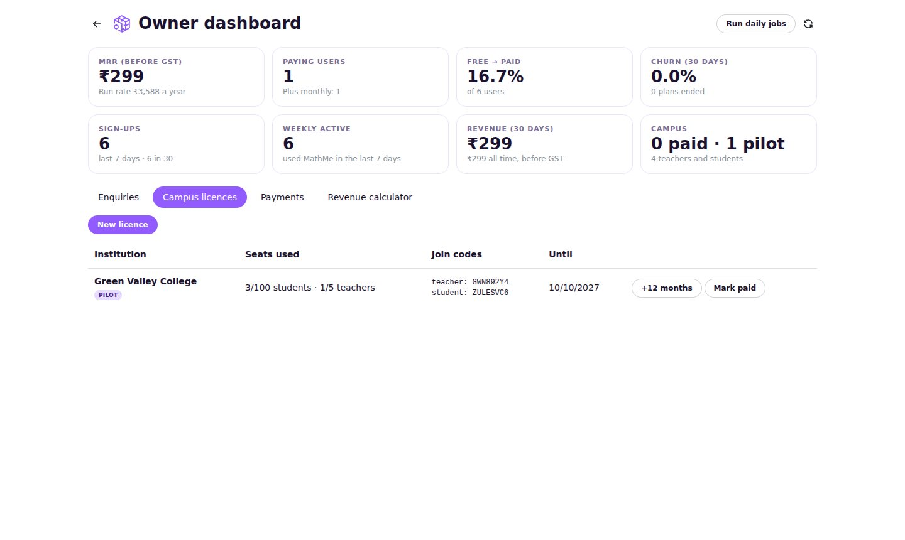
Figure 3.28: Campus licences in the owner dashboard
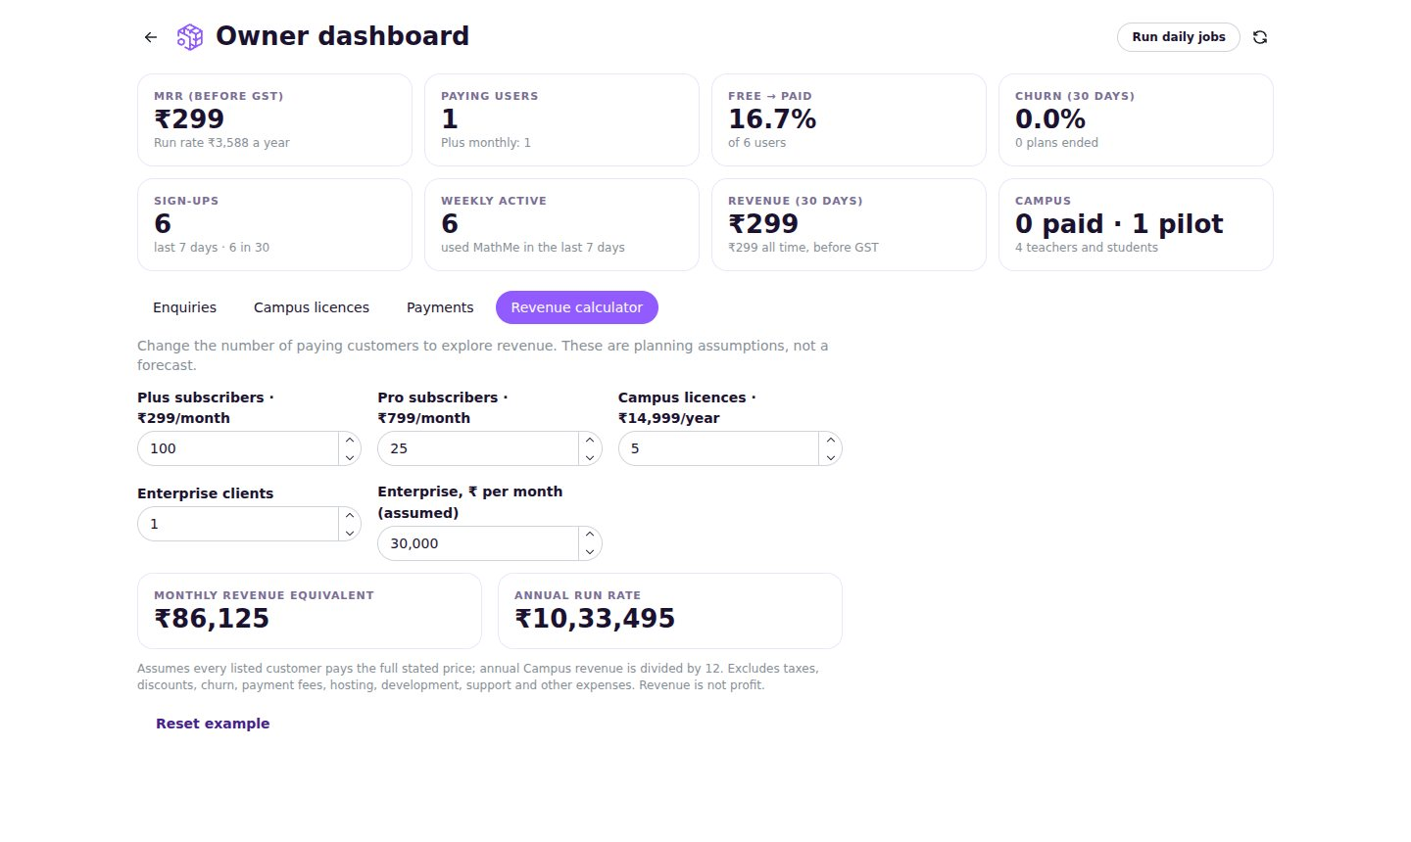
Figure 3.29: The revenue scenario calculator

3.4.16 Landing Page, Enquiries and Policy Pages
The public landing page (Figures 2.1 and 2.2) was designed in the colours of the MathMe presentation deck. It explains the idea in four steps (add a shape, let maths copy it, see the formulas, export and share), shows a gallery of patterns, the heart atlas and the export formats, and ends with the pricing section. The prices on this page are checked by an automated test against the shared plans file, so they can never fall out of step with the prices charged at checkout.
Schools and companies use the enquiry form on the landing page to ask for a Campus pilot or an Enterprise quotation. The form sends the request to the account service, which stores it for the owner dashboard and emails the owner. A hidden field catches automated spam, and the form never emails the address typed into it, so it cannot be misused to send mail to strangers.
A payment gateway in India requires a business to publish its Terms of Use, Privacy Policy, Refund and Cancellation Policy and Contact details before it can accept payments. Draft versions of all four pages were written during the internship in plain language. They describe the plans, GST, automatic renewal and cancellation, refunds, commercial-use rights on the Pro plan, the personal data collected and the rights of users under India’s Digital Personal Data Protection Act, 2023. The drafts are clearly marked to be reviewed by a lawyer before launch.

3.5 Testing

3.5.1 Testing Strategy
Testing was done at four levels, and all of them run automatically in the continuous-integration pipeline:
- Unit tests (Vitest) check the maths engine: shapes, patterns, formulas, the recipe parser, the sketch solver, project files, plan limits and the revenue calculator.
- Browser tests (Playwright) open the real application in Chromium and act like a user: make a project, apply a pattern, draw with the pencil, sketch a triangle, export every file type, cut the heart, and so on.
- Accounts browser tests run the account service with a pretend payment provider and a test sign-in, and go through sign-in, limits, checkout with GST, cloud saves, the Campus flow, the dashboard and invoices.
- Service tests (pytest) check the geometry service (volumes, booleans, exports, the heart slicer) and the account service (sign-in, sessions, projects, quotas, GST, webhook signatures, subscriptions, Campus licences, admin access).

3.5.2 Test Cases
Table 3.9: Selected test cases
ID | Test scenario | Expected result | Result
TC1 | Type “100 spheres → spiral → radius 20” | 100 objects appear in a spiral | Pass
TC2 | Add a cuboid and apply the grid pattern | Object count becomes 200 | Pass
TC3 | Select object 10 of the spiral, open Learn | Worked example shows θ = 300° | Pass
TC4 | Sketch a 3-4-5 triangle and select it | Area 6 cm², perimeter 12 cm | Pass
TC5 | Draw a circle with radius 2 | Area 12.57 cm² | Pass
TC6 | Export GLB | Valid glTF 2.0 file, one mesh per object | Pass
TC7 | Join two overlapping cuboids (service) | One watertight solid, correct volume | Pass
TC8 | Cut the heart along the four-chamber view | Plane normal n = (0.054, 0.881, 0.47) | Pass
TC9 | Free user chooses STL export | Upgrade prompt names Plus | Pass
TC10 | Save a 4th cloud project on Free | Project stays on the device only | Pass
TC11 | Checkout Plus from Kerala (seller in Karnataka) | IGST 18%, total ₹352.82 | Pass
TC12 | Webhook with a wrong signature or old timestamp | Rejected (401) | Pass
TC13 | Same payment webhook delivered twice | Payment recorded once | Pass
TC14 | Teacher and student join with codes | Teacher gets Pro, student gets Plus | Pass
TC15 | Non-owner opens the admin API | Refused (403) | Pass
TC16 | Sign-in link replayed in another browser | Sign-in refused (login CSRF guard) | Pass

3.5.3 Test Results
Table 3.10: Summary of automated test results
Test suite | Tool | Tests | Passed
Web application: unit tests | Vitest | 147 | 147
Web application: browser tests | Playwright | 29 | 29
Accounts: browser tests | Playwright | 6 | 6
Account service | pytest | 51 | 51
Geometry service | pytest | 40 | 40
Total |  | 273 | 273

In addition, the code passes ESLint, Prettier and the strict TypeScript compiler for the web application, and ruff (lint and format) for both Python services. The layouts were checked by hand on a desktop screen and at phone width.

3.6 Deployment Plan
The application was built so that it can be hosted cheaply and scaled easily. The web application and the account service are deployed together on Cloudflare: the Worker serves the website files and answers every request under /api. The geometry service runs as a Docker container on any container host. A step-by-step deployment guide (docs/DEPLOY.md) was written as part of the internship; Table 3.11 summarises it.
Table 3.11: Deployment steps
Step | Activity | Result
1 | Create the D1 database and the R2 storage bucket; apply the SQL migrations | Tables ready in the cloud
2 | Store the secrets (Google, Cashfree, Resend, geometry secret) with the Wrangler tool | No secret is kept in the code
3 | Create a Google OAuth client with the sign-in callback address | Users can sign in with Google
4 | Activate Cashfree, test in the sandbox, register the webhook address | Payments and webhooks work
5 | Verify the email domain in Resend | Receipts and reminders are delivered
6 | Run the geometry container with the shared secret | Measure, join and cut work for signed-in users
7 | Build the web app with accounts on and deploy the Worker | MathMe is live on its own domain
8 | Check a preview deployment end to end before real customers | A safe launch

Without accounts, the same web application can be published as a plain static website (for example on GitHub Pages or a school server), with every feature free and projects kept in the browser. This makes MathMe easy to try in any classroom.

3.7 Security Measures
Because the product handles accounts and payments, security was reviewed before the work was completed. The main measures are:
- Session cookies are HttpOnly, Secure and SameSite=Lax; only a SHA-256 hash of each session token is stored.
- Every request that changes data must carry a custom header that other websites cannot send, which protects against cross-site request forgery.
- The Google sign-in round trip is tied to the browser that started it with a short-lived state cookie, and the return address after sign-in is checked so that it cannot send users to another website.
- Payment webhooks are accepted only with a valid HMAC signature, within a five-minute window, and only once per event.
- Test sign-in and the pretend payment page work only on a developer’s own computer (localhost), so a forgotten setting cannot give anyone free plans or owner access.
- The geometry service can require a shared secret, so only the account service, which checks quotas first, can use it.
- All input is validated (Pydantic on the server, Zod for project files), and uploads are limited in size and processing time.

3.8 Learning During the Internship
The internship provided hands-on experience in many areas of computer applications:
- Mathematics in software: trigonometry, the golden angle, Fibonacci spheres, vectors, plane equations, area and volume formulas, and scaling laws (k² and k³) turned into working code.
- 3D graphics: meshes, materials, cameras, instanced rendering, coordinate systems and units, and file formats such as glTF, STL and OBJ.
- Front-end development: React components and hooks, state management with undo and redo, TypeScript types, responsive layouts and accessibility.
- Back-end development: REST APIs with FastAPI, input validation, SQL database design, migrations and serverless deployment on Cloudflare Workers.
- Payments and compliance: subscription mandates, webhooks, idempotency, GST calculation (CGST, SGST, IGST), invoice numbering per financial year, and the policy pages required by a payment gateway.
- Security: sessions and cookies, OAuth 2.0, CSRF protection, HMAC signatures and the principle of least privilege.
- Software engineering: planning in milestones, version control with Git, code reviews, automated testing at several levels, continuous integration and technical documentation.
- Professional skills: breaking a large goal into small steps, managing time across ten weeks, explaining technical work in simple language, and writing this report.

CHAPTER IV
INTERNSHIP OUTCOMES AND CONCLUSION

4.1 Internship Outcomes
The internship achieved all the objectives listed in Chapter I. Its main outcomes are:
- A working web application, MathMe 3D Studio, in which one mathematical rule creates hundreds or thousands of 3D objects, and every formula is shown and worked out for the user.
- A maths engine with 21 shape types, 7 patterns, variation and symmetry, a plain-language recipe parser and a 2D constraint solver, all covered by unit tests.
- A complete set of exports (GLB, STL, OBJ, PNG, PDF, SVG, DXF and project files), so that work can be 3D-printed, used in games and presented in class.
- A Python geometry service for exact measurements, solid booleans and print-ready files, and an educational human-heart slice atlas with 21 standard planes.
- A 2D sketch board with measurements and geometric rules, and a pencil tool for drawing in 3D.
- An account service that makes the product sustainable: Google sign-in, cloud saves, plans in Indian rupees with GST-compliant invoices, Cashfree payments, Campus licences for schools and an owner dashboard.
- A tested and documented code base with continuous integration, a deployment guide and draft policy pages.

4.2 Achievements in Numbers
Table 4.1: The project in numbers
Measure | Value
Internship duration | 90 hours over 10 weeks
TypeScript source files in the web application | 138 files, about 18,400 lines
Python code in the two services | about 5,000 lines (plus about 1,200 lines of tests)
Shape types / patterns / ready-made ideas | 21 / 7 / 12
Export formats | 8 (GLB, STL, OBJ, PNG, PDF, SVG, DXF, project file)
Heart atlas | 51 structures, 21 standard cutting planes
Automated tests | 273, all passing
Plans | Free, Plus, Pro, Campus and Enterprise
Database tables | 14 (users, sessions, projects, subscriptions, payments, invoices, …)

4.3 Skills Gained
Table 4.2: Skills gained during the internship
Technical skills | Professional skills
TypeScript and React for large applications | Planning work in milestones and meeting them
3D graphics with Three.js and WebGL | Breaking a large problem into small, testable parts
Applying trigonometry and geometry in code | Writing clear documentation for different readers
Python, FastAPI and REST API design | Explaining technical ideas in simple language
SQL database design and migrations | Thinking about users: students, teachers and owners
Payment integration, webhooks and GST | Attention to legal and financial accuracy
Authentication, sessions and web security | Reviewing one’s own work critically
Automated testing (Vitest, Playwright, pytest) | Time management across a semester
Git, GitHub Actions and continuous integration | Presenting results with diagrams and screenshots

4.4 Challenges Faced and Solutions
Table 4.3: Challenges and how they were solved
Challenge | Solution
Thousands of objects made the 3D view slow | Instanced rendering: one shape and a list of positions per pattern
Formulas had to be correct and easy to read | Each pattern explains itself from the same numbers it uses to place objects, and tests compare both
Exact volumes of overlapping shapes are hard in the browser | A Python geometry service with trimesh and the manifold3d engine
Some hosts could not serve 3D model files | Load the models from a text (base64) copy when needed
Sketch rules can conflict with each other | An iterative solver that reports the rules it cannot satisfy instead of failing
Prices must match everywhere | One shared plans file read by the app, the server and the landing-page test
Money must never be counted twice | Signed webhooks, a table of processed event ids and amounts in whole paise
Login and payment safety | Security review: state cookie for sign-in, localhost-only test modes, shared secret for the geometry service
Testing payments without real money | A pretend payment provider that sends correctly signed webhooks in development

4.5 Educational and Social Impact
MathMe is designed to change how students feel about mathematics. When a student types a rule and immediately sees a spiral, a sunflower or a wave appear, the formula stops being an abstract line in a textbook and becomes a tool they control. The Learn panel then shows them exactly which numbers produced which object, so curiosity leads directly to understanding.
- For students: a free, installation-free studio that runs on ordinary school computers and connects geometry, trigonometry and science to creative work they can print, share and present.
- For teachers: a ready demonstration tool for lessons on angles, sequences, area, volume and human anatomy, and a class page to see and discuss students’ work.
- For schools: an affordable Campus licence priced in Indian rupees with proper GST invoices, which suits institutional purchasing.
- For accessibility of technology: the whole product is built on open standards and open-source tools, and the free plan keeps the core learning features available to everyone.

4.6 Limitations
- Some limits (export formats, the pattern list and 2D-to-3D) are checked in the browser and could be bypassed by a technical user; cloud saves, geometry jobs and AI messages are enforced on the server.
- The Cloudflare Worker adapters and the live Cashfree integration were tested with local substitutes and still need a test on the real services before launch.
- Real-time collaboration, class assignments and grading are not yet available.
- The heart atlas shows one reference heart and is meant for education only.
- Very large models are limited by the memory of the user’s computer and by the size limits of the geometry service.

4.7 Future Enhancements
- Class assignments with deadlines, submissions and teacher feedback.
- Buying extra seats for a Campus licence, and changing plans with prorated prices.
- Real-time collaborative editing for group projects.
- More anatomy models (brain, skeleton) and more science topics.
- A marketplace where students and teachers share patterns and lessons.
- A public API for developers and offline support as an installable web app.
- Support for regional Indian languages in the interface.

4.8 Conclusion
The internship project “MathMe 3D Studio: Generative 3D Art & Object Studio” set out to show that mathematics can be the main tool of a creative 3D studio. The finished application lets a student write one rule, such as “100 spheres → spiral → radius 20 → rotation 30° → scale 0.5–2”, and see every object placed by the formulas they study in class, with every step explained. The same tool measures, cuts, prints and exports real files, and it now has the accounts, plans, payments and school licences needed to be offered sustainably.
Building MathMe over ten weeks provided practical experience of the full software development life cycle, from requirement analysis and system design to implementation, testing, security and documentation, using current industry tools. It also showed the value of planning in small steps, testing everything automatically and writing for the people who will use the software.
The project is ready for a pilot with real users after its deployment on Cloudflare and the activation of the payment account. It forms a strong foundation for the future enhancements listed above.

BIBLIOGRAPHY
Books
- Roger S. Pressman and Bruce R. Maxim, Software Engineering: A Practitioner’s Approach, 9th Edition, McGraw-Hill Education, 2020.
- Ian Sommerville, Software Engineering, 10th Edition, Pearson Education, 2016.
- Jos Dirksen, Learn Three.js, 4th Edition, Packt Publishing, 2023.
- Alex Banks and Eve Porcello, Learning React: Modern Patterns for Developing React Apps, 2nd Edition, O’Reilly Media, 2020.
- Boris Cherny, Programming TypeScript, O’Reilly Media, 2019.
- Bill Lubanovic, FastAPI: Modern Python Web Development, O’Reilly Media, 2023.
- Mark de Berg, Otfried Cheong, Marc van Kreveld and Mark Overmars, Computational Geometry: Algorithms and Applications, 3rd Edition, Springer, 2008.
- Steve Marschner and Peter Shirley, Fundamentals of Computer Graphics, 5th Edition, CRC Press, 2021.
- Abraham Silberschatz, Henry F. Korth and S. Sudarshan, Database System Concepts, 7th Edition, McGraw-Hill Education, 2019.
- William Stallings, Cryptography and Network Security: Principles and Practice, 8th Edition, Pearson, 2020.
Online documentation
- React documentation, https://react.dev
- Three.js documentation, https://threejs.org/docs
- react-three-fiber documentation, https://r3f.docs.pmnd.rs
- Mantine UI documentation, https://mantine.dev
- TypeScript Handbook, https://www.typescriptlang.org/docs
- FastAPI documentation, https://fastapi.tiangolo.com
- trimesh documentation, https://trimesh.org
- Manifold geometry library, https://github.com/elalish/manifold
- Cloudflare Workers, D1 and R2 documentation, https://developers.cloudflare.com
- Cashfree Payments developer documentation, https://www.cashfree.com/docs
- Google Identity: OAuth 2.0 for web server applications, https://developers.google.com/identity
- Khronos Group, glTF 2.0 specification, https://registry.khronos.org/glTF
- HuBMAP Consortium, Human Reference Atlas, https://humanatlas.io
- Playwright documentation, https://playwright.dev
- Goods and Services Tax Council, GST law and invoice rules, https://gstcouncil.gov.in

