--1

create table Podrazdeleniye(pod_id number,

podrazdeleniye varchar2(100),

constraint podraz_pk Primary key (pod_id))

create table doljnost(dolj_id number,

doljnost varchar2(100),

constraint dolj_pk Primary key (dolj_id))

create table sotrudnik(sot_id number,

surname varchar2(50),

name varchar2(50),

father_name varchar2(50),

birthday date,

constraint sot_pk Primary key (sot_id))

create table shtat(shtat_id number,

pod_id number,

sot_id number ,

dolj_id number ,

constraint pod_fk foreign key (pod_id) references Podrazdeleniye(pod_id),

constraint sot_fk foreign key(sot_id) references sotrudnik(sot_id),

constraint dolj_fk foreign key(dolj_id) references doljnost(dolj_id)

)

insert into sotrudnik values( 1, 'Almakhan', 'Serik', 'B', to_date('18/08/1997', 'dd/mm/yyyy'))

insert into sotrudnik values( 2, 'Vasya', 'Pupkin', 'S', to_date('29/08/1995', 'dd/mm/yyyy'))

insert into sotrudnik values( 3, 'Zhanabek', 'Nurzat', 'D', to_date('2/09/1982', 'dd/mm/yyyy'))

insert into sotrudnik values( 4, 'Babishev', 'Abzal', 'Q', to_date('30/08/1977', 'dd/mm/yyyy'))

insert into sotrudnik values( 5, 'Madesh', 'Kaldibay', 'A', to_date('2/08/1957', 'dd/mm/yyyy'))

insert into doljnost values(1, 'Director')

insert into doljnost values(2, 'Manager')

insert into doljnost values(3, 'Hr')

insert into doljnost values(4, 'Developer')

insert into doljnost values(5, 'Security')

insert into Podrazdeleniye values(1, 'DSM')

insert into Podrazdeleniye values(2, 'BI developers')

insert into shtat values(1, 1, 1,1)

insert into shtat values(2, 1, 2,2)

insert into shtat values(3, 2, 3,3)

insert into shtat values(4, 2, 4,4)

insert into shtat values(5, 1, 5,5)

select * from sotrudnik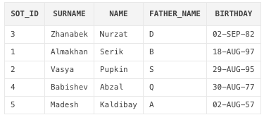

select * from doljnost

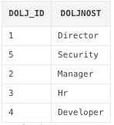

select * from Podrazdeleniye

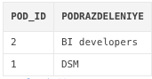

select * from shtat

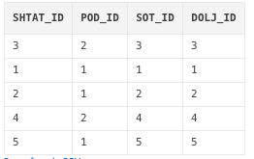

--2 Подразделение и количество штатов в подразделение

select a.podrazdeleniye, count(b.pod_id) as shtat

from shtat b

inner join Podrazdeleniye a

on a.pod_id = b.pod_id

group by a.podrazdeleniye

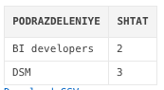

--4

select * from sotrudnik

where mod((birthday-trunc(birthday,'yyyy'))+(add_months(trunc(sysdate,'year'),12)-trunc(sysdate,'year'))

- (sysdate-trunc(sysdate,'year')),(add_months(trunc(sysdate,'year'),12)-trunc(sysdate,'year')) ) < 3

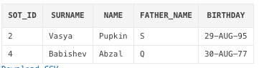

--5

select concat(concat(substr(d.surname,0,1),'.'),(d.name)) as name, b.doljnost, c.podrazdeleniye

from shtat a

inner join sotrudnik d

on a.sot_id = d.sot_id

inner join Podrazdeleniye c

on a.pod_id = c.pod_id

inner join doljnost b

on a.dolj_id = b.dolj_id

