Your Own Serverless Infrastructure

**TABLE OF CONTENTS**

Figlet Function Invocation from command line 2

Complete slack-request/handler.py 2

Complete slack-interactive/handler.py 2

## Slack Interactive -

## Build

## Push

## Deploy

## 3-5

## Slack Request -

## Build

## Push

## Deploy

**6-8**

## sudo journalctl -u faasd --lines 40 9

## OpenFaaS Gateway Screenshots -

## All Function Display

## Figlet Function

## Slack Interactive Function

## Slack Request Function

## 10-14

## Screenshots of invoking Slack Request and Slack Interactive Functions

## 15-16

# Figlet Function Invocation from command line -

Figlet Function is a function that is already deployed and present in faas-cli store that can be invoked through faas-cli or curl command or using gateway UI through browser. The function generates ascii valued figures of given string input. For example, in the below screenshot the function takes input string - “Hello, FaaS, world” and generates the figure as shown in the screenshot.

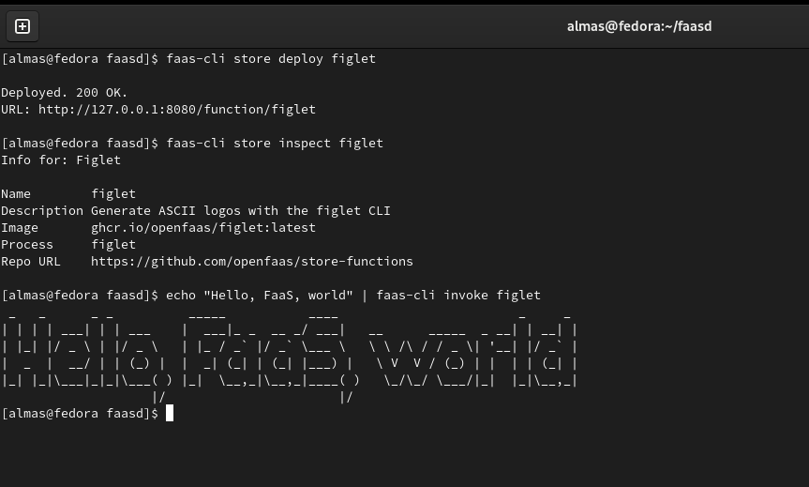

# Complete slack-request/handler.py -

Complete slack-request can be found in this folder -

https://github.com/almasaslamkhan/cloudcomputing/tree/main/hw2/slack-request

# Complete slack-interactive/handler.py -

Complete slack-request can be found in this folder -

[https://github.com/almasaslamkhan/cloudcomputing/tree/main/hw2/slack-in](%20https://github.com/almasaslamkhan/cloudcomputing/tree/main/hw2/slack-in)

[teractive](https://github.com/panu2306/cloud-computing-course/tree/main/homeworks/hw2/slack-interactive)

# Slack Interactive Build -

The slack build command builds a docker image for the function and its dependencies which is used for creating and running a container. Below screenshot shows the functionality of ‘faas-cli push -f ./slack-interactive.yml’ command -

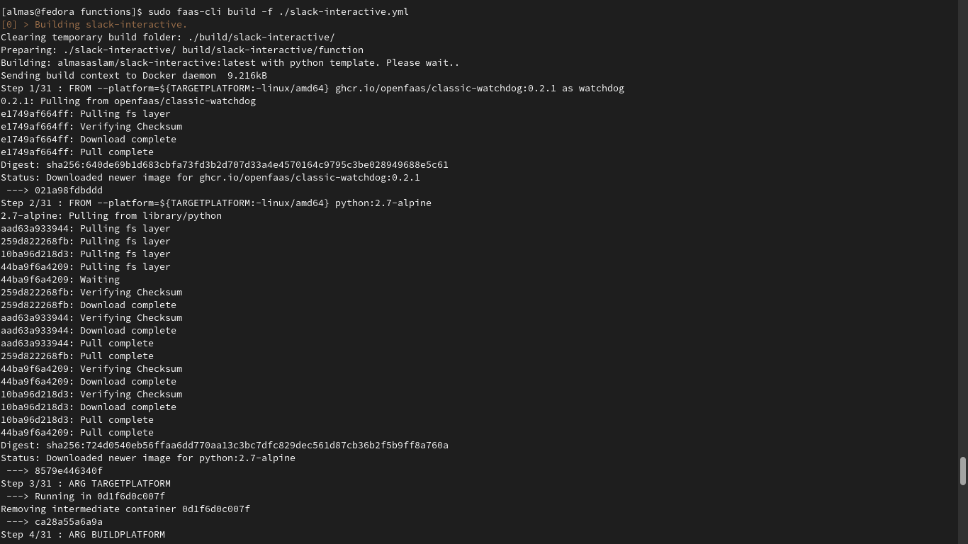

* **Slack Interactive Push -**

Slack Push command uploads the image of the functions with its runtime libraries and dependencies to the docker hub. Below screenshot shows the functionality of ‘faas-cli push -f ./slack-interactive.yml’ command -

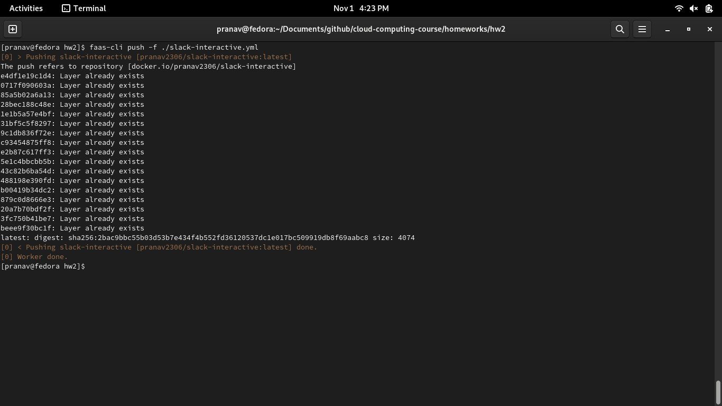

* **Slack Interactive Deploy -**

Slack Push command takes the image from docker hub and runs a container/s for the provided function. Below screenshot shows the functionality of ‘faas-cli deploy -f

./slack-interactive.yml’ command -

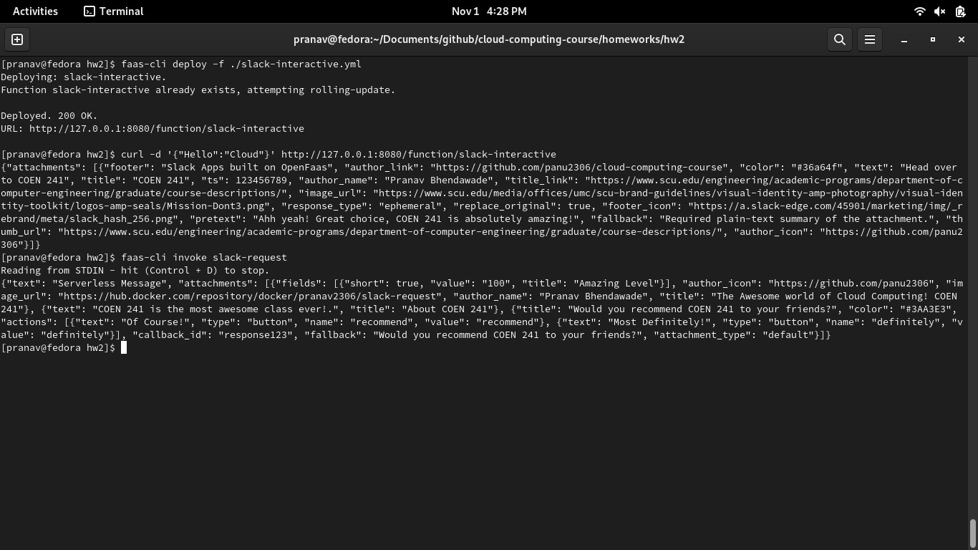

* **Slack Request Build -**

The slack build command builds a docker image for the function and its dependencies which is used for creating and running a container. Below screenshot shows the functionality of ‘faas-cli push -f ./slack-request.yml’ command -

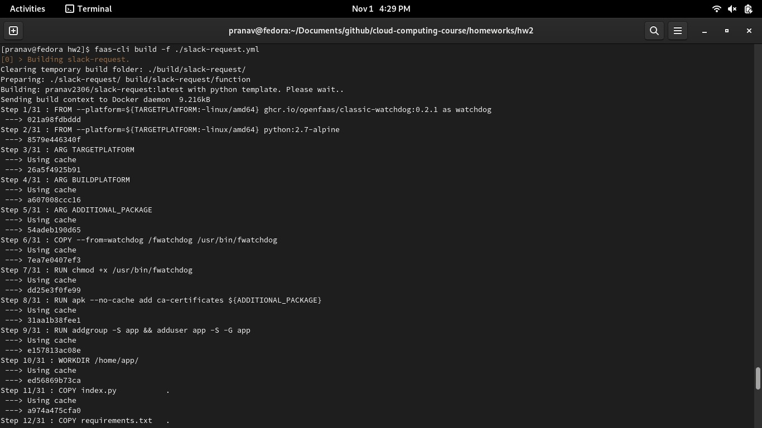

* **Slack Request Push -**

Slack Push command uploads the image of the functions with its runtime libraries and dependencies to the docker hub. Below screenshot shows the functionality of ‘faas-cli push -f ./slack-interactive.yml’ command -

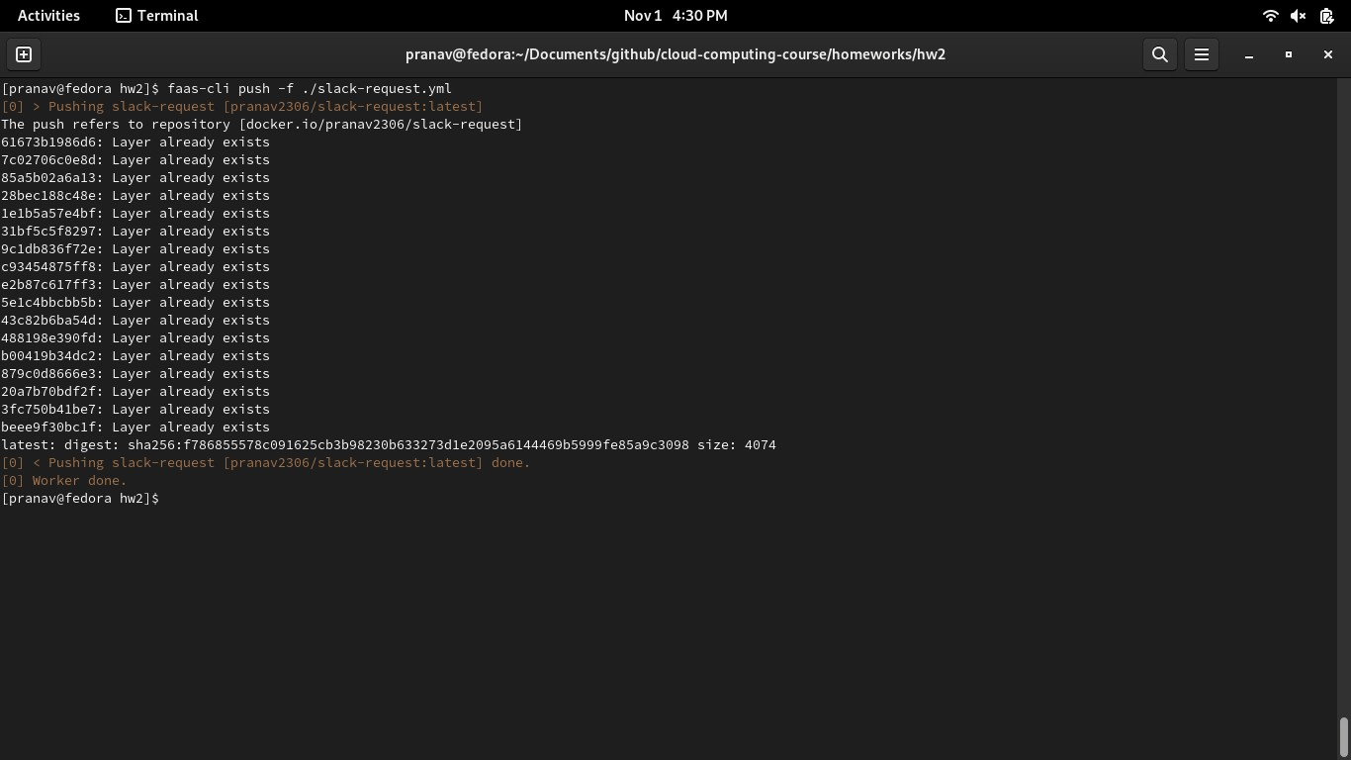

* **Slack Request Deploy -**

Slack Push command takes the image from docker hub and runs a container/s for the provided function. Below screenshot shows the functionality of ‘faas-cli deploy -f

./slack-request.yml’ command -

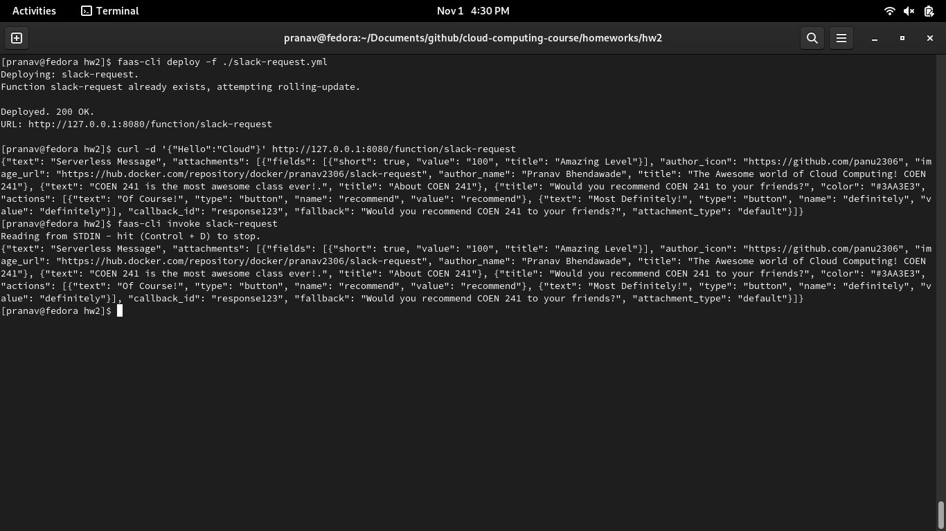

* **sudo journalctl -u faasd --lines 40 -**

Journalctl command utility helps to collect the kernel space and user space logs of different processes. Above command is used to display the 40 lines of logs of faasd.service. Below is the screenshot of output of above command -

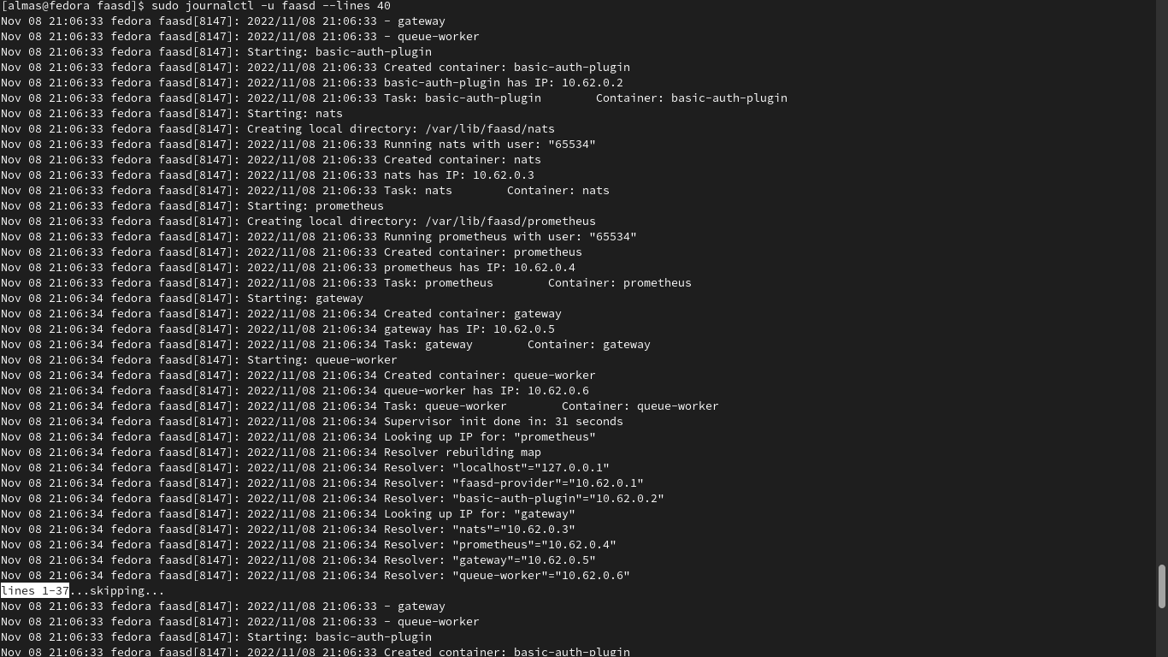

* **OpenFaaS Gateway Screenshots -**

OpenFaaS Gateway is the API gateway that accepts and processes the commands from faas-cli, REST APIs or programs and passes it over to other components like Prometheus, NATFS, Containerd, Kubernetes etc. to perform their tasks. OpenFaaS gateway UI can be launched at h ttp://127.0.0.1:8080/ui/ to check the list of functions that are deployed. Using UI, we can also invoke functions that are deployed.

## All Function Display -

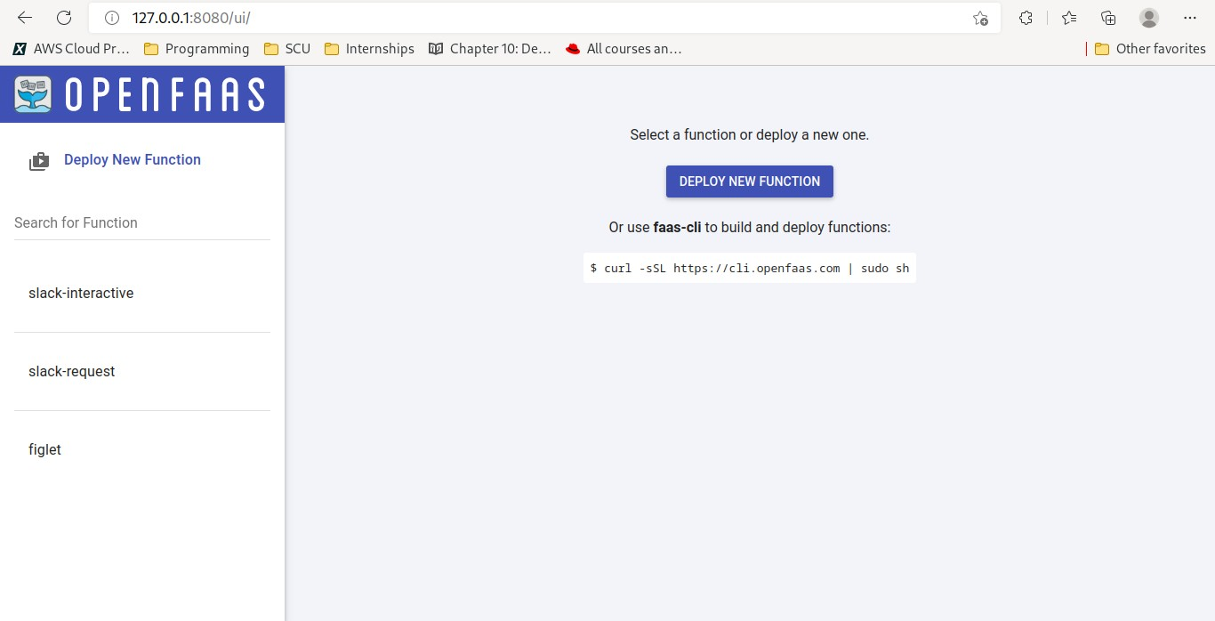

## Figlet Function -

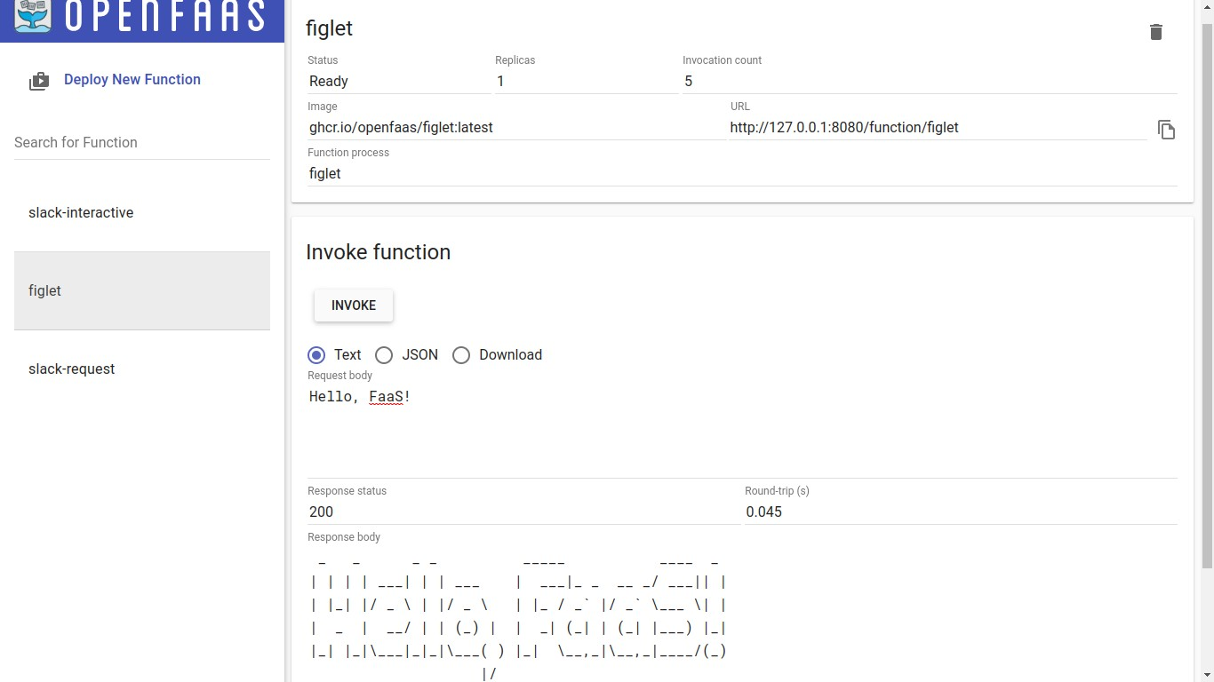

## Slack Request Function -

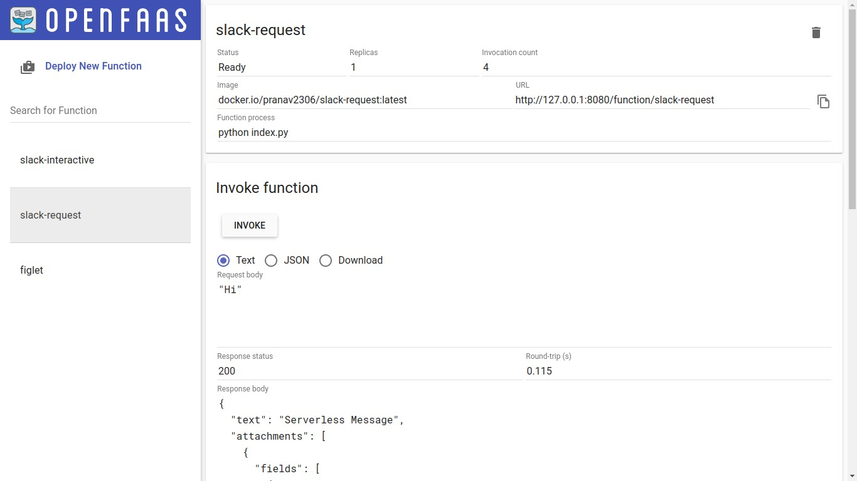

## Slack Interactive Function -

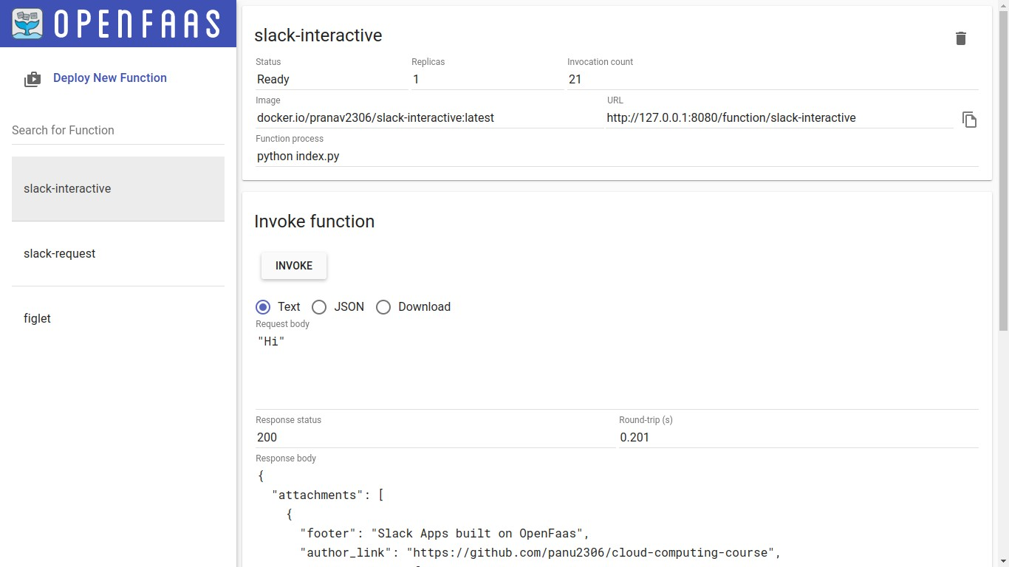

* **Screenshots of invoking Slack Request and Slack Interactive Functions -**

OpenFaaS functions can be invoked using multiple ways. Two of the ways are using faas-cli invoke command and curl command. Below are the screenshot of invoking both - slack interactive and slack request - functions using these two options.

## Invoke Slack Interactive using ‘faas-cli invoke’ and ‘curl’ command -



## Invoke Slack Request using ‘faas-cli invoke’ and ‘curl’ command -

