**Week 4 – Rasa installation and intent classification**

**Mathiopoulou Alexia A.M: 7115182100017**

1. **Bot Description:**

For this assignment, I wanted to create an entertainment bot that would be able to make movie recommendations to its users. The initial thought was that the user would be able to ask from the bot a movie recommendation and then the bot would provide him with a link from a movie site.

For the first stage of the bot’s creation, I opted in designing small, simple stories, with just a couple of intents and actions. More specifically, when the user greets the bot, it responds by greeting back and asking how it can help. If the user responds by asking for a movie recommendation, then the bot follows the *movie_recommendation_simple* story path and informs the user that it will give him a link where he can find some movie recommendations. If the user asks for another link, then the bot follows the *movie_recommendation_simple2* story path and gives another link. After the user thanks the bot and it says goodbye.

1. **Intents:**

In the pictures below, I present the intents that I used for the 4 stories presented above:

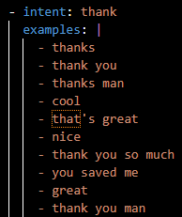

Figure 3. Thank Intent

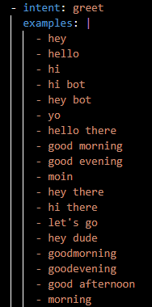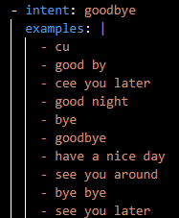

Figure 2. Goodbye Intent

Figure 1. Greet Intent

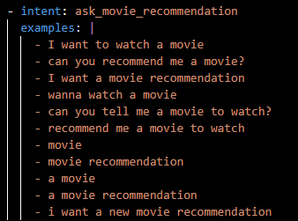

Figure 4. ask_movie_recommendation Intent

1. **Stories:**

The two stories that I created for the movie recommendation path are the following (for music recommendation they are the same, with some differences in the naming of a few intents and actions to avoid the bot’s confusion):

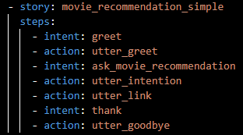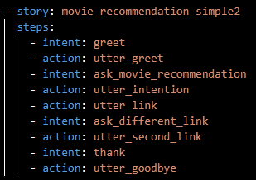

Figure 5. 1st movie recommendation story

Figure 6. 2nd movie recommendation story

1. **Dialogues:**

Finally, I present below a few examples of my interactions with the bot, for the 4 stories that I created:

* **Dialogue 1: “Movie_recommendation_simple”**

Your input -> hi

Bot -> Hey! How can I help you?

Your input -> i want to watch a movie

Bot -> I will give you a link, where you can look for a movie to watch.

Bot -> https://www.imdb.com/list/ls031037940/

Your input -> thanks

Bot -> Have fun! Bye!

* **Dialogue 2 : « Movie_recommendation_simple 2»**

Your input -> hi

Bot -> Hey! How can I help you?

Your input -> can you recommend me a movie?

Bot -> I will give you a link, where you can look for a movie to watch.

Bot -> https://www.imdb.com/list/ls031037940/

Your input -> i want another link

Bot -> https://www.nytimes.com/article/best-movies-netflix.html

Your input -> thanks

Bot -> Have fun! Bye!

1. **Comments :**

In this form, the bot and the dialogues created are very simple. The things that the user can ask from the bot are very limited, as well as the bot’s capabilities.

For the next stage of the bot’s creation, I was thinking of adding a *sign_up* story or something similar. With this story, the bot would get the user’s name and some other information in order to make the dialogue more personalized.

Furthermore, for the already created stories, I could add some slots and entities that would make the bot able to ask and take from the user his preferred movie genre.

For future work, I was thinking of making a small database (excel) that would contain several movies, divided by genre. The bot could extract information by this file and give specific recommendations to the user.