Report

* **Name:**
* **Group:** SE-2439

**Objective**

The objective of this assignment was to create a simple webpage using basic and intermediate HTML elements. The task involved structuring text, adding lists, images, links, buttons, tables, emojis, and forms, as well as deploying the project online.

**Description of Steps Taken**

**Part 1: Basic HTML**

**Step 0 – Setup**

* + Created a new file index.html with the HTML boilerplate.
  + Title: *My First Webpage*.

1. <!DOCTYPE html>
2. <html lang="en">
3. <head>
4. <meta charset="UTF-8" />
5. <meta name="viewport" content="width=device-width, initial-scale=1.0" />
6. <title>My fisrt webpage</title>
7. </head>
8. <body>
9. </body>
10. </html>

**Step 1 – Structure Text**

* + Added <h1> with my name, <h2> with my course, <h3> “About Me”, and a short paragraph.
  + 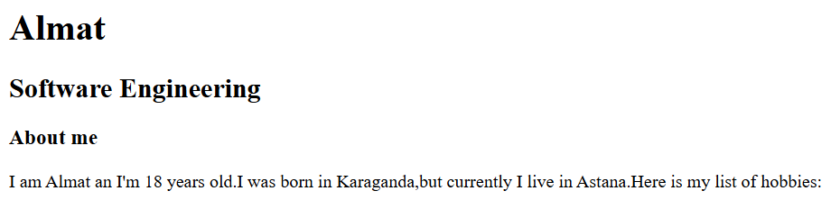

**Step 2 – Lists**

* + Added ordered list (<ol>) of hobbies.
  + Added unordered list (<ul>) of favorite websites.
  + 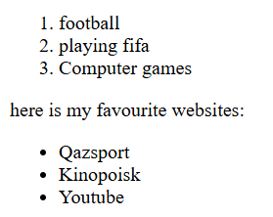

**Step 3 – Images and Links**

* + Inserted personal photo with <img>.
  + Added two clickable links (<a>).
  + 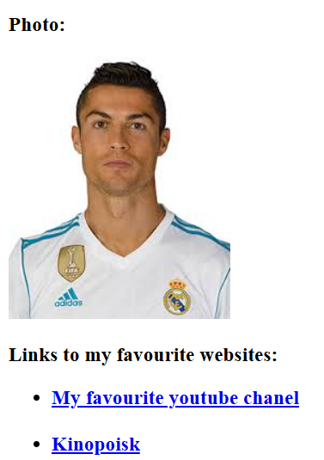

**Step 4 – Button**

* + Added a simple button with text *Click Me*.
  + 

**Part 2: Intermediate HTML**

**Step 5 – Table**

* + Created a table with 3 columns: *Subject, Day, Time*
  + 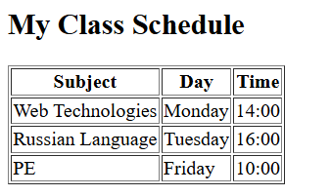

**Step 6 – Layout Table**

* + Used a table to create two columns (menu + content).
  + 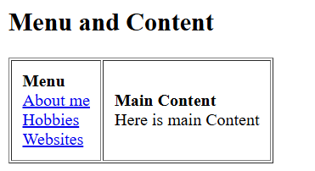

**Step 7 – Emojis**

* + Added a paragraph with at least 3 emojis describing my mood.
  + 

**Step 8 – Form**

* + Created a form with fields: Name, Email , Favorite Color, and a Submit button.
  + 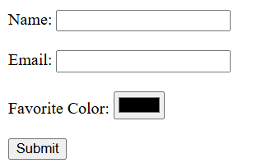

**Step 9. Publish Your First Website**

Published my project to github.Here is link: [**https://almatmz.github.io/frontentd-assignment1/**](https://almatmz.github.io/frontentd-assignment1/)

**Final Result**

* The webpage successfully displays structured content including headings, lists, images, links, tables, emojis, and a form.
* The project runs without any errors in the browser.

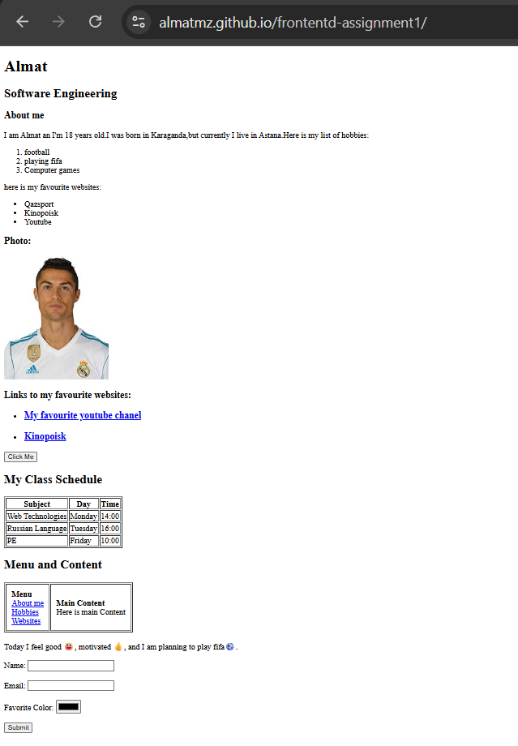

**Reflection**

This assignment helped me understand how to use HTML to structure a webpage. I practiced working with headings, lists, links, forms, and tables. Additionally, I learned how to organize a project folder and prepare it for deployment. Overall, this project strengthened my basic web development skills.