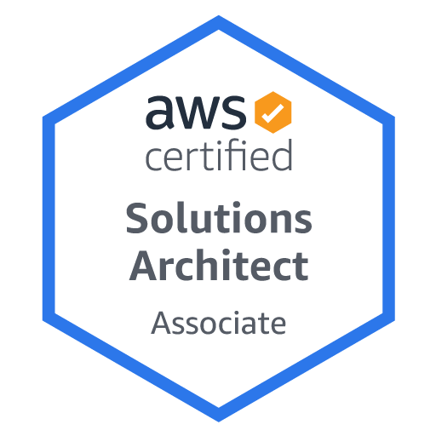

**Pradeep Sunkara**

**Phone: +91-**7659974650

**E-Mail:** pradeep.ssit379@gmail.com

**Professional Experience**

* 3+ years of experience as **AWS DevOps Engineer**, with hands on experience on Configuration Management, Continuous Integration, Continuous Deployment, Release Management and Cloud Implementations.
* A total 3+ years of experience in **AWS DevOps Engineer** combined with 1.5 years of experience in Windows System administration implementing and troubleshooting of critical IT system on 24/7
* Experience setting up **AWS support Engineer**, Experience in setting up **VPC, Route Tables, Public Subnets, Private Subnets** and **Gateways**.
* Implemented **Infrastructure as a code** using **Cloud Formation.**
* Experience in setting up **VPC Peering** and routing traffic between VPC’s.
* Proficient in using amazon web services like **EC2, EBS, IAM, S3, ELB, RDS, VPC, Route 53, Cloud Watch, Cloud Formation** etc.
* Hands on experience in writing **Ansible** playbooks and Roles to automate the deployment.
* Configured **AWS IAM** users, groups & Roles for improved login authentication.
* Experience in writing **AWS IAM Policies** for better security and service access.
* Implemented AWS high-availability using AWS Elastic Load Balancing (**ELB**), which performed balance across instances in multiple availability zones.
* Implemented **S3** Bucket life cycle polices.
* Automated provisioning, configuration and deployment in AWS environment using Cloud Formation and Ansible.
* Managing Windows server 2012 & 2016 environment.
* Creating user account.
* Troubleshooting hardware related issues in physical servers.
* Handling change management calls.
* Handling Daily review calls.
* Handling incidents related to issues like disk space,CPU utilization, Memory, backup issues,permission issues ect on windows servers.
* Perfoorming changes on production servers.
* Performing windows patching.
* Worked on application servers like **Apache tomcat.**
* Knowledge in writing Ansible playbooks and Roles to automate the deployment.
* Knowledge on using Maven builds.
* Knowledge on CI tool like Jenkins.
* Knowledge on setting up Docker containers and orchestrated using Kubernetes.
* Excellent analytical, problem solving, communication and interpersonal skills.
* Capable of quickly learning and delivering solutions as an individual and as part of a team.

**Technical Skills**

|  |  |
| --- | --- |
| **Cloud Technologies** | AWS EC2, ELB, EFS, EBS, Auto Scaling, Route53,Lambda, Elastic Beanstalk, RDS, VPC, VPC Peering, Cloud Watch, Cloud Formation, IAM,,SNS & Cloud Front. |
| **DevOps Skills** | AWS, Ansible,Ansible galaxy,Git,Docker,Maven |
| **Operating System** | Windows server 2008, 2008R2,2012,2012R2, 2016,Redhat Linux, Ubuntu. |
| **Networking Concepts** | FTP, SFTP, SCP, TCP/IP, UDP, SSH ,DHCP,DNS,AD,NFS |
| **Application server** | IIS,Apache,Tomcat |
| **Monitoring Tools** | Cloud Watch,Nagios |

**Education**

* B.Tech from Jawaharlal Nehru Technological University**, Hyderabad , 2018.**

**Professional Experience**

Working as Junior AWS DevOpsEngineer in Tech Mahindra, Hyderabad from June 2018 to till date.

**Roles and Responsibilities**

* Experience in setting up **VPC, Route Tables, Public Subnets, Private Subnets** and **Gateways.**
* Implemented Infrastructure as a code using **Cloud Formation**.
* Creating architecture on AWS, document the design and provisioning the infrastructure on AWS
* Design AWS infrastructure based on the application requirements.
* Design and implemented Security using **VPC, IAM, Security Groups** and **NACL.** **Cloud Watch, Cloud Trail and Simple Notification Service.**
* Created **Multifactor Authentication** for AWS Users in the organizations.
* Experience in setting up **VPC Peering** and routing traffic between **VPCS**.
* Proficient in using all amazon web services like **EC2, EBS, IAM, S3, ELB, RDS, VPC, Route 53, Cloud Watch, Cloud Formation** etc.
* Managing Backups of **EBS** Volumes.
* Experience in real-time monitoring and alerting of applications deployed in AWS using
* Configured **AWS IAM users, groups & Roles** for improved login authentication.
* Experience in writing AWS IAM Policies for better security and service access.
* Implemented AWS high-availability using AWS **Elastic Load Balancing (ELB),** which performed balance across instances in multiple availability zones.
* Implemented **S3 Bucket life cycles**.
* Hands on experience on source code management using **GitHub**.
* Worked on application servers like **Apache tomcat**
* Managing Windows server 2012 & 2016 environment.
* Creating user account.
* Troubleshooting hardware related issues in physical servers.
* Handling change management calls.
* Handling Daily review calls.
* Handling incidents related to issues like disk space,CPU utilization, Memory, backup issues,permission issues ect on windows servers.
* Perfoorming changes on production servers.
* Performing windows patching.
* Administration of **Linux** servers in Amazon WebServices.
* Manage servers, certificates, web servers and load balancers

**Achived Certifications**

* AWS Solution Architect-Associate

**Passport Details**

* Passport Number: U6284531
* Validity: 12/01/2031