**K Shankar** 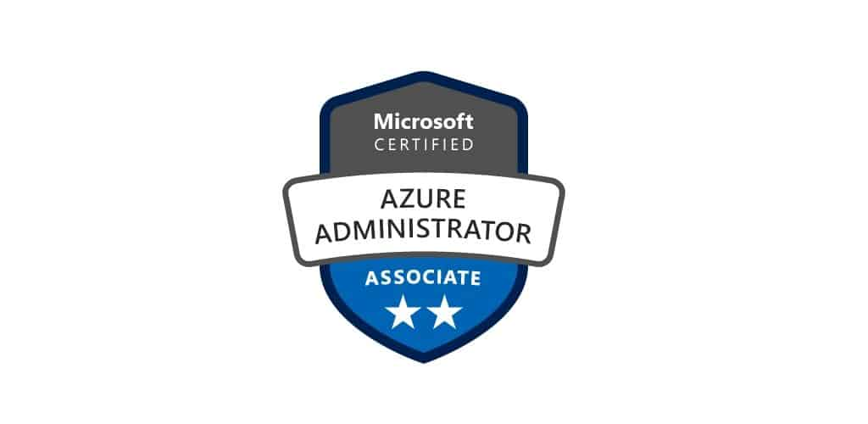

**Mob No: - 9959448466**

**Email: -kusumashankar017@gmail.com**

**Objective:**

* Looking for a challenging career in IT Industries with opportunities to utilize my technical & analytical skills. Getting best of the exposure and good working environment where my efforts can contribute towards the organization growth.

**Professional Synopsis:**

* Total **6.6**years of IT Industry experience comprising of Administration.
* **3**.**5years** of experience in Automation, Configuration Management and cloud platform services.
* **Certified Azure Admin (AZ-103).**
* Managing the **Microsoft Azure portal**, creating the resource manager, and maintaining the infrastructure.
* **Microsoft Windows Server** **2016,2012 R2, 2008 R2 &Active Directory Domain Services.**
* **On-Premise Directory** Synchronization with **Azure Active Directory** on Cloud.
* Experienced in launching the windows and Linux **Virtual Machines** in Azure.
* **Deep understanding of Infrastructure components like Azure IaaS (VM) and PaaS (Azure AD, Azure BLOB, Backup, ASR) services.**
* Experience in creating the **Azure blob**.
* Experience in Migrating databases from **On-Premise SQL Server to Azure SQL Server,** **SQL Server in Virtual Machine** using **DMA (Data Migration Assistant**) and **DMS (Data Migration Service).**
* Migrate the workloads from **on prem to Azure** using **Azure Migrate.**
* **Develop PowerShell scripts and ARM templates to automate the provisioning and deployment process.**
* **Working on Azure Active Directory.**
* **Working Experience on Linux and Windows Workloads.**
* **Azure Networking – (VNet, Subnet, NSG)**

**Skill Sets:**

|  |  |
| --- | --- |
| **Azure Services** | **VM’s, Load balancer, Automation, policies, Azure AD, Backup and recovery, Storage, ARM Templates, PowerShell** |
| **App & Web Servers** | **IIS** |
| **Databases** | **Oracle, MS SQL Database** |
| **Virtualization** | **VMware v Sphere** |
| **OS Platforms** | **Windows server 2008 R2/ 2012R2 / Linux** |

**Work Experience:**

**Company : Mouritech**

**July 2020 to till**

**Role : Sr Specialist**

**Client : REEF**

**Roles and responsibilities:**

* Involved Azure Cost management and doing payment methods.
* Applied Azure policies based on the requirement.
* Created Appinsights and alerts for resources level and subscription level.
* Created Azure VM’s and assign to vnet to that VM’s.
* Created Databases and allow local ip to the database to access DB’s.
* Created Azure firewall and add the Ip’s into it.
* Created Azure bastion and access the VM’s without using Public IP.

**Payroll: eTeam Info Services Pvt Ltd.**

**Company: HCL**

**Oct 2018 to Mar 2019**

**Role: Azure Migration Specialist**

**Project: Ripieno**

**Roles and Responsibilities:**

* Involved in database migration from on-premises environment to azure environment.
* Migrated VM'S from **AWS** to **Azure**.
* **Involved in environment assessment process.**
* Had experience in creating VM'S storage account as per requirement.
* Db migration from **My SQL to Azure SQL DB.**
* **Azure BLOB Storage.**
* Database Migration using Data Migration Assistant and Database Migration Service.

**Company: Esmob Technologies Pvt Ltd**

**Dec 2015 – Sep 2018**

**Role: System Administrator**

**Responsibilities**:

* Create an **Azure Virtual Machines** in Azure portal.
* Create an **Azure Virtual network** in Azure portal.
* Configure Virtual networks connectivity using **V- Net peering** and **V Net-to-V Net VPN** gateway connection using the azure portal.
* Configure a **Site to Site VPN & Point-to-Site** connection to a V Net using Native Azure certificate authentication.
* **Resize of Azure VM** in ARM Portal and Create VMs inside an **Availability set.** Create and manage VM **scale set**. Create and manage **NSG (Network security group).**
* Create a **Traffic manager** profile & **Manage Load balancer.**
* Backup a Virtual machine in Azure use MARS **Backup** and take backup for Multiple Virtual machines.
* Create Add **custom domain** in **Azure Active Directory**. Create **Azure AD connect** to Sync with **server AD.**
* Experience in lift **and shift migration** for migrating our application and associated data to the cloud with minimal or no changes. (Re-host).

**Sun Icon Systems Pvt Ltd.**

**Dec 2013 –Dec 2015**

**Role: System Associate**

**Responsibilities**:

* To Launch **EC2 instances on AWS** (**Windows & Linux).**
* To Configure **Web server** on Amazon Linux instance with **Elastic IP, Assign Elastic IP Address.**
* To Manage **EBS, IAM users, Groups and Policies**. To Configure **Amazon S3 and Glacier**.
* To Configure **VPC, Cloud Watch, SNS, ELB & Auto Scaling with Load Balancer.**
* User administration (setup and maintaining account).
* Provide technical support for both hardware and software issues our users encounter.
* Manage the configuration and operation of client-based computer operating systems.
* Monitor the system daily and respond immediately to security or usability concerns.
* Monitor system performance, create file systems, Install software.
* Create a backup and recovery policy.
* Monitor network communication.
* Respond to and resolve help desk requests.
* Upgrade systems and processes as required for enhanced functionality and security issue resolution.
* Review application logs.
* Update system as soon as new version of OS and application software comes out.
* Implement the policies for the use of the computer system and network.
* Setup security policies for users and Password and identity management.
* Configure Servers like **ADDS**, **FTP**, **DNS**, **DHCP** and configure services **Group Policy & RDS.**

**Academic:**

|  |  |
| --- | --- |
| **M.C.A from OSMANIA UNIVERSITY, HYD.** | **June 2011** |

I hereby declare that all the information made in this resume is true, Complete and correct to the best of my knowledge and belief. In the event of any information being found false or incorrect, I shall be responsible for the same.

**Date: Shankar. K**

**Place: Hyderabad.**