Hmwk9.R

Audrey McCombs

Fri Nov 10 22:02:27 2017

#Problem 1  
  
matfunc <- function(n,k) {  
 diag(x = k, nrow = n, ncol = n)  
}  
matfunc(6,5)

## [,1] [,2] [,3] [,4] [,5] [,6]  
## [1,] 5 0 0 0 0 0  
## [2,] 0 5 0 0 0 0  
## [3,] 0 0 5 0 0 0  
## [4,] 0 0 0 5 0 0  
## [5,] 0 0 0 0 5 0  
## [6,] 0 0 0 0 0 5

rm(list = ls())  
  
#Problem 2  
  
tmpFn <- function(xVec) {  
 ifelse(test = xVec < 0,  
 yes = ((xVec^2) + (2*xVec) + 3),  
 no = ifelse(test = 0 <= xVec & xVec < 2,  
 yes = (xVec + 3),  
 no = ((xVec^2) + (4* xVec) - 7)))  
 }  
  
xVec <- seq(from = -3, to = 3, by = .01)  
yVec <- tmpFn(xVec)  
plot(xVec, yVec, xlab = "Input value", ylab = "Function output", main = "tmpFn function", asp = 1)

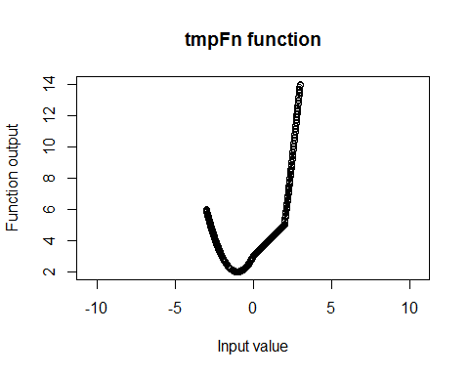

rm(list = ls())  
  
#Problem 3  
  
gdc <- function(m,n) {  
 firstm <- m  
 firstn <- n  
 r <- 1  
 while (r != 0) {  
 r <- m %% n  
 m <- n  
 n <- r  
 }  
print(c(firstm, firstn, m))  
}  
  
gdc(1420,95)

## [1] 1420 95 5

rm(list = ls())  
  
#Problem 4  
  
order.matrix <- function(mymat) {  
ordvec <- sort(mymat)  
indrow <- (rep(NA, length(ordvec)))  
indcol <- (rep(NA, length(ordvec)))  
for (i in 1:length(ordvec)) {  
 rowcol <- which(mymat == ordvec[i], arr.ind = TRUE)  
 indrow[i] <- rowcol[1,1]  
 indcol[i] <- rowcol[1,2]  
}  
values <- data.frame(number = ordvec, rowindex = indrow, colindex = indcol)  
return(values)  
}  
  
mymat <- matrix(rchisq(12, 1), nrow = 4)  
order.matrix(mymat)

## number rowindex colindex  
## 1 0.1665623 3 2  
## 2 0.2657899 3 1  
## 3 0.4045661 1 1  
## 4 0.4430517 4 1  
## 5 0.5744085 1 2  
## 6 0.7288544 2 3  
## 7 0.7877767 4 2  
## 8 0.9221183 2 1  
## 9 0.9850161 3 3  
## 10 1.5887811 2 2  
## 11 3.1262032 1 3  
## 12 4.5532919 4 3

mymat <- matrix(rchisq(20, 1), nrow = 5)  
order.matrix(mymat)

## number rowindex colindex  
## 1 0.0001931904 1 4  
## 2 0.0044179904 5 1  
## 3 0.0139876989 1 2  
## 4 0.0239771482 1 3  
## 5 0.0349673022 2 4  
## 6 0.0429590343 4 2  
## 7 0.0484625034 4 4  
## 8 0.0551572657 4 1  
## 9 0.0600482125 2 1  
## 10 0.0677640266 4 3  
## 11 0.0792188237 5 3  
## 12 0.1001339343 3 1  
## 13 0.1037628103 1 1  
## 14 0.1093666476 3 4  
## 15 0.1869270890 2 2  
## 16 0.2544719847 3 2  
## 17 0.4785152108 2 3  
## 18 0.7036197419 5 2  
## 19 0.8737965178 3 3  
## 20 0.9176613976 5 4

rm(list = ls())