Hmwk9.R

Audrey McCombs

Fri Nov 10 22:02:27 2017

#Problem 1  
  
matfunc <- function(n,k) {  
 diag(x = k, nrow = n, ncol = n)  
}  
matfunc(6,5)

## [,1] [,2] [,3] [,4] [,5] [,6]  
## [1,] 5 0 0 0 0 0  
## [2,] 0 5 0 0 0 0  
## [3,] 0 0 5 0 0 0  
## [4,] 0 0 0 5 0 0  
## [5,] 0 0 0 0 5 0  
## [6,] 0 0 0 0 0 5

rm(list = ls())  
  
#Problem 2  
  
tmpFn <- function(xVec) {  
 ifelse(test = xVec < 0,  
 yes = ((xVec^2) + (2*xVec) + 3),  
 no = ifelse(test = 0 <= xVec & xVec < 2,  
 yes = (xVec + 3),  
 no = ((xVec^2) + (4* xVec) - 7)))  
 }  
  
xVec <- seq(from = -3, to = 3, by = .01)  
yVec <- tmpFn(xVec)  
plot(xVec, yVec, xlab = "Input value", ylab = "Function output", main = "tmpFn function", asp = 1)

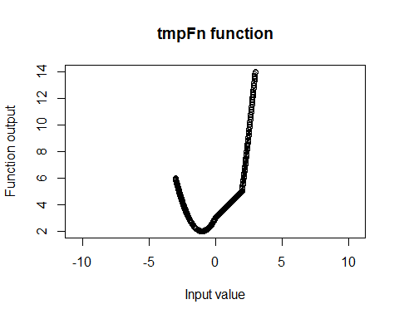

rm(list = ls())  
  
#Problem 3  
  
gdc <- function(m,n) {  
 firstm <- m  
 firstn <- n  
 r <- 1  
 while (r != 0) {  
 r <- m %% n  
 m <- n  
 n <- r  
 }  
print(c(firstm, firstn, m))  
}  
  
gdc(1420,95)

## [1] 1420 95 5

rm(list = ls())  
  
#Problem 4  
  
order.matrix <- function(mymat) {  
ordvec <- sort(mymat)  
indrow <- (rep(NA, length(ordvec)))  
indcol <- (rep(NA, length(ordvec)))  
for (i in 1:length(ordvec)) {  
 rowcol <- which(mymat == ordvec[i], arr.ind = TRUE)  
 indrow[i] <- rowcol[1,1]  
 indcol[i] <- rowcol[1,2]  
}  
values <- data.frame(number = ordvec, rowindex = indrow, colindex = indcol)  
return(values)  
}  
  
mymat <- matrix(rchisq(12, 1), nrow = 4)  
order.matrix(mymat)

## number rowindex colindex  
## 1 0.1665623 3 2  
## 2 0.2657899 3 1  
## 3 0.4045661 1 1  
## 4 0.4430517 4 1  
## 5 0.5744085 1 2  
## 6 0.7288544 2 3  
## 7 0.7877767 4 2  
## 8 0.9221183 2 1  
## 9 0.9850161 3 3  
## 10 1.5887811 2 2  
## 11 3.1262032 1 3  
## 12 4.5532919 4 3

mymat <- matrix(rchisq(20, 1), nrow = 5)  
order.matrix(mymat)

## number rowindex colindex  
## 1 0.0001931904 1 4  
## 2 0.0044179904 5 1  
## 3 0.0139876989 1 2  
## 4 0.0239771482 1 3  
## 5 0.0349673022 2 4  
## 6 0.0429590343 4 2  
## 7 0.0484625034 4 4  
## 8 0.0551572657 4 1  
## 9 0.0600482125 2 1  
## 10 0.0677640266 4 3  
## 11 0.0792188237 5 3  
## 12 0.1001339343 3 1  
## 13 0.1037628103 1 1  
## 14 0.1093666476 3 4  
## 15 0.1869270890 2 2  
## 16 0.2544719847 3 2  
## 17 0.4785152108 2 3  
## 18 0.7036197419 5 2  
## 19 0.8737965178 3 3  
## 20 0.9176613976 5 4

rm(list = ls())

#Problem 5  
op <- par()  
  
#Problem 5.a  
polaroid <- function(x) {  
 p <- length(x)  
 r <- sqrt(sum(x^2))  
   
 theta <- rep(0, p-1)  
 den <- rep(0, p-2)  
   
 theta[1] <- acos(x[1]/r)  
 den[1] <- r  
   
 for (i in 2:(p-1)) {  
 den[i] <- den[i-1] * sin(theta[i-1])  
 theta[i] <- acos(x[i]/den[i])  
 }  
   
 polar <- c(r, theta)  
 return(polar)  
}  
  
x <- seq(from = 0, to = 10, by = 2)  
polaroid(x)

## [1] 14.8323970 1.5707963 1.4355444 1.2951535 1.1326473 0.8960554

#Problem 5.b  
normalize <- function(vec) {  
 den <- sqrt(sum(vec^2))  
 output <- vec/den  
}  
  
#Problem 5.c  
y <- matrix(rnorm(5000, mean = 0, sd = 1), nrow = 1000, ncol = 5)  
zt <- apply(y, 1, normalize)  
z <- t(zt)  
  
ks.test(z,"punif",min=-1,max=1)

##   
## One-sample Kolmogorov-Smirnov test  
##   
## data: z  
## D = 0.099436, p-value < 2.2e-16  
## alternative hypothesis: two-sided

hist(z)

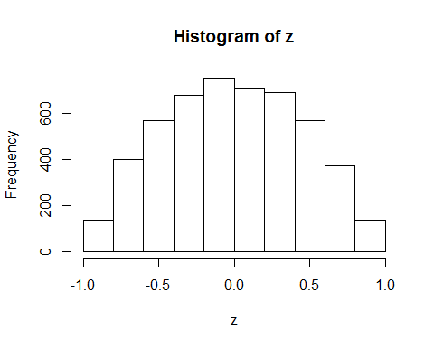

#Based on the Kolmogorov–Smirnov test, the z matrix is not uniformly distributed. We can see this clearly in the histogram of values in the matrix.  
  
#Problem 5.d  
polarst <- apply(y, 1, polaroid)  
polars <- t(polarst)  
  
ks.test(polars[,1]^2, "pchisq", 5)

##   
## One-sample Kolmogorov-Smirnov test  
##   
## data: polars[, 1]^2  
## D = 0.026994, p-value = 0.4598  
## alternative hypothesis: two-sided

boxplot(polars[,2:5])

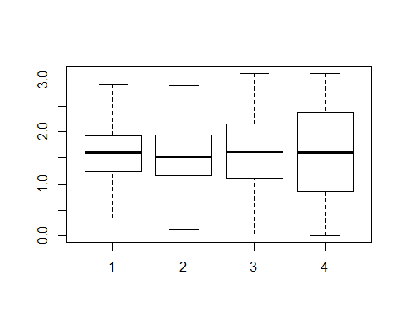

ks.test(polars[,2], "punif", min = 0, max = 2*pi)

##   
## One-sample Kolmogorov-Smirnov test  
##   
## data: polars[, 2]  
## D = 0.57589, p-value < 2.2e-16  
## alternative hypothesis: two-sided

ks.test(polars[,3], "punif", min = 0, max = pi)

##   
## One-sample Kolmogorov-Smirnov test  
##   
## data: polars[, 3]  
## D = 0.17876, p-value < 2.2e-16  
## alternative hypothesis: two-sided

ks.test(polars[,4], "punif", min = 0, max = pi)

##   
## One-sample Kolmogorov-Smirnov test  
##   
## data: polars[, 4]  
## D = 0.11135, p-value = 3.403e-11  
## alternative hypothesis: two-sided

ks.test(polars[,5], "punif", min = 0, max = pi)

##   
## One-sample Kolmogorov-Smirnov test  
##   
## data: polars[, 5]  
## D = 0.024207, p-value = 0.6012  
## alternative hypothesis: two-sided

#Multiple distributions  
par(mfrow = c(3,3))  
for (i in 1:9) {  
 y <- matrix(rnorm(5000, mean = 0, sd = 1), nrow = 1000, ncol = 5)  
 zt <- apply(y, 1, normalize)  
 z <- t(zt)  
 polarst <- apply(y, 1, polaroid)  
 polars <- t(polarst)  
 boxplot(polars[,2:5])  
}

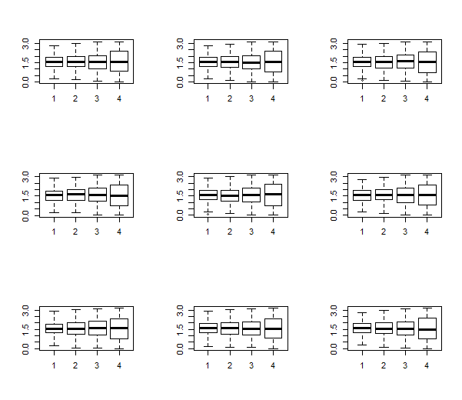

par(op)

#Problem 6  
  
 #Problem 6.a  
x <-c(3.91, 4.85, 2.28, 4.06, 3.70, 4.04, 5.46, 3.53, 2.28, 1.96, 2.53, 3.88, 2.22, 3.47, 4.82, 2.46, 2.99, 2.54, 0.52, 2.50)  
theta <- seq(0,10,,100)  
  
hm <- function(theta = theta, x = 3.91) (1-cos(x - theta))/(2*pi)  
loghm <- function(theta, x) (-log(2*pi)+sum(log(1-cos(x-theta)^2)))  
plot(theta,sapply(theta,loghm,x),type="l",ylab="LogL of HW distribution", xlim = c(-3.1415927, 3.1415927))

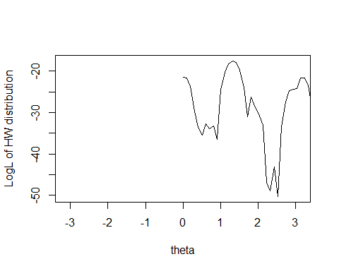

plot(theta,sapply(theta,loghm,x),type="l",ylab="LogL of HW distribution", xlim = c(0, 10))  
  
 #Problem 6.b  
optimize(function(theta) sapply(theta, loghm, x), interval = c(1,2), maximum = T)

## $maximum  
## [1] 1.326029  
##   
## $objective  
## [1] -17.51277

#Problem 6.c  
ghm <- function(theta,x) sin(x-theta)/(1-cos(x-theta))  
derghm <- function(theta,x) 1/(1-cos(x-theta))  
  
loglik <- function(fun, derf, x0, eps, nlim,...) {  
 iter <- 0  
 repeat {  
 iter <- iter + 1  
 if(iter > nlim) {  
 cat(" Iteration Limit Exceeded: Current = ",iter, fill = T)  
 x1 <- NA  
 break  
 }  
 x1 <- x0 - fun(x0,...)/derf(x0,...)  
 if(abs(x0 - x1) < eps||abs(fun(x1,...))<1.0e-12)  
 break  
 x0 <- x1  
 cat("\n****** Iter. No: ", iter, " Current Iterate = ", x1, fill=T)  
 }  
 return(x1)  
}  
  
loglik(ghm, derghm, 0, 0.00001, 100, x)

##   
## ****** Iter. No: 1 Current Iterate = 0.694991 0.9905465 -0.7588807   
## 0.7946357 0.5298361 0.7823359 0.7333152 0.3787149 -0.7588807 -0.9252115   
## -0.5741721 0.6731109 -0.7965655 0.3225359 0.9942155 -0.6300306 -0.1510127   
## -0.5659562 -0.4968801 -0.5984721  
##   
## ****** Iter. No: 2 Current Iterate = 0.7683414 1.648321 -0.8614122   
## 0.9180916 0.5584035 0.8981469 1.733213 0.3884072 -0.8614122 -1.178793   
## -0.6115839 0.738361 -0.9212672 0.3284073 1.626262 -0.6815698 -0.1515927   
## -0.6015851 -1.347351 -0.6415793

## [1] 0.7684073 1.7083712 -0.8615927 0.9184073 0.5584073 0.8984073  
## [7] 2.2855744 0.3884073 -0.8615927 -1.1815926 -0.6115927 0.7384073  
## [13] -0.9215927 0.3284073 1.6783837 -0.6815927 -0.1515927 -0.6015927  
## [19] -2.3037001 -0.6415927

#This found the MLE value at -0.64: the local maximum near x = 0.  
  
 #Problem 6.d  
loglik(ghm, derghm, -2.0, 0.00001, 100, x)

##   
## ****** Iter. No: 1 Current Iterate = -1.635417 -2.536948 -1.092033   
## -1.778663 -1.449314 -1.759205 -2.923388 -1.316034 -1.092033 -1.269942   
## -1.016587 -1.60765 -1.118794 -1.27352 -2.511401 -1.031681 -1.038287   
## -1.014822 -2.582331 -1.02247  
##   
## ****** Iter. No: 2 Current Iterate = -0.9627782 -3.429855 -0.8636267   
## -1.348636 -0.5432575 -1.293898 -3.786495 -0.3249513 -0.8636267 -1.181708   
## -0.6225734 -0.8934112 -0.9228683 -0.2740048 -3.377936 -0.6887002   
## -0.2633001 -0.6132531 -2.621583 -0.6507349  
##   
## ****** Iter. No: 3 Current Iterate = 0.02438699 -4.340533 -0.8615927   
## -0.5813819 0.3487038 -0.4808975 -3.963835 0.3294259 -0.8615927 -1.181593   
## -0.6115929 0.1047275 -0.9215927 0.2926269 -4.319364 -0.6815927 -0.1518248   
## -0.6015929 -2.621593 -0.6415928  
##   
## ****** Iter. No: 4 Current Iterate = 0.7016384 -4.572642 -0.8615927   
## 0.4160982 0.5568737 0.5008239 -3.964778 0.3883732 -0.8615927 -1.181593   
## -0.6115927 0.6968417 -0.9215927 0.3283997 -4.600919 -0.6815927 -0.1515927   
## -0.6015927 -2.621593 -0.6415927  
##   
## ****** Iter. No: 5 Current Iterate = 0.7683577 -4.574778 -0.8615927   
## 0.8975489 0.5584073 0.8880153 -3.964778 0.3884073 -0.8615927 -1.181593   
## -0.6115927 0.7383954 -0.9215927 0.3284073 -4.604778 -0.6815927 -0.1515927   
## -0.6015927 -2.621593 -0.6415927

## [1] 0.7684073 -4.5747780 -0.8615927 0.9184058 0.5584073 0.8984072  
## [7] -3.9647780 0.3884073 -0.8615927 -1.1815927 -0.6115927 0.7384073  
## [13] -0.9215927 0.3284073 -4.6047780 -0.6815927 -0.1515927 -0.6015927  
## [19] -2.6215927 -0.6415927

loglik(ghm, derghm, -2.7, 0.00001, 100, x)

##   
## ****** Iter. No: 1 Current Iterate = -3.021028 -3.654152 -1.735595   
## -3.158951 -2.816549 -3.141092 -3.653541 -2.64684 -1.735595 -1.701372   
## -1.830996 -2.992476 -1.721474 -2.587056 -3.644745 -1.798516 -2.140995   
## -1.835988 -2.621673 -1.816545  
##   
## ****** Iter. No: 2 Current Iterate = -3.624496 -4.450133 -0.9686912   
## -3.964005 -3.047801 -3.923115 -3.959777 -2.540695 -0.9686912 -1.204683   
## -0.892102 -3.548247 -1.004201 -2.362849 -4.463955 -0.8997605 -1.227339   
## -0.892039 -2.621593 -0.8938737  
##   
## ****** Iter. No: 3 Current Iterate = -4.573892 -4.574455 -0.8617973   
## -4.949586 -3.49588 -4.917166 -3.964778 -2.329799 -0.8617973 -1.181595   
## -0.6152569 -4.458982 -0.9216866 -1.927581 -4.604313 -0.6833192 -0.3473938   
## -0.6056591 -2.621593 -0.6442603  
##   
## ****** Iter. No: 4 Current Iterate = -5.381973 -4.574778 -0.8615927   
## -5.352952 -4.287034 -5.367922 -3.964778 -1.918949 -0.8615927 -1.181593   
## -0.6115927 -5.343657 -0.9215927 -1.153284 -4.604778 -0.6815927 -0.1528414   
## -0.6015927 -2.621593 -0.6415927  
##   
## ****** Iter. No: 5 Current Iterate = -5.514388 -4.574778 -0.8615927   
## -5.364778 -5.278196 -5.384777 -3.964778 -1.178166 -0.8615927 -1.181593   
## -0.6115927 -5.543425 -0.9215927 -0.1572512 -4.604778 -0.6815927 -0.1515927   
## -0.6015927 -2.621593 -0.6415927  
##   
## ****** Iter. No: 6 Current Iterate = -5.514778 -4.574778 -0.8615927   
## -5.364778 -5.710081 -5.384778 -3.964778 -0.1781749 -0.8615927 -1.181593   
## -0.6115927 -5.544778 -0.9215927 0.3095397 -4.604778 -0.6815927 -0.1515927   
## -0.6015927 -2.621593 -0.6415927

## [1] -5.5147780 -4.5747780 -0.8615927 -5.3647780 -5.7247774 -5.3847780  
## [7] -3.9647780 0.3585766 -0.8615927 -1.1815927 -0.6115927 -5.5447780  
## [13] -0.9215927 0.3284062 -4.6047780 -0.6815927 -0.1515927 -0.6015927  
## [19] -2.6215927 -0.6415927

# At a starting value of -2.0, the first iteration found an MLE of -1.02, which is a local maximum near -2.0. Later iterations found the same MLE as with starting point of 0 (i.e., -0.64). At a starting value of 2.7, however, the first iteration found the MLE at -1.8165, and it took more iterations to find the MLE of -0.64. This function bounces around a lot, so it's not surprising that the function finds local maxima and takes a while to settle.  
  
#Problem 7 – Go Galton!  
  
 #Problem 7.a  
men <- rnorm(n = 100, mean = 125, sd = 25)  
women <- rnorm(n = 100, mean = 125, sd = 15)  
t0 <- data.frame(M = men, W = women)  
head(t0)

## M W  
## 1 94.18540 142.2488  
## 2 98.84936 112.6996  
## 3 103.38450 121.5094  
## 4 185.52787 119.4877  
## 5 145.68981 119.1958  
## 6 93.34521 139.0001

#Problem 7.b  
permute <- function(t0, iter) {  
 t <- as.list(rep(NA, iter))  
 output <- as.list(rep(NA, iter))  
 ttemp <- t0  
 for (i in 1:iter) {  
 t[[i]] <- data.frame(M = sample(x = ttemp$M, 100), W = ttemp$W)  
 output[[i]] <- apply(t[[i]], 1, mean)  
 ttemp <- data.frame(M = output[[i]], W = output[[i]])  
 }  
 return(output)  
}  
  
 #Problem 7.c  
library(ggplot2)

## Warning: package 'ggplot2' was built under R version 3.2.5

library(reshape2)

## Warning: package 'reshape2' was built under R version 3.2.5

heights <- permute(t0, 9)  
heights <- as.data.frame(heights)  
names(heights) <- paste("G", 1:9, sep = "")  
head(heights)

## G1 G2 G3 G4 G5 G6 G7 G8  
## 1 135.8820 136.1448 137.6520 129.1269 125.2955 125.6155 124.9099 124.7827  
## 2 116.8171 115.3775 112.4821 118.9764 118.8376 123.0381 124.2781 124.9299  
## 3 118.8127 127.7004 129.5418 126.7541 127.3588 124.2797 124.1995 124.2551  
## 4 112.0907 122.3789 119.9758 120.4831 128.1408 128.5821 127.7421 127.9181  
## 5 123.5298 125.8862 121.2932 123.3369 122.2617 121.9554 123.9541 124.9214  
## 6 121.1923 121.1923 120.8602 126.5974 125.4531 126.4668 126.6820 126.0116  
## G9  
## 1 126.1103  
## 2 125.1944  
## 3 125.1173  
## 4 125.3302  
## 5 126.4198  
## 6 125.7347

heights <- melt(heights)

## No id variables; using all as measure variables

names(heights) <- c("gen", "height")  
head(heights)

## gen height  
## 1 G1 135.8820  
## 2 G1 116.8171  
## 3 G1 118.8127  
## 4 G1 112.0907  
## 5 G1 123.5298  
## 6 G1 121.1923

ggplot(heights, aes(x=height)) + geom_histogram(binwidth = 1) + facet_wrap(~ gen)

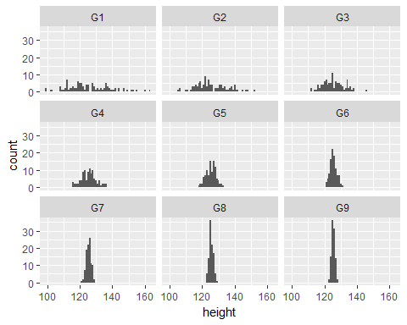

#Problem 8  
  
 #Problem 8.a  
  
prettyvec <- function(filename) {  
 iris <- readLines(con = filename)  
 iris <- iris[-c(1:2, length(iris))] #remove first 2 lines and blank last line  
 indices <- grep(pattern = "\\s", iris)  
  
 iris <- iris[-c(indices-1)] #remove blank lines  
 indices <- grep(pattern = "\\s", iris)  
  
 final <- as.list(rep(NA, length(indices)))  
 for (i in 1:length(indices)) {  
 grpsize <- strsplit(x = iris[indices[i]], split = "=")  
 final[[i]] <- rep(i-1, grpsize[[1]][2])  
 }  
  
 finalvec <- unlist(final)  
 iris <- iris[-c(indices)]  
  
 finaldf <- as.data.frame(cbind(finalvec, iris))  
 names(finaldf) <- c("group", "observation")  
 return(finaldf)  
}  
  
 #Problem 8.b  
prettyvec("Iris1.out")

## group observation  
## 1 0 100  
## 2 0 102  
## 3 0 103  
## 4 0 104  
## 5 0 105  
## 6 0 107  
## 7 0 108  
## 8 0 109  
## 9 0 110  
## 10 0 111  
## 11 0 112  
## 12 0 114  
## 13 0 115  
## 14 0 116  
## 15 0 117  
## 16 0 118  
## 17 0 120  
## 18 0 122  
## 19 0 124  
## 20 0 125  
## 21 0 128  
## 22 0 129  
## 23 0 130  
## 24 0 131  
## 25 0 132  
## 26 0 134  
## 27 0 135  
## 28 0 136  
## 29 0 137  
## 30 0 139  
## 31 0 140  
## 32 0 141  
## 33 0 143  
## 34 0 144  
## 35 0 145  
## 36 0 147  
## 37 0 148  
## 38 1 0  
## 39 1 1  
## 40 1 2  
## 41 1 3  
## 42 1 4  
## 43 1 5  
## 44 1 6  
## 45 1 7  
## 46 1 8  
## 47 1 9  
## 48 1 10  
## 49 1 11  
## 50 1 12  
## 51 1 13  
## 52 1 14  
## 53 1 15  
## 54 1 16  
## 55 1 17  
## 56 1 18  
## 57 1 19  
## 58 1 20  
## 59 1 21  
## 60 1 22  
## 61 1 23  
## 62 1 24  
## 63 1 25  
## 64 1 26  
## 65 1 27  
## 66 1 28  
## 67 1 29  
## 68 1 30  
## 69 1 31  
## 70 1 32  
## 71 1 33  
## 72 1 34  
## 73 1 35  
## 74 1 36  
## 75 1 37  
## 76 1 38  
## 77 1 39  
## 78 1 40  
## 79 1 41  
## 80 1 42  
## 81 1 43  
## 82 1 44  
## 83 1 45  
## 84 1 46  
## 85 1 47  
## 86 1 48  
## 87 1 49  
## 88 2 50  
## 89 2 51  
## 90 2 52  
## 91 2 53  
## 92 2 54  
## 93 2 55  
## 94 2 56  
## 95 2 57  
## 96 2 58  
## 97 2 59  
## 98 2 60  
## 99 2 61  
## 100 2 62  
## 101 2 63  
## 102 2 64  
## 103 2 65  
## 104 2 66  
## 105 2 67  
## 106 2 68  
## 107 2 69  
## 108 2 70  
## 109 2 71  
## 110 2 72  
## 111 2 73  
## 112 2 74  
## 113 2 75  
## 114 2 76  
## 115 2 77  
## 116 2 78  
## 117 2 79  
## 118 2 80  
## 119 2 81  
## 120 2 82  
## 121 2 83  
## 122 2 84  
## 123 2 85  
## 124 2 86  
## 125 2 87  
## 126 2 88  
## 127 2 89  
## 128 2 90  
## 129 2 91  
## 130 2 92  
## 131 2 93  
## 132 2 94  
## 133 2 95  
## 134 2 96  
## 135 2 97  
## 136 2 98  
## 137 2 99  
## 138 2 101  
## 139 2 106  
## 140 2 113  
## 141 2 119  
## 142 2 121  
## 143 2 123  
## 144 2 126  
## 145 2 127  
## 146 2 133  
## 147 2 138  
## 148 2 142  
## 149 2 146  
## 150 2 149

prettyvec("Iris2.out")

## group observation  
## 1 0 50  
## 2 0 51  
## 3 0 52  
## 4 0 53  
## 5 0 54  
## 6 0 55  
## 7 0 56  
## 8 0 57  
## 9 0 58  
## 10 0 59  
## 11 0 60  
## 12 0 61  
## 13 0 62  
## 14 0 63  
## 15 0 64  
## 16 0 65  
## 17 0 66  
## 18 0 67  
## 19 0 68  
## 20 0 69  
## 21 0 70  
## 22 0 71  
## 23 0 72  
## 24 0 73  
## 25 0 74  
## 26 0 75  
## 27 0 76  
## 28 0 77  
## 29 0 78  
## 30 0 79  
## 31 0 80  
## 32 0 81  
## 33 0 82  
## 34 0 83  
## 35 0 84  
## 36 0 85  
## 37 0 86  
## 38 0 87  
## 39 0 88  
## 40 0 89  
## 41 0 90  
## 42 0 91  
## 43 0 92  
## 44 0 93  
## 45 0 94  
## 46 0 95  
## 47 0 96  
## 48 0 97  
## 49 0 98  
## 50 0 99  
## 51 0 100  
## 52 0 101  
## 53 0 102  
## 54 0 103  
## 55 0 104  
## 56 0 105  
## 57 0 106  
## 58 0 107  
## 59 0 108  
## 60 0 109  
## 61 0 110  
## 62 0 111  
## 63 0 112  
## 64 0 113  
## 65 0 114  
## 66 0 115  
## 67 0 116  
## 68 0 117  
## 69 0 118  
## 70 0 119  
## 71 0 120  
## 72 0 121  
## 73 0 122  
## 74 0 123  
## 75 0 124  
## 76 0 125  
## 77 0 126  
## 78 0 127  
## 79 0 128  
## 80 0 129  
## 81 0 130  
## 82 0 131  
## 83 0 132  
## 84 0 133  
## 85 0 134  
## 86 0 135  
## 87 0 136  
## 88 0 137  
## 89 0 138  
## 90 0 139  
## 91 0 140  
## 92 0 141  
## 93 0 142  
## 94 0 143  
## 95 0 144  
## 96 0 145  
## 97 0 146  
## 98 0 147  
## 99 0 148  
## 100 0 149  
## 101 1 0  
## 102 1 1  
## 103 1 2  
## 104 1 3  
## 105 1 4  
## 106 1 5  
## 107 1 6  
## 108 1 7  
## 109 1 8  
## 110 1 9  
## 111 1 10  
## 112 1 11  
## 113 1 12  
## 114 1 13  
## 115 1 14  
## 116 1 15  
## 117 1 16  
## 118 1 17  
## 119 1 18  
## 120 1 19  
## 121 1 20  
## 122 1 21  
## 123 1 22  
## 124 1 23  
## 125 1 24  
## 126 1 25  
## 127 1 26  
## 128 1 27  
## 129 1 28  
## 130 1 29  
## 131 1 30  
## 132 1 31  
## 133 1 32  
## 134 1 33  
## 135 1 34  
## 136 1 35  
## 137 1 36  
## 138 1 37  
## 139 1 38  
## 140 1 39  
## 141 1 40  
## 142 1 41  
## 143 1 42  
## 144 1 43  
## 145 1 44  
## 146 1 45  
## 147 1 46  
## 148 1 47  
## 149 1 48  
## 150 1 49