Prob5.R

Audrey McCombs

Fri Nov 10 22:02:51 2017

#Problem 5  
op <- par()  
  
#Problem 5.a  
polaroid <- function(x) {  
 p <- length(x)  
 r <- sqrt(sum(x^2))  
   
 theta <- rep(0, p-1)  
 den <- rep(0, p-2)  
   
 theta[1] <- acos(x[1]/r)  
 den[1] <- r  
   
 for (i in 2:(p-1)) {  
 den[i] <- den[i-1] * sin(theta[i-1])  
 theta[i] <- acos(x[i]/den[i])  
 }  
   
 polar <- c(r, theta)  
 return(polar)  
}  
  
x <- seq(from = 0, to = 10, by = 2)  
polaroid(x)

## [1] 14.8323970 1.5707963 1.4355444 1.2951535 1.1326473 0.8960554

#Problem 5.b  
normalize <- function(vec) {  
 den <- sqrt(sum(vec^2))  
 output <- vec/den  
}  
  
#Problem 5.c  
y <- matrix(rnorm(5000, mean = 0, sd = 1), nrow = 1000, ncol = 5)  
zt <- apply(y, 1, normalize)  
z <- t(zt)  
  
ks.test(z,"punif",min=-1,max=1)

##   
## One-sample Kolmogorov-Smirnov test  
##   
## data: z  
## D = 0.099436, p-value < 2.2e-16  
## alternative hypothesis: two-sided

hist(z)

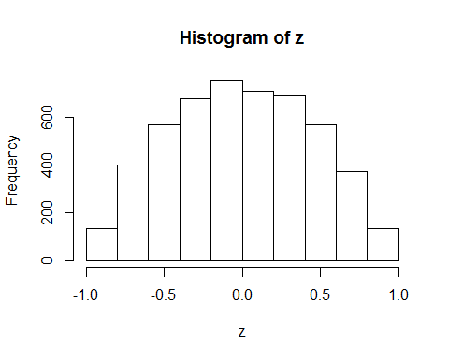

#Based on the Kolmogorov–Smirnov test, the z matrix is not uniformly distributed. We can see this clearly in the histogram of values in the matrix.  
  
#Problem 5.d  
polarst <- apply(y, 1, polaroid)  
polars <- t(polarst)  
  
ks.test(polars[,1]^2, "pchisq", 5)

##   
## One-sample Kolmogorov-Smirnov test  
##   
## data: polars[, 1]^2  
## D = 0.026994, p-value = 0.4598  
## alternative hypothesis: two-sided

boxplot(polars[,2:5])

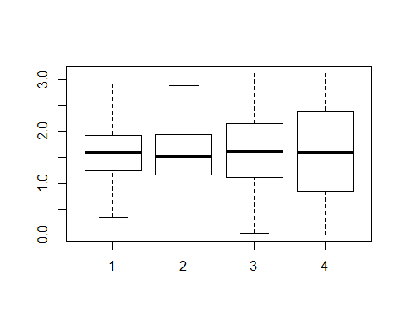

ks.test(polars[,2], "punif", min = 0, max = 2*pi)

##   
## One-sample Kolmogorov-Smirnov test  
##   
## data: polars[, 2]  
## D = 0.57589, p-value < 2.2e-16  
## alternative hypothesis: two-sided

ks.test(polars[,3], "punif", min = 0, max = pi)

##   
## One-sample Kolmogorov-Smirnov test  
##   
## data: polars[, 3]  
## D = 0.17876, p-value < 2.2e-16  
## alternative hypothesis: two-sided

ks.test(polars[,4], "punif", min = 0, max = pi)

##   
## One-sample Kolmogorov-Smirnov test  
##   
## data: polars[, 4]  
## D = 0.11135, p-value = 3.403e-11  
## alternative hypothesis: two-sided

ks.test(polars[,5], "punif", min = 0, max = pi)

##   
## One-sample Kolmogorov-Smirnov test  
##   
## data: polars[, 5]  
## D = 0.024207, p-value = 0.6012  
## alternative hypothesis: two-sided

#Multiple distributions  
par(mfrow = c(3,3))  
for (i in 1:9) {  
 y <- matrix(rnorm(5000, mean = 0, sd = 1), nrow = 1000, ncol = 5)  
 zt <- apply(y, 1, normalize)  
 z <- t(zt)  
 polarst <- apply(y, 1, polaroid)  
 polars <- t(polarst)  
 boxplot(polars[,2:5])  
}

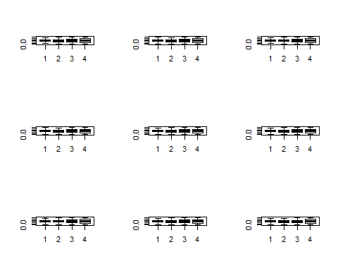

par(op)

## Warning in par(op): graphical parameter "cin" cannot be set

## Warning in par(op): graphical parameter "cra" cannot be set

## Warning in par(op): graphical parameter "csi" cannot be set

## Warning in par(op): graphical parameter "cxy" cannot be set

## Warning in par(op): graphical parameter "din" cannot be set

## Warning in par(op): graphical parameter "page" cannot be set