

**الجُمْهُورِيّةُ اَلْعَرَبِيَّةُ اَلسُّورِيَّة**

**وِزَارَةُ التَّعْلِيمِ الْعَالِيْ وَاَلْبَحث العِلْمِيْ**

**جَامِعَةُ تِشرِيْن - السَّنَة الخَامِسَة**

**كِليّة الهَندَسةِ الميكانِيكيّة والكَهرَبَائِيَّة**

**هَنْدَسَةُ الاِتّصَالَاتِ وَالاِلكترُونِيّاتْ**

**العَام الدّراسِي**

**2023 - 2024**

**1444 - 1445**

**المقداد بسّام مسلّم**

**الرّقم الجَامِعِيْ: 2825**

**إعدَادْ وَتَقدِيمْ:**

**إِشْرَافْ:**

**الدّكتور المُهَندِسْ مُهنّد عِيسَى**

**First Network Programming Homework**

**Question 1: Python Basic**

**A: If you have two lists, L1=[‘HTTP’,’HTTPS’,’FTP’,’DNS’] L2=[80,443,21,53], convert it to generate this dictionary d={‘HTTP’:80,’HTTPS’:443,’FTP’:21,’DNS’:53 } .**

**Solve:**

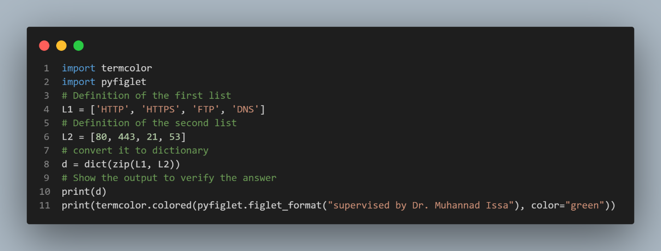

**Output:**

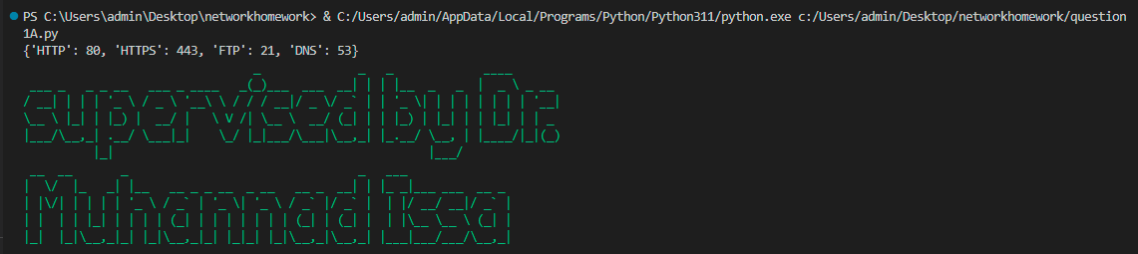

**Explanation:**

The zip function is used to pair the corresponding elements from the previous two lists and then convert the resulting pairs into a dictionary named "d".

**Python File Name:**

**question1A.py**

**....................................................................................................................**

**B: Write a Python program that calculates the factorial of a given number entered by user.**

**Solve:**

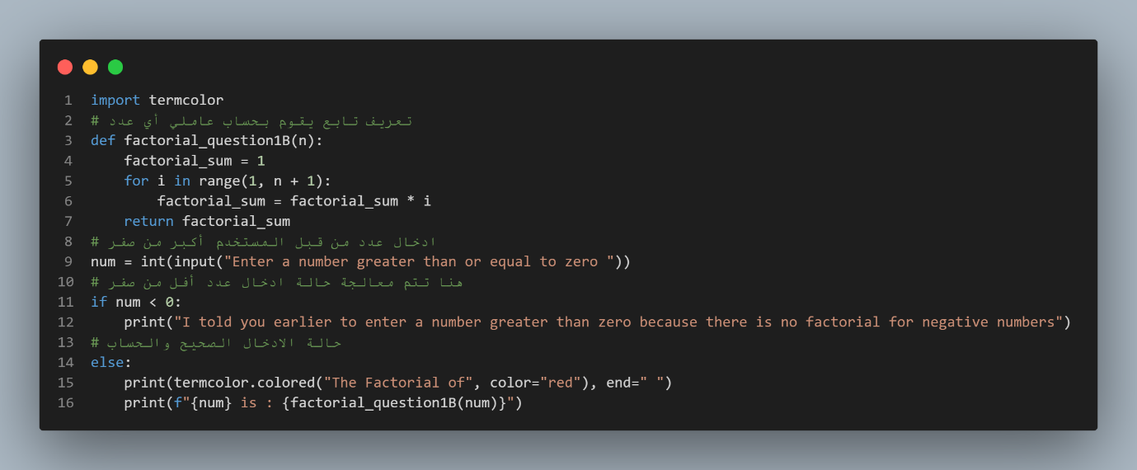

**Output:**

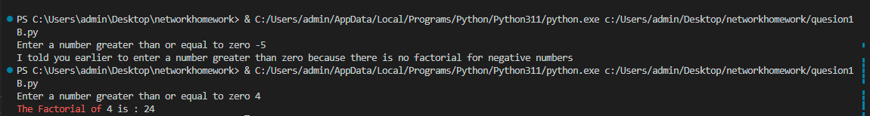

**Explanation:**

Using range makes us very comfortable with the ability to pass through numbers from one up to the entered number.

It is worth noting that the end of range increases the entered number by one digit because its mechanism of action is to reach the number that precedes the end of its definition.

**Python File Name:**

**question1B.py**

**....................................................................................................................**

**C: L=[‘Network’ , ’Bio’ , ’Programming’, ‘Physics’ , ‘Music’] In this exercise, you will implement a Python program that reads the items of the previous list and identifies the items that starts with ‘B’ letter, then print it on screen.**

**Tips: using loop, ‘len ()’ , startswith() methods.**

**Solve:**

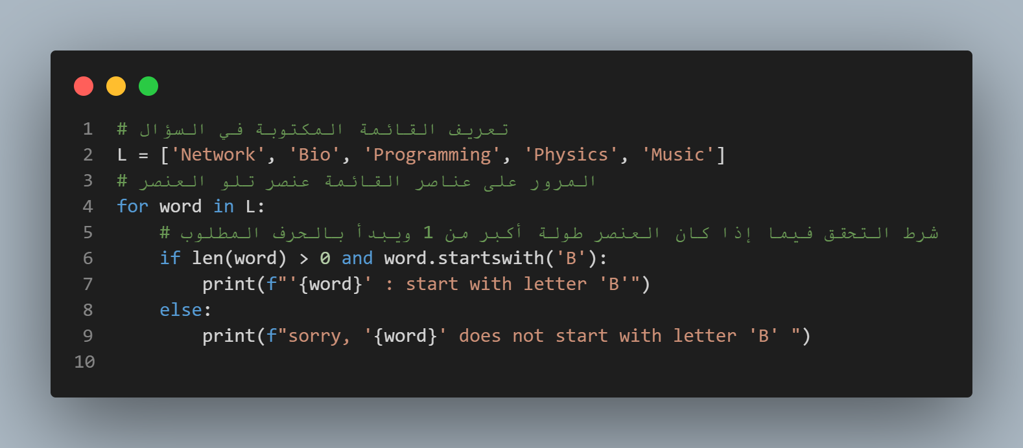

**Output:**

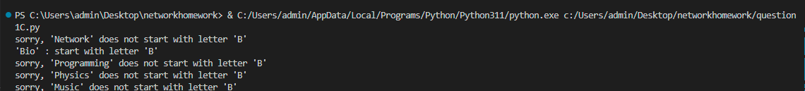

**Explanation:**

We Define the list, then go through its elements through a loop, then check for the presence of an element that begins with the letter B, then print it. If it does not exist, we print a message that it does not exist.

**Python File Name:**

**question1C.py**

**....................................................................................................................**

**D: Using Dictionary comprehension, Generate this dictionary d={0:1,1:2,2:3,3:4,4:5,5:6,6:7,7:8,8:9,9:10,10:11}**

**Solve:**

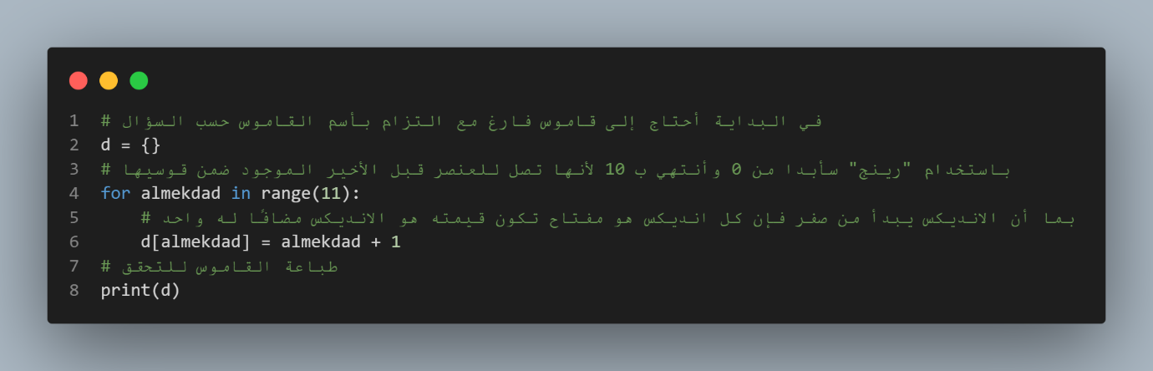

**Output:**



**Explanation:**

The solution to the question is explained in the first image within the code, which indicates an understanding of dictionaries.

**Python File Name:**

**question1D.py**

**....................................................................................................................**

**Question 2: Convert From Binary To Decimal PAGE 1 / 1**

**Write a Python program that converts a Binary number into its equivalent Decimal number.**

**The program should start reading the binary number from the user. Then the decimal equivalent number must be calculated.**

**Finally, the program must display the equivalent decimal number on the screen.**

**Solve:**

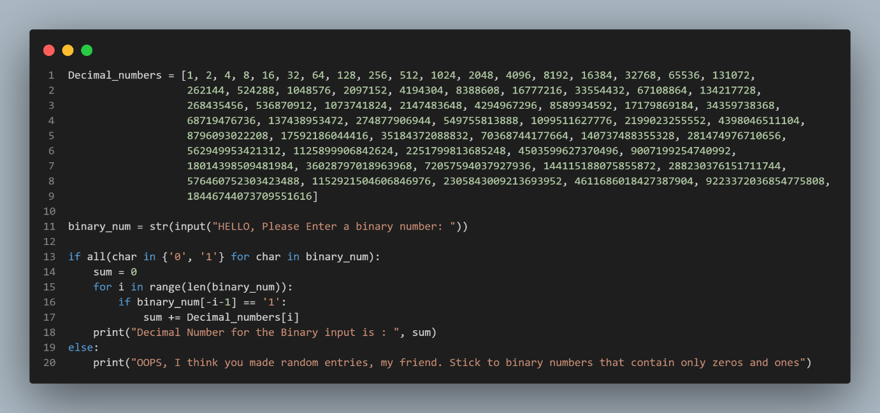

**Output:**



**Explanation:**

A list containing numbers from 1 to multiples of one was defined because the solution method is not similar to anyone and because it is the traditional method used in mental arithmetic, A value is entered by the user and read as text We check that the text is composed of zeros and ones After that, we start from the right of the text and multiply each character after converting it to a number by its counterpart from the matrix of decimal numbers from the left.

**Python File Name:**

**question2.py**

**....................................................................................................................**

**Question 3: Working With Files "Quiz Program" PAGE 1 / 3**

**Type python quiz program that takes a text or json or csv file as input for (20(Questions-Answers)).**

**It asks the questions and finally computes and prints user results and store user name and result in separate file csv or json file.**

**Solve:**

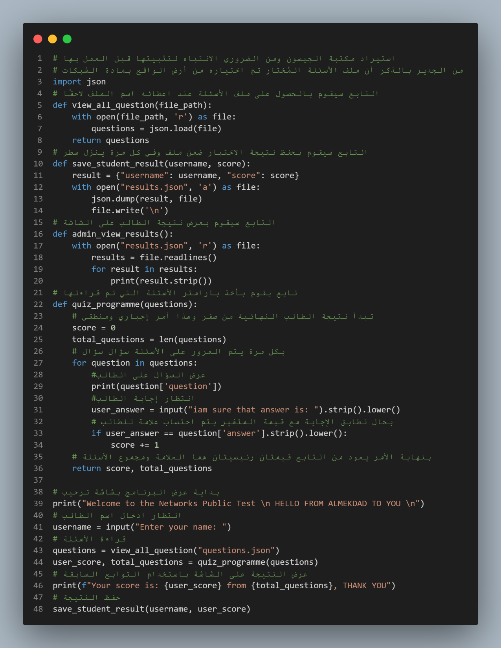

**Question 3: Working With Files "Quiz Program" PAGE 2 / 3**

**Output:**

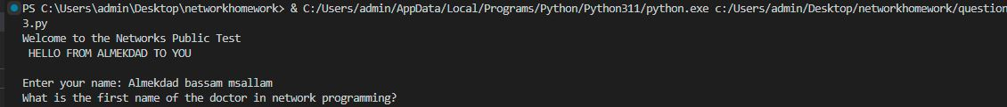

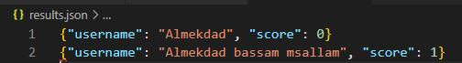

**Explanation:**

The explanation has been written on the pictures and a screenshot of the Jason file will be attached.

Note that the questions were written manually and they talk about the network programming subject at Tishreen University under the supervision of Dr. Muhannad Issa.

**Question 3: Working With Files "Quiz Program" PAGE 3 / 3**

**Questions json file:**

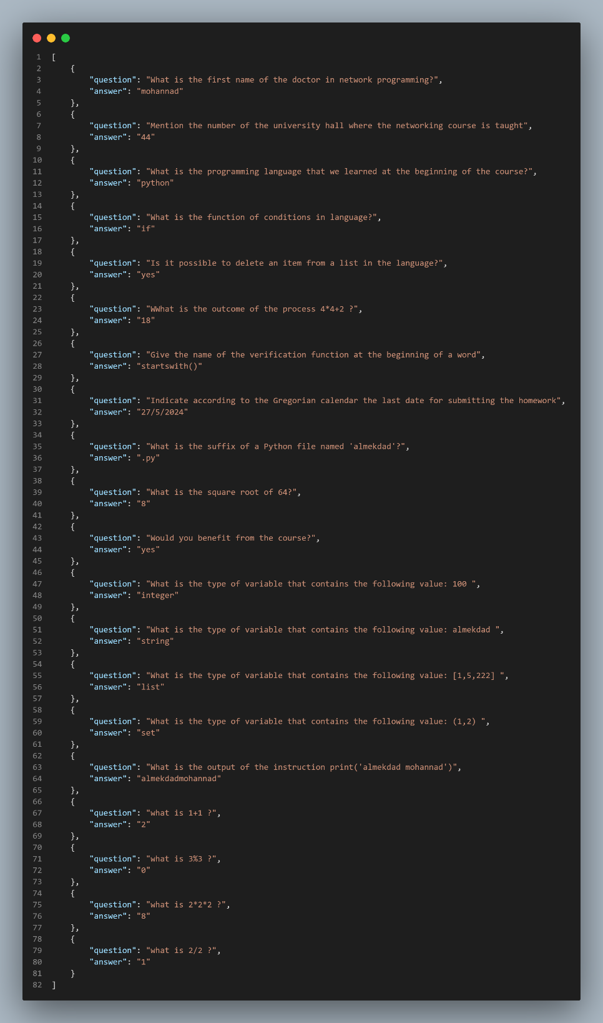

**Python File Name:**

**question3.py**

**....................................................................................................................**

**Question 4: Object-Oriented Programming - Bank Class PAGE 1 / 2**

**Define a class BankAccount with the following attributes and methods:**

**Attributes: account_number (string), account_holder (string), balance (float, initialized to 0.0) Methods:deposit(amount), withdraw(amount) , get_balance()**

**- Create an instance of BankAccount,- Perform a deposit of $1000, - Perform a withdrawal of $500.**

**- Print the current balance after each operation.**

**- Define a subclass SavingsAccount that inherits from BankAccount and adds interest_rate Attribute and apply_interest() method that Applies interest to the balance based on the interest rate. And Override print() method to print the current balance and rate.**

**- Create an instance of SavingsAccount , and call apply_interest() and print() functions.**

**Solve:**

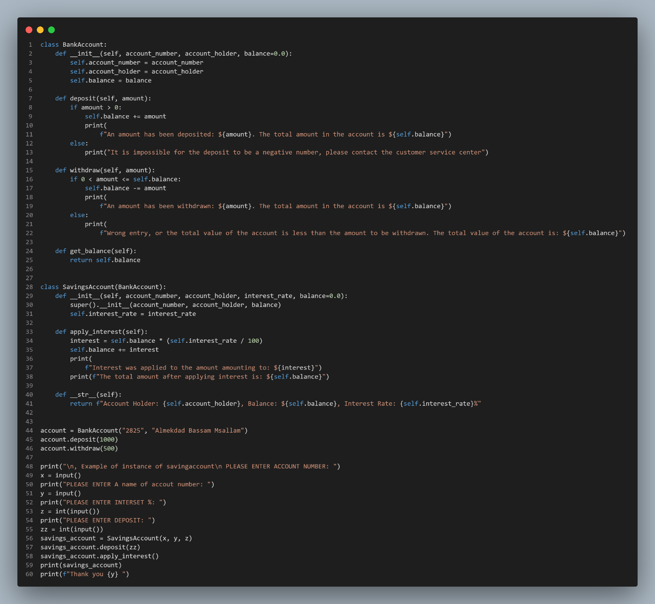

**Question 4: Object-Oriented Programming - Bank Class PAGE 2 / 2**

**Output:**

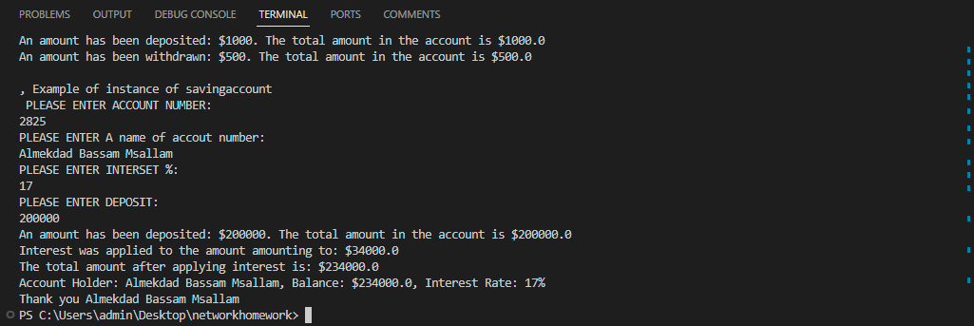

**Explanation:**

The deposit tracker takes the value of the deposit amount and checks whether the amount entered is a positive value. If it is a positive value, it is added to the total account.

The withdrawal follower takes the value of the withdrawal amount and checks whether the amount to be withdrawn is a lower value or settles the amount in the total account, otherwise an error message appears.

The interest calculation function is a simple function, just multiply the value of the entered amount by the interest value as a percentage and return the value.

There are only examples, and the possibility of user-made choices as a form of better and more durable code could be added.

**Python File Name:**

**question4.py**

**....................................................................................................................**

