Звіт

Автор: Пумня О., КІТ118Б

Дата: 02.03.2020

Лабораторна робота №16

РОЗРОБКА ГРАФІЧНОГО ІНТЕРФЕЙСУ КОРИСТУВАЧА

**Мета.** Придбання навичок використання засобів клієнтських технологій (Client Technologies) платформи Java SE.

**Вимоги:**

Розробити графічний інтерфейс користувача для програми рішення попередньої лабораторної роботи з використанням засобів JavaFX.

ОПИС ПРОГРАМИ

**Ієрархія та структура класів**

Pumnya16 – Точка входу в програму

EventSheduler – Клас, що реалізує захід

Util – Утилітарний клас

FXMLController – Абстрактний клас-контролер

GreetingPageController – Клас-контролер сторінки-вітання

MainPageController – Клас контролер головної сторінки

AboutPageController – Клас контролер сторінки «About»

ТЕКСТ ПРОГРАМИ

**Текст файлу Pumnya16.java**

package labs.pumnya16;

import javafx.fxml.FXMLLoader;

import javafx.scene.Scene;

import javafx.scene.image.Image;

import javafx.application.Application;

import javafx.collections.FXCollections;

import javafx.collections.ObservableList;

import javafx.stage.Modality;

import javafx.stage.Stage;

import labs.pumnya16.Model.EventScheduler;

import labs.pumnya16.Util.Util;

import labs.pumnya16.View.AboutPageController;

import labs.pumnya16.View.GreetingPageController;

import labs.pumnya16.View.MainPageController;

import java.io.IOException;

import java.util.ArrayList;

public class Pumnya16 extends Application {

private Stage primaryStage;

private ObservableList<EventScheduler> eventData = FXCollections.observableArrayList();

public ObservableList<EventScheduler> getEventData() {

return this.eventData;

}

public void setEventData(ArrayList<EventScheduler> list) {

this.eventData.clear();

this.eventData.addAll(list);

}

public Stage getPrimaryStage() {

return this.primaryStage;

}

public Pumnya16() {

eventData.add(new EventScheduler("01.01.1111", "01:01", 1, "Первое место.", "Первое описание!", "А. Бук"));

eventData.add(new EventScheduler("02.02.2222", "02:02", 2, "Второе место!", "Второе описание?", "Б. Вук"));

eventData.add(new EventScheduler("03.03.3333", "03:03", 3, "Третье место?", "Третье описание.", "В. Гук"));

Util.setMain(this);

}

@Override

public void start(Stage stage) throws Exception {

primaryStage = stage;

primaryStage.setTitle("Event Scheduler");

primaryStage.setResizable(false);

primaryStage.getIcons().add(new Image(Pumnya16.class.getResourceAsStream("Content/EventScheduler.png")));

initGreetingPage();

}

public static void main(String[] args) {

launch();

}

public void initGreetingPage() {

try {

FXMLLoader loader = new FXMLLoader();

loader.setLocation(Pumnya16.class.getResource("View/GreetingPage.fxml"));

primaryStage.setScene(new Scene(loader.load()));

GreetingPageController controller = loader.getController();

controller.setMain(this);

primaryStage.show();

} catch (IOException e) {

e.printStackTrace();

}

}

public void showMainPage() {

try {

FXMLLoader loader = new FXMLLoader();

loader.setLocation(Pumnya16.class.getResource("View/MainPage.fxml"));

primaryStage.setScene(new Scene(loader.load()));

MainPageController controller = loader.getController();

controller.setMain(this);

controller.setTableItems(this.getEventData());

primaryStage.show();

} catch (IOException e) {

e.printStackTrace();

}

}

public void showAboutPage() {

try {

FXMLLoader loader = new FXMLLoader();

loader.setLocation(Pumnya16.class.getResource("View/AboutPage.fxml"));

Stage dialogStage = new Stage();

dialogStage.setTitle("About");

dialogStage.setScene(new Scene(loader.load()));

dialogStage.initModality(Modality.WINDOW_MODAL);

dialogStage.initOwner(primaryStage);

dialogStage.setResizable(false);

dialogStage.getIcons().add(new Image(Pumnya16.class.getResourceAsStream("Content/about.png")));

AboutPageController controller = loader.getController();

controller.setMain(this);

controller.setDialogStage(dialogStage);

dialogStage.show();

} catch (IOException e) {

e.printStackTrace();

}

}

}

**Текст файлу EventScheduler.java**

package labs.pumnya16.Model;

import javafx.beans.property.*;

import java.io.IOException;

import java.io.ObjectInputStream;

import java.io.ObjectOutputStream;

import java.io.Serializable;

import java.text.ParseException;

import java.text.SimpleDateFormat;

import java.util.regex.Matcher;

import java.util.regex.Pattern;

public class EventScheduler implements Serializable {

private static final long serialVersionUID = -4232419163919693876L;

private transient StringProperty date;

private transient StringProperty time;

private transient StringProperty venue;

private transient StringProperty description;

private transient FloatProperty duration;

private transient StringProperty organizer;

public EventScheduler(String date, String time, float dur, String venue, String descr, String organizer) {

this.date = new SimpleStringProperty(date);

this.time = new SimpleStringProperty(time);

this.venue = new SimpleStringProperty(venue);

this.description = new SimpleStringProperty(descr);

this.organizer = new SimpleStringProperty(organizer);

this.duration = new SimpleFloatProperty(dur);

}

public EventScheduler() {

}

public final StringProperty getDateProperty() {

return this.date;

}

public final String getDate() {

return this.date.get();

}

public final void setDate(final String date) {

if (checkDate(date)) {

this.date.setValue(date);

}

}

public final StringProperty getTimeProperty() {

return this.time;

}

public final String getTime() {

return time.get();

}

public final void setTime(final String time) {

if (checkTime(time)) {

this.time.setValue(time);

}

}

public final StringProperty getVenueProperty() {

return this.venue;

}

public final String getVenue() {

return this.venue.get();

}

public final void setVenue(final String venue) {

if (checkVenue(venue)) {

this.venue.setValue(venue);

}

}

public final StringProperty getDescriptionProperty() {

return this.description;

}

public final String getDescription() {

return this.description.get();

}

public final void setDescription(final String descr) {

if (checkDescription(descr)) {

this.description.setValue(descr);

}

}

public final FloatProperty getDurationProperty() {

return this.duration;

}

public final float getDuration() {

return this.duration.get();

}

public final void setDuration(final Float duration) {

if (checkDuration(duration)) {

this.duration.setValue(duration);

}

}

public final StringProperty getOrganizerProperty() {

return this.organizer;

}

public final String getOrganizer() {

return this.organizer.get();

}

public final void setOrganizer(final String organizer) {

if (checkName(organizer)) {

this.organizer.setValue(organizer);

}

}

private void writeObject(ObjectOutputStream s) throws IOException {

s.defaultWriteObject();

s.writeUTF(getDate());

s.writeUTF(getTime());

s.writeUTF(getDescription());

s.writeUTF(getOrganizer());

s.writeUTF(getVenue());

s.writeFloat(getDuration());

}

private void readObject(ObjectInputStream s) throws IOException, ClassNotFoundException {

date = new SimpleStringProperty(s.readUTF());

time = new SimpleStringProperty(s.readUTF());

description = new SimpleStringProperty(s.readUTF());

organizer = new SimpleStringProperty(s.readUTF());

venue = new SimpleStringProperty(s.readUTF());

duration = new SimpleFloatProperty(s.readFloat());

}

public static boolean checkDate(final String d) {

if (d == null) {

return false;

}

final String df = "dd.MM.yyyy";

try {

SimpleDateFormat sdf = new SimpleDateFormat(df);

sdf.setLenient(false);

sdf.parse(d);

return true;

} catch (ParseException e) {

return false;

}

}

public static boolean checkTime(final String time) {

if (time == null) {

return false;

}

final String tf = "HH:mm";

try {

SimpleDateFormat sdf = new SimpleDateFormat(tf);

sdf.setLenient(false);

sdf.parse(time);

return true;

} catch (ParseException e) {

return false;

}

}

public static boolean checkVenue(final String venue) {

if (venue == null) {

return false;

}

Pattern pattern = Pattern.compile(

"^[А-Я][а-я]+(\\s[\"<>№]?[А-Я]*[а-я]+[\"<>№]?)*");

Matcher matcher = pattern.matcher(venue);

return matcher.matches();

}

public static boolean checkName(final String name) {

if (name == null) {

return false;

}

Pattern pattern = Pattern.compile("^[А-Я а-я ,.'-]+$");

Matcher matcher = pattern.matcher(name);

return matcher.matches();

}

public static boolean checkDescription(final String desc) {

if (desc == null) {

return false;

}

Pattern pattern = Pattern.compile(

"^[А-Я][а-я]+(\\s[А-Я]*[а-я]+)*");

Matcher matcher = pattern.matcher(desc);

return matcher.matches();

}

public static boolean checkDuration(final Float dur) {

if(dur <= 0) {

return false;

}

return true;

}

@Override

public String toString() {

StringBuilder builder = new StringBuilder();

builder.append("Дата: ").append(this.getDate()).append("\n");

builder.append("Время начала: ").append(

this.getTime()).append("\n");

builder.append("Длительность (часы): ").append(

this.getDuration()).append("\n");

builder.append("Место проведения: ").append(

this.getVenue()).append("\n");

builder.append("Описание: ").append(

this.getDescription()).append("\n");

builder.append("Организатор: ").append(

this.getOrganizer()).append("\n");

return builder.toString();

}

}

**Текст файлу Util.java**

package labs.pumnya16.Util;

import javafx.collections.FXCollections;

import javafx.collections.ObservableList;

import javafx.stage.FileChooser;

import labs.pumnya16.Model.EventScheduler;

import labs.pumnya16.Pumnya16;

import java.io.*;

import java.util.ArrayList;

public class Util {

private Util() {

// empty body

}

private static Pumnya16 main;

public static void setMain(Pumnya16 m) {

main = m;

}

public static void saveToFile() {

FileChooser fileChooser = new FileChooser();

fileChooser.setTitle("Save Resource File");

fileChooser.getExtensionFilters().add(

new FileChooser.ExtensionFilter("Event files", "*.event"));

fileChooser.setInitialDirectory(new File("D:/Programming Projects/Java Projects/pumnya-alex"));

File file = fileChooser.showSaveDialog(main.getPrimaryStage());

if (file != null) {

try {

ObjectOutputStream oos = new ObjectOutputStream(

new FileOutputStream(file.getName()));

oos.writeObject(new ArrayList<>(main.getEventData()));

} catch (IOException e) {

e.printStackTrace();

}

}

}

public static void loadFromFile() {

FileChooser fileChooser = new FileChooser();

fileChooser.setTitle("Open Resource File");

fileChooser.getExtensionFilters().add(

new FileChooser.ExtensionFilter("Event files", "*.event"));

fileChooser.setInitialDirectory(new File("D:/Programming Projects/Java Projects/pumnya-alex"));

File file = fileChooser.showOpenDialog(main.getPrimaryStage());

if (file != null) {

try {

ObjectInputStream ois = new ObjectInputStream(

new FileInputStream(file.getName()));

main.setEventData((ArrayList<EventScheduler>) ois.readObject());

} catch (IOException | ClassNotFoundException e) {

e.printStackTrace();

}

}

}

public static ObservableList<EventScheduler> search(String str) {

ObservableList<EventScheduler> temp = FXCollections.observableArrayList();

for(int i = 0; i < main.getEventData().size(); i++) {

if(searchInItem(main.getEventData().get(i), str)) {

temp.add(main.getEventData().get(i));

}

}

return temp;

}

private static boolean searchInItem(EventScheduler item, String str) {

if(item.getDate().contains(str)) {

return true;

}

if(item.getTime().contains(str)) {

return true;

}

if(item.getVenue().contains(str)) {

return true;

}

if(item.getDescription().contains(str)) {

return true;

}

if(item.getOrganizer().contains(str)) {

return true;

}

if(String.valueOf(item.getDuration()).contains(str)) {

return true;

}

return false;

}

}

**Текст файлу AboutPageController.java**

package labs.pumnya16.View;

import javafx.fxml.FXML;

import javafx.scene.input.KeyCode;

import javafx.scene.input.KeyEvent;

import javafx.stage.Stage;

import java.awt.*;

import java.io.IOException;

import java.net.URI;

import java.net.URISyntaxException;

public class AboutPageController extends FXMLController{

private Stage dialogStage;

public void setDialogStage(Stage stage) {

this.dialogStage = stage;

}

@FXML

public void handleClose() {

this.dialogStage.close();

}

@FXML

public void handleDiscord() {

try {

Desktop.getDesktop().browse(new URI("https://discord.com/users/527049968176070656"));

} catch (IOException | URISyntaxException e1) {

e1.printStackTrace();

}

}

@FXML

public void handleTelegram() {

try {

Desktop.getDesktop().browse(new URI("https://t.me/SiriusQuase"));

} catch (IOException | URISyntaxException e1) {

e1.printStackTrace();

}

}

@FXML

public void handleSkype() {

try {

Desktop.getDesktop().browse(new URI("https://join.skype.com/invite/i6li7fhK7Yqw"));

} catch (IOException | URISyntaxException e1) {

e1.printStackTrace();

}

}

@FXML

public void handleYoutube() {

try {

Desktop.getDesktop().browse(new URI("https://www.youtube.com/channel/UCfrAsAoknyVJtOuWge0ojIg"));

} catch (IOException | URISyntaxException e1) {

e1.printStackTrace();

}

}

@FXML

public void handleExit(KeyEvent keyEvent) {

if(keyEvent.getCode() == KeyCode.ESCAPE) {

this.dialogStage.close();

}

}

}

**Текст файлу AboutPage.fxml**

<?xml version="1.0" encoding="UTF-8"?>

<?import javafx.scene.*?>

<?import javafx.scene.control.*?>

<?import javafx.scene.image.*?>

<?import javafx.scene.layout.*?>

<?import javafx.scene.text.*?>

<AnchorPane fx:id="anchor_pane" onKeyReleased="#handleExit" prefHeight="323.0" prefWidth="640.0" stylesheets="@../Content/sceneStyle.css" xmlns="http://javafx.com/javafx/10.0.2-internal" xmlns:fx="http://javafx.com/fxml/1" fx:controller="labs.pumnya16.View.AboutPageController">

<children>

<ImageView fitHeight="301.0" fitWidth="339.0" layoutX="14.0" layoutY="14.0" pickOnBounds="true" preserveRatio="true">

<image>

<Image url="@../Content/about_photo.jpg" />

</image>

</ImageView>

<ImageView fitHeight="56.0" fitWidth="62.0" layoutX="344.0" layoutY="262.0" onMouseClicked="#handleDiscord" pickOnBounds="true" preserveRatio="true">

<image>

<Image url="@../Content/discord.png" />

</image>

<cursor>

<Cursor fx:constant="HAND" />

</cursor></ImageView>

<ImageView fitHeight="56.0" fitWidth="69.0" layoutX="414.0" layoutY="262.0" onMouseClicked="#handleTelegram" pickOnBounds="true" preserveRatio="true">

<image>

<Image url="@../Content/telegram.png" />

</image>

<cursor>

<Cursor fx:constant="HAND" />

</cursor>

</ImageView>

<ImageView fitHeight="56.0" fitWidth="63.0" layoutX="491.0" layoutY="262.0" onMouseClicked="#handleSkype" pickOnBounds="true" preserveRatio="true">

<image>

<Image url="@../Content/skype.png" />

</image>

<cursor>

<Cursor fx:constant="HAND" />

</cursor>

</ImageView>

<ImageView fitHeight="56.0" fitWidth="74.0" layoutX="562.0" layoutY="262.0" onMouseClicked="#handleYoutube" pickOnBounds="true" preserveRatio="true">

<image>

<Image url="@../Content/youtube.png" />

</image>

<cursor>

<Cursor fx:constant="HAND" />

</cursor>

</ImageView>

<Label layoutX="325.0" layoutY="14.0" prefHeight="63.0" prefWidth="301.0" text="This program was created using Java 13 &amp; JavaFX 14" textAlignment="CENTER" wrapText="true">

<font>

<Font name="Times New Roman Bold" size="24.0" />

</font>

</Label>

<Label layoutX="344.0" layoutY="144.0" text="Platform: Windows">

<font>

<Font name="Times New Roman Bold" size="18.0" />

</font>

</Label>

<Label layoutX="344.0" layoutY="175.5" text="Version: 1.0">

<font>

<Font name="Times New Roman Bold" size="18.0" />

</font>

</Label>

<Label layoutX="344.0" layoutY="207.0" text="Author: Pumnya Alex">

<font>

<Font name="Times New Roman Bold" size="18.0" />

</font>

</Label>

<Label layoutX="422.0" layoutY="234.0" text="Contact me">

<font>

<Font name="Times New Roman Bold" size="24.0" />

</font>

</Label>

<Button layoutX="427.0" layoutY="87.0" mnemonicParsing="false" onAction="#handleClose" prefHeight="38.0" prefWidth="85.0" text="Close">

<font>

<Font name="Comic Sans MS Bold" size="18.0" />

</font>

</Button>

</children>

</AnchorPane>

**Текст файлу GreetingPageController.java**

package labs.pumnya16.View;

import javafx.fxml.FXML;

import javafx.scene.control.Button;

public class GreetingPageController extends FXMLController {

@FXML

private Button startButton;

@FXML

private void handleStart() {

getMain().showMainPage();

}

}

**Текст файлу GreetingPage.fxml**

<?xml version="1.0" encoding="UTF-8"?>

<?import javafx.scene.control.*?>

<?import javafx.scene.layout.*?>

<?import javafx.scene.text.*?>

<AnchorPane fx:id="anchor_pane" prefHeight="500" prefWidth="800" stylesheets="@../Content/sceneStyle.css" xmlns="http://javafx.com/javafx/10.0.2-internal" xmlns:fx="http://javafx.com/fxml/1" fx:controller="labs.pumnya16.View.GreetingPageController">

<children>

<Label ellipsisString="" layoutX="66.0" layoutY="70.0" text="Welcome to the Event Scheduler">

<font>

<Font name="Times New Roman Bold" size="48.0" />

</font>

</Label>

<Button fx:id="startButton" layoutX="342.0" layoutY="397.0" mnemonicParsing="false" onAction="#handleStart" text="START">

<font>

<Font name="Comic Sans MS" size="24.0" />

</font>

</Button>

<Label layoutX="103.0" layoutY="136.0" prefHeight="94.0" prefWidth="593.0" text="Here you can manipulate your events by the following actions:" textAlignment="CENTER" wrapText="true">

<font>

<Font name="Times New Roman Bold" size="36.0" />

</font>

</Label>

<Label layoutX="103.0" layoutY="249.0" text="○ Create new events">

<font>

<Font name="Times New Roman Bold" size="28.0" />

</font>

</Label>

<Label layoutX="103.0" layoutY="297.0" text="○ Delete events">

<font>

<Font name="Times New Roman Bold" size="28.0" />

</font>

</Label>

<Label layoutX="470.0" layoutY="297.0" text="○ View events data">

<font>

<Font name="Times New Roman Bold" size="28.0" />

</font>

</Label>

<Label layoutX="470.0" layoutY="249.0" text="○ Sort events">

<font>

<Font name="Times New Roman Bold" size="28.0" />

</font>

</Label>

<Label layoutX="329.0" layoutY="340.0" text="And more...">

<font>

<Font name="Times New Roman Bold" size="28.0" />

</font>

</Label>

</children>

</AnchorPane>

**Текст файлу MainPageController.java**

package labs.pumnya16.View;

import javafx.collections.ObservableList;

import javafx.fxml.FXML;

import javafx.scene.control.Alert;

import javafx.scene.control.TableColumn;

import javafx.scene.control.TableView;

import javafx.scene.control.TextField;

import javafx.scene.control.cell.PropertyValueFactory;

import javafx.scene.control.cell.TextFieldTableCell;

import javafx.scene.input.MouseButton;

import javafx.scene.input.MouseEvent;

import javafx.stage.Modality;

import javafx.util.StringConverter;

import labs.pumnya16.Model.EventScheduler;

import labs.pumnya16.Util.Util;

public class MainPageController extends FXMLController {

@FXML

public TextField searchField;

@FXML

private TextField dateField;

@FXML

private TextField timeField;

@FXML

private TextField durationField;

@FXML

private TextField venueField;

@FXML

private TextField descrField;

@FXML

private TextField organizerField;

@FXML

private TableView<EventScheduler> tableView;

@FXML

private TableColumn<EventScheduler, String> dateCol;

@FXML

private TableColumn<EventScheduler, String> timeCol;

@FXML

private TableColumn<EventScheduler, Float> durationCol;

@FXML

private TableColumn<EventScheduler, String> venueCol;

@FXML

private TableColumn<EventScheduler, String> descrCol;

@FXML

private TableColumn<EventScheduler, String> organizerCol;

private EventScheduler selectedColumn;

@FXML

public void handleOpen() {

Util.loadFromFile();

setTableItems(getMain().getEventData());

}

@FXML

public void handleSave() {

Util.saveToFile();

}

@FXML

public void handleExit() {

getMain().getPrimaryStage().close();

}

@FXML

public void handleExitButton() {

getMain().getPrimaryStage().close();

}

@FXML

public void handleAbout() {

getMain().showAboutPage();

}

@FXML

public void handleAdd() {

if(isInputValid()) {

getMain().getEventData().add(new EventScheduler(

dateField.getText(), timeField.getText(), Float.parseFloat(durationField.getText()),

venueField.getText(), descrField.getText(), organizerField.getText()));

}

dateField.clear();

timeField.clear();

venueField.clear();

descrField.clear();

durationField.clear();

organizerField.clear();

setTableItems(getMain().getEventData());

}

@FXML

public void handleClear() {

getMain().getEventData().clear();

setTableItems(getMain().getEventData());

}

@FXML

public void handleDelete() {

getMain().getEventData().remove(getSelectedColumn());

setTableItems(getMain().getEventData());

}

@FXML

public void handleTextInput() {

if(searchField.getText().length() == 0) {

setTableItems(getMain().getEventData());

} else {

ObservableList<EventScheduler> temp = Util.search(searchField.getText());

setTableItems(temp);

}

}

@FXML

public void handleSaveButton() {

Util.saveToFile();

}

@FXML

public void handleLoadButton() {

Util.loadFromFile();

setTableItems(getMain().getEventData());

}

@FXML

public void handleDateChange(TableColumn.CellEditEvent<EventScheduler, String> t) {

t.getTableView().getItems().get(t.getTablePosition().getRow()).setDate(t.getNewValue());

}

@FXML

public void handleTimeChange(TableColumn.CellEditEvent<EventScheduler, String> t) {

t.getTableView().getItems().get(t.getTablePosition().getRow()).setTime(t.getNewValue());

}

@FXML

public void handleVenueChange(TableColumn.CellEditEvent<EventScheduler, String> t) {

t.getTableView().getItems().get(t.getTablePosition().getRow()).setVenue(t.getNewValue());

}

@FXML

public void handleDescrChange(TableColumn.CellEditEvent<EventScheduler, String> t) {

t.getTableView().getItems().get(t.getTablePosition().getRow()).setDescription(t.getNewValue());

}

@FXML

public void handleOrganizerChange(TableColumn.CellEditEvent<EventScheduler, String> t) {

t.getTableView().getItems().get(t.getTablePosition().getRow()).setOrganizer(t.getNewValue());

}

@FXML

public void handleDurationChange(TableColumn.CellEditEvent<EventScheduler, Float> t) {

t.getTableView().getItems().get(t.getTablePosition().getRow()).setDuration(t.getNewValue());

}

@FXML

void initialize() {

dateCol.setCellValueFactory(new PropertyValueFactory<>("date"));

dateCol.setCellFactory(TextFieldTableCell.forTableColumn());

timeCol.setCellValueFactory(new PropertyValueFactory<>("time"));

timeCol.setCellFactory(TextFieldTableCell.forTableColumn());

durationCol.setCellValueFactory(new PropertyValueFactory<>("duration"));

durationCol.setCellFactory(TextFieldTableCell.forTableColumn(new StringConverter<>() {

@Override

public String toString(Float value) {

return Float.toString(value);

}

@Override

public Float fromString(String s) {

return Float.parseFloat(s);

}

}));

venueCol.setCellValueFactory(new PropertyValueFactory<>("venue"));

venueCol.setCellFactory(TextFieldTableCell.forTableColumn());

descrCol.setCellValueFactory(new PropertyValueFactory<>("description"));

descrCol.setCellFactory(TextFieldTableCell.forTableColumn());

organizerCol.setCellValueFactory(new PropertyValueFactory<>("organizer"));

organizerCol.setCellFactory(TextFieldTableCell.forTableColumn());

tableView.setOnMouseClicked((MouseEvent event) -> {

if(event.getButton().equals(MouseButton.PRIMARY)) {

setSelectedColumn(tableView.getSelectionModel().getSelectedItem());

}

});

}

public void setTableItems(ObservableList<EventScheduler> data) {

tableView.setItems(data);

}

private void setSelectedColumn(EventScheduler event) {

selectedColumn = event;

}

private EventScheduler getSelectedColumn() {

return selectedColumn;

}

private boolean isInputValid() {

StringBuilder error = new StringBuilder();

if (!EventScheduler.checkDate(dateField.getText())) {

error.append("\"Date\" ");

}

if (!EventScheduler.checkTime(timeField.getText())) {

error.append("\"Time\" ");

}

if (!EventScheduler.checkVenue(venueField.getText())) {

error.append("\"Venue\" ");

}

if (!EventScheduler.checkDescription(descrField.getText())) {

error.append("\"Description\" ");

}

if (!EventScheduler.checkName(organizerField.getText())) {

error.append("\"Organizer\" ");

}

if (durationField.getText().equals("") ||

!EventScheduler.checkDuration(Float.parseFloat(durationField.getText()))) {

error.append("\"Duration\" ");

}

if (error.length() == 0) {

return true;

} else {

error.append("- поле(я) с ошибками");

Alert alert = new Alert(Alert.AlertType.ERROR);

alert.setHeight(600);

alert.setWidth(800);

alert.initOwner(getMain().getPrimaryStage());

alert.initModality(Modality.WINDOW_MODAL);

alert.setTitle("Invalid Fields");

alert.setHeaderText("Некоторым полям требуются правки!");

alert.setContentText(error.toString());

alert.showAndWait();

return false;

}

}

}

**Текст файлу MainPage.fxml**

<?xml version="1.0" encoding="UTF-8"?>

<?import javafx.scene.control.*?>

<?import javafx.scene.image.*?>

<?import javafx.scene.input.*?>

<?import javafx.scene.layout.*?>

<?import javafx.scene.text.*?>

<AnchorPane prefHeight="500.0" prefWidth="800.0" xmlns="http://javafx.com/javafx/10.0.2-internal" xmlns:fx="http://javafx.com/fxml/1" fx:controller="labs.pumnya16.View.MainPageController">

<children>

<AnchorPane fx:id="anchor_pane" layoutY="26.0" prefHeight="474.0" prefWidth="800.0" stylesheets="@../Content/sceneStyle.css">

<children>

<TableView fx:id="tableView" editable="true" layoutX="10.0" layoutY="59.0" prefHeight="356.0" prefWidth="698.0">

<columns>

<TableColumn fx:id="dateCol" onEditCommit="#handleDateChange" prefWidth="84.0" style="-fx-alignment: center;" text="Date" />

<TableColumn fx:id="timeCol" onEditCommit="#handleTimeChange" prefWidth="78.0" style="-fx-alignment: center;" text="Time" />

<TableColumn fx:id="durationCol" onEditCommit="#handleDurationChange" prefWidth="56.0" style="-fx-alignment: center;" text="Duration" />

<TableColumn fx:id="venueCol" onEditCommit="#handleVenueChange" prefWidth="144.59999084472656" style="-fx-alignment: center;" text="Venue" />

<TableColumn fx:id="descrCol" onEditCommit="#handleDescrChange" prefWidth="222.4000244140625" style="-fx-alignment: center;" text="Description" />

<TableColumn fx:id="organizerCol" onEditCommit="#handleOrganizerChange" prefWidth="111.19998779296873" style="-fx-alignment: center;" text="Organizer" />

</columns>

</TableView>

<Label layoutX="86.0" layoutY="14.0" text="Events Book">

<font>

<Font name="Times New Roman Bold" size="36.0" />

</font>

</Label>

<TextField fx:id="dateField" layoutX="12.0" layoutY="427.0" prefHeight="26.0" prefWidth="73.0" promptText="Date" />

<TextField fx:id="timeField" layoutX="90.0" layoutY="427.0" prefHeight="26.0" prefWidth="73.0" promptText="Time" />

<TextField fx:id="durationField" layoutX="168.0" layoutY="427.0" prefHeight="26.0" prefWidth="62.0" promptText="Duration" />

<TextField fx:id="venueField" layoutX="235.0" layoutY="427.0" prefHeight="26.0" prefWidth="131.0" promptText="Venue" />

<TextField fx:id="descrField" layoutX="371.0" layoutY="427.0" prefHeight="26.0" prefWidth="170.0" promptText="Description" />

<TextField fx:id="organizerField" layoutX="546.0" layoutY="427.0" prefHeight="26.0" prefWidth="96.0" promptText="Organizer" />

<TextField fx:id="searchField" layoutX="555.0" layoutY="21.0" onKeyReleased="#handleTextInput" promptText="Search field" />

<Label layoutX="456.0" layoutY="16.0" text="Search:">

<font>

<Font name="Comic Sans MS Bold" size="24.0" />

</font>

</Label>

<ImageView fitHeight="53.0" fitWidth="58.0" layoutX="22.0" layoutY="8.0" pickOnBounds="true" preserveRatio="true">

<image>

<Image url="@../Content/book.png" />

</image>

</ImageView>

<Button layoutX="646.0" layoutY="427.0" mnemonicParsing="false" onAction="#handleAdd" prefHeight="26.0" prefWidth="58.0" text="Add">

<font>

<Font name="Comic Sans MS Bold" size="12.0" />

</font></Button>

<Button layoutX="722.0" layoutY="83.0" mnemonicParsing="false" onAction="#handleClear" prefHeight="40.0" prefWidth="62.0" text="Clear">

<font>

<Font name="Comic Sans MS Bold" size="14.0" />

</font>

</Button>

<Button layoutX="719.0" layoutY="158.0" mnemonicParsing="false" onAction="#handleDelete" prefHeight="40.0" prefWidth="68.0" text="Delete">

<font>

<Font name="Comic Sans MS Bold" size="14.0" />

</font>

</Button>

<Button layoutX="719.0" layoutY="355.0" mnemonicParsing="false" onAction="#handleExitButton" prefHeight="40.0" prefWidth="68.0" text="Exit">

<font>

<Font name="Comic Sans MS Bold" size="18.0" />

</font>

</Button>

<Button layoutX="720.0" layoutY="217.0" mnemonicParsing="false" onAction="#handleSaveButton" prefHeight="40.0" prefWidth="68.0" text="Save">

<font>

<Font name="Comic Sans MS Bold" size="18.0" />

</font>

</Button>

<Button layoutX="720.0" layoutY="275.0" mnemonicParsing="false" onAction="#handleLoadButton" prefHeight="40.0" prefWidth="68.0" text="Load">

<font>

<Font name="Comic Sans MS Bold" size="18.0" />

</font>

</Button>

<ImageView fitHeight="53.0" fitWidth="96.0" layoutX="726.0" layoutY="8.0" pickOnBounds="true" preserveRatio="true">

<image>

<Image url="@../Content/search.png" />

</image>

</ImageView>

<ImageView fitHeight="26.0" fitWidth="31.0" layoutX="754.0" layoutY="427.0" pickOnBounds="true" preserveRatio="true">

<image>

<Image url="@../Content/copyright-symbol.png" />

</image>

</ImageView>

</children></AnchorPane>

<MenuBar prefHeight="26.0" prefWidth="800.0">

<menus>

<Menu mnemonicParsing="false" text="File">

<items>

<MenuItem mnemonicParsing="false" onAction="#handleOpen" text="Open">

<accelerator>

<KeyCodeCombination alt="UP" code="O" control="DOWN" meta="UP" shift="UP" shortcut="UP" />

</accelerator>

</MenuItem>

<MenuItem mnemonicParsing="false" onAction="#handleSave" text="Save">

<accelerator>

<KeyCodeCombination alt="UP" code="S" control="DOWN" meta="UP" shift="UP" shortcut="UP" />

</accelerator>

</MenuItem>

<MenuItem mnemonicParsing="false" onAction="#handleExit" text="Exit" />

</items>

</Menu>

<Menu mnemonicParsing="false" text="Help">

<items>

<MenuItem mnemonicParsing="false" onAction="#handleAbout" text="About" />

</items>

</Menu>

</menus>

</MenuBar>

</children>

</AnchorPane>

ВАРІАНТИ ВИКОРИСТАННЯ

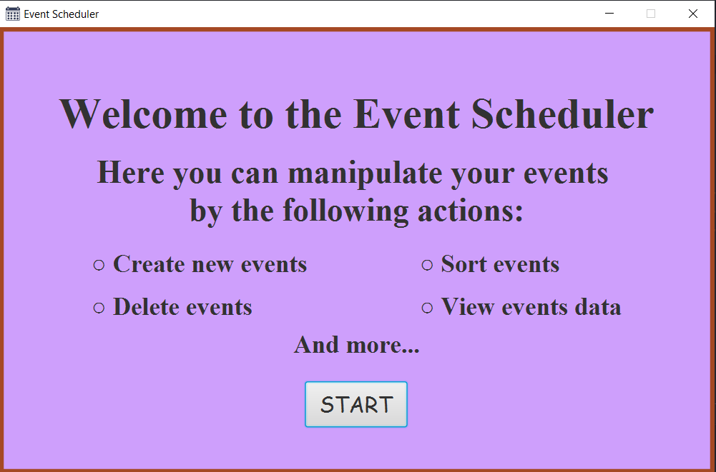  
Рисунок 1 – Сторінка-вітання

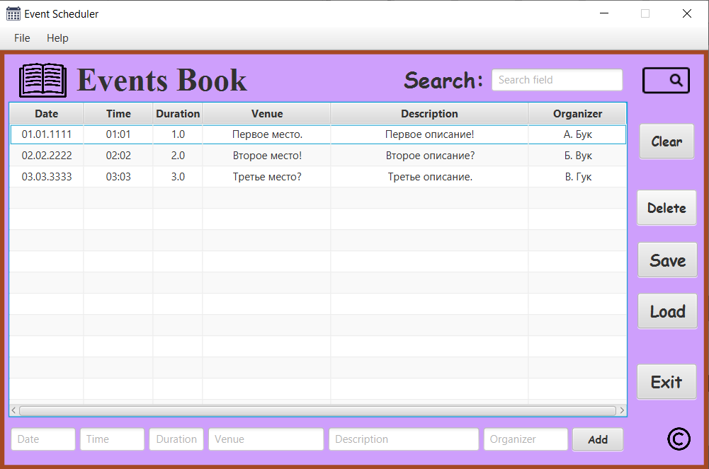  
Рисунок 2 – Головна сторінка

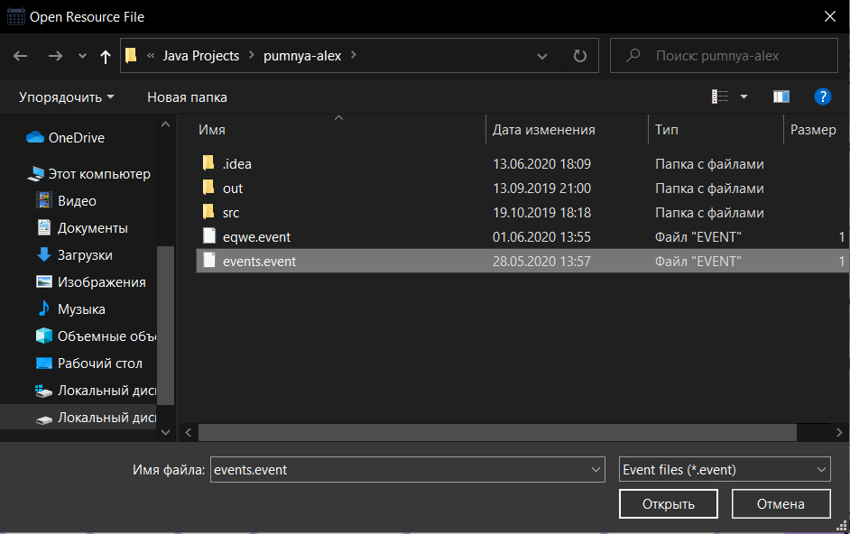  
Рисунок 3 – Вікно «Загрузити дані з файлу»

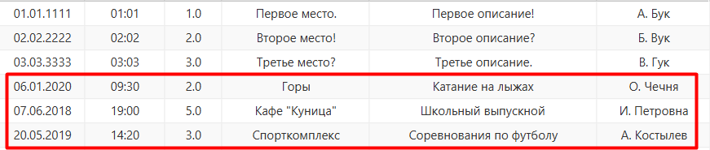  
Рисунок 4 – Результат

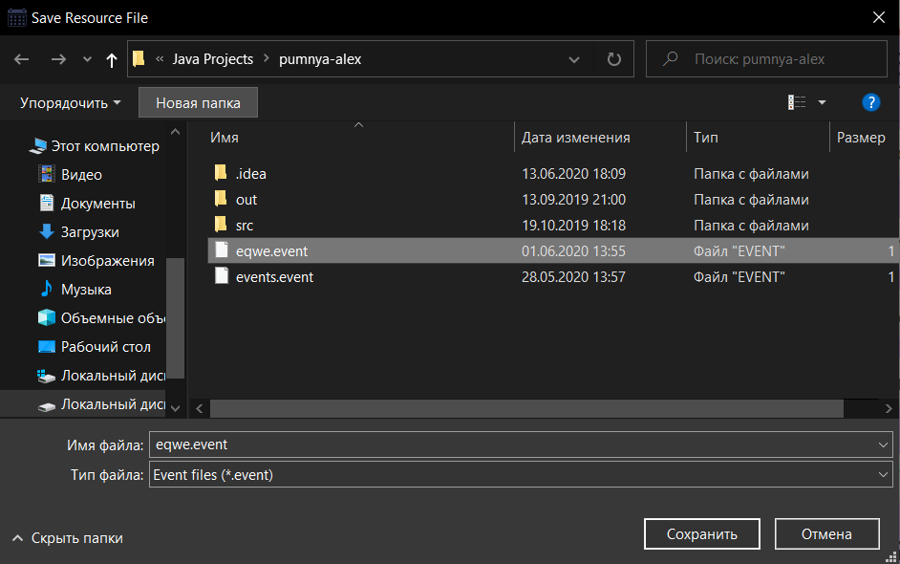  
Рисунок 5 – Вікно «Зберегти у файл»

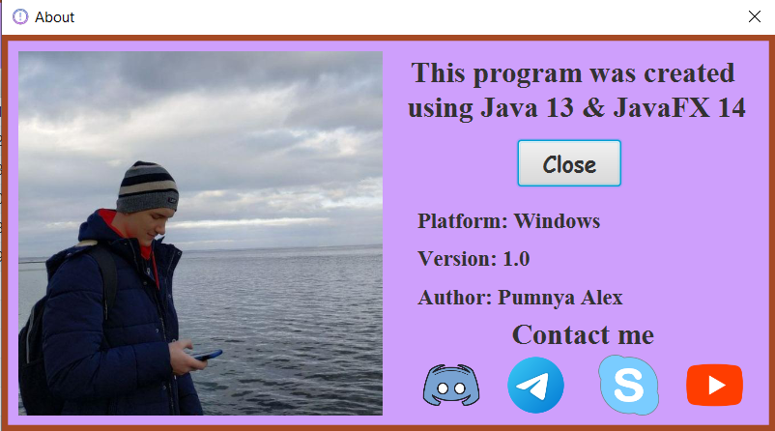  
Рисунок 6 – Сторінка «About»

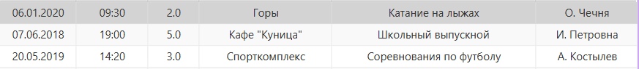  
Рисунок 7 – Результат видалення

  
Рисунок 8 – Додавання заходу

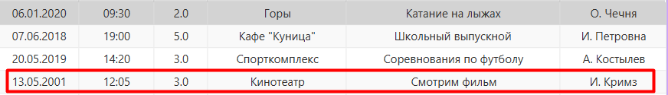  
Рисунок 9 – Результат додавання

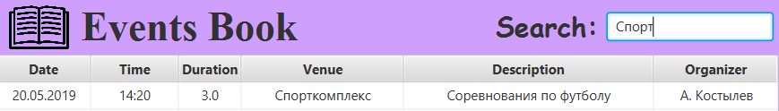  
Рисунок 10 – Результат пошуку

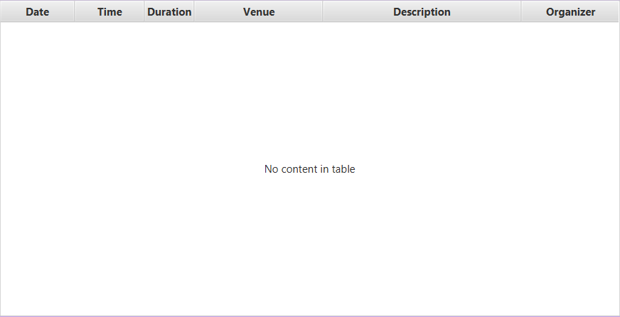  
Рисунок 11 – Результат «Clear»

ВИСНОВКИ

При виконанні лабораторної набуто практичних навичок роботи з JavaFX. Створено програму-планувальник заходами. Розроблений функціонал: створення заходів, видалення заходів, пошук заходів по всім характеристикам, збереження у файл, зчитування з файлу. Також розроблено додаткову сторінку «About», де коротко описано програму, та наведено інформацію про автора.