Assignment 1 — Reliability Engineering and Failure Analysis
AITU Student Information and Learning Services
Astana IT University | Fault Tolerance | Academic Year 2026–2027
Context note: All operational data in this assignment are synthetic educational data. They are designed to represent a realistic Kazakhstan/Astana university context and do not describe actual AITU infrastructure, incidents, or internal systems.

Scenario
Astana IT University is planning a resilient digital service for student academic activities. For this assignment, treat the following as a synthetic architecture for an AITU student portal that supports course registration, timetable access, and examination-related information.
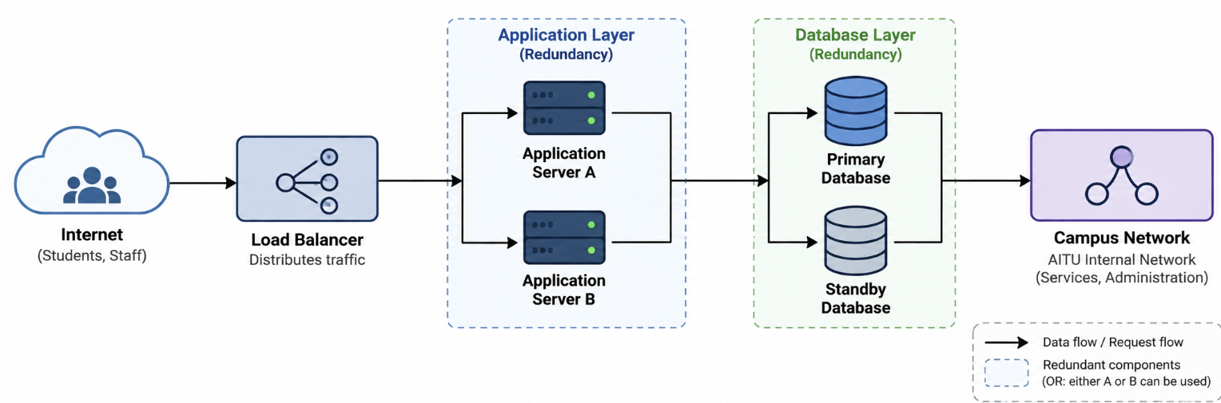

Given operating period
The service operates continuously for 720 hours (30 days).

Synthetic failure and repair data
Event | Component | Failure time (h) (At what hour the failure occurred) | Repair completed (h) | Duration (h)
1 | Application Server A | 38 | 40 | 2
2 | Primary Database | 91 | 95 | 4
3 | Campus Network | 143 | 144 | 1
4 | Application Server B | 201 | 203 | 2
5 | Primary Database | 287 | 291 | 4
6 | Load Balancer | 356 | 357 | 1
7 | Application Server A | 411 | 413 | 2
8 | Campus Network | 478 | 480 | 2
9 | Primary Database | 529 | 534 | 5
10 | Application Server B | 601 | 603 | 2
11 | Application Server A | 654 | 655 | 1
12 | Load Balancer | 689 | 690 | 1

Synthetic component reliability values
Component | Reliability
Load Balancer | 0.995
Application Server A | 0.970
Application Server B | 0.970
Primary Database | 0.980
Standby Database | 0.990
Campus Network | 0.995
Assumptions: A/B are redundant; Primary/Standby databases are redundant; Load Balancer and Campus Network are single components.

Part A — Reliability Metrics (7 points)
- Calculate total downtime and uptime.
- Calculate availability.
- Calculate MTTF, MTTR, and MTBF.
- Complete and interpret the table.
Metric | Formula | Calculation | Result | Interpretation
Total downtime | Sum of all repair durations | 2+4+1+2+4+1+2+2+5+2+1+1 = 27 h | 27 h | 27 hours of the 720-hour period were lost to failures across all components.
Total uptime | Total time − Total downtime | 720 − 27 | 693 h | The portal was available and functioning for 693 of 720 hours.
Availability | Uptime / Total time | 693 / 720 | 0.9625 (96.25%) | The system met roughly 2.4 nines of availability (~96.25%), below the ~99.9% typically expected of production-grade student services.
MTTF | Total uptime / Number of failures | 693 / 12 | 57.75 h | On average the portal ran about 57.75 hours between the end of one repair and the next failure.
MTTR | Total downtime / Number of failures | 27 / 12 | 2.25 h | The average repair took 2.25 hours; this is the main maintainability indicator.
MTBF | Total time / Number of failures (= MTTF + MTTR) | 720 / 12 (check: 57.75 + 2.25) | 60 h | A failure occurred, on average, every 60 hours during the 30-day window.

Analysis questions
- Which component creates the greatest downtime risk for the student service?
- Answer: The Primary Database. It caused 13 of the 27 downtime-hours (48%) across 3 failures (events 2, 5, 9), more than any other component, and its repair durations are trending upward (4h → 4h → 5h), indicating a worsening underlying issue rather than random noise.
- Which failure pattern should the AITU engineering team address first?
- Answer: The recurring Primary Database failures. They are tied for the most frequent failures (3 events) and carry the longest, increasing repair times, which puts registration/exam data at the greatest availability risk of any component in the architecture.
- Is the resulting availability appropriate for a student-facing academic service?
- Answer: At 96.25%, the system is below the ≥99.9% (“three-nines”) benchmark generally expected of a student-facing academic service, especially during registration and examination windows where downtime directly blocks time-critical student actions. The current level is acceptable for a low-stakes internal tool but not for a mission-critical academic service.
- Which metric is most useful for maintainability and why?
- Answer: MTTR (2.25 h). Maintainability describes how quickly a failed system can be restored, and MTTR directly measures average repair speed; MTTF/MTBF instead describe failure frequency, which reflects reliability rather than how easily the system is repaired.

Part B — Reliability Block Diagram (6 points)
Construct the RBD for: Load Balancer → [Application A OR Application B] → [Primary DB OR Standby DB] → Campus Network.
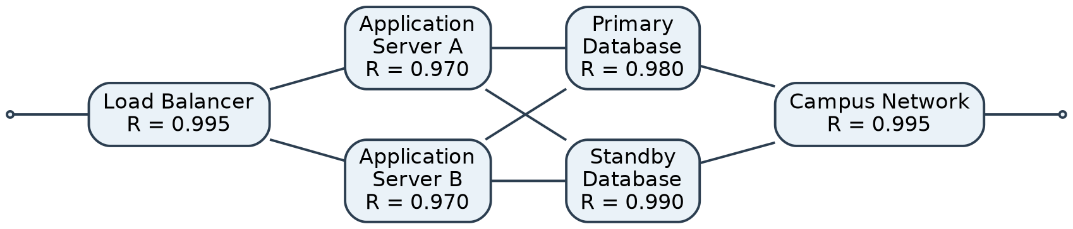
Subsystem | Configuration | Formula | Reliability
Application | A OR B | R = 1 − (1−R_A)(1−R_B) = 1 − (1−0.970)(1−0.970) = 1 − (0.03)(0.03) | 0.9991
Database | Primary OR Standby | R = 1 − (1−R_P)(1−R_S) = 1 − (1−0.980)(1−0.990) = 1 − (0.02)(0.01) | 0.9998
Load Balancer | Single | R = R_LB (series component, no redundancy) | 0.9950
Campus Network | Single | R = R_NET (series component, no redundancy) | 0.9950
Overall | Series of subsystems | R_sys = R_LB × R_app × R_db × R_NET = 0.995 × 0.9991 × 0.9998 × 0.995 | 0.9889 (98.89%)

Part C — FMEA (7 points)
Use S, O, D scales from 1–10 and RPN = S × O × D.
S = Severity: How serious is the effect if the failure happens?
- 1 = negligible impact
- 10 = catastrophic impact / complete service outage
O = Occurrence: How likely/frequently is the failure to happen?
- 1 = very unlikely
- 10 = very frequent
D = Detection: How difficult is it to detect the failure before it causes/extends the impact?
- 1 = very easy to detect
- 10 = very difficult to detect
Component | Failure Mode | Effect on AITU service | Cause | S | O | D | RPN | Mitigation
Load Balancer | Hardware/software crash, overload, or misconfiguration causes it to stop routing traffic | Complete portal outage — no path exists to either application server (single point of failure) | Hardware fault, firmware bug, config error, traffic spike during registration | 9 | 3 | 4 | 108 | Deploy a second load balancer in active-passive failover with automated health checks
Application A | Process crash, memory leak, or resource exhaustion | Capacity reduced; service continues on Server B but with degraded response time | Software bug, unpatched memory leak, insufficient resource limits | 4 | 6 | 3 | 72 | Add process watchdog/auto-restart, periodic load testing, capacity alerts
Application B | Process crash, memory leak, or resource exhaustion | Capacity reduced; service continues on Server A but with degraded response time | Software bug, unpatched memory leak, insufficient resource limits | 4 | 5 | 3 | 60 | Add process watchdog/auto-restart, periodic load testing, capacity alerts
Primary Database | Service failure, corruption, or performance degradation (repair durations trending up: 4h, 4h, 5h) | Registration/exam data temporarily unavailable during failover to Standby; risk of inconsistency if failover is incomplete | Disk I/O fault, query overload during registration peaks, replication lag, unresolved root cause | 7 | 7 | 5 | 245 | Investigate root cause of the worsening repair trend, automate fast failover to Standby, add proactive DB health monitoring
Standby Database | Silent replication break or standby unavailability (no failures observed in this dataset) | If Primary fails while Standby is silently down, the whole database subsystem is lost | Replication lag/break, configuration drift, failover path never exercised | 6 | 1 | 8 | 48 | Schedule regular automated failover drills and continuous replication-lag monitoring/alerts
Campus Network | Link/switch/router failure | Entire portal unreachable for all users regardless of server/DB health (single point of failure) | ISP outage, switch/router hardware fault, misconfiguration | 8 | 4 | 3 | 96 | Add a redundant network path/secondary ISP link with automatic route failover

- Identify the three highest-RPN failure modes.
- Answer: (1) Primary Database — RPN 245; (2) Load Balancer — RPN 108; (3) Campus Network — RPN 96.
- Explain which mitigation should be implemented first.
- Answer: The Primary Database mitigation should be implemented first. Its RPN (245) is more than double the next-highest item, it is a data-critical component tied to registration/exam records, and its repair-time trend suggests an unresolved degrading fault rather than an isolated incident.
- Explain whether prevention, redundancy, or detection provides the strongest benefit for each priority failure.
- Answer: For the Primary Database, detection provides the strongest benefit — a Standby already exists, but the growing repair times show the root cause is not being caught early, so better health monitoring and root-cause diagnostics give the most improvement. For the Load Balancer, redundancy is strongest, since it is currently a single point of failure with no backup unit. For the Campus Network, redundancy is also strongest, since a second network path is the only way to remove that single point of failure.

Part D — Fault Tree Analysis (5 points)
TOP EVENT: "AITU student portal becomes unavailable during a registration/examination period."
Include Load Balancer failure, Campus Network failure, both application servers unavailable, and both database nodes unavailable.
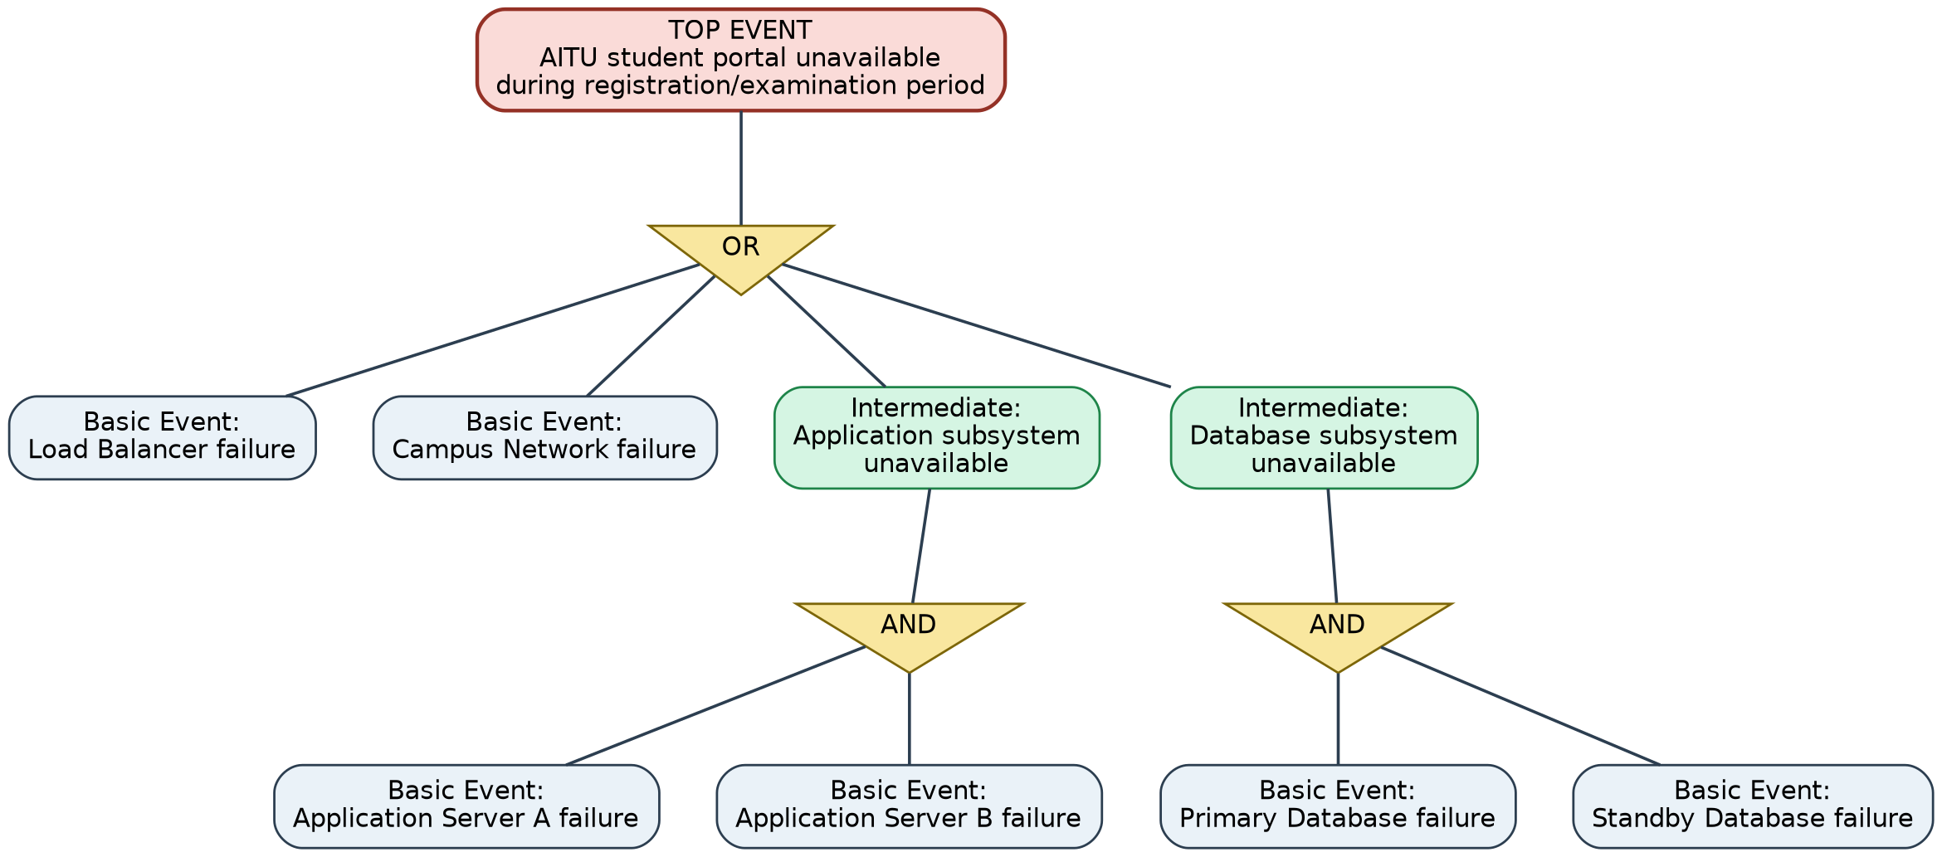
Explanation: The TOP EVENT occurs if the OR gate is satisfied by any one of four routes: (1) the Load Balancer fails outright (basic event, no redundancy), (2) the Campus Network fails outright (basic event, no redundancy), (3) the Application subsystem becomes unavailable, which itself requires an AND of both Application Server A AND Application Server B failing (since either alone is covered by the other), or (4) the Database subsystem becomes unavailable, requiring an AND of both Primary AND Standby Database failing. This structure shows that the two single (non-redundant) components — Load Balancer and Campus Network — are architecturally weaker than the redundant Application and Database subsystems, because a single basic event is enough to reach the TOP EVENT through them, whereas the redundant subsystems need two independent basic events to occur together.
Intermediate Event | Logic Gate | Basic Events
Application subsystem unavailable | AND | Application Server A failure AND Application Server B failure
Database subsystem unavailable | AND | Primary Database failure AND Standby Database failure
Complete service unavailable (TOP EVENT) | OR | Load Balancer failure, OR Campus Network failure, OR Application subsystem unavailable, OR Database subsystem unavailable

Part E — Engineering Recommendation (5 points)
Write 150–250 words recommending the three most important reliability improvements. Every recommendation must be supported by your calculations, RBD, FMEA, or FTA.
Recommendation: Three reliability improvements are proposed, each tied directly to the evidence above. First, add automated failover monitoring and root-cause diagnostics for the Primary Database: it holds the highest FMEA priority (RPN = 245) and contributed 13 of 27 downtime-hours (48%) with a repair trend rising from 4h to 5h, indicating an unresolved fault rather than random variation; this is also the top branch of the FTA's Database AND-gate. Second, deploy a redundant Load Balancer in active-passive configuration: the RBD and FTA both show it is a single point of failure (no OR-redundancy), and its FMEA severity (S=9) reflects that any failure causes a complete outage. Third, add a secondary network path for Campus Network, the other unmitigated single point of failure (RPN = 96, S=8); like the Load Balancer, one basic event here alone satisfies the FTA's top OR gate. Together these changes would raise overall availability above the current 96.25% and the RBD's calculated 98.89% system reliability, converting today's two weakest series links into redundant subsystems consistent with the Application and Database designs already in place.

Submission
- Completed tables and calculations
- RBD and FTA diagrams
- FMEA
- Python/Excel calculation file
- Engineering recommendation
- Oral defense
- Report

Master STUDENT TECHNICAL WORK REPORT / SUBMISSION RECORD
Assignment 1 — Reliability Engineering and Failure Analysis
Purpose: This form is a formal submission record. The student must complete every applicable field and attach evidence of their own work. Short generic explanations are not sufficient.

1. Student and Submission Information
Required field | Student entry
Student full name | Azamatov Almaz
Student ID | 255572
Group / cohort | CSE-2506
Instructor | Azamat Serek
Date of submission | 16.09.2026
Git repository / project link | https://github.com/almiinho/https---github.com-almiinho-Assign-1-fault-tol.git
Attached code / file names | reliability_calculations.py (Part A/B/C calculations); rbd.png, fta.png (diagrams)

2. Work Period and Task Record
Item | Student entry
Work start date/time | 14.09.26
Work completion date/time | 16.09.26
Main task completed | Calculated reliability metrics (availability, MTTF, MTTR, MTBF), built the RBD and FTA diagrams, completed the FMEA table, and formulated engineering recommendations for the synthetic AITU student portal.
Tools / technologies used | Python 3
Main technical output produced | Completed report (Word document), reliability_calculations.py calculation file, RBD and FTA diagrams (PNG).

3. Report Structure to Complete
For each section below, write the requested evidence in your own words. Include calculations, diagrams, code references, screenshots, logs, or experimental evidence where applicable.

1. Introduction and Service Context
Briefly define the synthetic AITU student service, its purpose, operating period, and the reliability problem being analyzed.
Required content | Student response / evidence
Summary | The synthetic AITU student portal supports course registration, timetable access, and exam information over a continuous 720-hour (30-day) operating period. The reliability problem analyzed is how single points of failure (Load Balancer, Campus Network) and redundant subsystems (dual Application Servers, dual Databases) affect overall availability, and where engineering effort should focus.
Evidence / calculation / artifact reference | See "Scenario" and Part A tables above; reliability_calculations.py, section part_a().
Student-specific decision or observation | The 96.25% measured availability is below the level expected of a registration/exam-critical service, which motivates the Part E recommendations.

2. Reliability Metrics
Show the formulas, substitutions, units, and final results for total downtime, uptime, availability, MTTF, MTTR, and MTBF. Interpret each result.
Required content | Student response / evidence
Summary | Total downtime = 27 h, total uptime = 693 h, availability = 693/720 = 96.25%, MTTF = 57.75 h, MTTR = 2.25 h, MTBF = 60 h (see Part A table for full formulas and substitutions).
Evidence / calculation / artifact reference | Part A table above; reliability_calculations.py, function part_a().
Student-specific decision or observation | The Primary Database accounts for 13 of the 27 downtime-hours (48%), the single largest contributor, which drove the focus of the FMEA and recommendation.

3. Reliability Block Diagram
Insert your RBD and show how redundant application/database subsystems and series components are represented. Explain your configuration and calculation.
Required content | Student response / evidence
Summary | The RBD models Load Balancer → [Application A OR Application B] → [Primary OR Standby Database] → Campus Network as a series chain of four subsystems, with the Application and Database subsystems each built from two parallel (OR-redundant) components.
Evidence / calculation / artifact reference | See RBD diagram and Part B table above; reliability_calculations.py, function part_b().
Student-specific decision or observation | R_application = 0.9991 and R_database = 0.9998 are both very high because of redundancy, while the two single components (0.995 each) pull the overall system reliability down to 0.9889 — showing redundancy, not single-component quality, is what limits further gains.

4. FMEA
Complete the FMEA using S, O, D from 1–10 and RPN = S×O×D. Identify the three highest-RPN failure modes and justify the priority of mitigation.
Required content | Student response / evidence
Summary | Six components were scored for Severity, Occurrence, and Detection (1–10 scale) and ranked by RPN = S×O×D. Primary Database (245), Load Balancer (108), and Campus Network (96) are the three highest-RPN failure modes.
Evidence / calculation / artifact reference | Part C FMEA table above; reliability_calculations.py, function part_c().
Student-specific decision or observation | The Standby Database's low Occurrence but high Detection score (RPN 48) illustrates a "silent failure" risk: it has not failed yet, but a failure would likely go unnoticed until an actual failover was needed.

5. Fault Tree Analysis
Create the required FTA for portal unavailability. Show intermediate events, logic gates, and basic events, then explain the top event.
Required content | Student response / evidence
Summary | The TOP EVENT ("portal unavailable during registration/examination") is reached through an OR gate with four inputs: Load Balancer failure, Campus Network failure, Application subsystem unavailable (AND of Server A and Server B failing), and Database subsystem unavailable (AND of Primary and Standby failing).
Evidence / calculation / artifact reference | See FTA diagram and Part D table above.
Student-specific decision or observation | Because the two single components sit directly under the top OR gate while the redundant subsystems sit behind an extra AND gate, the FTA visually confirms the RBD's conclusion that the Load Balancer and Campus Network are the weakest links.

6. Engineering Recommendation
Write the required recommendation and explicitly connect every recommendation to your calculated reliability evidence, RBD, FMEA, or FTA.
Required content | Student response / evidence
Summary | Three improvements are recommended: (1) automated failover/root-cause monitoring for the Primary Database, (2) a redundant active-passive Load Balancer, and (3) a secondary Campus Network path.
Evidence / calculation / artifact reference | See Part E recommendation text above.
Student-specific decision or observation | All three recommendations target the exact weaknesses identified by the RPN ranking (Part C) and the single-point-of-failure branches of the RBD/FTA (Parts B and D), rather than generic best practice.

4. Individual Work and Anti-Plagiarism Record
Because the assignment uses a common educational scenario and dataset, the submitted report must contain verifiable evidence of the individual student's work. Copying another student's wording, calculations, architecture, code, logs, screenshots, or conclusions is not acceptable.
- Record your individual variant/task code on the first page and use it consistently.
- Show intermediate calculations rather than only final numerical answers.
- Use your own RBD/FTA layout and explain why you selected the logic shown.
- Provide an artifact reference for the calculation file (Excel/Python).
- Be prepared to reproduce at least one calculation and explain one FMEA/FTA decision during oral defense.
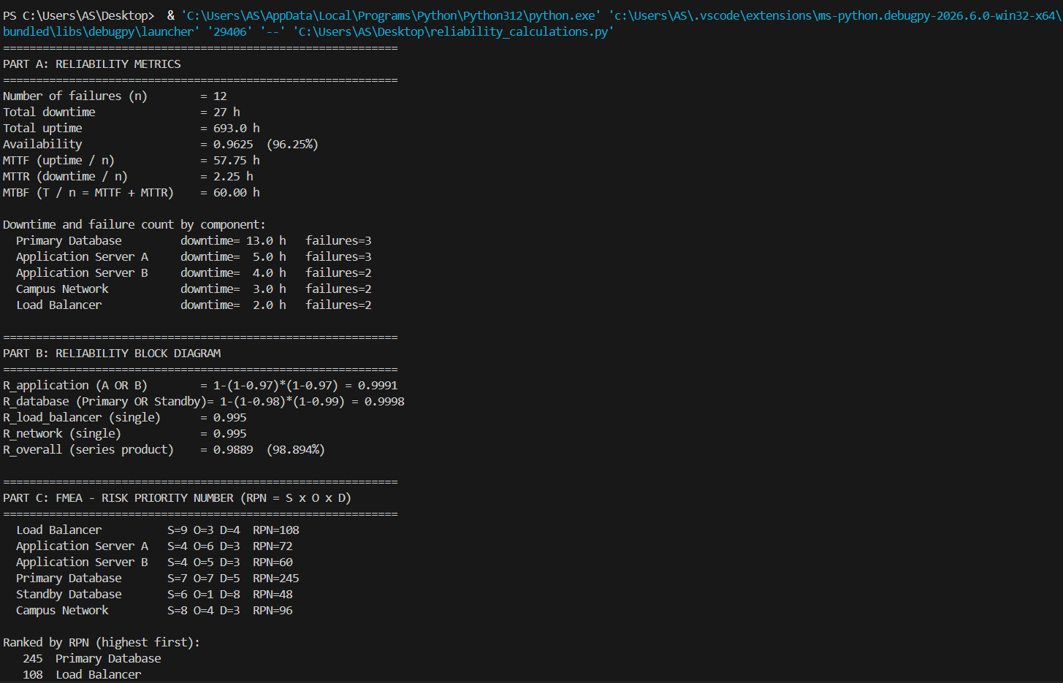

5. Evidence Checklist
- ☐ Completed required tables and calculations
- ☐ Architecture / RBD / FTA / security diagram where applicable
- ☐ Source code or configuration files where applicable
- ☐ Execution logs / experiment results where applicable
- ☐ Screenshots or other reproducible evidence where applicable
- ☐ Links to code, datasets, notebooks, or artifacts
- ☐ Before/after comparison where applicable
- ☐ Final technical conclusion

6. Student Declaration
I confirm that this report describes my own work. I have not copied another student's report, code, calculations, diagrams, logs, screenshots, or conclusions. Any external source or reused material has been identified. I understand that I may be asked to reproduce or explain any part of this submission during the oral defense.
Role | Name | Signature | Date
Student | Almaz

