Freight rate prediction - Spotter take-home
Goal: predict posted_rate for 12,000 validation loads (Nov-Dec 2025) from Jan-Oct 2025 history, plus a daily December 2025 rate for Lexington -> Fort Wayne (360 mi, Dry Van, 32,000 lb). No metric was given, so I optimise MAE/MAPE and report RMSE too.

1. Data quality
Every check below is computed by src/data.py:audit and written to outputs/data_quality.csv on each run.
file | issue | count | action
train_test.csv | duplicate load_id | 0 | none found
train_test.csv | duplicate rows (ex load_id) | 0 | none found
train_test.csv | missing weight | 300 | impute w/ train median per equipment
train_test.csv | negative weight | 292 | abs() - same dist + same rpm as positives, sign glitch
train_test.csv | weight at 47,500 cap | 1204 | keep, looks like clipping
train_test.csv | missing market_index | 374 | not used by final model
train_test.csv | distance at 70 mi floor | 48 | keep, consistent per lane
train_test.csv | distance > 2x great-circle | 22 | keep, all short lanes on the 70 mi floor
train_test.csv | lat clipped at 25.5 | 0 | keep, distance carries the real info
train_test.csv | lon clipped at -69.5 | 2052 | keep, distance carries the real info
train_test.csv | pickup == delivery | 0 | none found
train_test.csv | non-positive rate | 0 | none found
train_test.csv | rate > 1.8x lane median rpm | 328 | train: keep
train_test.csv | rate < 1/1.8x lane median rpm | 320 | train: keep
validation.csv | duplicate load_id | 0 | none found
validation.csv | duplicate rows (ex load_id) | 0 | none found
validation.csv | missing weight | 165 | impute w/ train median per equipment
validation.csv | negative weight | 145 | abs() - same dist + same rpm as positives, sign glitch
validation.csv | weight at 47,500 cap | 301 | keep, looks like clipping
validation.csv | missing market_index | 249 | not used by final model
validation.csv | distance at 70 mi floor | 21 | keep, consistent per lane
validation.csv | distance > 2x great-circle | 16 | keep, all short lanes on the 70 mi floor
validation.csv | lat clipped at 25.5 | 195 | keep, distance carries the real info
validation.csv | lon clipped at -69.5 | 479 | keep, distance carries the real info
validation.csv | pickup == delivery | 0 | none found
Negative weights: the absolute values have the same distribution (5k-47.5k) and the same rate per mile as positive rows, so it's a sign glitch and abs() is safe. Missing weight is imputed with the train median per equipment. Rate outliers form two tight clusters (~0.3x and ~3.5x the lane norm) - label noise, not market moves. They are kept in training (robust loss handles them, see table) and never removed from any evaluation set.
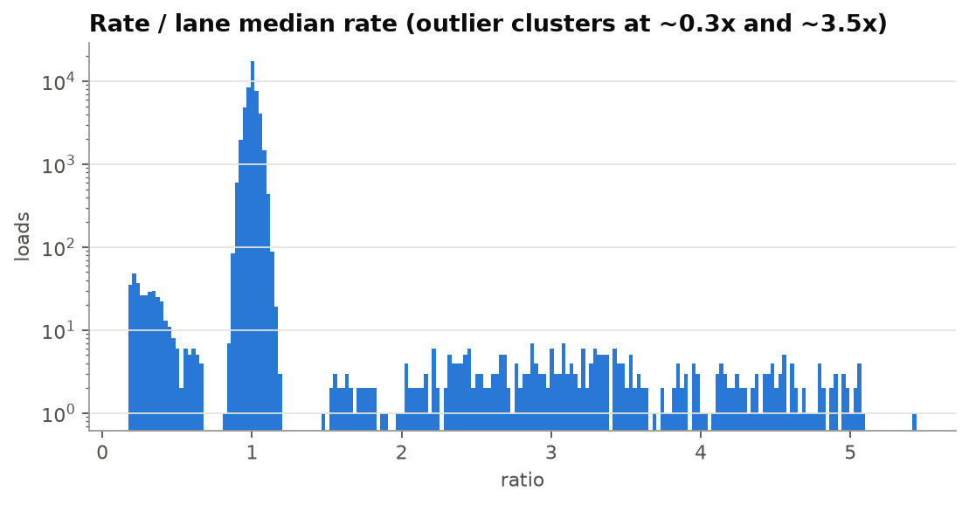

2. Key EDA findings
- Rate is mostly distance x rate-per-mile; rpm falls w/ distance and Reefer > Flatbed > Dry Van. Target = log(rate / distance), predictions are multiplied back by distance.
- Market level over time is a hump (-4% in Jan, +4% in Jun, -1% in Aug, back to ~+0.7% by Oct), not a steady drift.
- market_index has the same rough shape but a much larger swing and doesn't line up out of time (Sep has the lowest index but a normal rate level). Adding it made 3 of 4 validation windows worse (holdout MAE 127 vs 85).
- 8 cities (12% of validation rows) never appear in train, so the model can't lean on city IDs alone; lat/lon + distance carry new lanes.
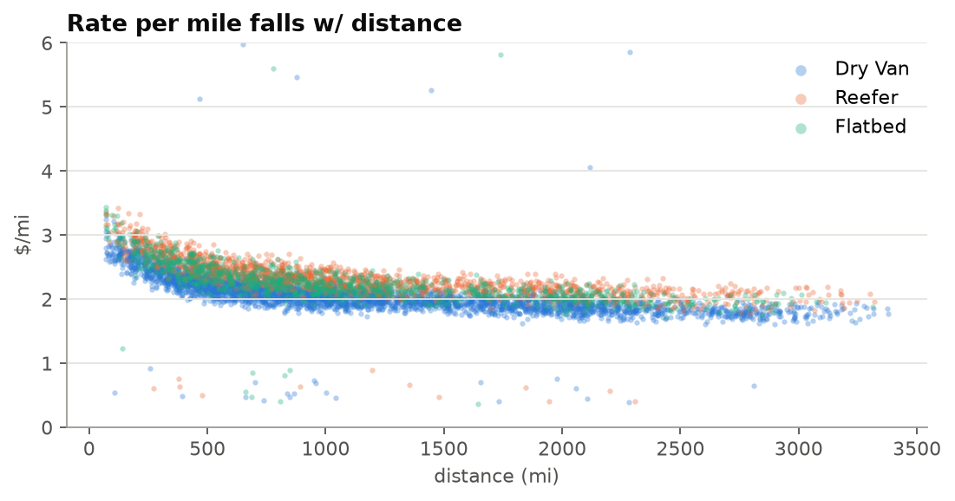
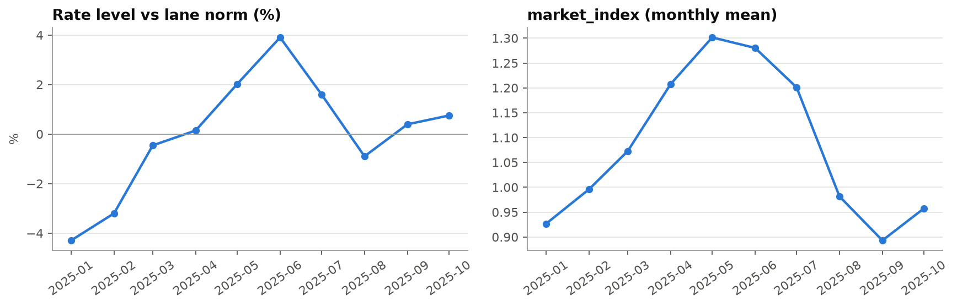

3. Validation approach
Validation is Nov-Dec, so everything is evaluated forward in time - no random splits. Main holdout: train on Jan-Aug, score Sep-Oct (same 1-2 month horizon as the real task). Plus 3 expanding-window folds (train up to Jul/Aug/Sep, score the next month). All encoders, imputation medians, lane medians and the trend are fit inside each training window only. Headline metrics are on ALL rows; 'clean' (excluding the label-noise outliers) is secondary. Seen vs unseen lanes are reported separately, and a city-holdout sim hides 8 random cities from training (3 repeats) to mimic the cities that only appear in validation. After choosing the config, the model is refit on all Jan-Oct data for the final predictions.

4. Model comparison
model | cv_MAE | cv_MAPE | ho_MAE | ho_RMSE | ho_MAPE | ho_MAPE_clean
HGB final | 115.2 | 5.34% | 85.3 | 628.6 | 3.71% | 1.32%
HGB, outliers w=0.1 | 115.3 | 5.33% | 85.4 | 628.5 | 3.71% | 1.32%
HGB, outliers dropped | 115.4 | 5.35% | 85.7 | 628.6 | 3.72% | 1.33%
HGB + city ids | 115.1 | 5.34% | 86.8 | 628.7 | 3.76% | 1.38%
HGB + level trend | 112.7 | 5.01% | 90.7 | 629.5 | 3.98% | 1.61%
HGB, squared loss | 118.9 | 5.44% | 98.8 | 629.1 | 4.40% | 2.03%
HGB + time index | 130.0 | 6.17% | 108.5 | 634.4 | 4.59% | 2.25%
HGB + market_index | 136.8 | 6.20% | 127.0 | 639.7 | 5.25% | 2.95%
lane median rpm x dist | 153.0 | 6.82% | 152.1 | 673.8 | 6.72% | 4.29%
global rpm x dist | 258.4 | 11.57% | 257.0 | 684.2 | 11.63% | 9.39%
cv_* = mean over the 3 monthly folds, ho_* = Sep-Oct holdout. RMSE is dominated by the ~1.4% outlier labels, which no model can predict.
Final model by lane type (holdout):
subset | ho_n | ho_MAE | ho_MAPE
all | 9523 | 85.3 | 3.71%
seen lane | 9502 | 85.5 | 3.71%
unseen lane | 21 | 20.7 | 0.97%
Unseen-city sim (8 cities hidden from train, rows touching them, mean of 3 repeats; the lane baseline has no history for those lanes so it falls back to global rpm x distance):
model | n | MAE | MAPE
lane median rpm x dist | 2261 | 275.9 | 11.58%
model | 2261 | 86.7 | 3.89%

5. Final model
- sklearn HistGradientBoostingRegressor (installs cleanly on Python 3.14/macOS w/ pip, handles NaN natively; LightGBM/XGBoost need libomp on macOS so I skipped them).
- Target: log(rate per mile); prediction = exp(trees) x distance. The rpm target removes most of the distance scale, the log makes errors relative.
- Absolute-error loss: robust to the ~1.4% noisy labels. With it, dropping or down-weighting outliers made no measurable difference, so nothing is dropped. Squared loss was clearly worse.
- Features: lat/lon, distance, equipment, weight, quote_signal, day of week. No city IDs - coords-only ties on CV, wins the holdout (85.3 vs 86.8 MAE) and treats new cities exactly like known ones. No month/day-of-year (Nov/Dec never seen in train).
- market_index left out: hurt every window except Aug (holdout MAE 127 vs 85). Its relation to rates isn't stable over time.
- No time trend in the final model. Tested: time index as a tree feature (flat extrapolation, clearly worse), linear/damped slopes on the detrended target (early scratch run, overshot - the level is a hump, not a drift) and a market-level component (smoothed daily rate vs lane norm, held flat at the last-60-day level). The level component only won the Aug fold, right after the Jun peak, and lost Sep, Oct and the Sep-Oct holdout, so it's off. The model therefore predicts at the Jan-Oct average level, which is close to the Aug-Oct level (~0-1% apart).
- Fallback chain: model -> lane median rpm x distance -> global rpm x distance, w/ asserts for no NaN / non-positive values. The model produced every final prediction (fallback never triggered).
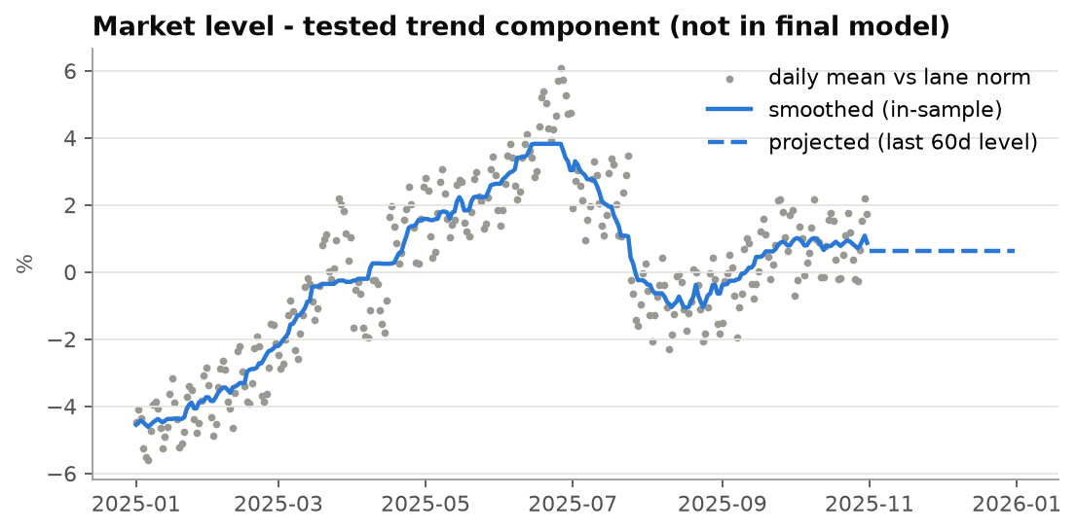
Feature importance - permutation on the Sep-Oct holdout (model trained Jan-Aug):
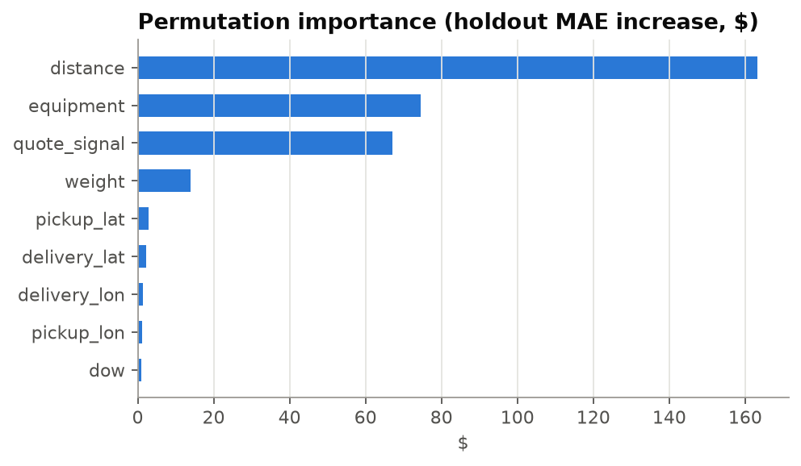

6. December chart (score.py)
Lexington -> Fort Wayne, 360 mi, Dry Van, 32,000 lb. Predictions range $812-$825 ($2.25-$2.29/mi). City coords come from the train lookup. quote_signal isn't in the chart inputs, so each December date is predicted w/ every real quote_signal value from validation.csv loads on that date, then averaged - i.e. the expected rate for a load that day. Plugging in the daily median instead came out ~5% low: on this lane the model's quote_signal curve has its dip right at the median. Day-to-day movement comes from day of week + quote_signal; there's no time trend, so there's no extrapolated slope or made-up seasonality. For reference, the 21 Dry Van loads on this lane in train averaged $823 (median $808, range $758-$934, Jan-Oct).
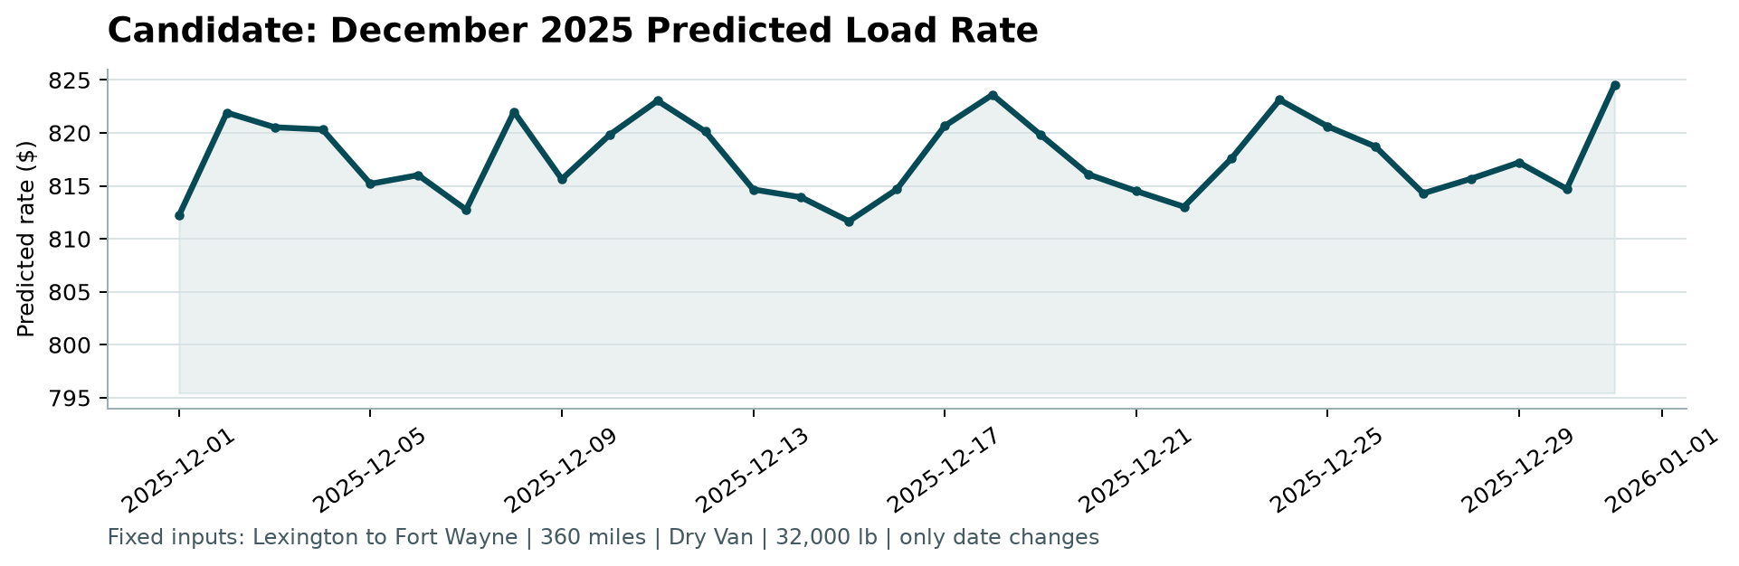

7. Caveats
- Weak spot: in the Aug fold (train through Jul, right after the Jun peak) the model was worse than the lane-median baseline (MAE 174 vs 159) - it lags when the market level drops fast. The level-trend variant handled that fold best (155) but lost everywhere else. If Nov-Dec has a sharp level move, expect a similar lag.
- No December history in train, so holiday seasonality can't be learned; the December line is the average level + weekday pattern.
- Only 21 holdout rows are on lanes unseen in Jan-Aug, so the seen/unseen lane split is thin; the city-holdout sim is the real test there.
- No metric was specified; MAE/MAPE are optimised. If Spotter scores on RMSE, the outlier labels will dominate.
- quote_signal is used as given in validation.csv; if it's not known at quote time in production that's leakage risk worth checking. For the December chart I averaged over the real values seen each day in validation.csv.
- Coordinates look synthetic/clipped (Laredo lat 25.5, Boston/Providence lon -69.5); fine here since every city has one consistent coord pair, but worth knowing.

