**Visualization of Multivariate Data Using Parallel Coordinates**

**Omar Alminagorta**

**January 31st, 2020**

**Ecology & Evolutionary Biology**

**University of Toronto**

1. **Overview**

Parallel coordinates provide a method to visualize and examine multivariable data. This document will provide a tutorial for the implementation of the parallel coordinate approach using software (XDAT).

1. **Objectives**

Implement a parallel coordinates plot. You will use the [XDAT software](https://www.xdat.org/) to implement a parallel coordinates approach and data from the [Ontario Freshwater Fishes Life History Database](http://www.ontariofishes.ca/home.htm). Specific objectives are:

1. Enter data into the parallel coordinates software
2. Run the software and interpret results
3. **Software Requirements**

You will need to install the XDAT software on your computer [These instructions are for Windows, I am not sure if it works for Mac]:

Download the XDAT software and the data from [here](https://github.com/alminagorta/Parallel-Coordinates/archive/master.zip). This is a zipped file. You need to unzip it. If you don’t have unzip software, you can get from this [site](https://www.7-zip.org/).

1. **Activities**

In the downloaded folder, you will find two main files: “xdat” and “Fish_data”. Run the program (xdat), input data, and create the parallel coordinates:

1. Run the program=> Open the “xdat-2.3” folder and execute the file “xdat”
2. Input the “Fish_data” file=> In **xdat** window, select **Data** option and **Import data with Headers** [Fig1]
3. Create Parallel Coordinates plot=> In the option **Chart** select **Create Parallel Coordinates Chart** [Fig.2]

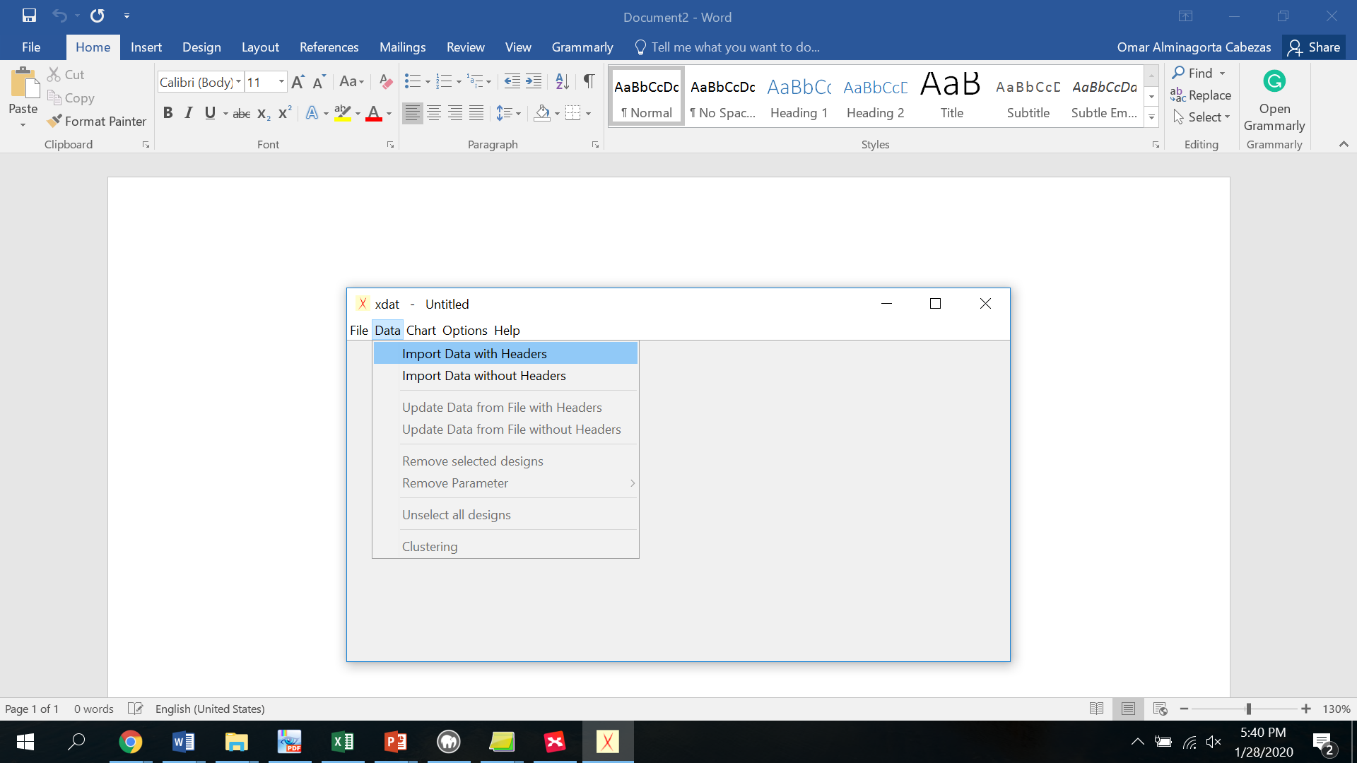

Fig.1

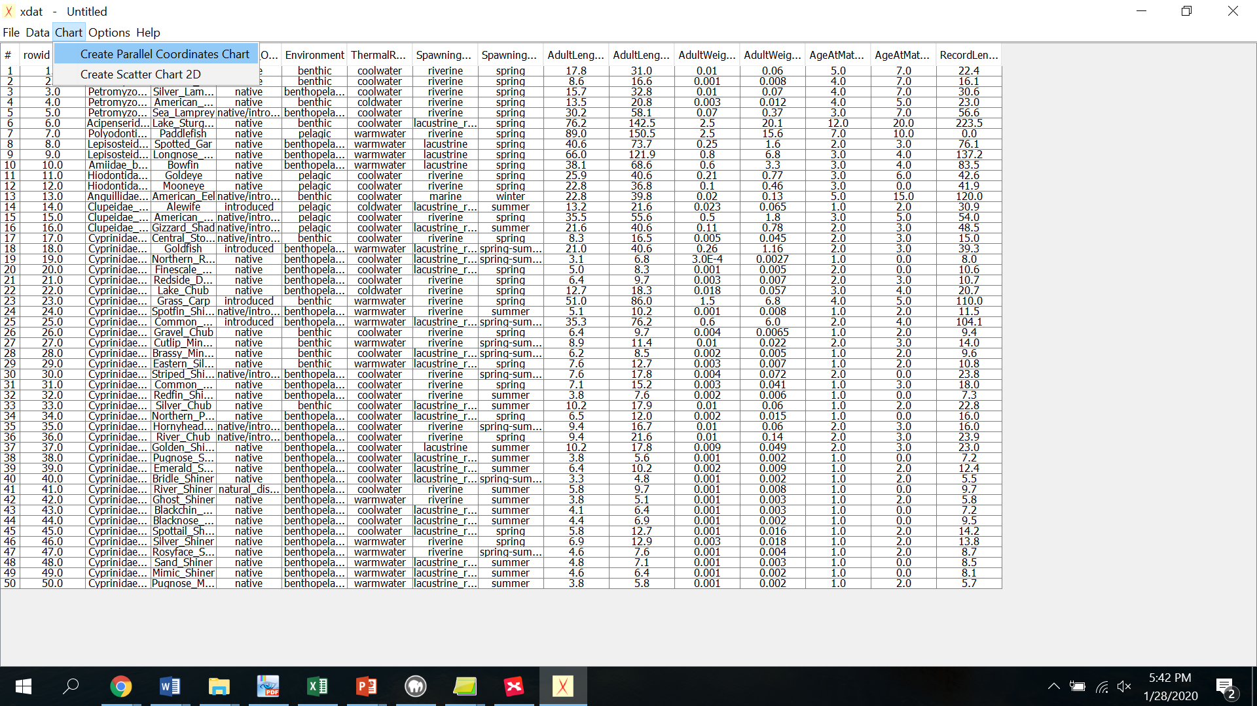 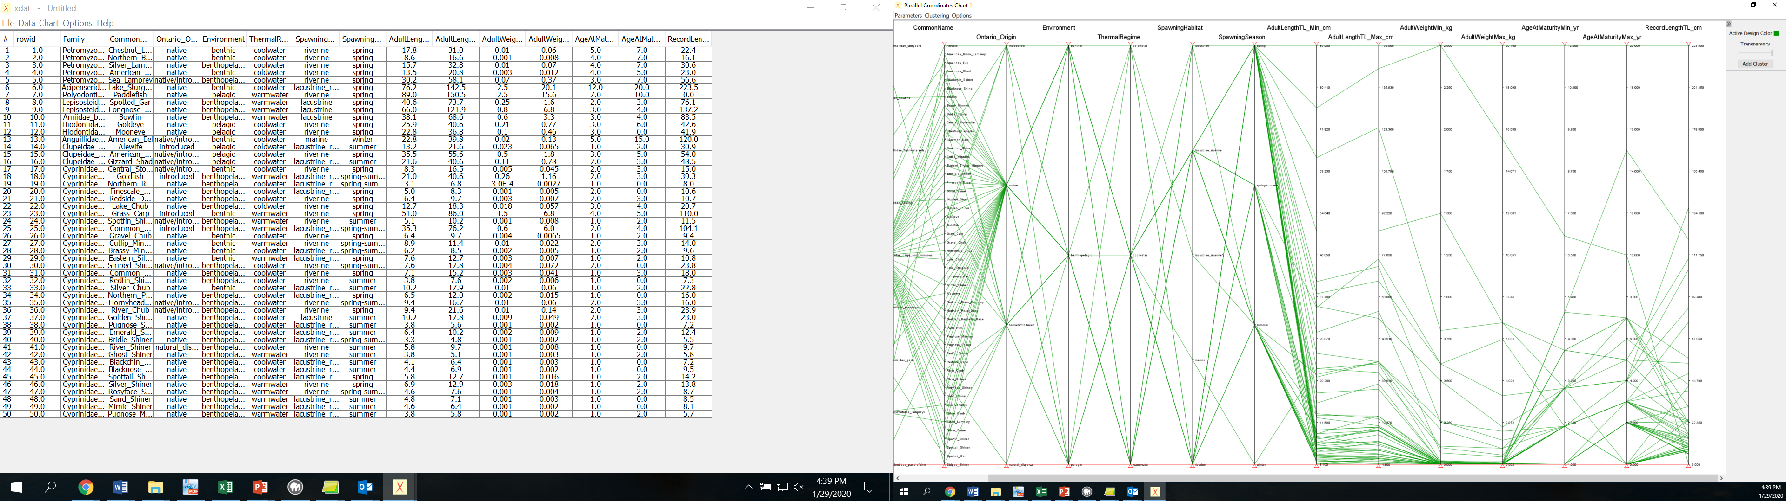

Fig.2

**Getting familiar with the software and interpret the results**

1. In the parallel coordinates, plot eliminates axis: “rowid”, “Environment”, “SpawnigHabitat”, and “SpawningSeason”
2. In the “ThermalRegime” axis. What is your interpretation of the density of lines?
3. In the parallel coordinate plot identifies the three species with the highest record length (use the red lines in the last axis)