CIS 436  
Ahmed Almoamen  
Project 4

This is a simple weather app that uses the openweathermap API to retrieve weather data for any city in the world. It allows users to enter the name of the city and get real-time information about the temperature, humidity, and weather conditions.   
  
Screenshots of it working:

On launch:  
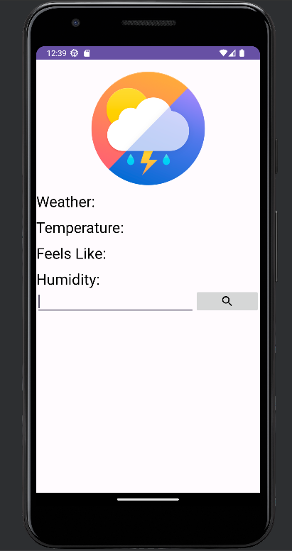  
  
Typing in Detroit:

Leaving field blank:

Entering an international city:

Comparing to data off of Google:  
