Rayon GUI

April 2012

Address : Hamelacha 8 .st, industrial zone Netania. POB 916 Pardesia 42815 Israel

Tel: 972-9-8923125. Fax:972-9-8923126 Email: shaya@redler.co.il web: www.redler.co.il

**Motor Control Software**

**User manual**

**Revision 1.0**

**Redler Technologies**

**02.05.2019**

# About Redler

Thank you for choosing our product. Redler Computers Ltd since 1994, is an innovative & reputable Aerospace and defense advanced Control and Mechatronics Company.

Our company specializes in cost effective digital servo drivers and advanced multi and single axis motion control systems for Precise Guided Monition, Unmanned Avionic Vehicles, Unmanned Ground Vehicles, gimbaled stabilized system, heavy duty sensor less controller driver and many other applications that demands robustness and exceptional reliability.

The company's embedded systems, based DSP microcontrollers and unique motion control solutions, designed with special care for extreme environmental condition, high performance and low losses.

# Contents

1. About Redler 2

2. Contents 3

3. Read this first 5

3.1 Safety 5

3.2 System considerations 5

3.3 Cooling 5

3.4 Load considerations 5

4. Using GUI. 6

4.1 Preface 6

4.2 GUI installation. 6

4.2.1 Requirements 6

4.2.2 Install “Motor Controller” on computer. 6

4.2.3 Running aplication 7

4.3 General 8

4.3.1 main GUI window 8

Main GUI window devided to six areas: 8

4.3.2 Sending command 8

4.3.3 Reading values 8

4.4 Comunication - area 1: 9

4.5 Setting - area 2: 10

4.5.1 Motor parameters tab 10

4.5.2 Feedbacks parameters tab 11

4.5.3 PID parameters tab 11

4.5.4 Device parameters tab 12

4.5.5 Motion parameters tab 12

4.5.6 Manual calibration Tab 13

4.5.7 Maintenance tab 13

4.6 Motor - area 3: 15

4.7 Motion Commands - area 4: 15

4.8 Motion Status - area 5: 16

4.9 Graph - area 6: 17

4.10 Firmware update 18

4.10.1 Requirements 18

4.10.2 Install “Serial Programmer” on computer. 18

4.10.3 Serial Programmer GUI. 19

# Read this first

## Safety

This product intended to use by professionals, user must take care when using this product, Redler does not take liability to loss or damage caused by this product, Skill needed to operate this controller, please read this manual carefully, while using this product, please apply safety precautions to protect human and machine, especially while developing and integrating system.

## System considerations

* Please verify that the motor is secured carefully to the system or bench.

If not secured, Motor may move during calibrations and accelerations.

* All motor controller screw must be tightened to specifications.
* Please secure all cables to bench, cables will should be arranged so that they will not be harmed or tingled.
* Driver, motor or cables should not be moved during operation.
* Verify that the driver environmental conditions are met.

## Cooling

Motor controller performance are related to temperature. Maximum current capability can be reduced if not cooled properly, see thermal consideration chapter.

## Load considerations

* Please verify load is secured to motor shaft or gear.
* Verify system rigidness and no excessive backlash.
* Stopping motor and deceleration with heavy load, can increase voltage on power supply rail, this can lead to motor controller failure or PSU failure. Special care should be taken to absorb this kinetic energy. See inertia consideration chapter.

# Using GUI.

## Preface

This GUI is intended to use in laboratory for motor calibration, parameter setup, motion evaluation, debugging and monitoring. It is necessary to add safety power kill switch to overcome any communication loss in driver side or PC side.

## GUI installation.

### Requirements

The installation is for Windows 7 64 Bit or higher computer.

To see graph records you will also need Microsoft Office Excel 2013.

### Install “Motor Controller” on computer.

Open installation folder, Double click on: < Disk >\MotorController Setup\ “setup.exe”

Follow instructions, press next when asked and leave default installation folder.

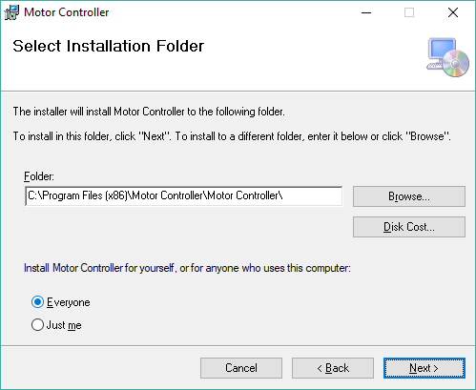

If asked to allow app to make changes, press “Yes”:

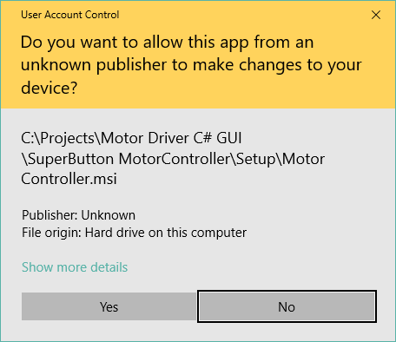

### Running aplication

The application shortcut is placed in the windows start menu and “Motor Controller:” shortcut will be placed on desktop

## General

### main GUI window

### Main GUI window devided to six areas:

1. Communication- Com PC setup and status indicators.
2. Setting – MC Parameters
3. Motor – Status and enable.
4. Motion commands – send movement commands to MC
5. Motion Status – Read motor feadbacks and MC status.
6. Graph – 3Khz live graph for signal and motor feedback monitoring.

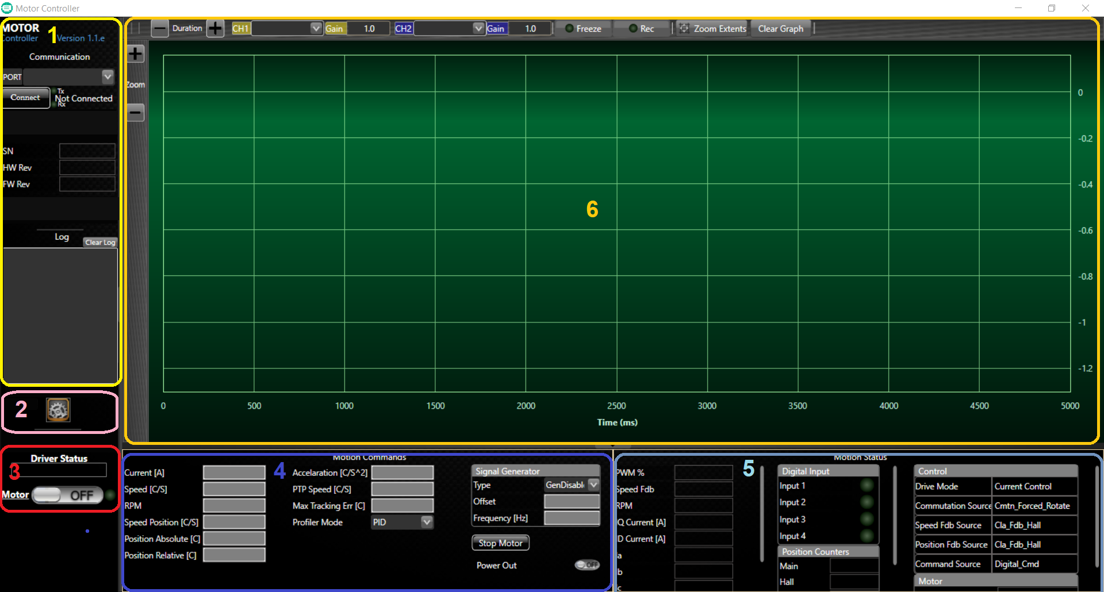

Figure 1: main window

We will explain each area in the folowing paragraphs.

### Sending command

To send command just click on any gray textbox, textbox background color will change to red, indicating the user can type a value to send. When you finished updating the value, you can press enter key to send the value or escape to cancel operation, when canceling textbox will return to previous value.

### Reading values

All the displayed data in GUI is refreshed automatically every one second by sending “get command” to the MC in the background.

## Comunication - area 1:

From top to bottom:

1. **Application version:** GUI version
2. **Communication:**

* COM port selection: if port detected at application starting time, the port will be selected by default, if more than one COM port are available you will have to choose from the combo box list.
* **Connect button:** allow to open the selected COM port to establish communication with the unit.
* **Connection status:** Tx and Rx led represents the received and transmitted data between the PC and the unit.

1. **Driver information:** updates at startup: SN, HW rev, FW rev
2. **Log:** Log section allow you to see some running processes of the application, Clear log allow you to erase the log data.

Note: The timestamp shows only minutes and seconds. e.g:

*34:07 - Failed*

*34:06 - Autobaud process...*

*34:06 - Success*

*34:06 - Connecting at COM5*

## Setting - area 2:

Pressing on this Icon, will Open the MC parameters window, ee will show and explain each tab in this window.

### Motor parameters tab

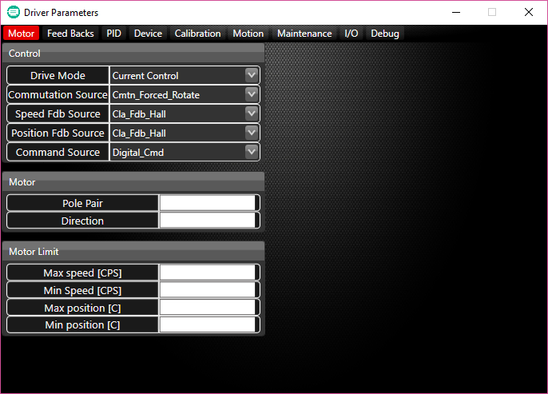

### Feedbacks parameters tab

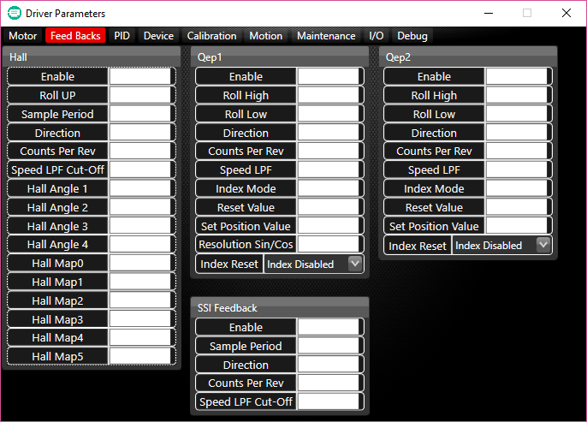

### PID parameters tab

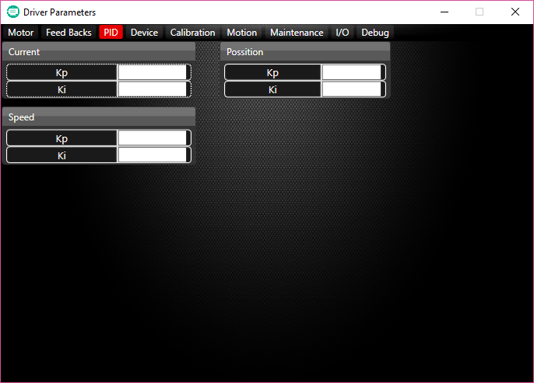

### Device parameters tab

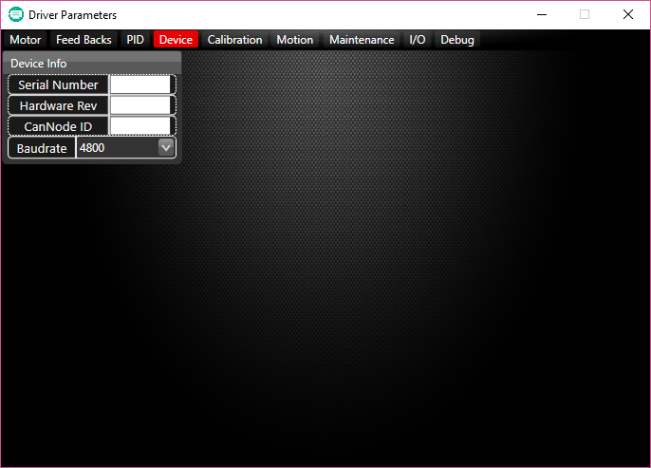

### Motion parameters tab

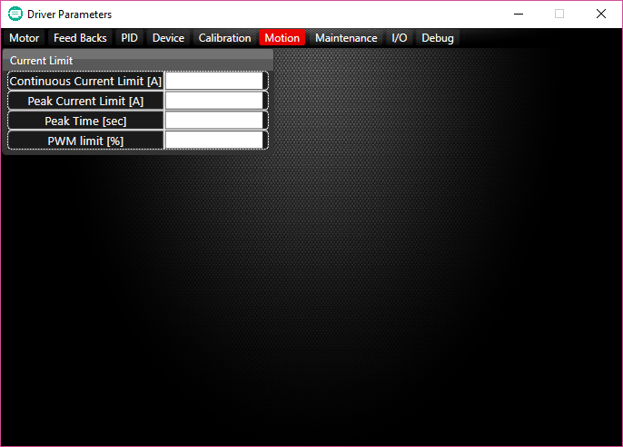

### Manual calibration Tab

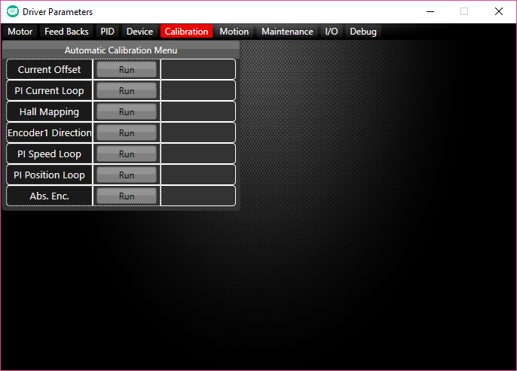

For calibration steps please see user manual - Calibration paragraph. Do not calibrate without motor parameter setup and save.

### Maintenance tab

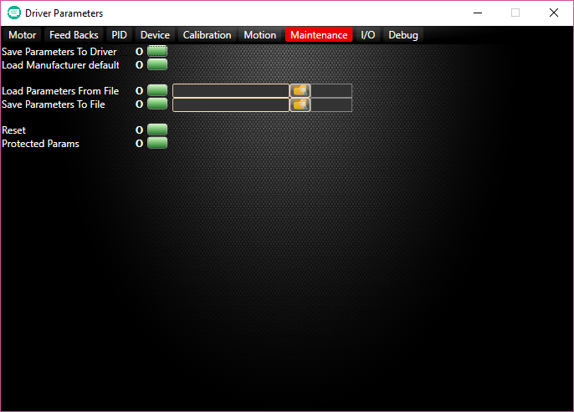

* **Save Parameters to Driver**: after any change performed in parameters, if you want to them to be saved to flash after a reset you must perform “Save Parameters to driver” operation. Otherwise the last parameters will be restored from flash after reset.
* **Load Manufacturer Default**: This operation allows you to restore manufacture defaults parameters of the unit.
* **Load Parameters from File**: you can load parameters to the unit from a file. You must click the “Folder Icon” and select the file before you press on “Save Button”.
* **Save Parameters to File**: allow you to save the unit parameters to a text file.

after downloading the data from the unit, you will be prompted to choose a directory and a file name to save the file.

directory.

* **Reset**: Send reset operation to the unit, useful to ensure that parameters were saved, after pressing “reset” in log window you will see “unit reset” massage.

**Protected Params**: Not relevat, for advance use.

## Motor - area 3:

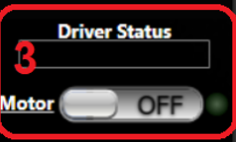

From top to bottom:

* **Driver Status:** display if the driver has no error or specify the error if there is one.
* **Motor ON/OFF:** Motor On/Off command and status, Green led indicate motor is “ON” state.

## Motion Commands - area 4:

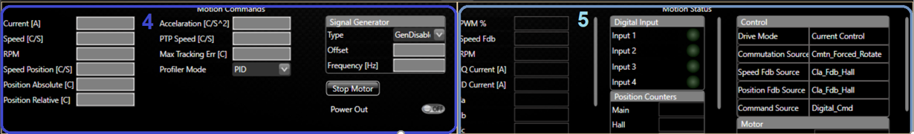

Motion commands allow you to send operation commands:

1. Commands: Current speed and position commands
2. Motion Profile: Profile type, acceleration, Max speed and tracking error.
3. Signal generator: for Current speed or position loops.

## Motion Status - area 5:



Motion status allow you to see the data of the controller.

## Graph - area 6:

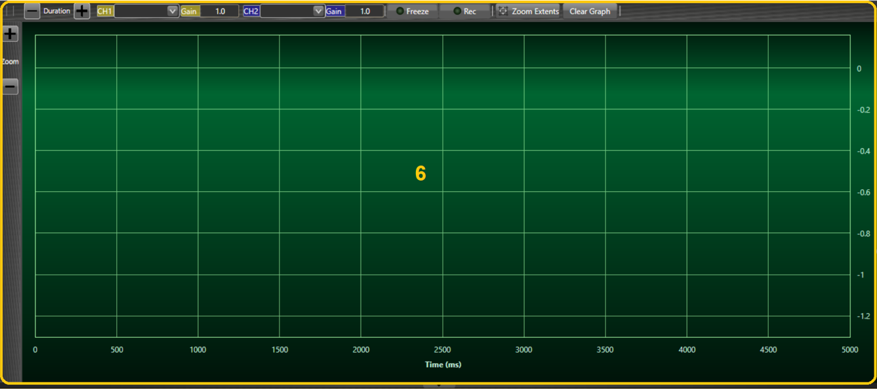

1. **Zoom**: Allow you to increase or decrease amplitude per graph decade.

This operation can be done also with mouse wheel by scrolling in or out.

1. **Duration**: Allow you to increase or decrease time per graph decade.

This operation can be done also by moving mouse cursor right/left on Time axis.

1. **Ch1, Ch2**: Graph selection list. Allow you to plot driver signals such as Current or Speed at 3KHz.
2. **Gain**: Gain factor to scale two plots on the same graph.
3. **Freeze**: Stop updating the graph by performing “pause” operation until you release the button. A round red led blink during the freeze operation.
4. **Record**: Record the graph signals in an Excel document.

Directory: “C:\Users\<name>\Documents\MotorController\Charts”.

The file is created and saved after releasing the record button.

A round red led will blink during the record operation.

1. **Zoom Extent**: Fit the graph plot to the window area.
2. **Clear Graph**: Clear the graph area.
3. **Graph area**: X axis title is Time (ms), Y axis updated dynamically depend of the data graph selected and gain.

## Firmware update

### Requirements

The installation is for Windows 7 64 Bit or higher computer.

### Install “Serial Programmer” on computer.

Open installation folder, Double click on: < Disk >\SerialProgrammer Setup\ “setup.exe”

Follow instructions, press next when asked and leave default installation folder.

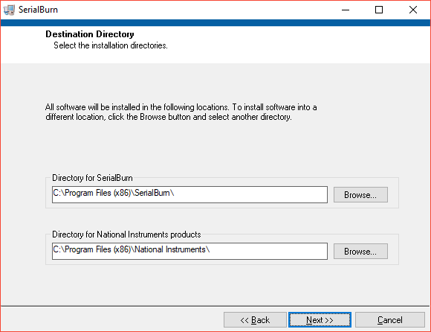

If asked to allow app to make changes, press “Yes”:

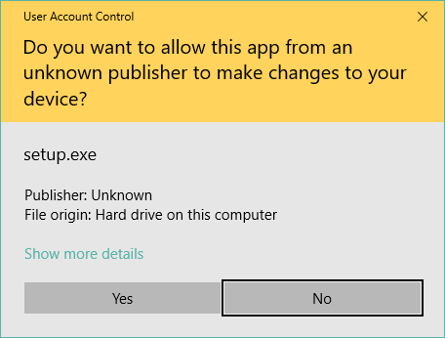

### Serial Programmer GUI.

Choose a COM port from the “COM Port” combo box.

Choose a command baud rate and flash baud rate.

Select a folder to burn into the unit.

Press Start button when ready.

Wait until end of operation message in the logger window.

