Read plot table protocol

Rayon M3

Contents

General: 1

example for table list: 1

Plot parameters: 2

Procedure: 5

Example: 5

# General:

While opening app-

1. Read plot length: ID 34, get (int)
2. get plot table: for each Idx (plot)- go over his 3 ID’s.

each Idx contains a different plot, and his ID’s contains his defines, as specified below:

# example for table list:

|  |  |  |  |  |
| --- | --- | --- | --- | --- |
| Full Scale- ID 36 (float) | General ID35 | | | ID  Idx |
| Units(24-31) | Type (16-23) | Name (0-15) |
|  |  |  |  | 1 |
|  |  |  |  | 2 |
|  |  |  |  | 3 |
|  |  |  |  | …. |
|  |  |  |  | n- length |

# Plot parameters:

Show plot list with main menu and sub menu like this:

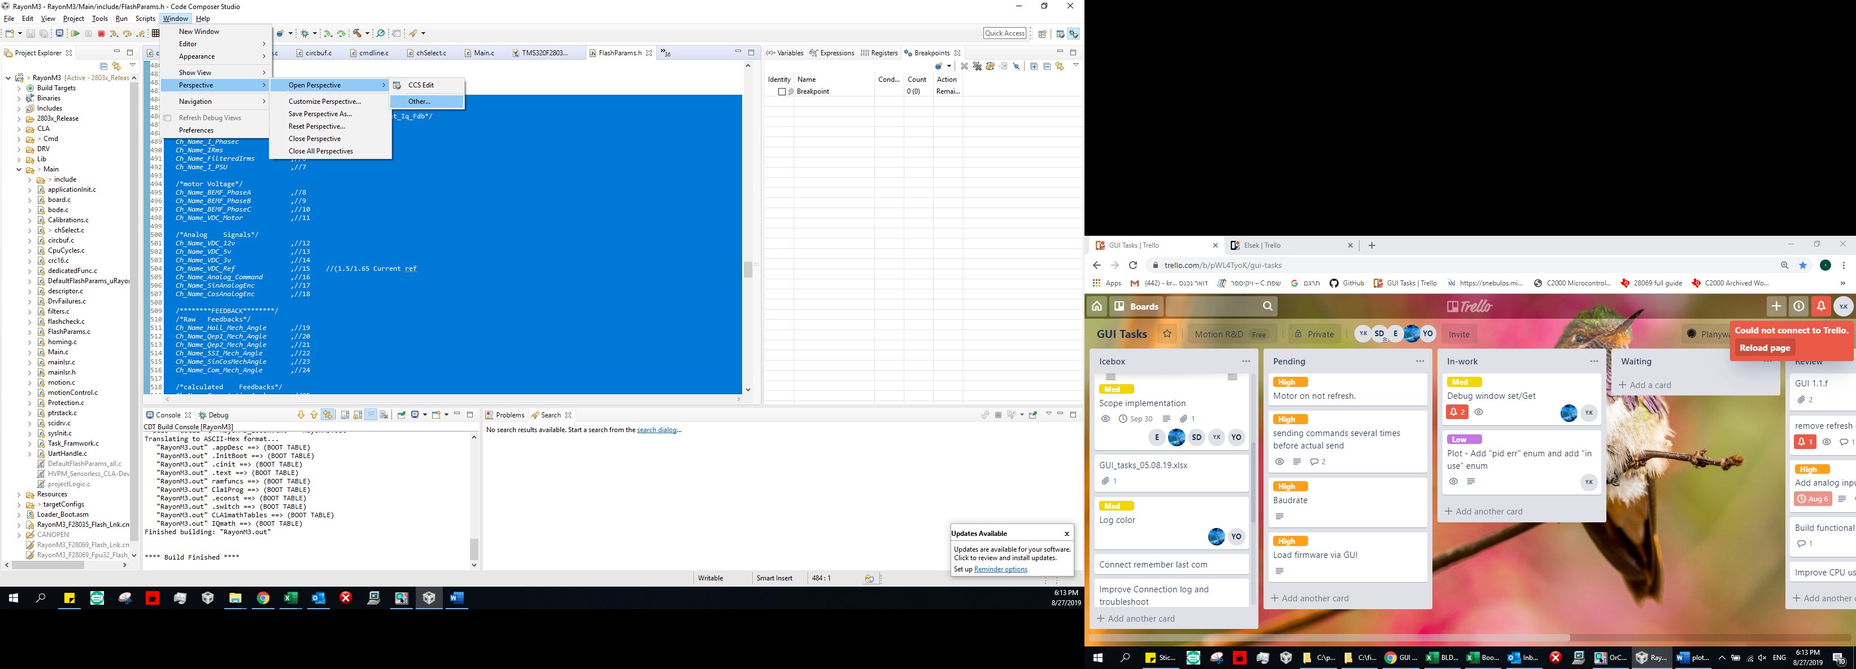

**Enum name list:**

## Plot name table:

|  |  |  |  |
| --- | --- | --- | --- |
| num | main list | sub list | plot name |
| 1 | Signal | motor Currents | Current feedback |
| 2 |  |  | I Phase A |
| 3 |  |  | I Phase B |
| 4 |  |  | I Phase c |
| 5 |  |  | IRms |
| 6 |  |  | Filtered Irms |
| 7 |  |  | I PSU |
| 9 |  | motor voltage | BEMF Phase A |
| 10 |  |  | BEMF Phase B |
| 11 |  |  | BEMF Phase C |
| 12 |  |  | VDC motor |
| 15 |  | Analog Signals | VDC 12v |
| 16 |  |  | VDC 5v |
| 17 |  |  | VDC 3v |
| 18 |  |  | VDC Ref |
| 19 |  |  | Analog Command |
| 20 |  |  | Sin Analog Enc |
| 21 |  |  | Cos Analog Enc |
| 25 | Feedbacks | Raw feedbacks | Hall Mech Angle |
| 26 |  |  | Qep1 Mech Angle |
| 27 |  |  | Qep2 Mech Angle |
| 28 |  |  | SSI Mech Angle |
| 29 |  |  | Sin Cos Mech Angle |
| 30 |  |  | Com Mech Angle |
| 33 |  | calculated feedbacks | Commutation Angle |
| 34 |  |  | HALL Speed |
| 35 |  |  | HALL Elect Angle |
| 36 |  |  | HALL Position |
| 37 |  |  | Enc1 Speed |
| 38 |  |  | Enc1 Elect Angle |
| 39 |  |  | Enc1 Position |
| 40 |  |  | Enc2 Speed |
| 41 |  |  | Enc2 Elect Angle |
| 42 |  |  | Enc2 Position |
| 43 |  |  | Sensorless Speed |
| 44 |  |  | Sensorless Elect Angle |
| 45 |  |  | SinCosAngle |
| 46 |  |  | delta Hall Enc |
| 50 | Control | control reference | Current Cmd |
| 51 |  |  | Speed Cmd |
| 52 |  |  | Position Cmd |
| 54 |  |  | Current Iq Fdb |
| 55 |  |  | Current Iq Ref |
| 56 |  |  | Current Iq Err |
| 58 |  |  | Current Id Fdb |
| 59 |  |  | Current Id Ref |
| 60 |  |  | Current Id Err |
| 62 |  |  | Speed Fdb |
| 63 |  |  | Speed Ref |
| 64 |  |  | Speed Fdb LPF |
| 65 |  |  | Speed Err |
| 67 |  |  | Position Fdb |
| 68 |  |  | Position Ref |
| 69 |  |  | Position Err |
| 72 | IO | in | Digital In1 |
| 73 |  |  | Digital In2 |
| 74 |  |  | Digital In3 |
| 75 |  |  | Digital In4 |
| 76 |  |  | Digital In5 |
| 77 |  |  | Digital In6 |
| 78 |  |  | Digital In7 |
| 79 |  |  | Digital In8 |
| 82 |  | out | Digital Out1 |
| 83 |  |  | Digital Out2 |
| 84 |  |  | Digital Out3 |
| 85 |  |  | Digital Out4 |
| 86 |  |  | Digital Out5 |
| 87 |  |  | Digital Out6 |
| 88 |  |  | Digital Out7 |
| 89 |  |  | Digital Out8 |
| 92 |  |  | /*Debug |
| 93 | DEBUG | Debug signals | cla Debug1 |
| 94 |  |  | cla Debug2 |
| 95 |  |  | Test Signal1 |
| 96 |  |  | Test Signal2 |
| 97 |  |  | Test Signal3 |
| 98 |  |  | Test Signal4 |

**Enum type list:**

|  |  |
| --- | --- |
| num | type |
| 0 | Integer |
| 1 | Float |
| 2 | Iq24 |
| 3 | Iq15 |

**Enum unit list:**

|  |  |
| --- | --- |
| num | unit |
| 0 | Amper |
| 1 | Volt |
| 5 | Elec Angle |
| 6 | mechanical Angle |
| 10 | RPM Per Volt |
| 11 | Count Per Sec |
| 12 | Round Per Minute |
| 13 | Counts |
| 20 | None **(-show nothing)** |

# Procedure:

1. after Connect:

Read plot length:  ID 34, get → int

1. Read General: ID 35[1] to 35[len]

plot name (0-15) → (0-70)

type (16-23) → (0-3)

unit (24-31) → 0 (0-13)

1. Full-scale:  ID 36[1-len] → float

# Example:

Get Len:

34[0]  - > drv answer: 4

Get Name, Type, Unit :

35[1] - > drv answer: 0x00010003  => Name = 3(I PhaseB) , type = 1(float), Unit=0(amper)

35[2] - > drv answer: 0x0101000B  => Name = 11(VDC Motor) , type = 1(float), Unit=1(volt)

35[3] - > drv answer: 0x00020041  => Name = 65(cla Debug1) , type = 2(Iq24), Unit=0(amper)

35[4] - > drv answer: 0x0B020020  => Name = 32(Enc2 Speed) , type = 2(Iq24), Unit=11(Count Per Sec)

Get Full-scale:

36[1] - > drv answer: 1.0

36[2] - > drv answer: 68.0

36[3] - > drv answer: 1.0

36[4] - > drv answer: 1.0

**Table result:**

|  |  |  |  |  |
| --- | --- | --- | --- | --- |
| Full Scale- ID 36 (float) | General ID35 | | | ID  Idx |
| Units(24-31) | Type (16-23) | Name (0-15) |
| 1.0 | amper | float | Phase B | 1 |
| 68.0 | volt | float | VDC Motor | 2 |
| 1.0 | amper | Iq24 | cla Debug1 | 3 |
| 1.0 | Count Per Sec) | Iq24 | Enc2 Speed | 4 |