|  |  |  |
| --- | --- | --- |
| Séquence 5 | Wild Worlds | 5ème |

Activity 1 : Fill in the post card with superlative adjectives.

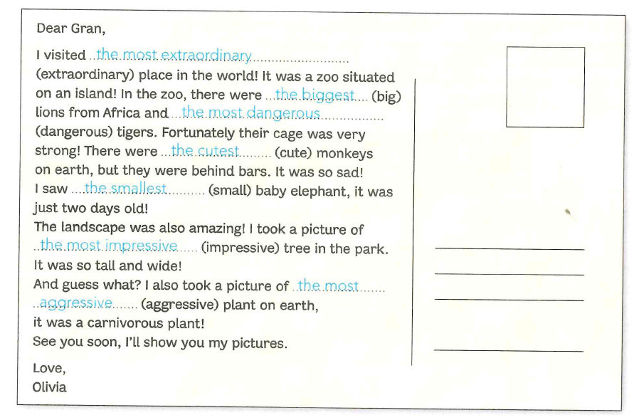

Activity 2 : Look at this table about South Africa’s national parks. Find a record in each category. Write a sentence to explain why the park holds the record.

Ex : Kruger Park has got the greatest number of animals.

|  |  |  |  |  |  |
| --- | --- | --- | --- | --- | --- |
|  | 1. Type of vegetation | 2. Temperature | 3. Animals | 4. Water | 5. Size |
| Kruger | Not a lot of **green** trees : savannah | Medium **hot**  25°C | **Grea**t number | Not very **wet** | Very **big** |
| Hluhluwe | Very **green**: tropical | Medium **hot**  25°C | Medium number | Very **wet** | Not very **big** |
| Karoo | Desert : not **green** at all | **Hot**  30°C | **Low** number | Very **dry** | Not very **big** |

1.

2.

3.

4.

5.

Activity 3 : Who holds the record ? Make a sentence as in the example.

* The snail – the tortoise – the koala bear (slow) : The slowest is the snail.

1. The whale – the elephant – the hippopotamus (heavy)
2. The cheetah – the lion – the kangaroo (fast)
3. Ben Nevis – Snowdon – Cross Fell (three mountains in Great Britain) (high)
4. Florida – Texas – California (thrre American states) (big)

Activity 3 : Who holds the record ? Make a sentence as in the example.

* The snail – the tortoise – the koala bear (slow) : The slowest is the snail.

1. The whale – the elephant – the hippopotamus (heavy)
2. The cheetah – the lion – the kangaroo (fast)
3. Ben Nevis – Snowdon – Cross Fell (three mountains in Great Britain) (high)
4. Florida – Texas – California (thrre American states) (big)

Activity 3 : Who holds the record ? Make a sentence as in the example.

* The snail – the tortoise – the koala bear (slow) : The slowest is the snail.

1. The whale – the elephant – the hippopotamus (heavy)
2. The cheetah – the lion – the kangaroo (fast)
3. Ben Nevis – Snowdon – Cross Fell (three mountains in Great Britain) (high)
4. Florida – Texas – California (thrre American states) (big)

Activity 3 : Who holds the record ? Make a sentence as in the example.

* The snail – the tortoise – the koala bear (slow) : The slowest is the snail.

1. The whale – the elephant – the hippopotamus (heavy)
2. The cheetah – the lion – the kangaroo (fast)
3. Ben Nevis – Snowdon – Cross Fell (three mountains in Great Britain) (high)
4. Florida – Texas – California (thrre American states) (big)

Activity 3 : Who holds the record ? Make a sentence as in the example.

* The snail – the tortoise – the koala bear (slow) : The slowest is the snail.

1. The whale – the elephant – the hippopotamus (heavy)
2. The cheetah – the lion – the kangaroo (fast)
3. Ben Nevis – Snowdon – Cross Fell (three mountains in Great Britain) (high)
4. Florida – Texas – California (thrre American states) (big)