Azani Internet Service Provider Information System
Project structure, UML diagrams, database schema, and logic flow
SCO 200 Object Oriented Programming II — September to November 2026

1. Overview
Azani provides internet connectivity to primary, junior, and senior schools, and to colleges. The brief sets five operations the application must support: institution registration, a readiness site visit, an equipment purchase path for institutions that fail that visit, monthly billing with fines and disconnection for defaulters, and a reconnection step once an institution clears its balance.
This document lays out the pieces a student builds from: the layered structure of the application, the class and object model, the database schema with its field list, and the two logic flows that carry the most marks in the coursework rubric, onboarding and the billing-to-disconnection cycle. The Java code, the SQL scripts, and the written report stay the student's own work.

2. System architecture
The application splits into four layers. A Swing form never talks to the database directly. It raises an event, a service class applies the business rule, and a data access object issues the SQL. This separation keeps a fee change or a fine calculation out of the GUI code, where a marker cannot find it and a student cannot test it in isolation.
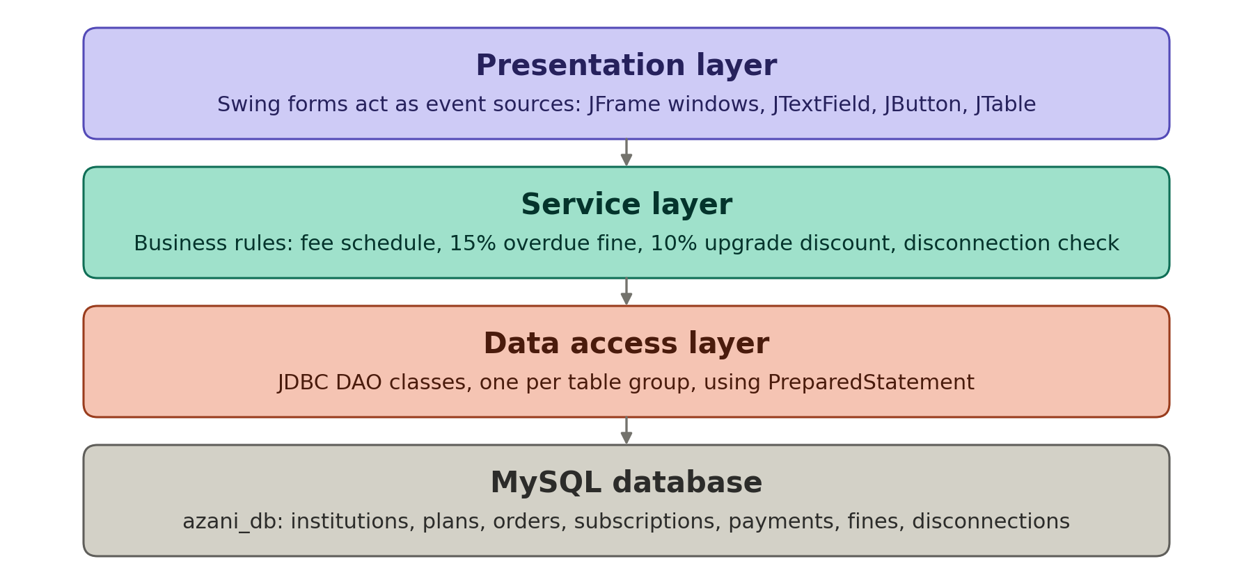
Figure 1. Layered architecture: Swing GUI, service layer, JDBC data access, MySQL database.

3. UML class diagram
The class model separates five concerns. Institution and ContactPerson capture the registration data. ReadinessAssessment, EquipmentOrder, and LANNodeTier capture the site visit and the equipment path an institution takes when it fails that visit. Installation, Subscription, BandwidthPlan, and Upgrade capture the service itself. OverdueFine and Disconnection capture the default path. Payment sits apart as an abstract class, since a registration charge, an installation charge, a monthly charge, and a reconnection charge all share the same shape: an amount, a payment date, and a method that computes what is owed.
Four subclasses extend Payment. RegistrationPayment and InstallationPayment need no extra field, because Institution already links to a fixed fee. MonthlyPayment carries a billingMonth field, since one institution accumulates many monthly payments across a subscription's life. ReconnectionPayment carries the flat KSh 1,000 charge that Azani surcharges once an institution clears both its bill and its fine.
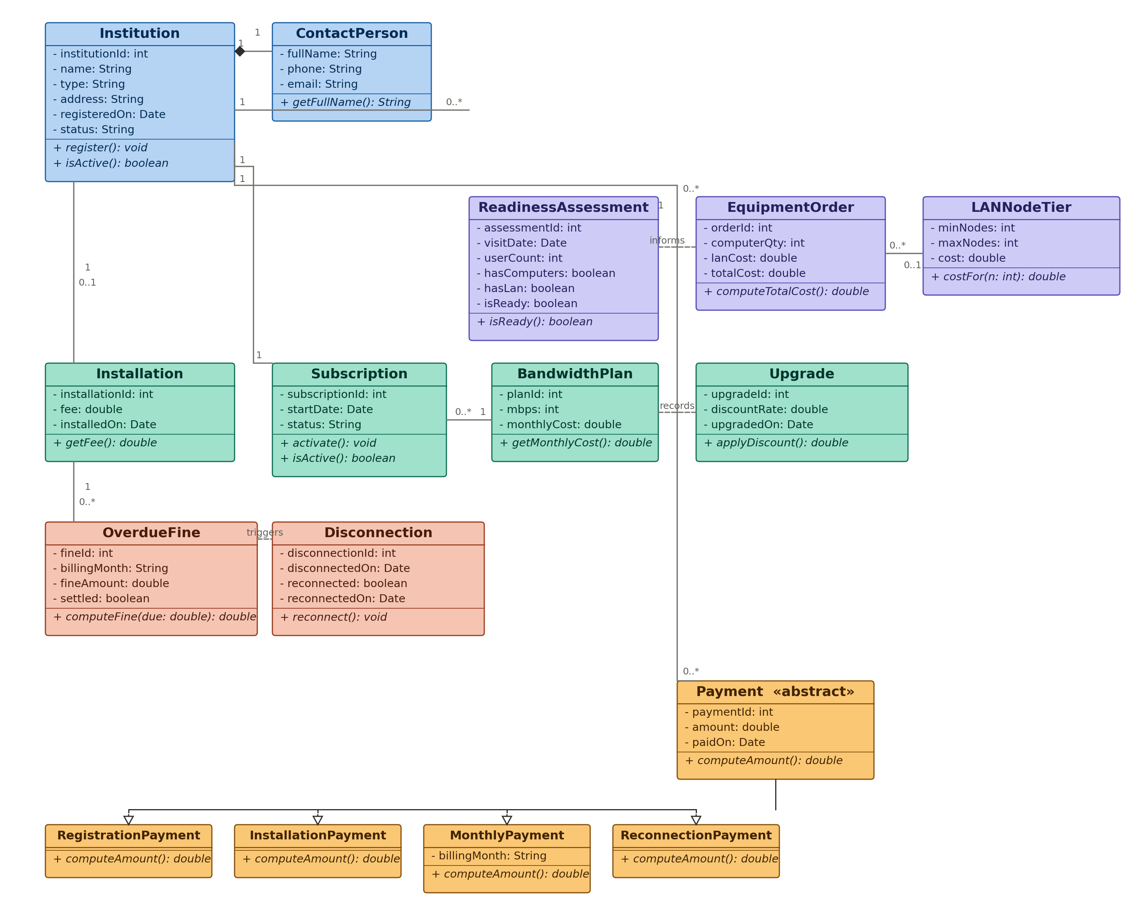
Figure 2. UML class diagram for the Azani domain model.

4. Object diagram
An object diagram freezes the class model at one moment, across the whole system rather than one function. Riverside Primary sits at the centre, linked to its contact person, its installation record, its active subscription and the bandwidth plan behind it, a settled monthly payment, and the history of one earlier fine and disconnection that the institution has since cleared. The snapshot carries the full onboarding-to-billing chain in one picture, not just the billing branch on its own.
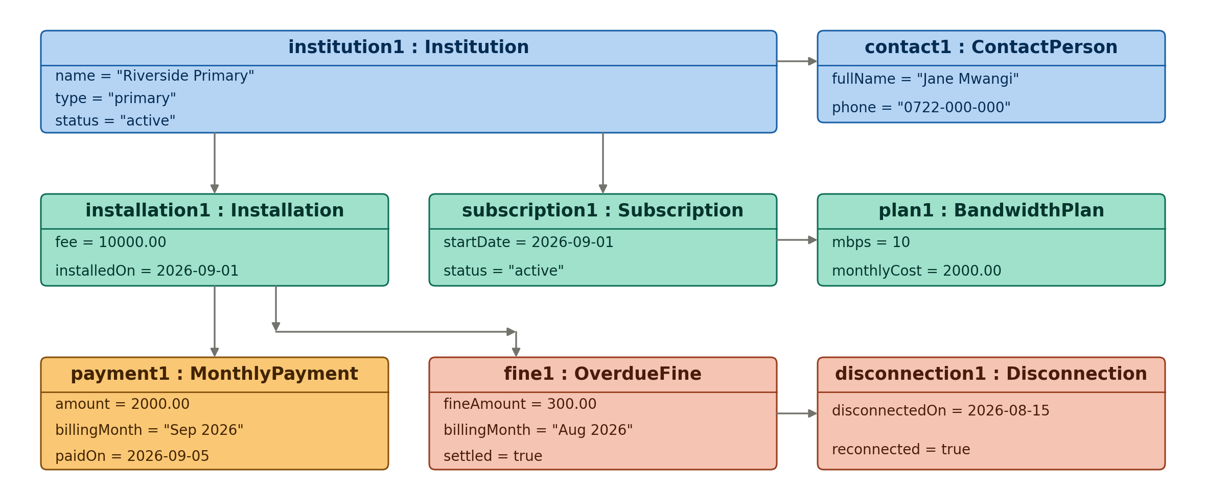
Figure 3. Object diagram: a general snapshot of one institution and every object type it touches.

5. Database schema
Eleven tables carry the class model into MySQL. bandwidth_plans and lan_node_tiers hold the two fixed price lists from the brief, so a rate change updates one row rather than a line of Java. payments carries a payment_type column instead of four separate tables, since a registration charge, an installation charge, a monthly charge, and a reconnection charge differ only in when they occur and what they reference, not in their shape.
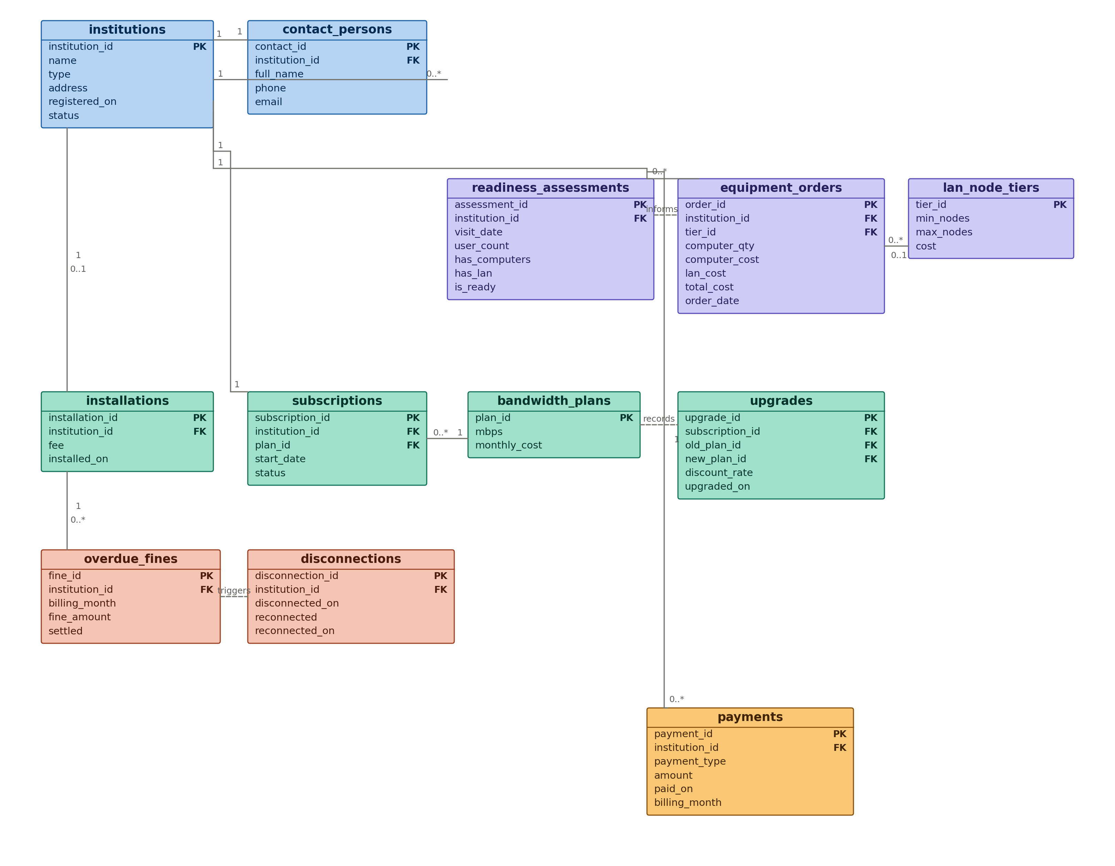
Figure 4. Entity relationship diagram for the azani_db schema.

5.1 Field list
The table below lists every field, its MySQL type, and whether it carries a primary or foreign key. A student wiring up JDBC PreparedStatement calls works from this list directly.
Table | Field | Type | Key
institutions | institution_id | INT, AUTO_INCR. | PK
 | name | VARCHAR(100)
 | type | VARCHAR(20)
 | address | VARCHAR(150)
 | registered_on | DATE
 | status | VARCHAR(20)
contact_persons | contact_id | INT, AUTO_INCR. | PK
 | institution_id | INT | FK
 | full_name | VARCHAR(100)
 | phone | VARCHAR(20)
 | email | VARCHAR(100)
readiness_assessments | assessment_id | INT, AUTO_INCR. | PK
 | institution_id | INT | FK
 | visit_date | DATE
 | user_count | INT
 | has_computers | BOOLEAN
 | has_lan | BOOLEAN
 | is_ready | BOOLEAN
lan_node_tiers | tier_id | INT, AUTO_INCR. | PK
 | min_nodes | INT
 | max_nodes | INT
 | cost | DECIMAL(10,2)
equipment_orders | order_id | INT, AUTO_INCR. | PK
 | institution_id | INT | FK
 | tier_id | INT, NULLABLE | FK
 | computer_qty | INT
 | computer_cost | DECIMAL(10,2)
 | lan_cost | DECIMAL(10,2)
 | total_cost | DECIMAL(10,2)
 | order_date | DATE
installations | installation_id | INT, AUTO_INCR. | PK
 | institution_id | INT | FK
 | fee | DECIMAL(10,2)
 | installed_on | DATE
bandwidth_plans | plan_id | INT, AUTO_INCR. | PK
 | mbps | INT
 | monthly_cost | DECIMAL(10,2)
subscriptions | subscription_id | INT, AUTO_INCR. | PK
 | institution_id | INT | FK
 | plan_id | INT | FK
 | start_date | DATE
 | status | VARCHAR(20)
upgrades | upgrade_id | INT, AUTO_INCR. | PK
 | subscription_id | INT | FK
 | old_plan_id | INT | FK
 | new_plan_id | INT | FK
 | discount_rate | DECIMAL(4,2)
 | upgraded_on | DATE
payments | payment_id | INT, AUTO_INCR. | PK
 | institution_id | INT | FK
 | payment_type | VARCHAR(20)
 | amount | DECIMAL(10,2)
 | paid_on | DATE
 | billing_month | VARCHAR(20), NULLABLE
overdue_fines | fine_id | INT, AUTO_INCR. | PK
 | institution_id | INT | FK
 | billing_month | VARCHAR(20)
 | fine_amount | DECIMAL(10,2)
 | settled | BOOLEAN
disconnections | disconnection_id | INT, AUTO_INCR. | PK
 | institution_id | INT | FK
 | disconnected_on | DATE
 | reconnected | BOOLEAN
 | reconnected_on | DATE, NULLABLE

6. Logic flow: onboarding
Registration and the readiness visit run once per institution, and both branches converge on a single subscription record. The billing service that runs afterward does not need to know which branch an institution took to get there.
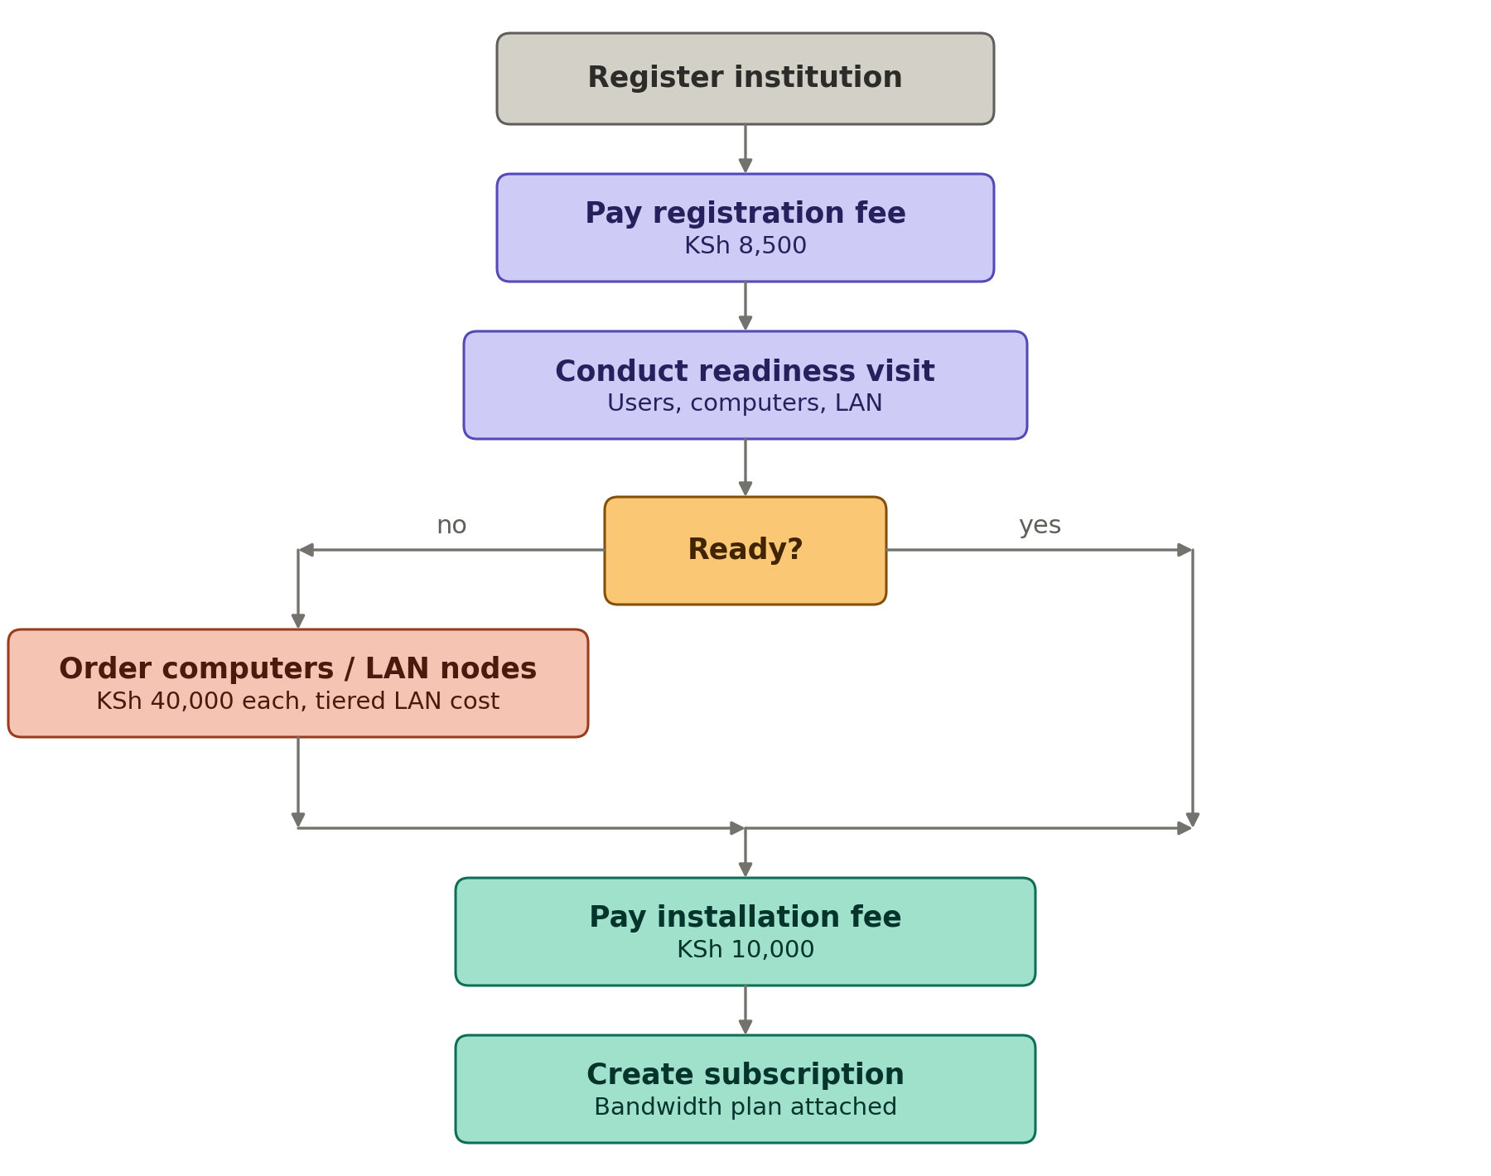
Figure 5. Onboarding logic: registration through to an active subscription.

7. Logic flow: billing and disconnection
The monthly cycle checks two deadlines. An institution that misses the first, the end of the billing month, picks up a fine of 15 percent of the amount due. An institution that then misses the second, the 10th of the following month, loses its connection until it clears the bill, the fine, and a KSh 1,000 reconnection charge.
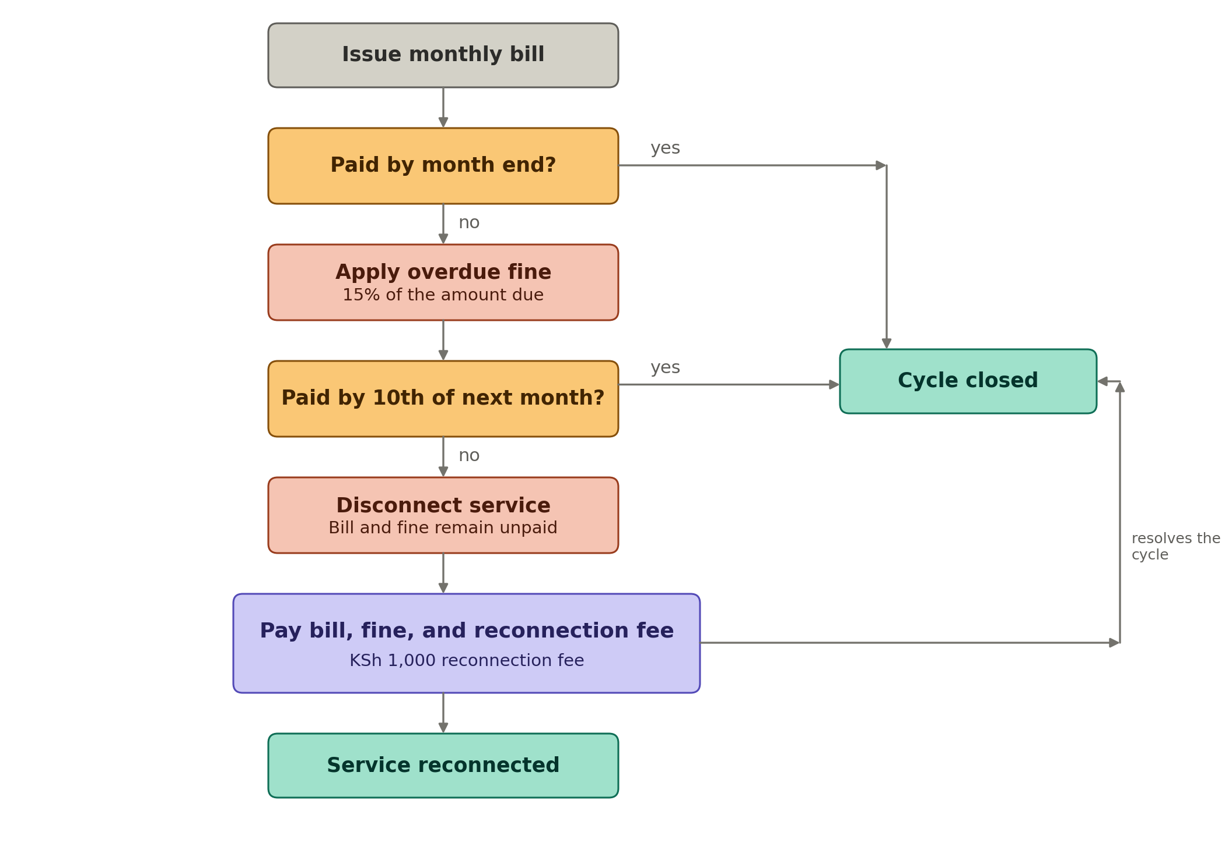
Figure 6. Billing cycle, overdue fine, and the disconnection and reconnection path.

8. Notes for the build
- Build the schema first, then the DAO layer, then the domain classes, then the Swing forms. Each screen then has real data behind it before a layout decision gets made.
- A save button implements ActionListener. Its actionPerformed method reads each JTextField with getText(), builds the object, and passes it to the service layer rather than to the DAO directly.
- The applet life cycle sits outside this project's scope, since the brief asks for a desktop application. Keep it as a separate revision item for the exam rather than a component to build here.
- The 15 percent fine applies once, against the unpaid bill for that month. A BillingService method checks the payment date against the cycle rather than looping and re-applying the fine on every run.
- Institution type is not a decorative field. Report requirement 4(d) asks for total monthly charges by category of institution, so the report query groups on institutions.type.
- Payments captured explicitly by the brief are registration, installation, and monthly. Treat the reconnection surcharge as a fourth payment type in the same table, since it is money the system still has to record and reconcile.

