SuperMarket

Kheir Almosally student number :3039285

JMS application is a chat application between store manager and store office, consist of two main part supermarket manager and office replier, where the manager ask for a product by product name, and the office replier replay him with a message and the quantity of product.

Supermarket manager as Requester

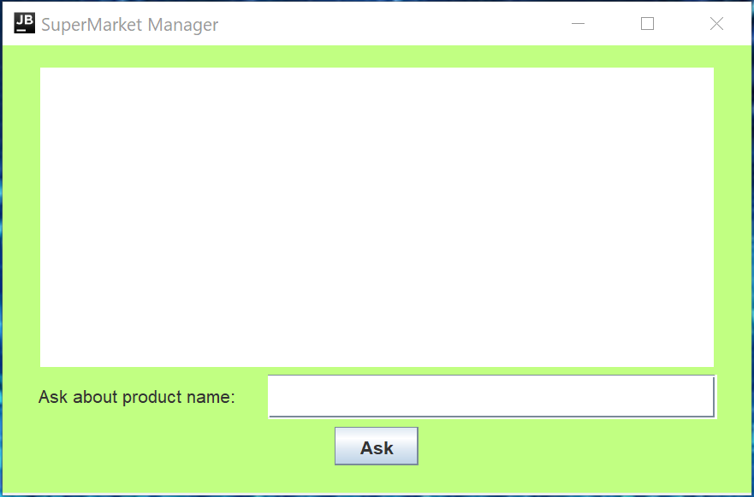

Supermarket office as replier

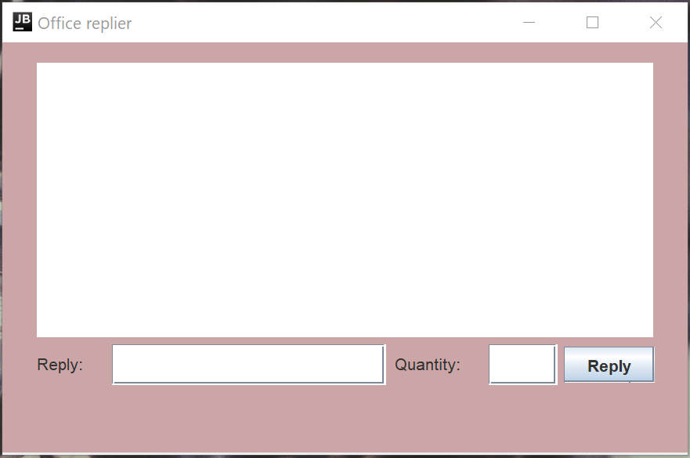

**Start-up**

* Please make sure that Apache-activemq-5.*.* is running on your device.
* Build project.
* Run Requester&replier.
* Note: please if any of the program cant build go to 🡪 gradle 🡪 run configuration 🡪 application run

**Application features.**

Requester and replier application with asynchronous communication.

Easy to define from the message the requester and replier.

Reply to any request by simply select it the request,

Gson library has been used.

Start another requester or replier without change the code or stop the application.

Error request and reply handler

* Manager can’t send empty request.
* Replier should first chose from the list before reply and cant reply with empty message

