NAME: Misty Baragar CS466-001

CHAPTER: 13

LAB: Lab 13 Ex 1 and 2

ANIMATED FLASHCARDS

1. Artificial intelligence (AI)

2. Artificial neural network

3. Breadth-first approach

4. Chatbot

5. Depth-first approach

6. Effective weight

7. Expert system

8. Inference engine

9. Knowledge-based system

10. Lexical ambiguity

11. Loebner prize

12. Natural language

13. Phonemes

14. Referential ambiguity

15. Rule-based system

16. Search tree

17. Semantic network

18. Strong equivalence

19. Syntactic ambiguity

20. Natural language comprehension

21. Training

22. Turing test

23. Voice recognition

24. Voiceprint

25. Weak equivalence

26. Voice synthesis

BOOK EXERCISES

1. A

2. C

3. B

4. C

5. B

6. A

7. A

8. A

9. A

10. A

11. B

12. B

13. A

14. B

15. A

16. B

17. A

18. A

19. B

20. A

21. A

31. The Turing Test is a test devised by Alan Turing to answer the question “How can we know we’ve succeeded in creating a machine that can think?” The test is based on whether a computer could fool a human into believing that the computer is another human being.

33. Weak equivalence is the equality of two systems based on their results. The Turing Test shows weak equivalence.

34. Strong equivalence is the quality of two systems based on their results and the process by which they arrive at those results

38. A graph is used to represent a semantic network. The nodes in the graph represent objects and the arrows (arcs) represent relationships.

39.



44. Depth-first searching begins at the top level (root) and continues going deeper and deeper into the tree until the search has reached a leaf node, at which time the search moves back up one level and starts down again. A breadth-first search begins at the top level, then searches every node on the next lower level, then searches every node at the next lower level, until it has searched every node on every level.

54. A neuron

55. A pathway in the brain

56. The signals depend on the state of the neurons through which the signal passes

57. Dendrites

58. An axon

59. The dendrites of one neuron pick up the signals from the axons of other neurons to forma neural network.

60. A synapse

|  |
| --- |
| 61. The chemical composition of a synapse tempers the strength of its input signal. |
| 62. The role of a synapse is to weight the input signal. |
| 63. A synapse is represented by a weight assigned to each input signal. |
| 64. An effective weight is the sum of the weights multiplied by the corresponding input values. |
| 65. Each neuron has a numeric threshold value. If the effective weight is greater than the threshold, a 1 is output; otherwise, a 0 is output.  66. 1 |

LAB EXERCISES

Exercise 1

5.

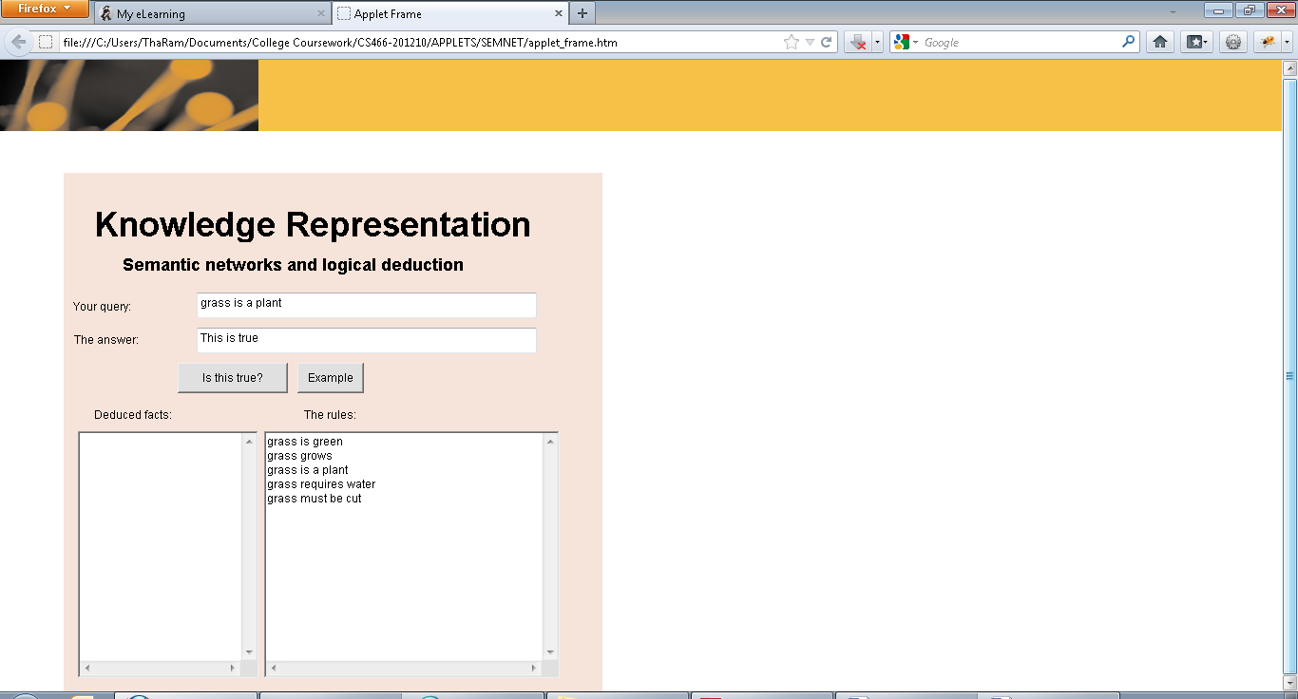

6.

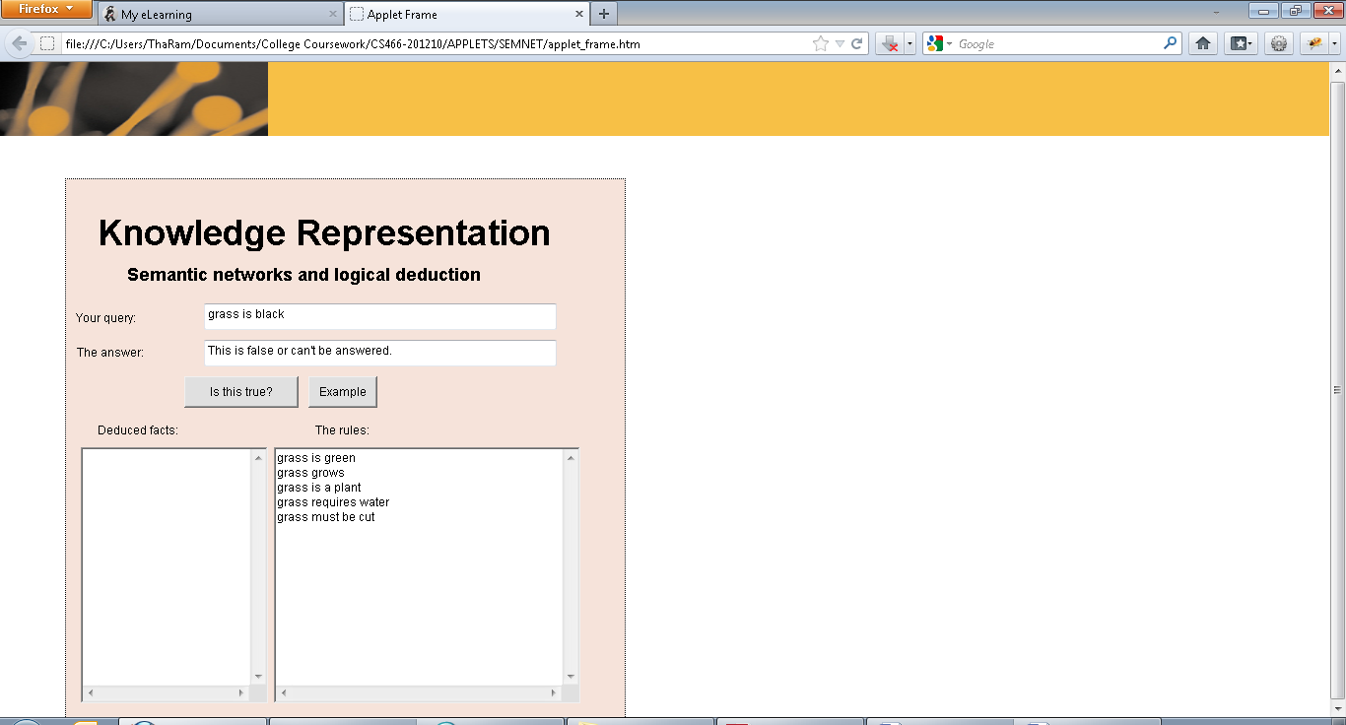

7. It is false. The rules only discuss hair.

8. In order for it to be true, rules about John and hair would have to be added.

Exercise 2

6.

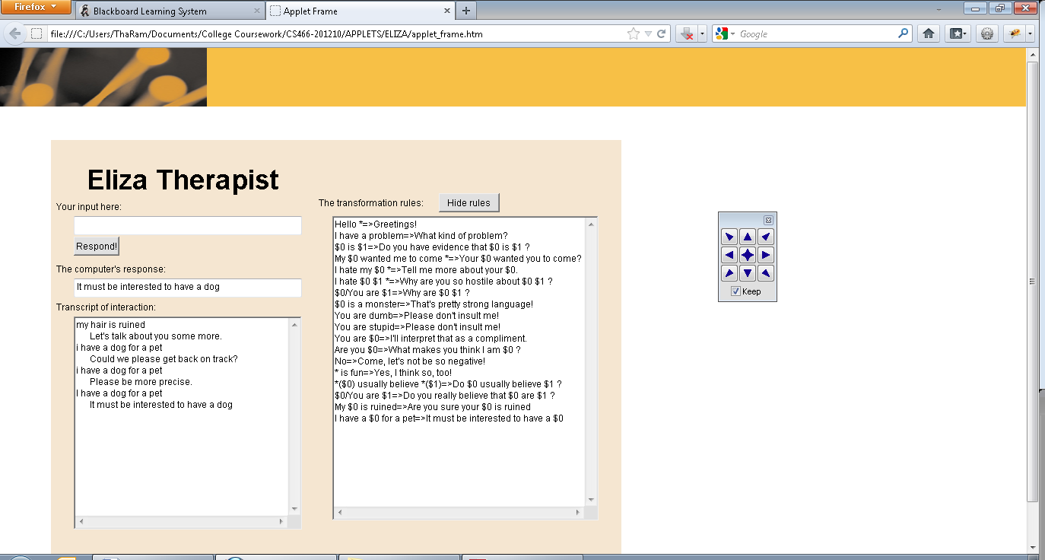

7.

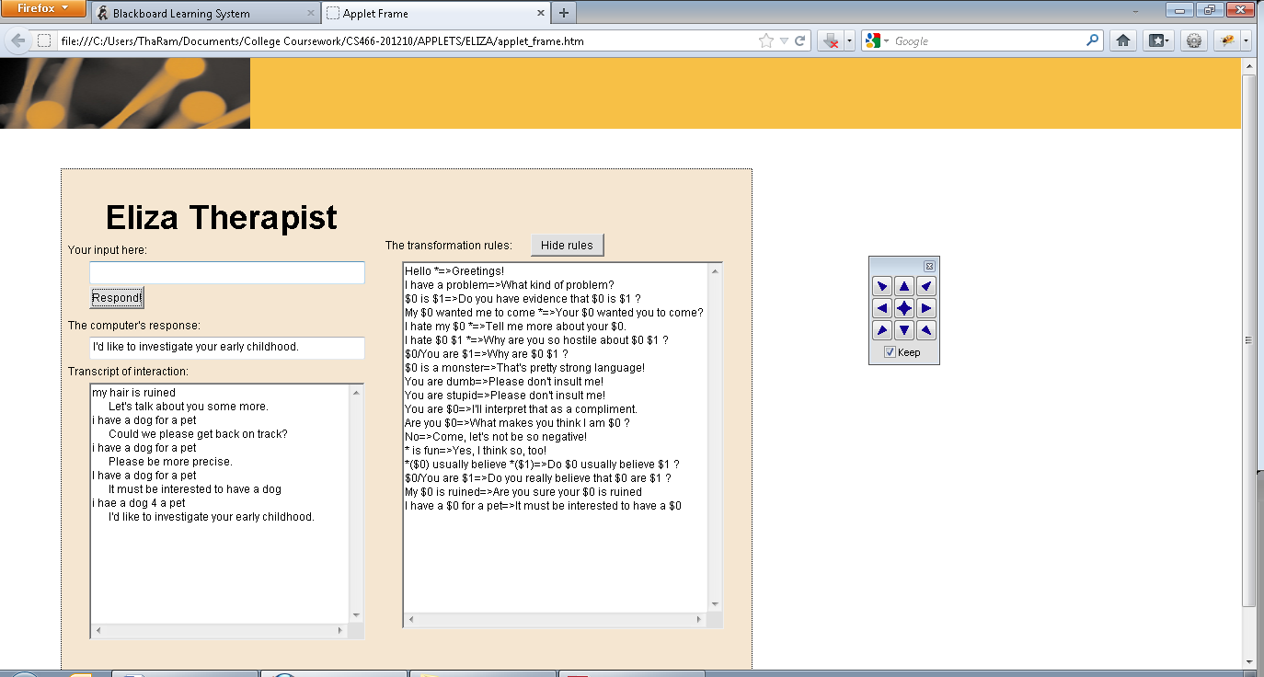

8.

