# FLASH CARDS

1. Word
2. Positional Notation
3. Base
4. Negative Number
5. Integer
6. Byte
7. Bit
8. Rational Number
9. Natural Number
10. Number
11. Binary Digit

# BOOK EXERCISES

1. Number
2. Integer number
3. Natural number
4. Rational number
5. Negative number
6. A -10001100
7. C - 1101010
8. B - 10011110
9. F - 1111000
10. D - 1100000
11. E - 1010001
12. True
13. False
14. False
15. False
16. True
17. False
18. A) 891 B) C)
19. A) 8 x 102 + 9 x 101 + 1 x 100 b) 8 x 82 + 9 x 81 + 1 x 80 c) 8 x 122 + 9 x 121 + 1 x 120 d) 8 x 132 + 9 x 131 + 1 x 130 e) 8 x 162 + 9 x 161 + 1 x 160
20. A) 7 B) 511 C) 4076 D) 1911 E) 73
21. 8 is a power of 2
22. A) 766 b) 101 c) 202 d) 142
23. A) A9 b) E7 c) 67 d) 7F
24. A) 251 b) 347 c) 156
25. A) 1FF b) 185 c) 123 d) 151 e) 1
26. A) 1605 b) 501 c) 2724 d) 2052 e) 3721
27. A) 101101 B) 1000101 C) 10000101010 D) 1100011 E)1
28. A) 42A B) 793 C) 1 D) 3E6 E) 2B
29. !@$%&*(
30. A) 1655 B) 1010 C) 1071
31. A) 19AF9 B)AF8 C) BC33
32. A) 70 B) 247 C) 2222
33. A) 9AB B) 98DD C) 9566
34. Because it is the language that the computer can understand.
35. 8 bits
36. 8 bytes
37. Fourth generation
38. Because the number range is limited based upon the base that is being used.
39. 23954

# LAB EXERCISES

1. 1*27 + 1*26 + 0*25 + 1*24 + 1*23 + 1*22 + 0*21 + 1*20  = 221
2. 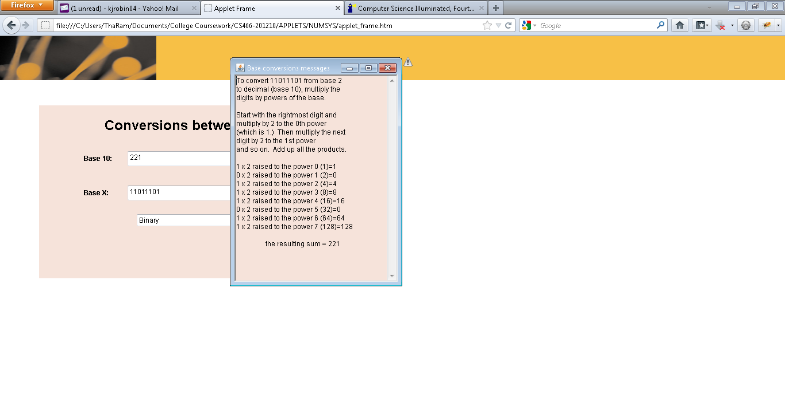
3. 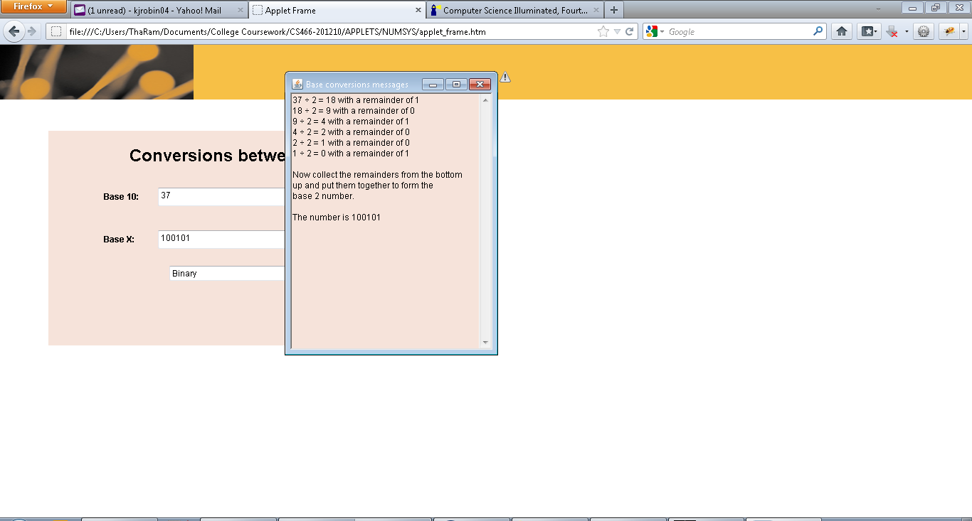
4. 53/2= 26 rem 1, 26/2= 13 rem 0, 13/2=6 rem 1, 6/2=3 rem 0, 3/2=1 rem 1, 1/2 = 0 rem 1 = 110101
5. 
6. 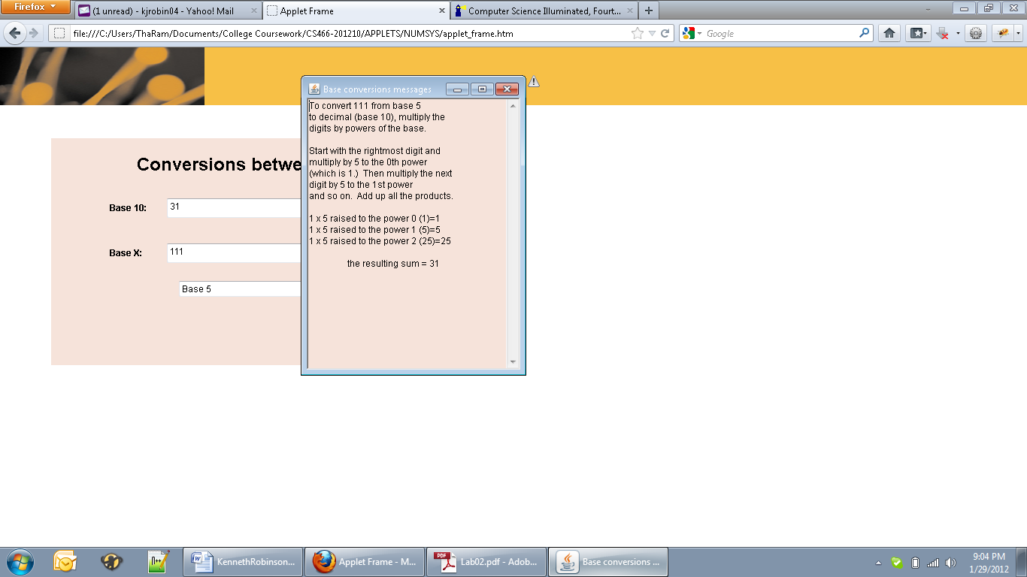
7. 10101101  
   +00111001  
    11100110
8. 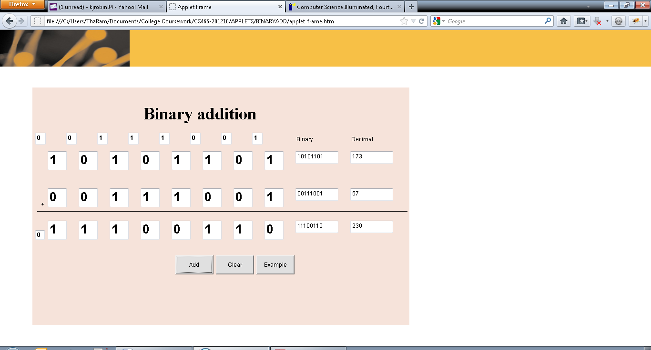
9. Largest Add: 255  
   Largest Produce: 510