NAME: Kenneth Robinson

CHAPTER: 10

LAB: Lab 10

ANIMATED FLASHCARDS

1. Address binding

2. Application software

3. Base register

4. Booting the system

5. Bounds register

6. Context switch

7. CPU scheduling

8. Demand paging

9. Dumb terminal

10. Dynamic-partition technique

11. Fixed-partition technique

12. Frame

13. Logical address

14. Mainframe

15. Memory management

16. Multiprogramming

17. Non-preemptive scheduling

18. Operating system

19. Page

20. Page map table (PMT)

21. Page swap

22. Paged memory technique

23. Personal computer (pc)

24. Physical address

25. Preemptive scheduling

26. Process

27. Process control block (PCB)

28. Process management

29. Process states

30. Real-time system

31. Response time

32. Single contiguous memory management

33. System software

34. Thrashing

35. Time slice

36. Timesharing

37. Turnaround time

38. Virtual machine

39. Virtual memory

BOOK EXERCISES

1. B

2. A

3. A

4. B

5. A

6. B

7. A

8. A

9. B

10. B

11. B

12. B

13. A

14. A

15. A

16. B

17. B

18. A

19. A

20. B

21. C

22. E

23. D

24. C

25. A

26. B

27. Systems software are tools to help others write programs; they manage a computer system and interact with hardware. Application software are programs to solve specific problems.

28. An operating system is a piece of software that manages a computer’s resources and provides an interface for system interaction.

31. A batch job was made up of the program and the instructions regarding the system software and other resources needed to execute the job.

33. Timesharing is a technique by which CPU time is shared among multiple interactive users at the same times.

34. Multiprogramming allows multiple processes to be active at once. Timesharing allows the multiple processes to be interactive one.

37. Each user is represented by a login process that runs on the mainframe. When the user runs a program, a new process is created that competes for CPU time with other processes. The rationale is that the computer is so fast that it can handle multiple users without anyone having to wait.

38. A real-time system is a system in which the speed of an answer is crucial.

39. Response time is how long it takes to get an answer. The expression comes from the delay between receiving a stimulus (asking a question) and producing a response (answering the question).

40. Time is critical in many real-time situations, so the response time must be kept to a minimum.

41. The OS must keep track of where and how a program resides in memory and converts logical program addresses into actual memory addresses.

42. A physical address is an actual address in the computer’s main memory device. A logical address is an address relative to the program. A logical address is sometimes called a relative address for obvious reasons.

43. Address binding is the mapping of a logical address into a physical address.

46. When the program is loaded into memory.

48. At location 0.

LAB EXERCISE

Exercise 1

1. There are 2 holes. There is 275KB that is free. The largest job that can be added can be no more than 100 KB.

2. An error message is displayed saying that it could not find a slot.

3. The job was added below Job 6.

5. Expected it to go in the first available spot.

6. It will go in the spot that fits the best or closest to the best.

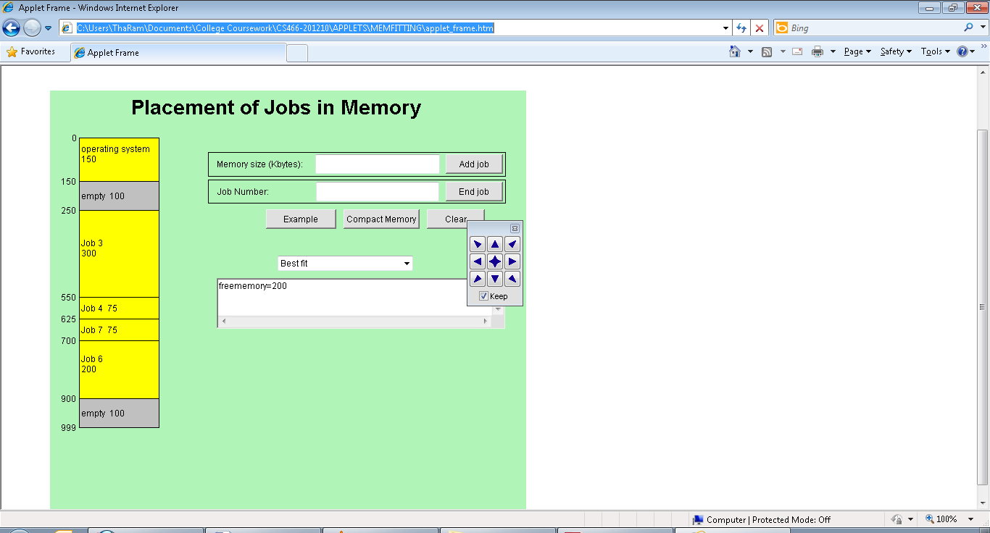

7. It will take a lot of time because if the memory that comes first is not large enough to be allocated to the job, it will have to go to the next one and keep looking for memory space that would fit best which may take time.

8. If the computer always did it, it would reduce performance.

Exercise 2

3. They both have the same total time; however, the average turnaround time for the Shortest Job First is better than the First Come, First Served.

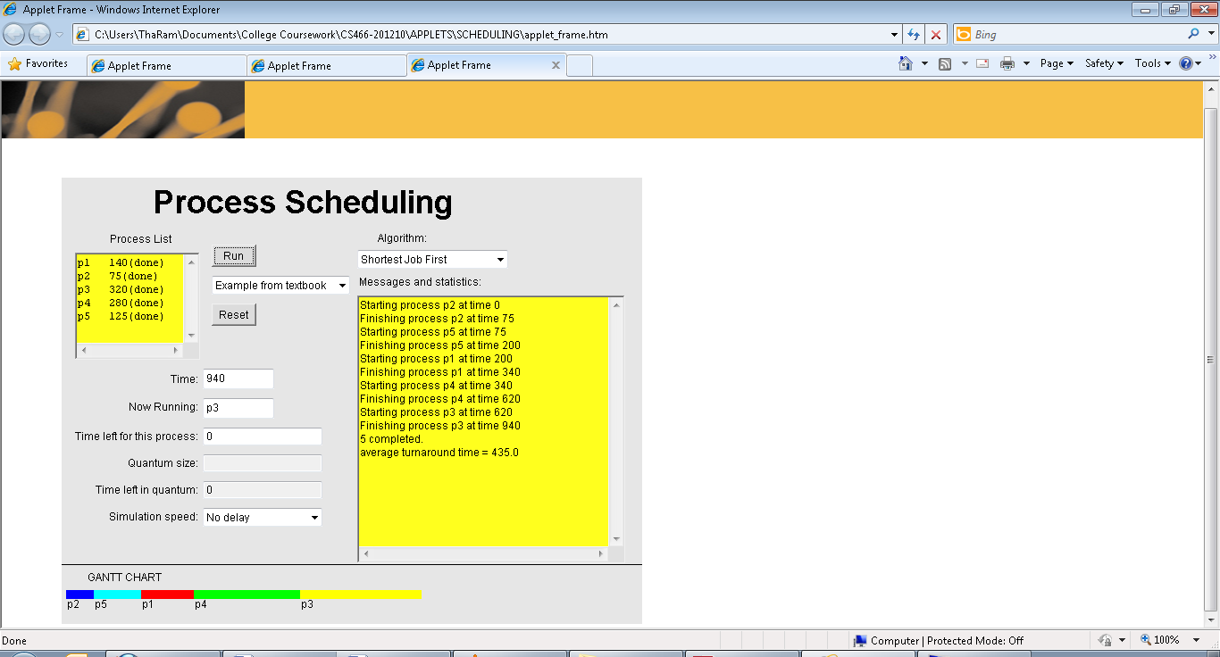

4. Although the total time used is same, the average turnaround time compared to the other two is a lot more, but we cannot say this Algortith is not as good as the others.

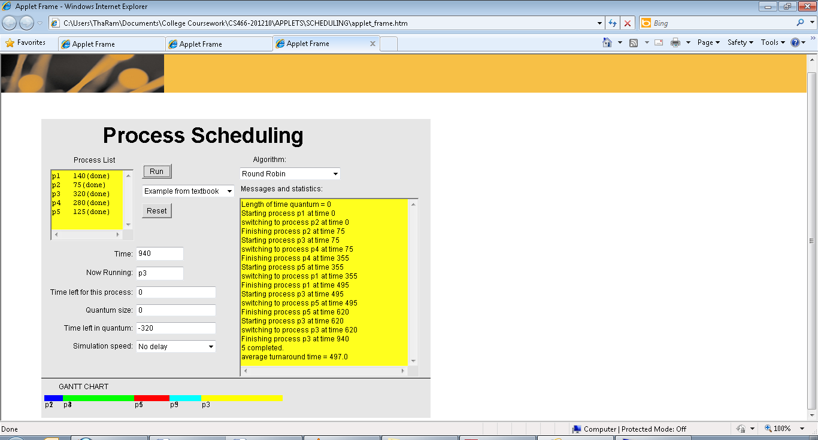

5. The Round Robin algorithm is preemptive because it establishes a particular time slice which is the amouth of time each process receives before it is preempted and returned to the ready sate to allow another process to take its turn. Most computing systems would use Round Robin because it supports all kinds of jobs.