NAME: Kenneth Robinson

CHAPTER: 14

LAB: Lab 14

ANIMATED FLASHCARDS

1. Authentication credentials

2. Back door

3. Biometrics

4. Buffer overflow

5. Computer gaming

6. Denial of service

7. Electronic commerce

8. Game engine

9. Gameplay

10. Interactive system

11. Logic bomb

12. Malicious code

13. Man-in-the-middle

14. Model

15. Password

16. Password guessing

17. Phishing

18. Simulation

19. Smart card

20. Spoofing

21. Trojan horse

22. Virus

23. Worm

BOOK EXERCISES

1. A

2. B

3. A

4. A

5. B

6. B

7. A

8. A

9. B

10. A

11. A

12. A

13. B

14. B

15. B

16. B

17. B

18. A

19. A

20. B

21. A

22. A

23. B

24. B

25. Simulation is the development of a model of a complex system and the experimentation with the model to observe the results. TV weather forecasters use computer models to predict the weather. Pilots spend time in a flight simulator before actually flying an aircraft. Engineers use wind tunnels to test out a new design. Automotive engineers use simulated crash test to see how cars survive at different speeds. Dummies are used in crash tests to see how they survive. A chef experiments with a new recipe to see which combination of ingredients is best.

26. The essence of constructing a model is to identify a small subset of characteristics or features that are sufficient to describe the behavior to be investigated.

27. Continuous simulation treats time as continuous and expresses changes in terms of a set of differential equations that reflect the relationships among the set of characteristics. Discrete event simulation is made up of entities, attributes, and events, where entities represent objects in the real system, attributes are characteristics of a particular entity, and events are interactions among entities.

28. The keys to constructing a good model are correctly choosing the entities to represent the system and correctly determining the rules that define the results of the events.

29. A set of rules that are part of the model determine the interactions among the events.

30. Abstract models are implemented in a computer program, so object-oriented design techniques can be used to build the model.

31. The goal of a queuing system is to determine how to minimize wait time.

32. The number of events and how they affect the system (to determine the rules of entity interaction)

• The number of servers (entities)

• The distribution of arrival times (to determine if an entity enters the system)

• The expected service time (to determine the duration of an event)

33. The random number generator is used to represent luck. If an event happens every x minutes, a random number generator is used to determine if the event happens at each minute.

34. If a car arrives, it gets in line. A car arrives if the random number is between 0.00 and 0.33. If the pump is free and there is a car waiting, the first car in line leaves the line and goes to the pump and the service time is set to four. If a car is at the pump, the time remaining for the car is decremented. If there are cars in line, the additional minute that they have been waiting is recorded.

35. No, the service time is greater than the arrival probability.

36. If a car arrives, it gets in line. A car arrives if the random number is between 0.0 and 0.5.

If the pump is free and there is a car waiting, the first car in line leaves the line and goes to the pump and the service time is set to two. If a car is at the pump, the time remaining for the car is decremented. If there are cars in line, the additional minute that they have been waiting is recorded.

37. If a customer arrives, he or she gets in line. A customer arrives if the random number is between 0.00 and 0.33. If a clerk is free and there is a person waiting, the first person in line leaves the line and goes to the free clerk and the service time is set to three. If a customer is with the clerk, the time remaining for the customer is decremented. If there are customers in line, the additional minute that they have been waiting is recorded.

38. Dequeue in a FIFO queue returns the entity that has been in the queue the longest time. Dequeue in a priority queue returns the entity with the highest priority.

39. SIMULA introduced the concepts of classes and objects, inheritance, and polymorphism.

40. Meteorological models are based on time-dependent equations from fluid mechanics and thermodynamics.

46. Generate a random number for each customer. If the number is between 0.00 and 0.20, the customer takes 8 minutes. Otherwise it takes the customer 3 minutes.

50. If the top of the table is rectangular, it could be defined by a series of rectangular planes for the top, side, and bottom surfaces. If the top of the table has rounded corners, planes with rounded corners could be used for the top and bottom. The sides would need a curved surface to create the rounded corners. If the table had square legs, a set of four planes could be used for the sides of each leg. If the table had round legs, a cylinder could be used for each leg. If the table has curved legs, one or more curved surfaces could be used.

51. Object movement must be done very carefully because people are very skilled at recognizing movement. Even the slightest problems will be very noticeable. Physical laws such as gravity can be used for some motion. Motion of figures is more complex because the motion is restricted by how the muscles work and the joints move. We people move, all of their joints are changing position simultaneously. This process must be duplicated if the resulting animation is going to appear realistic.

52. Bioinformatics, computational biomodeling, computational genomics, molecular modeling, and protein structure prediction.

LAB EXERCISES

Exercise 1

2.

|  |  |  |  |
| --- | --- | --- | --- |
| **Line length** | **Ending config** | **Time to reach** | **Notes** |
| 1 | Blank | 1 | Disappears almost completely |
| 2 | Blank | 1 | Disappears |
| 3 | Oscillating | 2 |  |
| 4 | Stable | 3 |  |
| 5 | Oscillating | 20 |  |
| 6 | Blank | 25 |  |
| 7 | Stable | 20 |  |
| 8 | Stable | 50 |  |
| 9 | Changing | 30 |  |
| 10 | Changing | 35 |  |
| 11 | Oscillating | 25 |  |
| 12 | Blank | 50 |  |
| 13 | Blank | 50 |  |
| 14 | Stable | 30 |  |

3. Some of the odd numbers ended up oscillating at the end.

4.

|  |  |  |  |
| --- | --- | --- | --- |
| **Line Length** | **Ending config.** | **Time to reach** | **Notes** |
| 2 | Stable | 1 |  |
| 3 | Stable | 10 |  |
| 4 | Stable | 10 |  |
| 5 | Stable | 15 |  |
| 6 | Oscillating | 15 |  |
| 7 | Oscillating | 10 |  |
| 8 | Stable | 10 |  |
| 9 | Stable | 20 |  |
| 10 | Oscillating | 15 |  |
| 11 | Oscillating | 35 |  |
| 12 | Oscillating | 25 |  |
| 13 | Oscillating | 20 |  |
| 14 | Oscillating | 20 |  |

Exercise 2

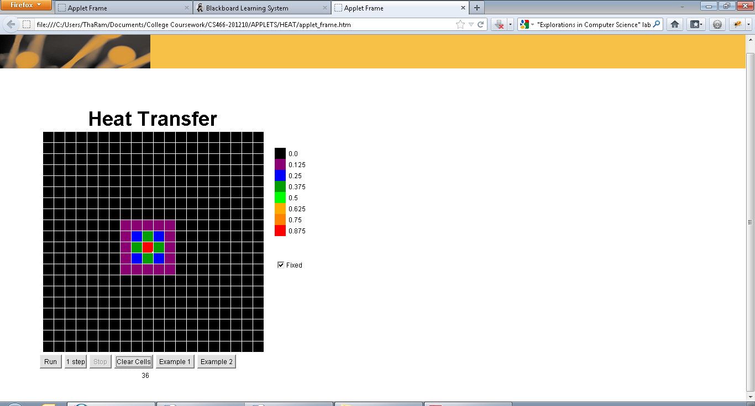

4. There are 4 different colors in a square like pattern.

5. Yes

6. If the coal is in the air

7. The rate of change is gradual and represents what might happen in reality

8. The colors gradually disappear beginning with the red and the other colors closest to it. I don’t really know what’s going on.