Flashcards Answers:

1. Data
2. Digital data
3. Keyword encoding
4. Mantissa
5. Analog data
6. Flag
7. Information
8. Run-length encoding
9. Ten’s complement
10. Video codec
11. Raster-graphics format
12. Character set
13. Pixels
14. Bandwidth
15. Reclock
16. Lossy compression
17. Signed-magnitude representation
18. Digitize
19. Data compression
20. Floating point
21. Resolution
22. Scientific notation
23. Huffman encoding
24. Pulse-code modulation
25. Radix point
26. Lossless compression
27. Compression ratio
28. Vector graphics
29. Overflow
30. Data representation
31. Temporal compression
32. Multimedia
33. Spatial compression

Exercises Answers:

1. True
2. False
3. True
4. True
5. False
6. True
7. True
8. False
9. True
10. True
11. True
12. True
13. False
14. True
15. True
16. True
17. False
18. True
19. True
20. True
21. E – Analog
22. A – Signed-magnitude representation
23. B – Radix point
24. F – Digital data
25. C – Frequency of use
26. D – sampling
27. Data compression is important because of the need to share data with others, in terms of the Web’s network having inherent bandwidth restrictions that define maximum number of bits or bytes that can be transmitted from one place to another in a fixed amount of time.
28. Lossless data compression is a technique in which there is no loss of information, while lossy data compression has loss of information.
29. Computers are not infinite because their memory and other hardware devices have only so much room to store and manipulate certain amount of data.
30. A clock with a sweeping hand is an analog device because the hands keep moving/increasing to measure time.
31. It means to break down into pieces and representing the pieces separately.
32. Pulse code modulation is a variation in a signal that jumps sharply between two extremes
33. A) 16 B)32 C)64 D)128
34. A) -1 B)45 C) 4 D) -42 E)30 F)11 G) -46 H) -40
35. 6 bits

49. The Unicode has a much stronger International influence because it represents many more characters in all languages.

50.

51. *A4BBB*C8*D4 hi there *E9FF = 0.675

52. XXXXXAAAAAAAAA

53. A) ELATE B) CHORES C) FANTASTIC D) NONSENSE

Lab 2

1. The 8 bit differs from the 32-bit in that the 32-bit has more numbers

|  |  |  |
| --- | --- | --- |
|  | **4** | **-4** |
| 8-bit | 00000100 | 10000100 |
| 12-bit | 000000000100 | 100000000100 |
| 16-bit | 0000000000000100 | 1000000000000100 |
| 32-bit | 00000000000000000000000000000100 | 10000000000000000000000000000100 |

1. 1000000000000000000000000000000000000000000000000000000000000100
2. Both results are the same.
3. 1111111111111111 & 1000000000000001

It’s like they are inverted. Usuallly the one with the many 0s is the signed magnitude.

1. No it doesn’t. It’s weird that the larger number can be represented and not 8  
   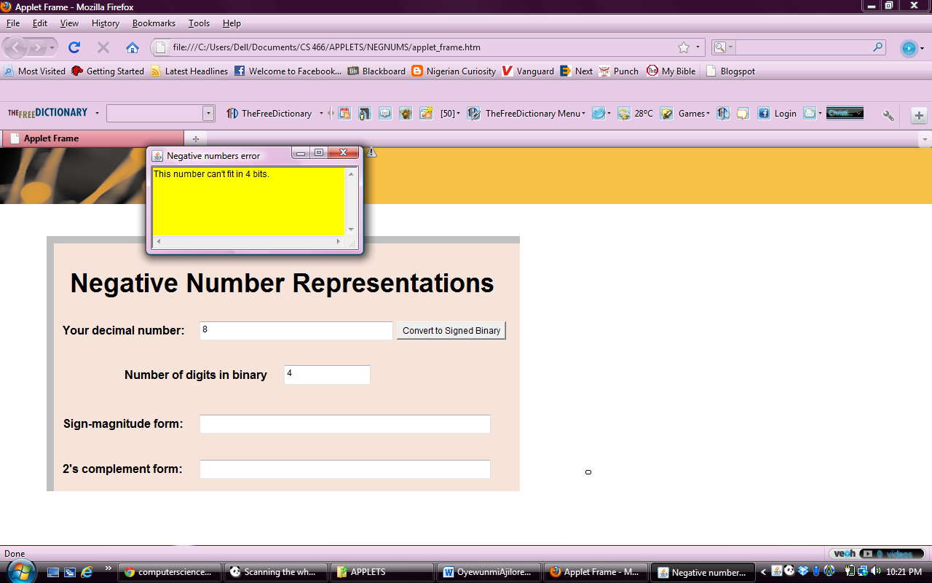

**Real Numbers:**

1. 9.419876302 & 0.5483089656336233
2. The differences vary based on the number. I can’t for sure say 10 is bigger than two even though that would be logically correct.
3. 0.1000110001 0100010
4. Sign of the exponent is negative (-)

|  |  |
| --- | --- |
| 0.5 | 0 0.1000000000 000000 |
| 0.25 | 0 0.1000000000 100001 |
| 0.125 | 0 0.1000000000 100001 |

The mantissa is the same for both 0.25 and 0.125

The exponent for the base 10 remains the same, while that for base 2 reduces

The next number will be 0.0625

**Text Compressor**

2) 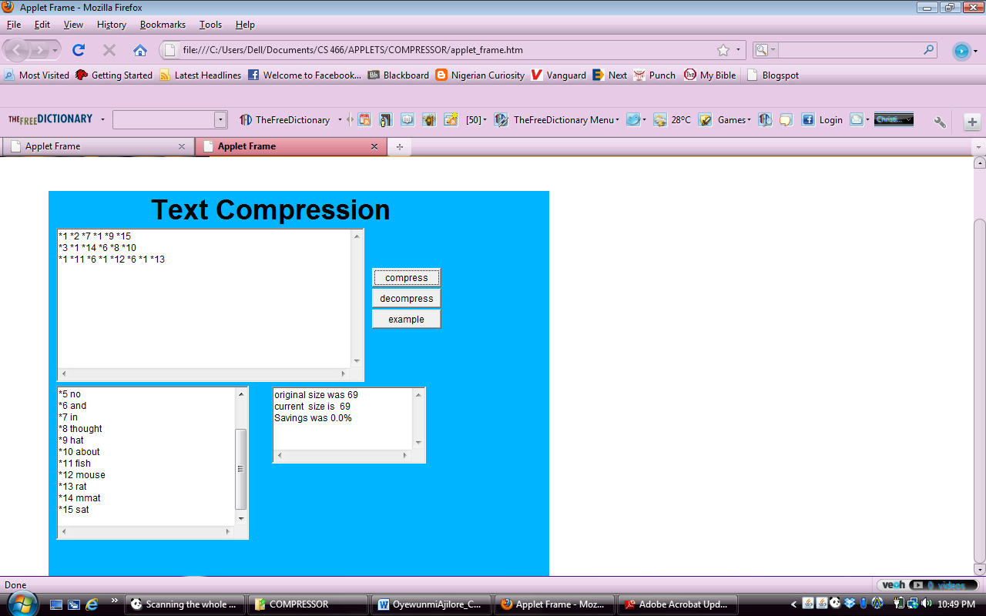

3) I don’t think it can be used for encryption because what of a situation whereby the data/information to be encrypted contains *, how will it be represented?

4) It doesn’t do anything