**Flashcards Answers:**

1. Transistor
2. Sequential Circuit
3. Circuit Equivalence
4. Boolean Operators
5. Gate
6. Half Adder
7. Full Adder
8. Boolean Algebra
9. Logic Diagram
10. Multiplexer
11. Adder
12. Combinational Circuit
13. Truth table
14. Computer
15. Integrated circuit
16. Circuit
17. Semiconductor

**Exercises Answers:**

1. True
2. False
3. False
4. True
5. False
6. True
7. False
8. False
9. False
10. True
11. True
12. True
13. False
14. True
15. False
16. True
17. True
18. F – NOT
19. A – AND
20. D – OR
21. C – XOR
22. B – NAND
23. E – NOR
24. F – NOT
25. A – AND
26. D – OR
27. C – XOR
28. B – NAND
29. E – NOR
30. Voltage levels range from 0-5volts. If the voltage level is from 0-2volts, it is considered low which is 0 in binary digits. If the voltage level is however 2-5volts, it’s considered high which is 1 in binary digits.
31. A gate can receive one or more input signals, but can however only produce 1 output signal.

53. Gates are combined into circuits by using the output of one gate as the input for another gate.

58.

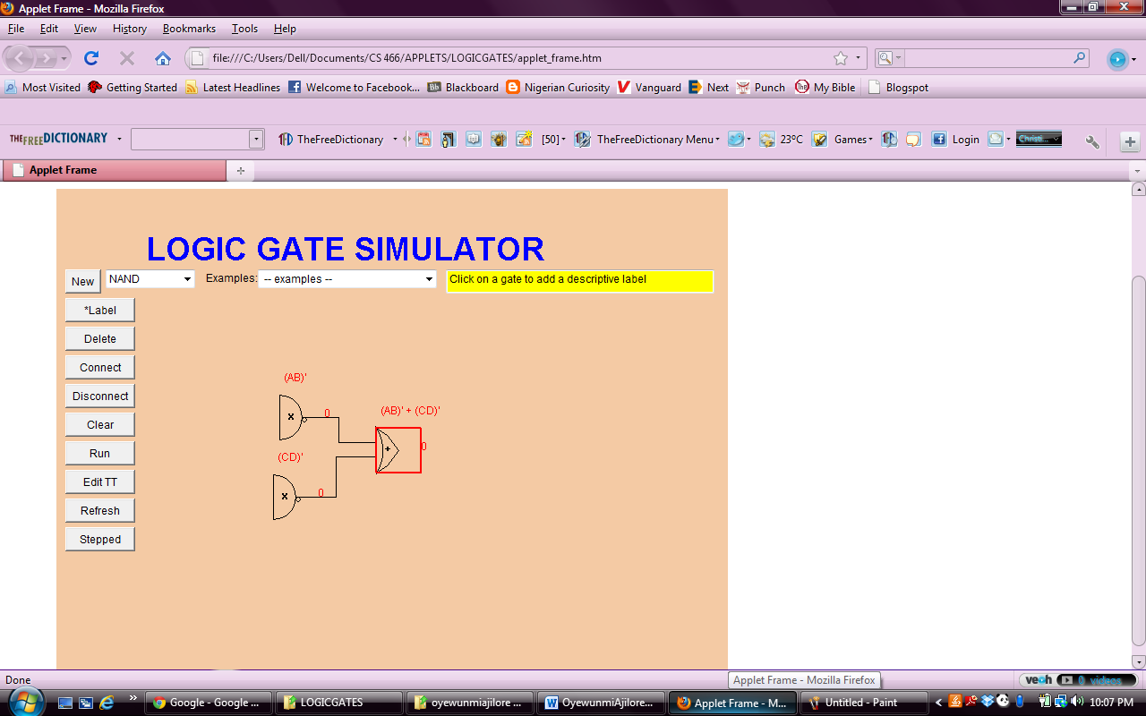

59.

|  |  |  |  |  |
| --- | --- | --- | --- | --- |
| A | B | AB | A+B | (AB) + (A+B) |
| 0 | 0 | 0 | 0 | 0 |
| 0 | 1 | 0 | 1 | 1 |
| 1 | 0 | 0 | 1 | 1 |
| 1 | 1 | 1 | 1 | 1 |

60.

|  |  |  |  |  |
| --- | --- | --- | --- | --- |
| A | B | A’ | AB | A’ XOR (AB) |
| 0 | 0 | 1 | 0 | 1 |
| 0 | 1 | 1 | 0 | 1 |
| 1 | 0 | 0 | 0 | 1 |
| 1 | 1 | 0 | 1 | 1 |

61.

|  |  |  |  |  |  |
| --- | --- | --- | --- | --- | --- |
| A | B | C | A’ | B XOR C | A’ (B XOR C) |
| 0 | 0 | 0 | 1 | 0 | 0 |
| 0 | 0 | 1 | 1 | 1 | 1 |
| 0 | 1 | 0 | 1 | 1 | 1 |
| 0 | 1 | 1 | 1 | 0 | 0 |
| 1 | 0 | 0 | 0 | 0 | 0 |
| 1 | 0 | 1 | 0 | 1 | 0 |
| 1 | 1 | 0 | 0 | 1 | 0 |
| 1 | 1 | 1 | 0 | 0 | 0 |

62.

|  |  |  |  |  |  |  |  |
| --- | --- | --- | --- | --- | --- | --- | --- |
| A | B | C | AB | (BC)’ | C’ | ((AB)+C’)’ | (BC)’+((AB)+C’)’ |
| 0 | 0 | 0 | 0 | 1 | 1 | 0 | 1 |
| 0 | 0 | 1 | 0 | 1 | 0 | 1 | 1 |
| 0 | 1 | 0 | 0 | 1 | 1 | 0 | 1 |
| 0 | 1 | 1 | 0 | 0 | 0 | 1 | 1 |
| 1 | 0 | 0 | 0 | 1 | 1 | 0 | 1 |
| 1 | 0 | 1 | 0 | 1 | 0 | 1 | 1 |
| 1 | 1 | 0 | 1 | 1 | 1 | 0 | 1 |
| 1 | 1 | 1 | 1 | 0 | 0 | 0 | 0 |

63. It’s the same output for each corresponding input value combination for two circuits.

69. A chip is a piece of silicon on which multiple gates have been embedded.

73.

**Lab Answers:**

*Exercise 1*

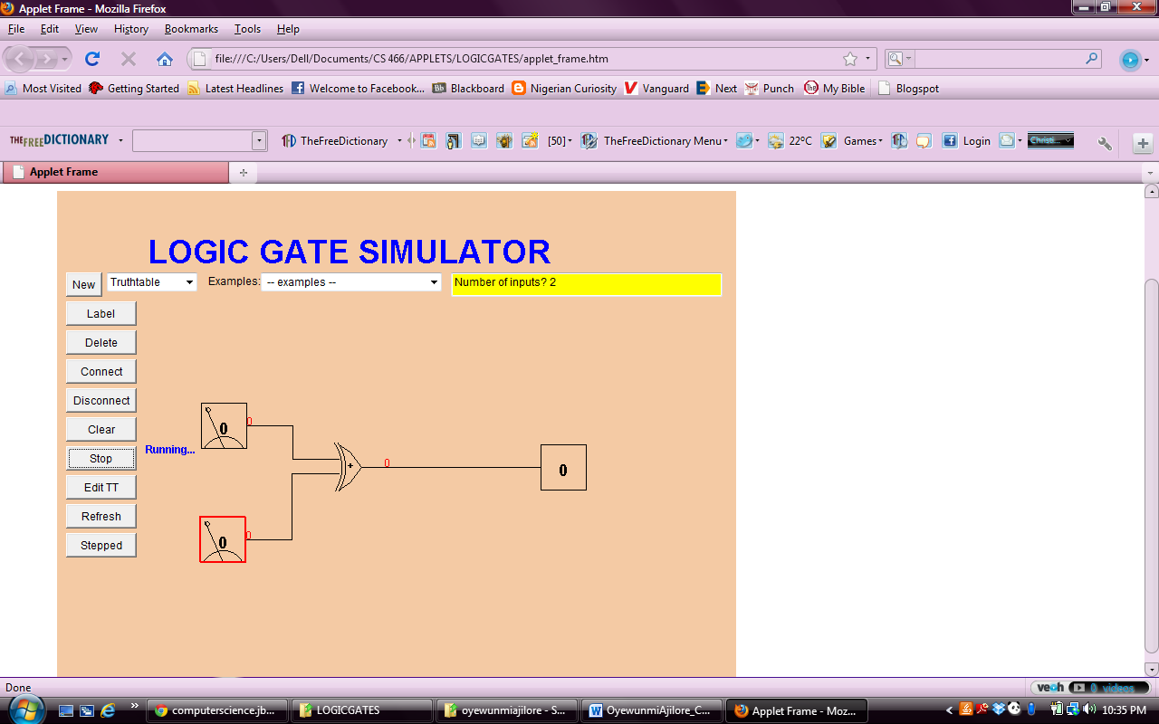

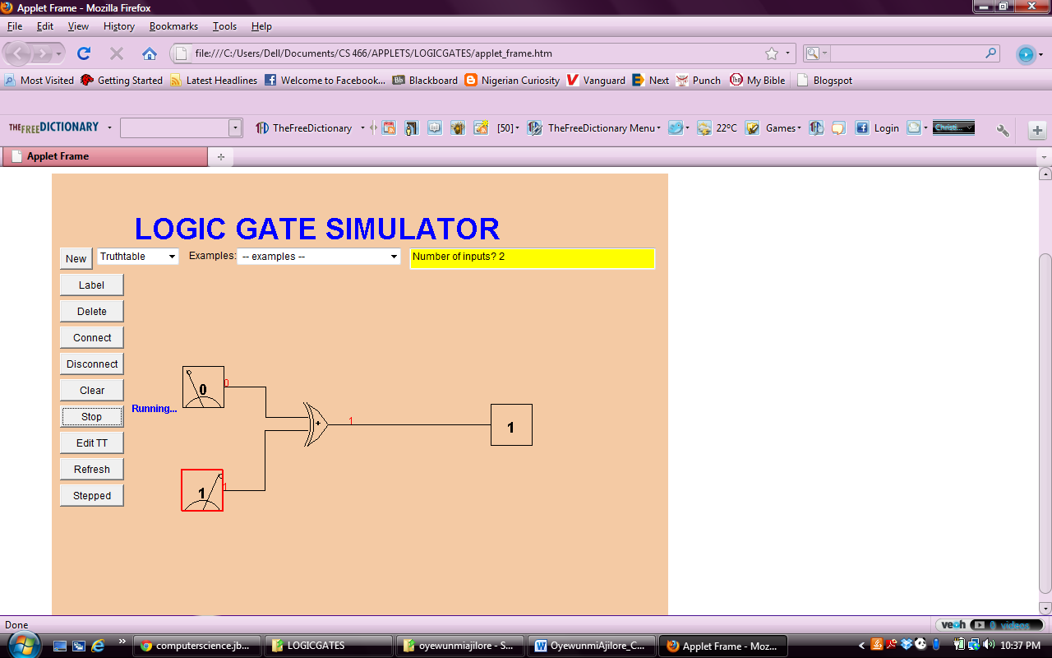

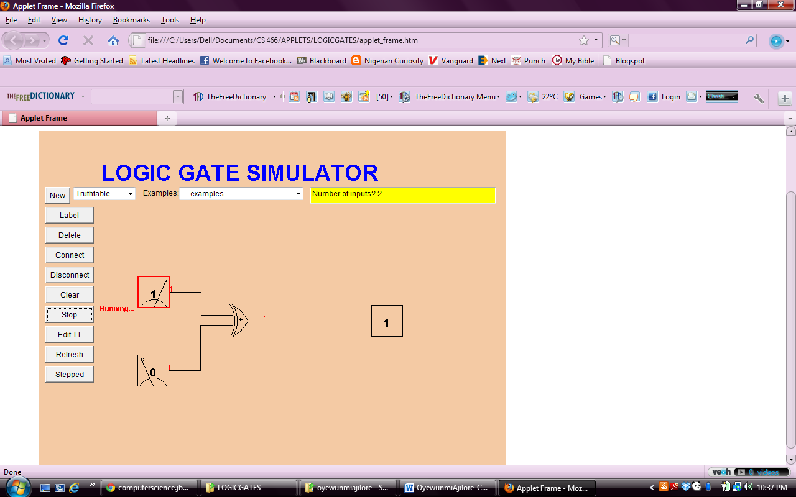

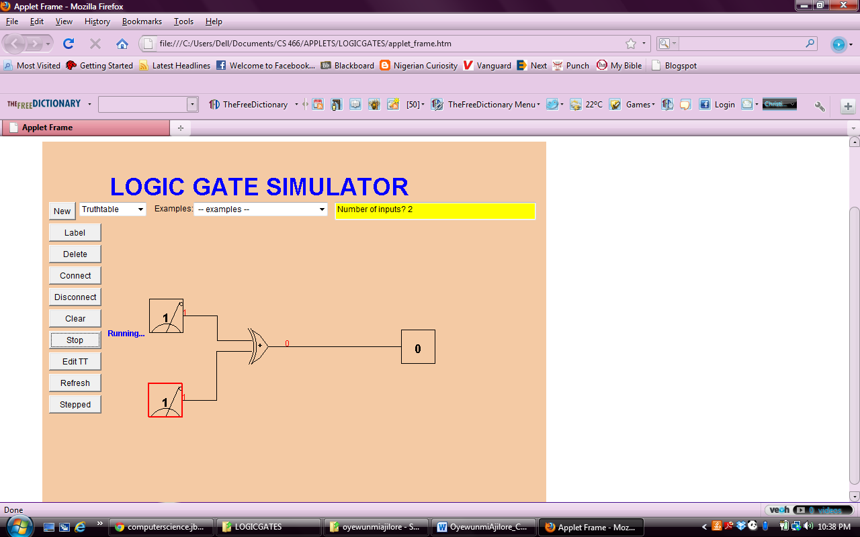

|  |  |  |
| --- | --- | --- |
| A | B | X |
| 0 | 0 | 0 |
| 0 | 1 | 1 |
| 1 | 0 | 1 |
| 1 | 1 | 0 |

*Exercise 2*

|  |  |  |  |  |
| --- | --- | --- | --- | --- |
| A | B | A XOR B | (A XOR B)’ | X |
| 0 | 0 | 0 | 1 | 1 |
| 0 | 1 | 1 | 0 | 0 |
| 1 | 0 | 1 | 0 | 0 |
| 1 | 1 | 0 | 1 | 1 |

It yields the same result only when A and B have the same values, ie if both A and B are true, or false.

*Exercise 3*

