Problem 1
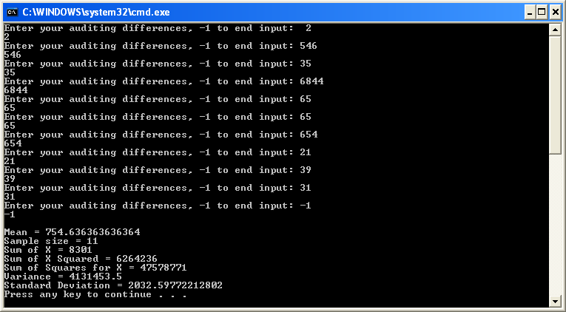
'Kenneth Robinson
'CS 375 Homework 1
'102017353
'January 29, 2010

Module Module1
Private Sub cmdComputeStatistics_Click()
Dim variance, standard_deviation, X_Bar As Double, n, sum As Integer
Statistics(sum, standard_deviation, variance, n)
End Sub

Private Sub Statistics(ByVal sumx As Integer, ByVal sd As Double, ByVal var As Double, ByVal n As Integer)
Dim ssx, sxsq As Long, x As Integer, mean As Double

While x <> (-1)
If x <> -1 Then
Console.Write("Enter your auditing differences, -1 to end input: ")
x = CDbl(Console.ReadLine)
ssx = ssx + x ^ 2
sumx = sumx + x
n = n + 1
Console.WriteLine(x)
End If
End While

mean = sumx / n
sxsq = (sumx ^ 2) / n
var = (ssx - sxsq) / (n - 1)

sd = Math.Sqrt(var)
Console.WriteLine()
Console.WriteLine("Mean = {0}", mean)
Console.WriteLine("Sample size = {0}", n)
Console.WriteLine("Sum of X = {0}", sumx)
Console.WriteLine("Sum of X Squared = {0}", sxsq)
Console.WriteLine("Sum of Squares for X = {0}", ssx)
Console.WriteLine("Variance = {0}", var)
Console.WriteLine("Standard Deviation = {0}", sd)

End Sub

Sub Main()
cmdComputeStatistics_Click()
End Sub

End Module
Problem 2
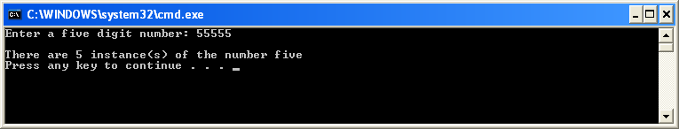

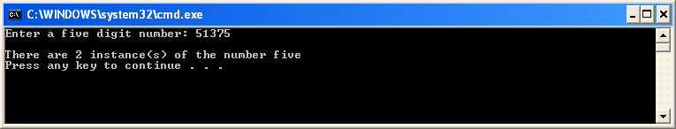

'KENNETH ROBINSON
'HOMEWORK 1 PROBLEM 2
'JANUARY 29, 2010
'
'CODED USING VISUAL STUDIO 2005

Module Module1

Dim user_input As String, num_of_input, number_found, start_position, position As Integer

Sub Main()
Console.Write("Enter a five digit number: ")
user_input = CStr(Console.ReadLine)

start_position = 1
number_found = 0

While start_position < 6

'RETURNS POSITION OF 5 IF FOUND
position = InStr(start_position, user_input, "5")

If position > 0 Then
number_found = number_found + 1
End If

If position > start_position Then
'IF THE START POSITION IS GREATER THAN THE CURRENT POSITION, GO TO THE NEXT POSITION AFTER THE 5
start_position = position + 1
' Console.WriteLine("changing position")
Else
'INCREMENT START POSITION
start_position = start_position + 1
'Console.WriteLine("incrementing position")
End If

End While

Console.WriteLine("")
Console.WriteLine("There are {0} instance(s) of the number five", number_found)
End Sub

End Module

