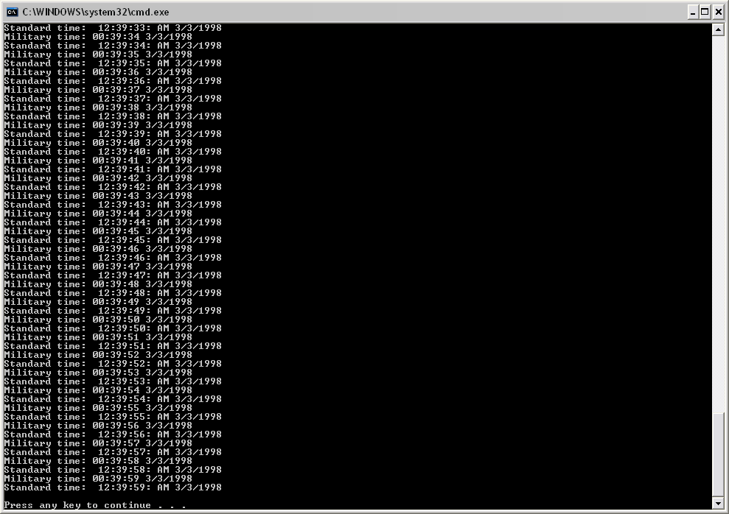

Public Class GlobalMembersHw
Shared Function Main() As Integer
Const MAXTICKS As Integer = 3000
Dim d As New DateTime(3, 2, 1998, 23, 50, 0)
For ticks As Integer = 1 To MAXTICKS
Console.Write("Military time: ")
d.printMilitary()
Console.Write("Standard time: ")
d.printStandard()
d.tick()
Next ticks
Console.Write(ControlChars.Lf)
Return 0
End Function
End Class

Public Class DateTime
Public Sub New(Optional ByVal m As Integer = 1, Optional ByVal d As Integer = 1, _
Optional ByVal y As Integer = 1900, Optional ByVal hr As Integer = 0, _
Optional ByVal min As Integer = 0, Optional ByVal sec As Integer = 0)
setDate(m, d, y)
setTime(hr, min, sec)
End Sub
Public Sub setDate(ByVal mo As Integer, ByVal dy As Integer, ByVal yr As Integer)
setMonth(mo)
setDay(dy)
setYear(yr)
End Sub
Public Sub setMonth(ByVal m As Integer)
If m <= 12 AndAlso m >= 1 Then
month = m
Else
month = 1
End If
End Sub
Public Sub setDay(ByVal d As Integer)
If month = 2 AndAlso leapYear() Then
If d <= 29 AndAlso d >= 1 Then
day = d
Else
day = 1
End If
Else
If d <= monthDays() AndAlso d >= 1 Then
day = d
Else
day = 1
End If
End If
End Sub
Public Sub setYear(ByVal y As Integer)
If y <= 2050 AndAlso y >= 1900 Then
year = y
Else
year = 1900
End If
End Sub
Public Function getMonth() As Integer
Return month
End Function
Public Function getDay() As Integer
Return day
End Function
Public Function getYear() As Integer
Return year
End Function
Public Sub nextDay()
day += 1
setDay(day)
If day = 1 Then
month += 1
setMonth(month)
If month = 1 Then
year += 1
setYear(year)
End If
End If
End Sub
Public Sub setTime(ByVal hr As Integer, ByVal min As Integer, ByVal sec As Integer)
setHour(hr)
setMinute(min)
setSecond(sec)
End Sub
Public Sub setHour(ByVal h As Integer)
If h >= 0 AndAlso h < 24 Then
hour = h
Else
hour = 0
End If
End Sub
Public Sub setMinute(ByVal m As Integer)
If m >= 0 AndAlso m < 60 Then
minute = m
Else
minute = 0
End If
End Sub
Public Sub setSecond(ByVal s As Integer)
If s >= 0 AndAlso s < 60 Then
second = s
Else
second = 0
End If
End Sub
Public Function getHour() As Integer
Return hour
End Function
Public Function getMinute() As Integer
Return minute
End Function
Public Function getSecond() As Integer
Return second
End Function
Public Sub printMilitary()
If hour < 10 Then
Console.Write("0")
Console.Write(hour)
Console.Write(":"c)
Else
Console.Write("")
Console.Write(hour)
Console.Write(":"c)
End If
If minute < 10 Then
Console.Write("0")
Console.Write(minute)
Console.Write(":"c)
Else
Console.Write("")
Console.Write(minute)
Console.Write(":"c)
End If
If second < 10 Then
Console.Write("0")
Console.Write(second)
Console.Write(" ")
Else
Console.Write("")
Console.Write(second)
Console.Write(" ")
End If
Console.Write(month)
Console.Write("/"c)
Console.Write(day)
Console.Write("/"c)
Console.Write(year)
Console.Write(ControlChars.Lf)
End Sub
Public Sub printStandard()
If hour Mod 12 = 0 Then
Console.Write(12)
Console.Write(":"c)
Else
Console.Write(hour Mod 12)
Console.Write(":"c)
End If
If minute < 10 Then
Console.Write("0")
Console.Write(minute)
Console.Write(":"c)
Else
Console.Write("")
Console.Write(minute)
Console.Write(":"c)
End If
If second < 10 Then
Console.Write("0")
Console.Write(second)
Console.Write(":"c)
Else
Console.Write("")
Console.Write(second)
Console.Write(":"c)
End If
If hour < 12 Then
Console.Write(" AM ")
Else
Console.Write(" PM ")
End If
Console.Write(month)
Console.Write("/"c)
Console.Write(day)
Console.Write("/"c)
Console.Write(year)
Console.Write(ControlChars.Lf)
End Sub
Public Function monthDays() As Integer
Dim days() As Integer = {31, 28, 31, 30, 31, 30, 31, 31, 30, 31, 30, 31}
If month = 2 AndAlso leapYear() Then
Return 29
Else
Return days((month - 1))
End If
End Function
Public Sub tick()
second += 1
setSecond(second)
If second = 0 Then
minute += 1
setMinute(minute)
If minute = 0 Then
hour += 1
setHour(hour)
If hour = 0 Then
nextDay()
End If
End If
End If
End Sub
Public Function leapYear() As Boolean
If year Mod 400 = 0 OrElse (year Mod 4 = 0 AndAlso year Mod 100 <> 0) Then
Return True
Else
Return False
End If
End Function
Private month As Integer
Private day As Integer
Private year As Integer
Private hour As Integer
Private minute As Integer
Private second As Integer
End Class

