Problem 1
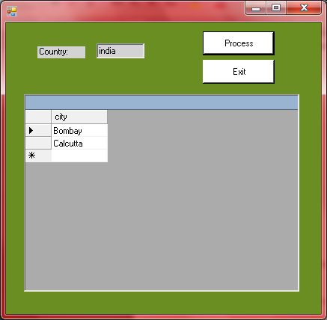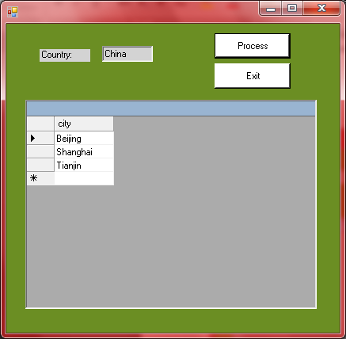
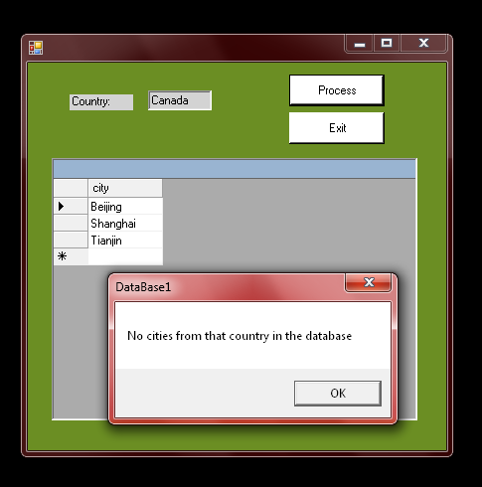

Problem 2

- DataTable – an object that contains columns and rows and is used to display organize data in a grid format
- DataAdapter – is used to fill a dataset using SQL Commands and a database connection
- DataSource – is a property in the DataGridView class that is used to get or set the source of the data that is being displayed.
- DataGrid – displays items from a data source in a table format.
- CommandBuilder – generates commands that make changes to data within a DataSet.

