Computer Exercise #16
Parameter Array
Sub Main()
Dim z As Integer() = New Integer(4) {}
Dim y As Integer() = New Integer(4) {}
Dim x As Integer() = New Integer(4) {}
Dim m, n, c As Integer
x = Green(9, 3, 7, 8, 2)
y = Yellow(1, 6, 4, 2, 5)
For m = 0 To z.GetUpperBound(0)
z(m) = (x(m) * y(m))
Next
Console.WriteLine("Values of Z:")
For n = 0 To z.GetUpperBound(0)
Console.WriteLine(" c = {0}, n = {1}", c, z(n))
c += 1
Next
End Sub
Private Function Green(ByVal ParamArray x() As Integer) As Array
Dim r, c As Integer
Console.WriteLine("Values of X:")
For Each r In x
Console.Write(" {0},{1} ", c, r)
c += 1
Next
Console.WriteLine()
Return x
End Function
Private Function Yellow(ByVal ParamArray y() As Integer) As Array
Dim i, c As Integer
Console.WriteLine("Values of Y:")
For Each i In y
Console.Write(" {0},{1} ", c, i)
c += 1
Next
Console.WriteLine()
Return y
End Function

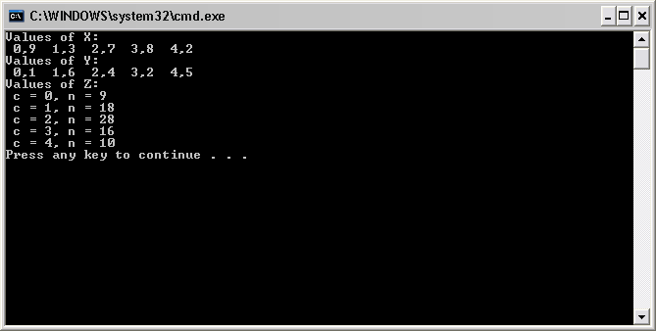
Computer Exercise #17
Random Numbers Generation
Module RandomSentence
Sub Main()
Dim Article As String() = New String() {"the", "a", "one", "some", "any"}
Dim Noun As String() = New String() {"boy", "girl", "dog", "town", "car"}
Dim Verb As String() = New String() {"drove", "jumped", "ran", "walked", "skipped"}
Dim Preposition() = New String() {"to", "from", "over", "under", "on"}
Dim sentence, firstWord As String
Dim randomObject As Random = New Random()
Dim randNumber As Integer = randomObject.Next
Dim k, j As Integer
For k = 1 To 20
j = randomObject.Next(1, 5)
firstword = UCase$(Left$(Article(j), 1)) & Right$(Article(j), Len(Article(j)) - 1)
sentence = firstWord & " " & Noun(randomObject.Next(1, 5)) & " " & _
Verb(randomObject.Next(1, 5)) & " " & Preposition(randomObject.Next(1, 5)) & " " _
& Article(randomObject.Next(1, 5)) & " " & Noun(randomObject.Next(1, 5)) & "."
Console.WriteLine("{0}", sentence)
Next
End Sub
End Module
Module ReverseSentence
Sub Main()
Dim s, sentence, token As String
Dim x As Integer
Console.WriteLine("Enter a sentence: ")
sentence = Console.ReadLine
s = InStr(1, sentence, " ")
Call Strtok(sentence, s)
End Sub
Private Sub Strtok(ByVal sentence As String, ByVal s As Long)
Dim token, newString, s2 As String
If s = 0 Then
Console.WriteLine("{0}", sentence)
Else
token = Left$(sentence, s - 1)
newString = Right$(sentence, Len(sentence) - s)
s2 = InStr(1, newString, " ")
Call Strtok(newString, s2)
Console.WriteLine("{0}", token)
End If
End Sub
End Module
Module ReverseSentence2
Sub Main()
Dim sentence As String
Console.WriteLine("Enter a phrase:")
sentence = Console.ReadLine
Call PrintBackwards(sentence)
End Sub
Private Sub PrintBackwards(ByVal sentence As String)
Dim s As String() = New String() {}
Dim j As Integer
s = Split(sentence)
For j = s.GetUpperBound(0) To s.GetLowerBound(0) Step -1
Console.WriteLine("{0}", s(j))
Next
End Sub
End Module

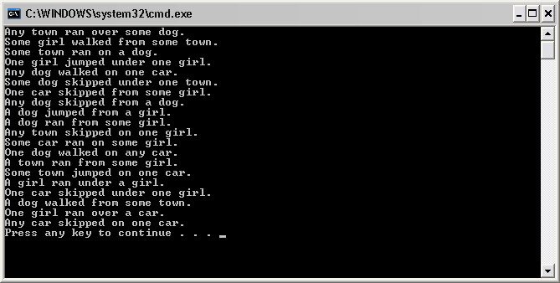

CS375 Computer Exercise #18
Scope of Variable Influence
Public Class frmScope
Inherits System.Windows.Forms.Form
Dim x As Integer
Private Sub btnScope_Click(ByVal sender As Object, ByVal e As System.EventArgs) Handles
btnScope.Click
Dim x As Integer ' Local variable
x = 6
lstOut.Items.Add("Local x is " & x & " on entering btnScope_click()")
lstOut.Items.Add(vbCrLf)
' Call procedures
Call One()
Call Two()
Call Three()
' Call procedures again
Call One()
Call Two()
Call Three()
lstOut.Items.Add("Local x is " & x & " on exiting cmdScope_click()")
End Sub
Private Sub One()
Dim x As Integer
x = 26
lstOut.Items.Add("Local x is " & x & " on entering One")
x = x + 1
lstOut.Items.Add("Local x is " & x & " on exiting One")
lstOut.Items.Add(vbCrLf)
End Sub
Private Sub Two()
Static x As Integer
' Initialize local static x to 60
' the first time into the procedure
If x = 0 Then
x = 60
End If
lstOut.Items.Add("Local static x is " & x & " on entering Two")
x = x + 1
lstOut.Items.Add("Local static x is " & x & " on exiting Two")
lstOut.Items.Add(vbCrLf)
End Sub
Private Sub Three()
lstOut.Items.Add("Module x is " & x & " on entering Three")
x = x + 5
lstOut.Items.Add("Module x is " & x & " on exiting Three")
lstOut.Items.Add(vbCrLf)
End Sub
Private Sub btnClear_Click(ByVal sender As Object, ByVal e As System.EventArgs) Handles
cmdClear.Click
lstOut.Items.Clear()
End Sub
Private Sub btnExit_Click(ByVal sender As Object, ByVal e As System.EventArgs) Handles
cmdExit.Click
Me.Close()
End Sub
Private Sub frmScope_Load(ByVal sender As System.Object, ByVal e As System.EventArgs)
Handles MyBase.Load
End Sub
End Class
CS375 Computer Exercise #19
Recursion Example #1

Private Sub btnFactorial_Click(ByVal sender As Object, ByVal e As System.EventArgs) Handles
btnFactorial.Click
Dim x, n As Integer
n = Convert.ToInt32(txtInput.Text) ‘Converts a specified value to a 32-bit signed integer
' Calculate factorial(s)
For x = 0 To n
lstOut.Items.Add(x & "! = " & _
Factorial((x))) ' Call-by-value
Next x
End Sub
Private Function Factorial(ByVal y As Double) As Double
If y <= 1 Then
Factorial = 1 ' Base case
Else
Factorial = y * Factorial(y - 1) ' Recursive step
End If
End Function
Private Sub btnClear_Click(ByVal sender As Object, ByVal e As System.EventArgs) Handles btnClear.Click
lstOut.Items.Clear()
txtInput.Clear()
txtInput.Focus()
End Sub
Private Sub btnExit_Click(ByVal sender As Object, ByVal e As System.EventArgs) Handles btnExit.Click
Me.Close()
End Sub
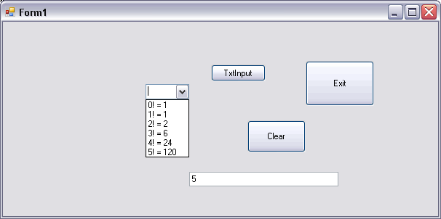

CS375 Computer Exercise #19
Recursion Example #2
Private Sub btnCompute_Click(ByVal sender As Object, ByVal e As System.EventArgs) Handles
btnCompute.Click
Dim n As Integer, fillcharacter As String, x As Integer
n = Convert.ToInt32(txtNumber.Text)
fillcharacter = txtCharacter.Text
For x = 1 To n
lstOut.Items.Add(Row(n, fillcharacter))
If x Mod n = 0 Then
lstOut.Items.Add(vbCrLf)
End If
Next x
End Sub
Private Function Row(ByVal n As Integer, ByVal x As String) As String
If n <= 1 Then
Row = x
Else
'Recursive step
Row = x & Row(n - 1, x)
End If
End Function
Private Sub btnClear_Click(ByVal sender As Object, ByVal e As System.EventArgs) Handles btnClear.Click
lstOut.Items.Clear()
txtNumber.Clear()
txtCharacter.Clear()
txtNumber.Focus()
End Sub

CS375 Computer Exercise #20
ReDim Statement
Module ReDimExample
Dim mC() As Integer = New Integer() {}
Dim mW() As String = New String() {}
Dim mS() As Integer
Dim size As Integer = 1
Sub Main()
ReDim mW(size)
mW(size) = " "
Dim s As String, tokens() As String = New String() {}
Dim result, c As Integer
Console.WriteLine("Enter your phrase to be evaluated:")
‘User enters I thought I saw a big pig fly by but it was a fly I saw or a big _
‘bird fly by
s = Console.ReadLine
tokens = Split(LCase$(s))
For c = 0 To tokens.GetUpperBound(0)
result = unknown(mW, tokens(c))
If result = -1 Then
size = size + 1
ReDim Preserve mC(size)
ReDim Preserve mW(size)
mW(size) = tokens(c)
mC(size) = mC(size) + 1
Else
mC(result) = mC(result) + 1
End If
Next c
Call Display()
End Sub
Private Sub Display()
Dim j As Integer
For j = (mW.GetLowerBound(0) + 2) To mW.GetUpperBound(0)
Console.WriteLine("{0,10} appeared {1,-1} time(s).", mW(j), mC(j))
Next
End Sub
Private Function unknown(ByVal a() As String, ByVal k As String) As Integer
Dim x As Integer
For x = 0 To a.GetUpperBound(0)
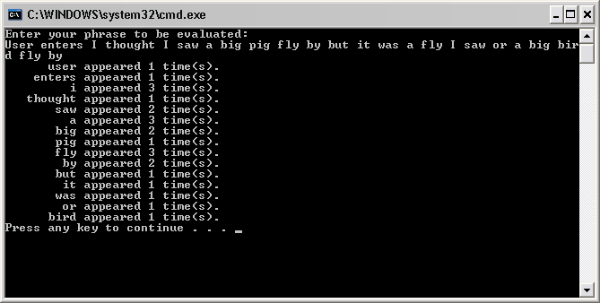
If a(x) = k Then
Return x
Exit Function
End If
Next
Return -1
End Function
End Module

CS375 Computer Exercise #21
Public Class FeetInches
Inherits Object
Private mFeet As Integer 'private data member
Private mInches As Integer 'private data member
Public Sub New() 'class constructor
SetData(0, 0) 'validate input data
End Sub
'Procedure to validate data and assign input data
Public Sub SetData(ByVal F As Integer, ByVal I As Integer)
If F <= 0 Then
mFeet = 1
Else
mFeet = F
End If
If I <= 0 Then
mInches = 1
Else
mInches = I
End If
'function to do the actual conversion for feet and inches
Call Simplify()
End Sub
Public Function GetFeet() As Integer 'output results
Return mFeet
End Function
Public Function GetInches() As Integer 'output results
Return mInches
End Function
'function to do the actual inches to feet conversion
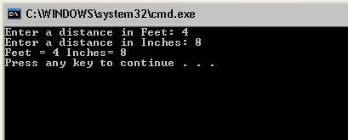
Private Sub Simplify()
If mInches >= 12 Then
mFeet += mInches \ 12
mInches = mInches Mod 12
ElseIf mInches < 0 Then
mFeet -= ((Math.Abs(mInches) / 12) + 1)
mInches = 12 - (Math.Abs(mInches) Mod 12)
End If
End Sub
End Class
‘Main program
Module FeetInchesExample
Sub Main()
Dim input As New FeetInches() 'Call the FeetInches constructor
Dim feet, inches As Integer
Console.Write("Enter a distance in Feet: ")
feet = Console.ReadLine()
Console.Write("Enter a distance in Inches: ")
inches = Console.ReadLine()
input.SetData(feet, inches) 'validate input data
'output results
Console.WriteLine("Feet = {0} Inches= {1}", input.GetFeet(), input.GetInches())
End Sub
End Module

CS375 Computer Exercise #22
Complex Numbers Class Example
Public Class Complex
Inherits Object
Private mReal As Double
Private mImaginary
Public Sub New()
Setdata(0, 0)
End Sub
Public Sub Setdata(ByVal r As Double, ByVal i As Double)
If r <= 0.0 Then
mReal = 1.0
Else
mReal = r
End If
If i <= 0.0 Then
mImaginary = 1.0
Else
mImaginary = i
End If
End Sub
Public Function GetReal() As Double
Return mReal
End Function
Public Function GetImaginary() As Double
Return mImaginary
End Function
Public Function Add(ByRef Second As Complex) As Complex
Dim Sum As New Complex()
Sum.mReal = mReal + Second.mReal
Sum.mImaginary = mImaginary + Second.mImaginary
Return Sum
End Function
Public Function Subtract(ByRef Second As Complex) As Complex
Dim Diff As New Complex()
Diff.mReal = mReal - Second.mReal
Diff.mImaginary = mImaginary - Second.mImaginary
Return Diff
End Function
Public Function Multiply(ByRef Second As Complex) As Complex
Dim Times As New Complex()
Times.mReal = mReal * Second.mReal
Times.mImaginary = mImaginary * Second.mImaginary
Return Times
End Function
End Class
‘Main program
Module ComplexNumbers
Sub Main()
Dim r As Double = 4.3, i As Double = 8.2
Dim x As New Complex()
Dim y As New Complex()
Dim z As New Complex()
x.Setdata(r, i)
r = 3.3 : i = 1.1
y.Setdata(r, i)
z = x.Add(y)
Console.WriteLine("Sum of Real part = {0} and Imaginary part = {1}", z.GetReal, z.GetImaginary)
z = x.Subtract(y)
Console.WriteLine("Difference of Real part = {0} and Imaginary part = {1}", z.GetReal, z.GetImaginary)
z = x.Multiply(y)
Console.WriteLine("Product of Real part = {0} and Imaginary part = {1}", z.GetReal, z.GetImaginary)
End Sub
End Module

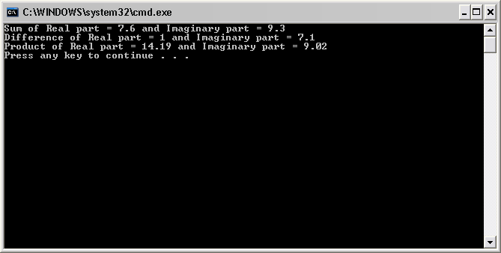

CS375 Computer Exercise #23
Class Complex Numbers Example
Public Class Complex
Inherits Object
Private mReal As Double
Private mImaginary As Double
Public Sub New()
Setdata(0, 0)
End Sub
Public Sub Setdata(ByVal r As Double, ByVal i As Double)
Real = r
Imaginary = i
End Sub
Public Property Real() As Double
Get
Return mReal
End Get
Set(ByVal r As Double)
If r <= 0.0 Then
mReal = 1.0
Else
mReal = r
End If
End Set
End Property
Public Property Imaginary() As Double
Get
Return mImaginary
End Get
Set(ByVal i As Double)
If i <= 0.0 Then
mImaginary = 1.0
Else
mImaginary = i
End If
End Set
End Property
Public Function Add(ByRef Second As Complex) As Complex
Dim Sum As New Complex()
Sum.mReal = mReal + Second.mReal
Sum.mImaginary = mImaginary + Second.mImaginary
Return Sum
End Function
Public Function Subtract(ByRef Second As Complex) As Complex
Dim Diff As New Complex()
Diff.mReal = mReal - Second.mReal
Diff.mImaginary = mImaginary - Second.mImaginary
Return Diff
End Function
Public Function Multiply(ByRef Second As Complex) As Complex
Dim Times As New Complex()
Times.mReal = mReal * Second.mReal
Times.mImaginary = mImaginary * Second.mImaginary
Return Times
End Function
End Class
Imports CPlexNumbers
Module CPlexNumRun
Sub Main()
Dim r As Double = 4.3, i As Double = 8.2
Dim x As New Complex()
Dim y As New Complex()
Dim z As New Complex()
x.Setdata(r, i)
r = 3.3 : i = 1.1
y.Setdata(r, i)
z = x.Add(y)
Console.WriteLine("Sum of Real part = {0} and Imaginary part = {1}", z.Real, z.Imaginary)
z = x.Subtract(y)
Console.WriteLine("Difference of Real part = {0} and Imaginary part = {1}", z.Real,
z.Imaginary)
z = x.Multiply(y)
Console.WriteLine("Product of Real part = {0} and Imaginary part = {1}", z.Real,
z.Imaginary)
End Sub
End Module
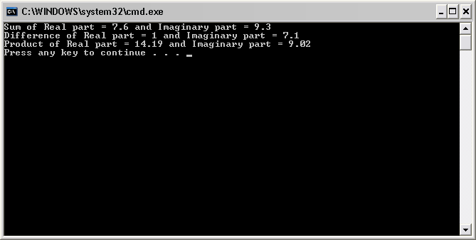

CS375 Computer Exercise #24
Feet Inches Class Example 2
Public Class FeetInches
Inherits Object
Private mFeet As Integer 'private data member
Private mInches As Integer 'private data member
Public Sub New() 'default class constructor
F = 0
I = 0 'validate input data
End Sub
'Class constructor
Public Sub New(ByVal Fvalue As Integer, ByVal Ivalue As Integer)
F = Fvalue
I = Ivalue
End Sub
Public Property F() As Integer
Get
Return mFeet 'Output Results
End Get
Set(ByVal F As Integer) ' Input Data
If F <= 0 Then
mFeet = 1
Else
mFeet = F
End If
Simplify()
End Set
End Property
Public Property I() As Integer
Get
Return mInches 'Output Results
End Get
Set(ByVal I As Integer) 'Input Data
If I <= 0 Then
mInches = 1
Else
mInches = I
End If
Simplify()
End Set
End Property
'function to do the actual inches to feet conversion
Private Sub Simplify()
If mInches >= 12 Then
mFeet += mInches \ 12
mInches = mInches Mod 12
ElseIf mInches < 0 Then
mFeet -= CInt(((Math.Abs(mInches) / 12) + 1))
mInches = 12 - (Math.Abs(mInches) Mod 12)
End If
End Sub
Public Function Add(ByVal Second As FeetInches) As FeetInches
Dim Temp As New FeetInches
Temp.mFeet = mFeet + Second.mFeet
Temp.mInches = mInches + Second.mInches
Temp.Simplify()
Return Temp
End Function
Public Function Subtract(ByVal Second As FeetInches) As FeetInches
Dim Temp As New FeetInches
Temp.mFeet = Math.Abs(mFeet - Second.mFeet)
Temp.mInches = Math.Abs(mInches - Second.mInches)
Temp.Simplify()
Return Temp
End Function
End Class
Module FeetInches2
Sub Main()
Dim First As New FeetInches 'Call the FeetInches constructor
Dim Second As New FeetInches
Dim Third As New FeetInches
Dim feet, inches As Integer
Console.Write("Enter a distance in Feet: ")
feet = CInt(Console.ReadLine())
Console.Write("Enter a distance in Inches: ")
inches = CInt(Console.ReadLine())
First.F = feet
First.I = inches
Console.Write("Enter a second distance in Feet: ")
feet = CInt(Console.ReadLine())
Console.Write("Enter a second distance in Inches: ")
inches = CInt(Console.ReadLine())
Second.F = feet
Second.I = inches
'output results
Console.WriteLine("Feet = {0} Inches= {1}", First.F(), First.I())
Console.WriteLine("Feet = {0} Inches= {1}", Second.F(), Second.I())
Console.WriteLine("Adding Feet and Inches")
Third = First.Add(Second)
Console.WriteLine("Feet = {0} Inches= {1}", Third.F(), Third.I())
Console.WriteLine("Subtracting Feet and Inches")
Third = First.Subtract(Second)
Console.WriteLine("Feet = {0} Inches= {1}", Third.F(), Third.I())
End Sub
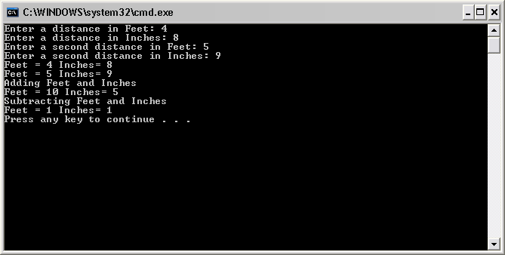

CS375 Computer Exercise #25
Circle Class Example
Public Class CCircle
Private mX, mY As Integer
Private mRadius As Double ' CCircle's radius
' default constructor
Public Sub New()
' implicit call to Object constructor occurs here
X = 0
Y = 0
Radius = 0
End Sub ' New
' constructor
Public Sub New(ByVal xValue As Integer, _
ByVal yValue As Integer, ByVal radiusValue As Double)
' implicit call to Object constructor occurs here
X = xValue
Y = yValue
Radius = radiusValue
End Sub
Public Property X() As Integer
Get
Return mX
End Get
Set(ByVal xValue As Integer)
mX = xValue
End Set
End Property ' X
Public Property Y() As Integer
Get
Return mY
End Get
Set(ByVal yValue As Integer)
mY = yValue
End Set
End Property
Public Property Radius() As Double
Get
Return mRadius
End Get
Set(ByVal radiusValue As Double)
If radiusValue > 0 Then
mRadius = radiusValue
End If
End Set
End Property ' Radius
Public Function Diameter() As Double
Return mRadius * 2
End Function ' Diameter
Public Function Circumference() As Double
Return Math.PI * Diameter()
End Function ' Circumference
Public Function Area() As Double
Return Math.PI * mRadius ^ 2
End Function ' Area
Public Overrides Function ToString() As String
Return "Center = " & "[" & mX & ", " & mY & "]" & _
"; Radius = " & mRadius
End Function ' ToString
End Class
Sub Main()
Dim circle As CCircle
Dim output As String
circle = New CCircle(37, 43, 2.5) ' instantiate CCircle
' get CCircle's initial x-y coordinates and radius
output = "X coordinate is " & circle.X & vbCrLf & _
"Y coordinate is " & circle.Y & vbCrLf & "Radius is " & _
circle.Radius
' set CCircle's x-y coordinates and radius to new values
circle.X = 2
circle.Y = 2
circle.Radius = 4.25
' display CCircle's String representation
output &= vbCrLf & vbCrLf & _
"The new location and radius of circle are " & _
vbCrLf & circle.ToString() & vbCrLf
' display CCircle's diameter
output &= "Diameter is " & _
String.Format("{0:F}", circle.Diameter()) & vbCrLf
' display CCircle's circumference
output &= "Circumference is " & _
String.Format("{0:F}", circle.Circumference()) & vbCrLf
' display CCircle's area
output &= "Area is " & String.Format("{0:F}", circle.Area())
Console.WriteLine(output)
End Sub ' Main
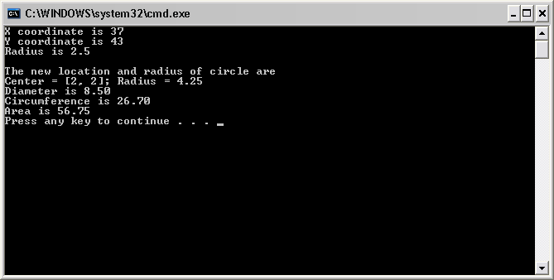

Computer Exercise #26
Module Module1

Sub Main()

Dim N1, N2 As Integer
Dim CalcM As Calculation = New Multiply
Dim CalcS As Calculation = New Subtract
Dim CalcA As Calculation = New Add
Dim CalcD As Calculation = New Divide
Console.Write("Enter your first whole number: ")
N1 = CInt(Console.ReadLine)
Console.Write("Enter your second whole number: ")
N2 = CInt(Console.ReadLine)
Console.WriteLine()

CalcM.Operation = "multiplication"
CalcM.Number1 = N1
CalcM.Number2 = N2
CalcM.DisplayResult()
CalcS.Operation = "subtraction"
CalcS.Number1 = N1
CalcS.Number2 = N2
CalcS.DisplayResult()
CalcA.Operation = "addition"
CalcA.Number1 = N1
CalcA.Number2 = N2
CalcA.DisplayResult()
CalcD.Operation = "division"
CalcD.Number1 = N1
CalcD.Number2 = N2
CalcD.DisplayResult()

Dim stopper As Integer = CInt(Console.ReadLine)

End Sub

MustInherit Class Calculation
Public Number1 As Double
Public Number2 As Double
Public Operation As String
Protected MustOverride Function Calculate() As Double

Public Overridable Sub DisplayResult()
Console.WriteLine("The result of {0} is {1}", Operation, Calculate)
End Sub

End Class

Class Add
Inherits Calculation
Protected Overrides Function Calculate() As Double
Return Number1 + Number2
End Function
End Class

Class Subtract
Inherits Calculation
Protected Overrides Function Calculate() As Double
Return Number1 - Number2
End Function
End Class

Class Multiply
Inherits Calculation
Protected Overrides Function Calculate() As Double
Return Number1 * Number2
End Function
End Class

Class Divide
Inherits Calculation
Protected Overrides Function Calculate() As Double
Return Number1 / Number2
End Function
Public Overrides Sub Displayresult()
Try
MyBase.DisplayResult()
Catch
Console.WriteLine("Division Error")
End Try
End Sub
End Class

End Module
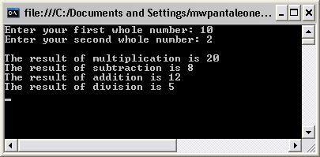
Computer Exercise #27
Module Module1

Public Class CShapeRun
Shared Sub Main()
' instantiate CPoint3, CCircle3 and CCylinder3 objects
Dim point As New CPoint3(7, 11)
Dim circle As New CCircle3(22, 8, 3.5)
Dim cylinder As New CCylinder3(10, 10, 3.3, 10)
' instantiate array of base-class references
Dim arrayOfShapes As CShape() = New CShape(2) {}
' arrayOfShapes(0) refers to CPoint3 object
arrayOfShapes(0) = point
' arrayOfShapes(1) refers to CCircle3 object
arrayOfShapes(1) = circle
' arrayOfShapes(2) refers to CCylinder3 object
arrayOfShapes(2) = cylinder
Dim output As String = point.Name & ": " & _
point.ToString() & vbCrLf & circle.Name & ": " & _
circle.ToString() & vbCrLf & cylinder.Name & _
": " & cylinder.ToString()
Dim shape As CShape
' display name, area and volume for each object in
' arrayOfShapes polymorphically
For Each shape In arrayOfShapes
output &= vbCrLf & vbCrLf & shape.Name & ": " & _
shape.ToString() & vbCrLf & "Area = " & _
String.Format("{0:F}", shape.Area) & vbCrLf & _
"Volume = " & String.Format("{0:F}", shape.Volume)
Next
Console.WriteLine(output)
Dim stopper As Integer = CInt(Console.ReadLine)
End Sub ' Main
End Class

Public MustInherit Class CShape
' return shape area
Public Overridable Function Area() As Double
Return 0
End Function ' Area
' return shape volume
Public Overridable Function Volume() As Double
Return 0
End Function ' Volume
' overridable method that should return shape name
Public MustOverride ReadOnly Property Name() As String
End Class ' CShape

Public Class CPoint3
Inherits CShape ' CPoint3 inherits from MustInherit class CShape
' point coordinate
Private mX, mY As Integer
' default constructor
Public Sub New()
' implicit call to Object constructor occurs here
X = 0
Y = 0
End Sub ' New
' constructor
Public Sub New(ByVal xValue As Integer, _
ByVal yValue As Integer)
' implicit call to Object constructor occurs here
X = xValue
Y = yValue
End Sub ' New
' property X
Public Property X() As Integer
Get
Return mX
End Get
Set(ByVal xValue As Integer)
mX = xValue ' no need for validation
End Set
End Property ' X
' property Y
Public Property Y() As Integer
Get
Return mY
End Get
Set(ByVal yValue As Integer)
mY = yValue ' no need for validation
End Set
End Property ' Y
' return String representation of CPoint3
Public Overrides Function ToString() As String
Return "[" & mX & ", " & mY & "]"
End Function ' ToString
' implement MustOverride property of class CShape
Public Overrides ReadOnly Property Name() As String
Get
Return "CPoint3"
End Get
End Property ' Name
End Class

Public Class CCircle3
Inherits CPoint3 ' CCircle3 Inherits from class CPoint3
Private mRadius As Double
' default constructor
Public Sub New()
' implicit call to CPoint3 constructor occurs here
Radius = 0
End Sub ' New
' constructor
Public Sub New(ByVal xValue As Integer, _
ByVal yValue As Integer, ByVal radiusValue As Double)
' use MyBase reference to CPoint3 constructor explicitly
MyBase.New(xValue, yValue)
Radius = radiusValue
End Sub ' New
' property Radius
Public Property Radius() As Double
Get
Return mRadius
End Get
Set(ByVal radiusValue As Double)
If radiusValue >= 0 Then ' mRadius must be nonnegative
mRadius = radiusValue
End If
End Set
End Property ' Radius
' calculate CCircle3 diameter
Public Function Diameter() As Double
Return mRadius * 2
End Function ' Diameter
' calculate CCircle3 circumference
Public Function Circumference() As Double
Return Math.PI * Diameter()
End Function ' Circumference
' calculate CCircle3 area
Public Overrides Function Area() As Double
Return Math.PI * mRadius ^ 2
End Function ' Area
' return String representation of CCircle3
Public Overrides Function ToString() As String
' use MyBase to return CCircle3 String representation
Return "Center= " & MyBase.ToString() & _
"; Radius = " & mRadius
End Function ' ToString
' override property Name from class CPoint3
Public Overrides ReadOnly Property Name() As String
Get
Return "CCircle3"
End Get
End Property ' Name
End Class

Public Class CCylinder3
Inherits CCircle3 ' CCylinder3 inherits from class CCircle3
Protected mHeight As Double
' default constructor
Public Sub New()
' implicit call to CCircle3 constructor occurs here
Height = 0
End Sub ' New
' four-argument constructor
Public Sub New(ByVal xValue As Integer, _
ByVal yValue As Integer, ByVal radiusValue As Double, _
ByVal heightValue As Double)
' explicit call to CCircle3 constructor
MyBase.New(xValue, yValue, radiusValue)
Height = heightValue ' set CCylinder3 height
End Sub ' New
' property Height
Public Property Height() As Double
Get
Return mHeight
End Get
' set CCylinder3 height if argument value is positive
Set(ByVal heightValue As Double)
If heightValue >= 0 Then ' mHeight must be nonnegative
mHeight = heightValue
End If
End Set
End Property ' Height
' override method Area to calculate CCylinder3 surface area
Public Overrides Function Area() As Double
Return 2 * MyBase.Area + MyBase.Circumference * mHeight
End Function ' Area
' calculate CCylinder3 volume
Public Overrides Function Volume() As Double
Return MyBase.Area * mHeight
End Function ' Volume
' convert CCylinder3 to String
Public Overrides Function ToString() As String
Return MyBase.ToString() & "; Height = " & mHeight
End Function ' ToString
' override property Name from class CCircle3
Public Overrides ReadOnly Property Name() As String
Get
Return "CCylinder3"
End Get
End Property ' Name
End Class

End Module
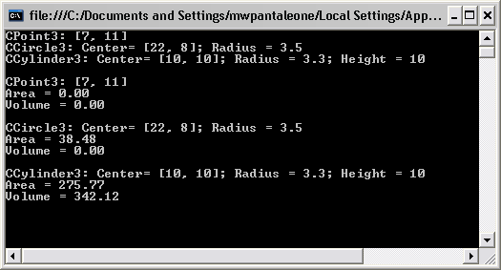
Exercise 28
Exercise 29
CS375 Exam 2 Key 10/26/2006

1. You are to trace the results of the following Visual Basic .Net program: (30pts.)
Sub Main()
Dim z As Integer() = New Integer(4) {}
Dim y As Integer() = New Integer(4) {}
Dim x As Integer() = New Integer(4) {}
Dim m, n, c As Integer
x = Green(9, 3, 7, 8, 2)
y = Yellow(1, 6, 4, 2, 5)
For m = 0 To z.GetUpperBound(0)
z(m) = (x(m) * y(m))
Next
Console.WriteLine("Values of Z:")
For n = 0 To z.GetUpperBound(0)
Console.WriteLine(" c = {0}, n = {1}", c, z(n))
c += 1
Next
End Sub
Private Function Green(ByVal ParamArray x() As Integer) As Array
Dim r, c As Integer
Console.WriteLine("Values of X:")
For Each r In x
Console.Write(" {0},{1} ", c, r)
c += 1
Next
Console.WriteLine()
Return x
End Function
Private Function Yellow(ByVal ParamArray y() As Integer) As Array
Dim i, c As Integer
Console.WriteLine("Values of Y:")
For Each i In y
Console.Write(" {0},{1} ", c, i)
c += 1
Next
Console.WriteLine()
Return y
End Function

2. You are to convert this C++ class Rectangle into Visual Basic .Net. (25 pts)
Rectangle.h
#ifndef RECTANGLE_H
#define RECTANGLE_H
#include <iostream>
using namespace std;
class Rectangle {
public:
Rectangle(double = 1.0, double = 1.0);
double perimeter (void);
double area(void);
void setWidth(double w);
void setLength(double l);
double getWidth(void);
double getLength(void);
private:
double length;
double width;
};
#endif
Rectangle.cpp
#include <iostream>
#include "Rectangle.h"
using namespace std;

Rectangle::Rectangle(double w, double l)
{
setWidth(w);
setLength(l);
}
double Rectangle::perimeter(void) {return 2 * (width + length);}
double Rectangle::area(void) {return width * length;}
void Rectangle::setWidth(double w) {width = w > 0 && w < 20.0 ? w : 1.0;}
void Rectangle::setLength(double l) {length = l > 0 && l < 20.0 ? l : 1.0;}
double Rectangle::getWidth(void) {return width;}
double Rectangle::getLength(void) {return length;}
Driver
#include <iostream>
#include <iomanip>
#include <fstream>
using namespace std;
#include "Rectangle.h"

int main(){
//declare input data points
double l, w;
//file setup
ifstream input1;
input1.open("rectangle.txt");

//format output
cout<<setiosflags(ios::fixed | ios::showpoint);
cout<<setprecision(1);

//read the data in from the file
while (!input1.eof()){
input1>>w>>l;
//invoke class
Rectangle input(w,l);
//output results
cout<<"input: Length = "<<input.getLength()
<<" Width = "<<input.getWidth()<<endl;
cout<<" Perimeter = "<<input.perimeter()
<< " Area = "<<input.area()<<endl;
cout<<endl;
}

return 0;
}
Write the Visual Basic .Net version of the Rectangle class here including the Driver:
Public Class Rectangle
Inherits Object
Private mLength As Double
Private mWidth As Double
Public Sub New()
Setdata(1.0, 1.0)
End Sub
Public Sub Setdata(ByVal L As Double, ByVal W As Double)
Length = L
Width = W
End Sub
Public Property Length() As Double
Get
Return mLength
End Get
Set(ByVal L As Double)
If L > 0 And L < 20.0 Then
mLength = 1.0
Else
mLength = L
End If
End Set
End Property

Public Property Width() As Double
Get
Return mWidth
End Get
Set(ByVal W As Double)
If W > 0 And W < 20.0 Then
mWidth = 1.0
Else
mWidth = W
End If
End Set
End Property

Public Function Perimeter() As Double
Return 2 * (mLength + mWidth)
End Function
Public Function Area() As Double
Return mLength * mWidth
End Function
End Class
Module RectangleProblem

Sub Main()
Dim Input As New Rectangle()
Dim Length, Width, Area, Perimeter As Double
Console.Write("Enter the length of the Rectangle: ")
Length = Console.ReadLine
Console.Write("Enter the width of the Rectangle: ")
width = Console.ReadLine
Input.Setdata(Length, width)
Area = Input.Area
Perimeter = Input.Perimeter
Console.WriteLine("The Area of the rectangle is {0}", Area)
Console.WriteLine("The Perimeter of the rectangle is {0}", Perimeter)
End Sub

End Module

3. You are to rewrite this Visual Basic 6.0 code into Visual Basic .Net code: (25 pts.)
Private Sub Unknown_Click()
Dim V1 As Integer, V2 As String, V3 As Variant
Dim V4 As Currency, V5 As Double, V6 As Double
V1 = 6
V2 = "Silver" + "Streak"
V3 = "Whose Your Daddy?" + "123"
V4 = 125.25
V5 = 9 \ 2
V6 = 5 Mod 2
RedBird 8, 9, V1, V2, V3, V4, V5, V6
End Sub
Private Sub RedBird(a As Integer, b As Integer, ParamArray q() As Variant)
Dim r As Variant
picOut.Print "The Results Are: "
For r = LBound(q) To UBound(q)
If Val(q(r)) Then
q(r) = q(r) \ 2
End If
picOut.Print "Subscript = "; r; vbTab; "Element = "; q(r)
Next r
a = a ^ 2 \ 4
b = b Mod 2 - 5
picOut.Print "First = "; a; vbTab; "Second = "; b
End Sub

Visual Basic Code goes here:
Sub Main()
Dim V1 As Integer, V2 As Object, V3 As Object
Dim V4 As Double, V5, V6 As Double
V1 = 6
V2 = "Silver Streak"
V3 = "Whose Your Dadday"
V4 = 12.25
V5 = 9 \ 2
V6 = 5 Mod 2
Call Redbird(8, 9, V1, V2, V3, V4, V5, V6)
End Sub
Public Sub Redbird(ByVal a As Integer, ByVal b As Integer, ByVal ParamArray q() As Object)
Dim r As Object, x As Double
Dim counter As Integer = 1
Console.WriteLine("The Results Are: ")
For Each r In q
If IsNumeric(r) Then
x = CDbl(r)
r = x ^ 2
End If
Console.WriteLine("Index = {0} Element = {1}", counter, r)
counter += 1
Next
a = CInt(a ^ 2) \ 4
b = b Mod 2 - 5
Console.WriteLine("Frist = {0} Second= {1}", a, b)
End Sub

4. You are to write the class Convert (which will change feet to inches) to be used in a Visual Basic module program. The class has two private members: feet and inches which are both integer types. The class has the following methods: constructor; Get/Set property; Add (two feet objects); Subtract (two feet objects); Multiply (two feet objects); Divide (two feet objects); private method Simplify (converts feet to inches). The data members should have the default value of 1. You are to create the implementation for the class. (45 pts.)
Public Class Convert
Inherits Object
Private mFeet As Integer 'private data member
Private mInches As Integer 'private data member
Public Sub New() 'default class constructor
F = 0
I = 0 'validate input data
End Sub
'class constructor
Public Sub New(ByVal Fvalue As Integer, ByVal Ivalue As Integer)
F = Fvalue
I = Ivalue
End Sub

Public Property F() As Integer
Get
Return mFeet 'Output Results
End Get
Set(ByVal F As Integer) ' Input Data
If F <= 0 Then
mFeet = 1
Else
mFeet = F
End If
Simplify()
End Set
End Property
Public Property I() As Integer
Get
Return mInches 'Output Results
End Get
Set(ByVal I As Integer) 'Input Data
If I <= 0 Then
mInches = 1
Else
mInches = I
End If
Simplify()
End Set
End Property
'function to do the actual inches to feet conversion
Private Sub Simplify()
If mInches >= 12 Then
mFeet += mInches \ 12
mInches = mInches Mod 12
ElseIf mInches < 0 Then
mFeet -= CInt(((Math.Abs(mInches) / 12) + 1))
mInches = 12 - (Math.Abs(mInches) Mod 12)
End If
End Sub

Public Function Add(ByVal Second As FeetInches) As FeetInches
Dim Temp As New FeetInches
Temp.mFeet = mFeet + Second.mFeet
Temp.mInches = mInches + Second.mInches
Temp.Simplify()
Return Temp
End Function
Public Function Subtract(ByVal Second As FeetInches) As FeetInches
Dim Temp As New FeetInches
Temp.mFeet = Math.Abs(mFeet - Second.mFeet)
Temp.mInches = Math.Abs(mInches - Second.mInches)
Temp.Simplify()
Return Temp
End Function
End Class
Sub Main()
Dim First As New Convert 'Call the Convert constructor
Dim Second As New Convert
Dim Third As New Convert
Dim feet, inches As Integer
Console.Write("Enter a distance in Feet: ")
feet = CInt(Console.ReadLine())
Console.Write("Enter a distance in Inches: ")
inches = CInt(Console.ReadLine())
First.F = feet
First.I = inches
Console.Write("Enter a second distance in Feet: ")
feet = CInt(Console.ReadLine())
Console.Write("Enter a second distance in Inches: ")
inches = CInt(Console.ReadLine())
Second.F = feet
Second.I = inches
'output results
Console.WriteLine("Feet = {0} Inches= {1}", First.F(), First.I())
Console.WriteLine("Feet = {0} Inches= {1}", Second.F(), Second.I())
Console.WriteLine("Adding Feet and Inches")
Third = First.Add(Second)
Console.WriteLine("Feet = {0} Inches= {1}", Third.F(), Third.I())
Console.WriteLine("Subtracting Feet and Inches")
Third = First.Subtract(Second)
Console.WriteLine("Feet = {0} Inches= {1}", Third.F(), Third.I())
End Sub

