NAME: Kenneth Robinson
CHAPTER: 3
LAB: 3

For each chapter, you will complete a set of Animated Flashcards, Book exercises, and Lab exercises. Although you will have three different activities, you will submit them in one document. Use this document to record your answers for submission.

ANIMATED FLASHCARDS

In order to receive any point value for the Book and Lab exercises, you must submit your answers to the chapter’s Animated Flashcards, found on the textbook companion web site. Identify your responses with the Flashcard question numbers in this section.

- Data
- Digital data
- Keyword encoding
- Mantissa
- Analog data
- Flag
- Information
- Run-length encoding
- Ten’s complement
- Video codec
- Raster-graphics format
- Character set
- Pixels
- Bandwidth
- Reclock
- Lossy compression
- Signed-magnitude representation
- Digitize
- Data compression
- Floating point
- Resolution
- Scientific notation
- Huffman encoding
- Pulse-code modulation
- Radix point
- Lossless compression
- Compression ratio
- Vector graphics
- Overflow
- Data representation
- Temporal compression
- Multimedia
- Spatial compression

BOOK EXERCISES

Refer to the chapter’s corresponding eLearning module or the course schedule for the assigned chapter exercises. Identify your responses to the exercises by including their numbers as they appear in the chapter in this section.
LAB EXERCISES

The Lab Exercises are found on the textbook companion web site by clicking Explorations in Computer Science link, located in the left-side panel. Refer to the chapter’s corresponding eLearning module or the course schedule for the assigned exercises. Identify the Exercise and the activity’s number as you record your responses in this section.

Lab 3A, Exercise 1
- It is indicated by the first digit in the sign-magnitude form. 0 is positive; 1 is negative.
- The 32-bit version of the number has more bits and represented by more numbers.

 | 4 | -4
8-bit | 00000100 | 10000100
12-bit | 000000000100 | 100000000100
16-bit | 0000000000000100 | 1000000000000100
32-bit | 00000000000000000000000000000100 | 10000000000000000000000000000100

- -1 and -4 would both be represented by 64 numbers or bits.
- This is the highest positive number that can be represented by a 16-bit number.
- 1111111111111111 & 1000000000000001
They are almost inverted. Usually the one with the many 0s is the signed magnitude
- 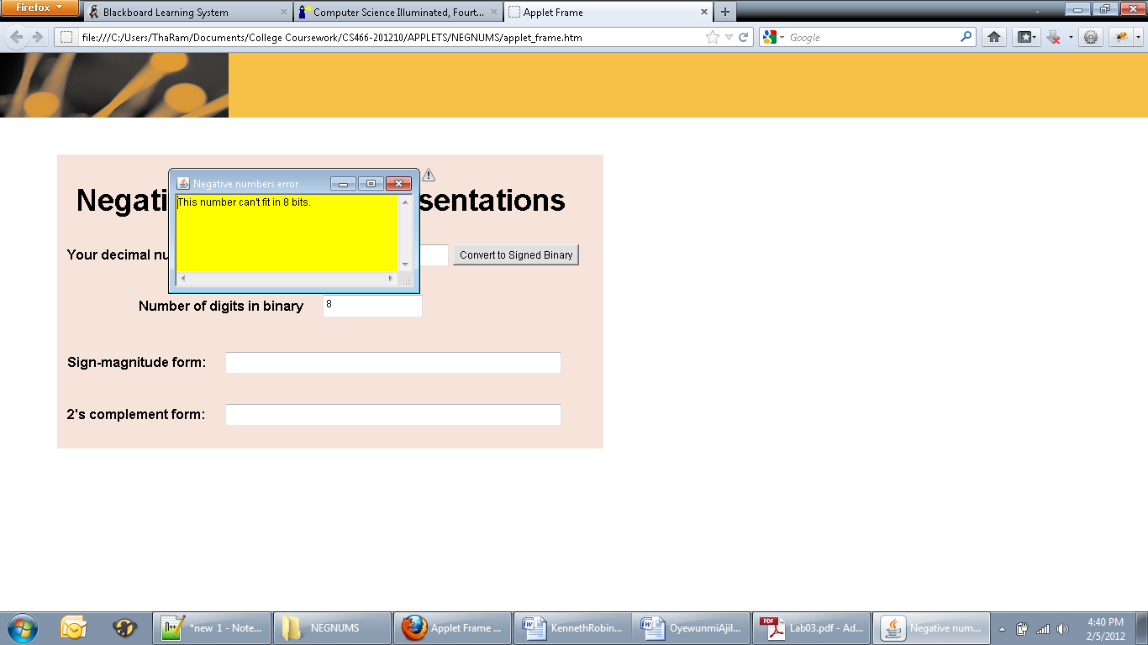
A number conversion error appears. The number cannot be represented by a 4-bit or 8-bit number.

Lab 3A, Exercise 2
- 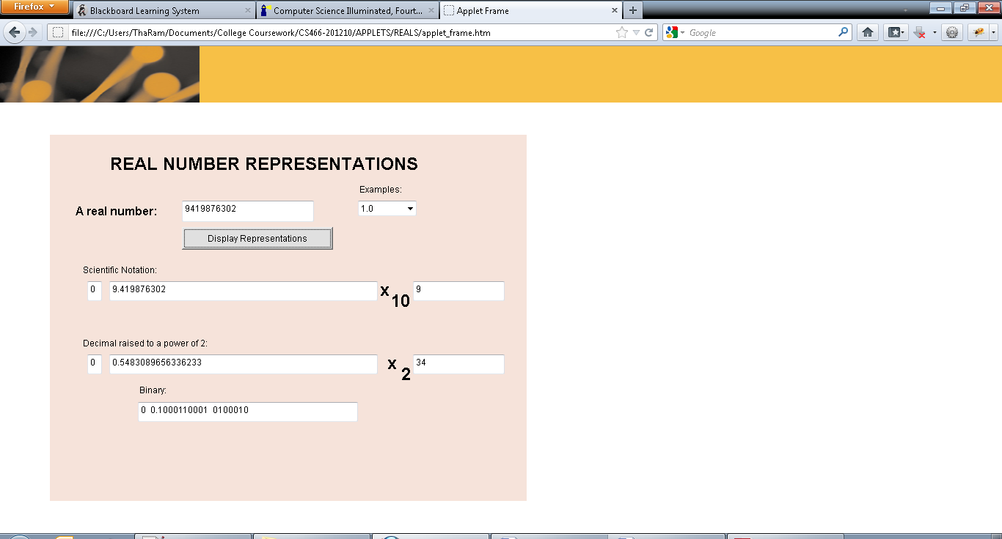
- Numbers that are raised to a power of two have a higher exponent.
- It devotes 10 bits to the mantissa.
- The sign of the exponent is negative.
- If the number has several zeros after the decimal place, the binary representation of the exponent is negative and begins with a 1.

0.5 | 0 0.1000000000 000000
0.25 | 0 0.1000000000 100001
0.125 | 0 0.1000000000 100001
The mantissa is the same. The exponent changes. The next number would be 0.0625.

Lab 3C Exercise 1
- 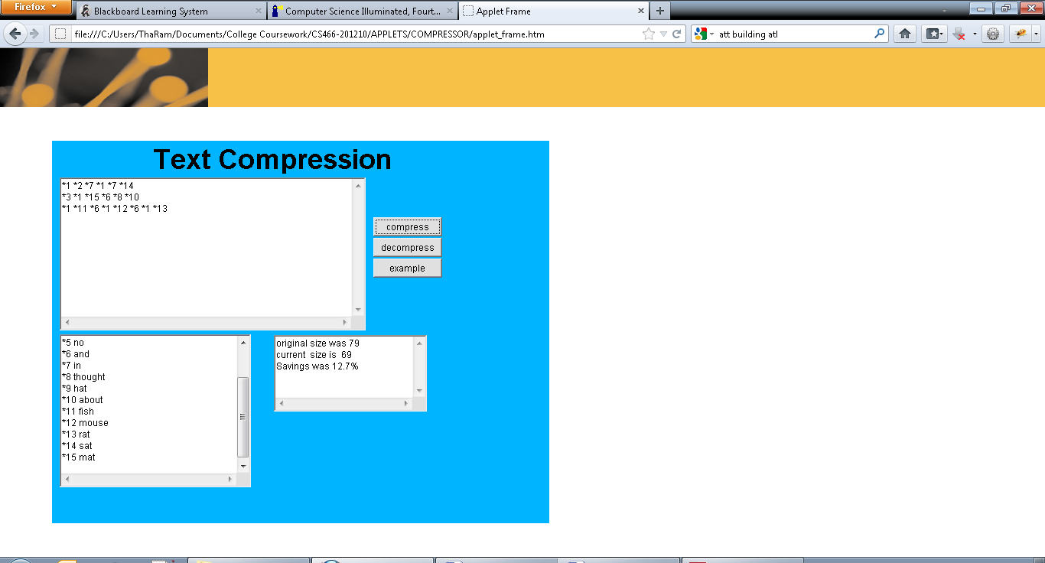
- The information could not be represented in encryption if it contained an * or any of the numbers used to compress it.
- The applet displays that there was a negative savings. Also the current size increased.
- Would have to substitute using “*3” to represent a word in the text with something else.

