NAME: Kenneth Robinson
CHAPTER: 4
LAB: 4

For each chapter, you will complete a set of Animated Flashcards, Book exercises, and Lab exercises. Although you will have three different activities, you will submit them in one document. Use this document to record your answers for submission.

ANIMATED FLASHCARDS

In order to receive any point value for the Book and Lab exercises, you must submit your answers to the chapter’s Animated Flashcards, found on the textbook companion web site. Identify your responses with the Flashcard question numbers in this section.
- Transistor
- Sequential Circuit
- Circuit Equivalence
- Boolean Operators
- Gate
- Half Adder
- Full Adder
- Boolean Algebra
- Logic Diagram
- Multiplexer
- Adder
- Combinational Circuit
- Truth table
- Computer
- Integrated circuit
- Circuit
- Semiconductor
BOOK EXERCISES

Refer to the chapter’s corresponding eLearning module or the course schedule for the assigned chapter exercises. Identify your responses to the exercises by including their numbers as they appear in the chapter in this section.

- True
- False
- False
- True
- True
- True
- False
- False
- False
- True
- True
- True
- False
- True
- False
- True
- True
- NOT
- AND
- NAND
- XOR
- NAND
- NOR
- NOT
- AND
- OR
- XOR
- NAND
- NOR
- Voltage levels range from 0-5volts. If the voltage level is from 0-2volts, it is considered low which is 0 in binary digits. If the voltage level is however 2-5volts, it’s considered high which is 1 in binary digits.
- A gate can receive one or more input signals. It can output only one signal.
53. Gates are combined into circuits by using the output of one gate as the input for another gate. There can also be multiple gates included on a single integrated circuit.
58.
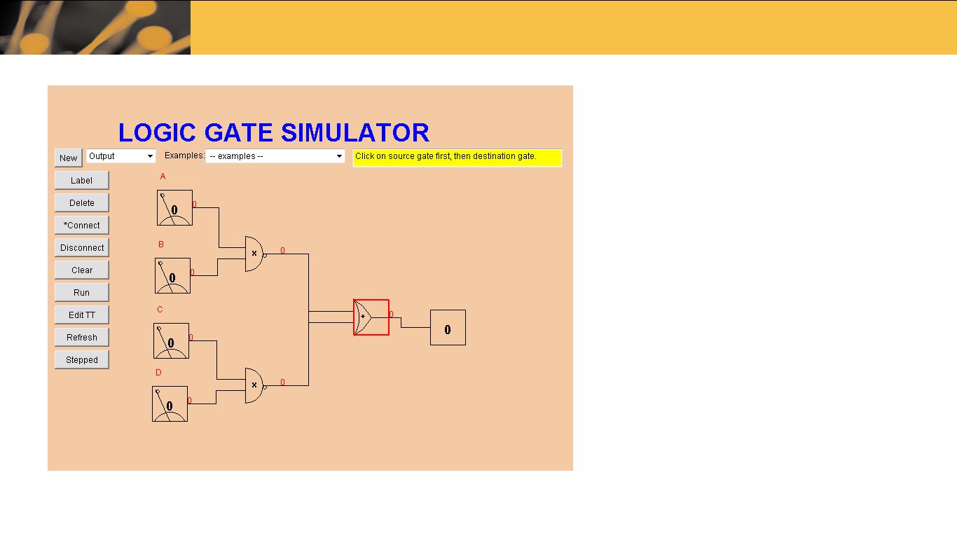
59.
A | B | (AB) + (A+B)
0 | 0 | 0
0 | 1 | 1
1 | 0 | 1
1 | 1 | 1

60.
A | B | A’ XOR (AB)
0 | 0 | 1
0 | 1 | 1
1 | 0 | 1
1 | 1 | 1

61.
A | B | C | A’ (B XOR C)
0 | 0 | 0 | 0
0 | 0 | 1 | 1
0 | 1 | 0 | 1
0 | 1 | 1 | 0
1 | 0 | 0 | 0
1 | 0 | 1 | 0
1 | 1 | 0 | 0
1 | 1 | 1 | 0

62.
A | B | C | (BC)’+((AB)+C’)’
0 | 0 | 0 | 1
0 | 0 | 1 | 1
0 | 1 | 0 | 1
0 | 1 | 1 | 1
1 | 0 | 0 | 1
1 | 0 | 1 | 1
1 | 1 | 0 | 1
1 | 1 | 1 | 0

63. It Is the same output for each corresponding input value combination for two circuits.
69. A chip is a piece of silicon on which multiple gates have been embedded.
73. It can be expressed by using two AND gates and one OR gate. One of the inputs to each of the AND gates would need to be inverted.
LAB EXERCISES

The Lab Exercises are found on the textbook companion web site by clicking Explorations in Computer Science link, located in the left-side panel. Refer to the chapter’s corresponding eLearning module or the course schedule for the assigned exercises. Identify the Exercise and the activity’s number as you record your responses in this section.

Exercise 1

A | B | X
0 | 0 | 0
0 | 1 | 1
1 | 0 | 1
1 | 1 | 0

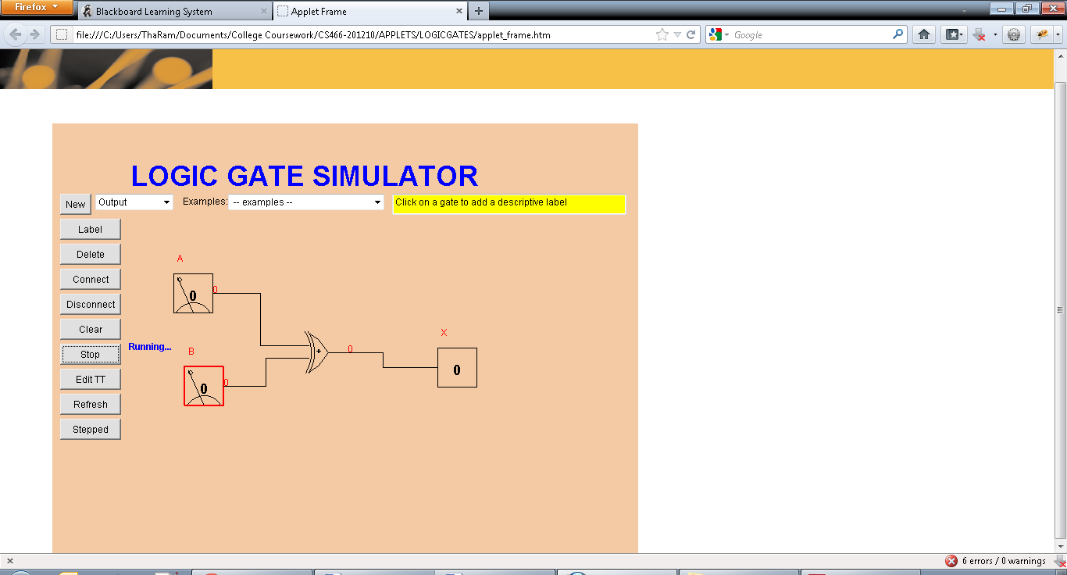

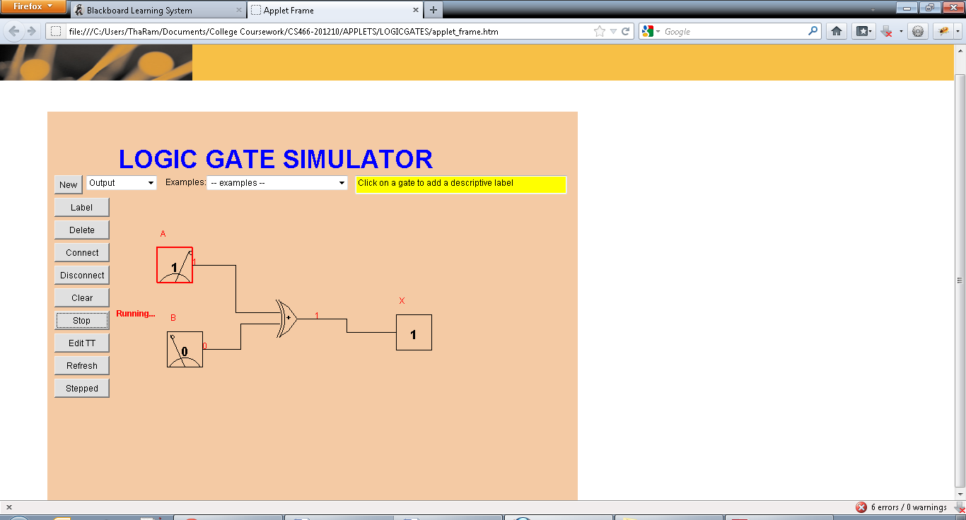

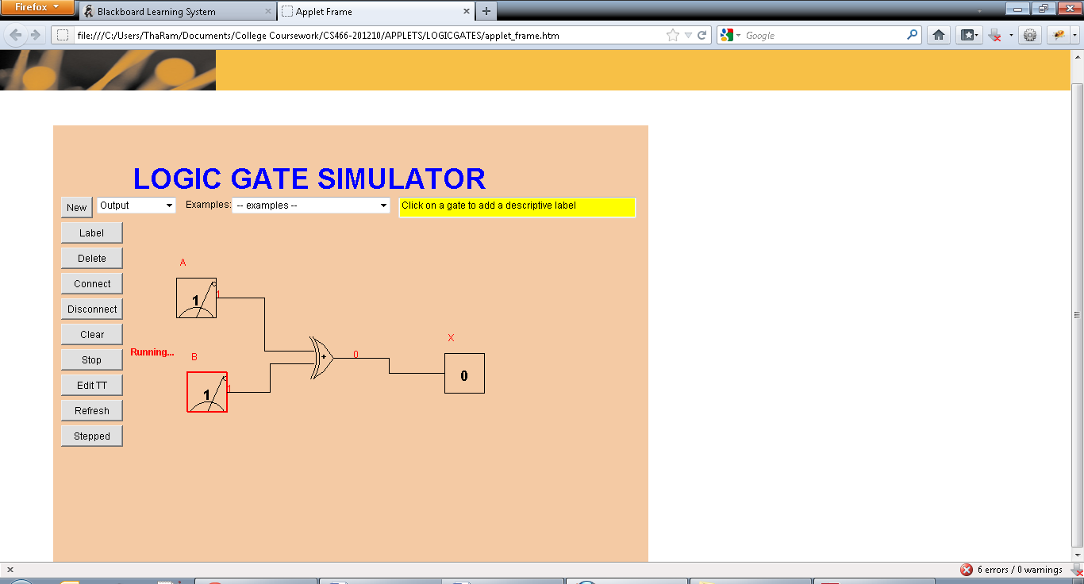

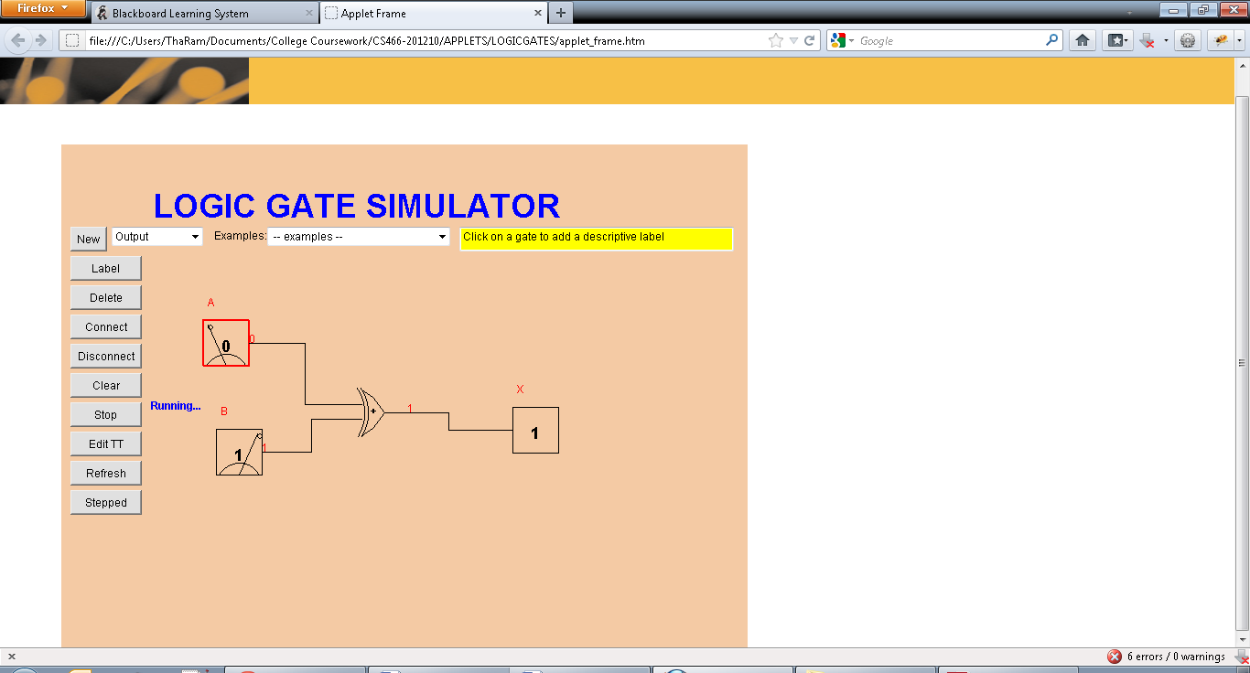

Exercise 2

A | B | X
0 | 0 | 1
0 | 1 | 0
1 | 0 | 0
1 | 1 | 1

If A and B input are the same, then the output is true.

Exercise 3

