NAME: Kenneth Robinson
CHAPTER: 5
LAB: 5

For each chapter, you will complete a set of Animated Flashcards, Book exercises, and Lab exercises. Although you will have three different activities, you will submit them in one document. Use this document to record your answers for submission.

ANIMATED FLASHCARDS

In order to receive any point value for the Book and Lab exercises, you must submit your answers to the chapter’s Animated Flashcards, found on the textbook companion web site. Identify your responses with the Flashcard question numbers in this section.
- Addressability
- Seek time
- Block
- Cylinder
- Control Unit
- Sector
- Track
- Auxiliary storage device
- Shared memory
- Instruction register
- Access time
- Input unit
- Transfer rate
- Input/output devices
- Input
- Motherboard
- Synchronous processing
- Latency
- Allocate
- Bus
- Fetch-execute cycle
- Arithmetic/logic unit
- Output unit
- Pipelining processing
- CPU
- Program Counter
- Register
BOOK EXERCISES

Refer to the chapter’s corresponding eLearning module or the course schedule for the assigned chapter exercises. Identify your responses to the exercises by including their numbers as they appear in the chapter in this section.

- B
- A
- C
- D
- H
- G
- E
- F
- G
- G
- E
- D
- A
- I
- E
- I
- F
- A
- C
- E
- B
- G
- D
- It indicates that the memory is running at 133 million cycles per second.
- A. 536 870 912 B. 2 147 483 648
- RPM means revolutions per minute. It helps determine the access time on computer hard disk drives which is the measurement of how many complete revolutions a computer’s hard disk drive makes in a single minute. The higher the RPM, the faster data can be accessed.
- It’s a principle on the realization that data and instructions to manipulate the data were logically the same and could be stored in the same place.
- It entails the stored-program principle.
- Control Unit, Arithmetic/Logic Unit, Memory Unit, Input/output Unit, the Bus
- 8-bit
- It performs arithmetic operations and logical operations.
- Control Unit
- Paper tapes could not hold much data and to access data in the middle of the tape, all the data before the piece you want must be accessed and discarded.
- The register that contains the Instruction currently being executed
- The register that contains the address of the next instruction to be executed
- Fetch next instruction, decode instruction, get data if needed, execute instruction
- The next instruction is fetched from the memory address that is currently stored in the Program Counter, and stored in the Instruction register. At the end of the fetch operation, the PC points to the next instruction that will be read at the next cycle.
- The decoder interprets the instruction. During this cycle the instruction inside the IR (instruction register) gets decoded.
- The CU passes the decoded information as a sequence of control signals to the relevant function units of the CPU to perform the actions required by the instruction such as reading values from registers, passing them to the ALU to perform mathematical or logic functions on them, and writing the result back to a register. If the ALU is involved, it sends a condition signal back to the CU. The result generated by the operation is stored in the main memory, or sent to an output device. Based on the condition of any feedback from the ALU, Program Counter may be updated to a different address from which the next instruction will be fetched.
- Both the RAM and ROM are memory units in the CPU. The ROM is a memory in which each location can be accessed but not changed, making it not volatile; while, the RAM is memory in which each location can be accessed and changed, making it volatile.
LAB EXERCISES

The Lab Exercises are found on the textbook companion web site by clicking Explorations in Computer Science link, located in the left-side panel. Refer to the chapter’s corresponding eLearning module or the course schedule for the assigned exercises. Identify the Exercise and the activity’s number as you record your responses in this section.

Exercise 1
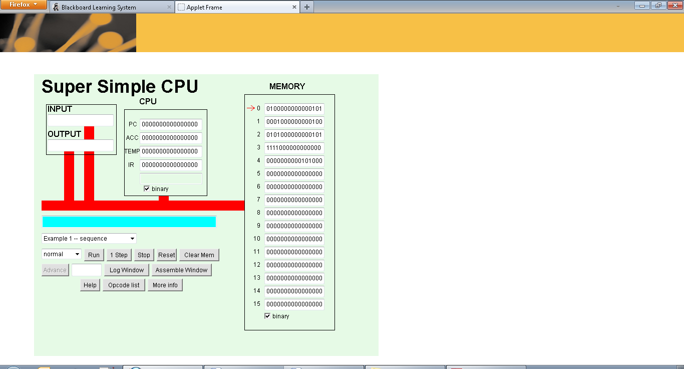

LDI, ADD, STO

It ran four cycles.
Exercise 2
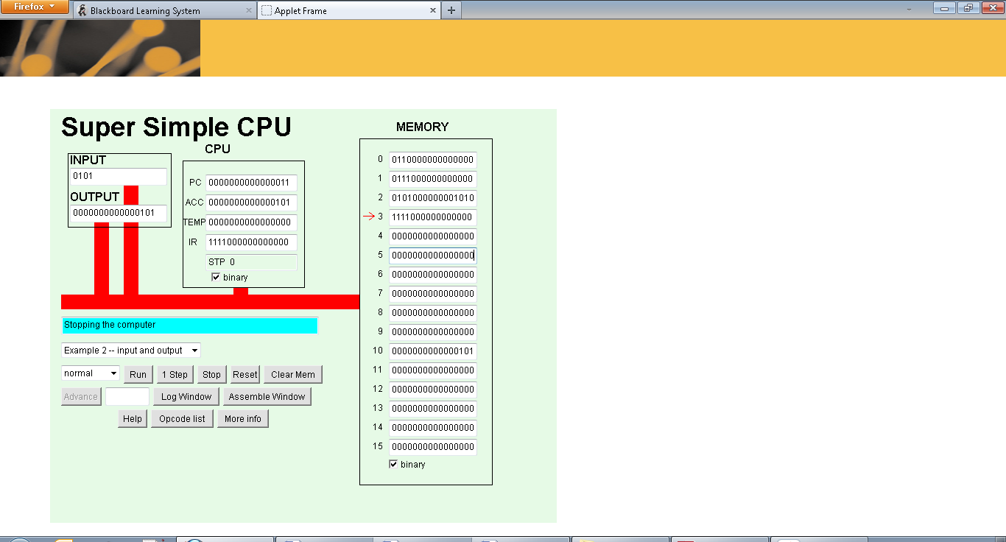

Exercise 3
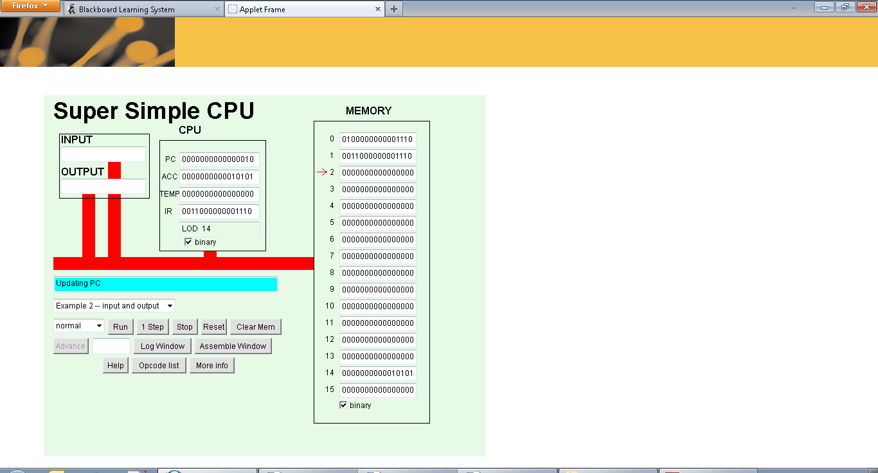

0011 LOD
Accumulator = 21

7. One says to load the number in memory into the accumulator. The other indicates to load the number in the accumulator into memory.

8. There is no store immediate because the instructions and data in the currently selected memory location may be overwritten with new data.

9. 0100000010000001
0101000000001100

