NAME
CHAPTER: Chapter 10
LAB: 10

For each chapter, you will complete a set of Animated Flashcards, Book exercises, and Lab exercises. Although you will have three different activities, you will submit them in one document. Use this document to record your answers for submission.

ANIMATED FLASHCARDS

In order to receive any point value for the Book and Lab exercises, you must submit your answers to the chapter’s Animated Flashcards, found on the textbook companion web site. Identify your responses with the Flashcard question numbers in this section.

- Time slice
- CPU Scheduling
- Frame
- Demand paging
- Virtual memory
- Multiprogramming
- Real-time system
- Process states
- Booting the system
- Physical address
- Dynamic-partition technique
- Address binding
- Base register
- Personal computer (pc)
- Mainframe
- Operating system
- Process
- Dumb terminal
- Thrashing
- Bounds register
- Preemptive scheduling
- Paged memory technique
- Context switch
- Logical address
- Memory management
- Turnaround time
- Timesharing
- Application software
- Virtual machine
- Page swap
- Fixed-partition technique
- Nonpreemptive scheduling
- Response time
- Process management
- Process Control Block
- Page map table
- System software
- Page
- Single contiguous memory management
BOOK EXERCISES

Refer to the chapter’s corresponding eLearning module or the course schedule for the assigned chapter exercises. Identify your responses to the exercises by including their numbers as they appear in the chapter in this section.

- B
- A
- A
- B
- A
- B
- A
- A
- B
- B
- B
- B
- A
- A
- A
- B
- B
- A
- A
- B
- C
- E
- D
- C
- A
- B
- Application software are programs to solve specific real-world problems; while, System software are tools to help others write programs by managing the computer system and interacting with hardware.
- An OS is system software that manages computer resources and provides an interface for system interaction.
- A batch job was made up of the program and instructions regarding the system software and other resources needed to execute the job.
- A system in which CPU time is shared among multiple interactive users at the same time.
- Multiprogramming allows multiple processes to be active at once while Timesharing allows the multiple processes to be interactive ones.
- User has login process to go through on the mainframe. When the user runs a program, another process is created that competes for CPU time with other processes.
- Real-time system is a system in which response time is crucial given the nature of the application domain.
- Response time is the time delay between receiving a stimulus and producing a response.
- Time is critical in many real-time situations, so the response time must be kept to a minimum.
- The OS must keep track of where and how a program resides in memory and converts logical program addresses into actual memory address.
- A logical address is a reference to a stored value relative to the program making the reference; while, a physical address is an actual address in the main memory device.
- Address binding is the mapping from a logical address to a physical address.
- When the program is loaded into memory
- At location 0

LAB EXERCISES

The Lab Exercises are found on the textbook companion web site by clicking Explorations in Computer Science link, located in the left-side panel. Refer to the chapter’s corresponding eLearning module or the course schedule for the assigned exercises. Identify the Exercise and the activity’s number as you record your responses in this section.

Exercise 1
- There are 3 holes. There are 275 free memory spaces. The largest job is 100
- It could not find a slot to place the job.
- i. There is 1 hole, 275 free memory and the largest job that can be processed is 275.
ii. It successfully adds the job, with a remainder of 125kb of free memory
- I expect it to go into the first available memory slot.
- It will go to the smallest partition big enough to hold it.
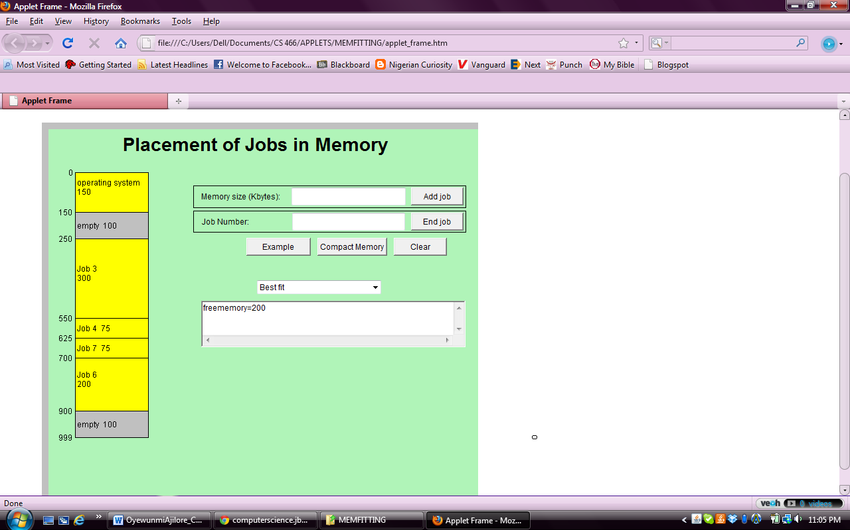

- It will take a lot of time because if the memory that comes first is not large enough to be allocated to the job, it will have to go to the next one and keep looking for memory partition that would fit best which may take time in computer definitions as opposed to other means.
- Frequent compaction is avoided in order to minimize perceived delay and to reduce the risk of corruption

Exercise 2
- They both have the same total time, however, the average turnaround time for the Shortest Job First is better than the First Come, First Served.
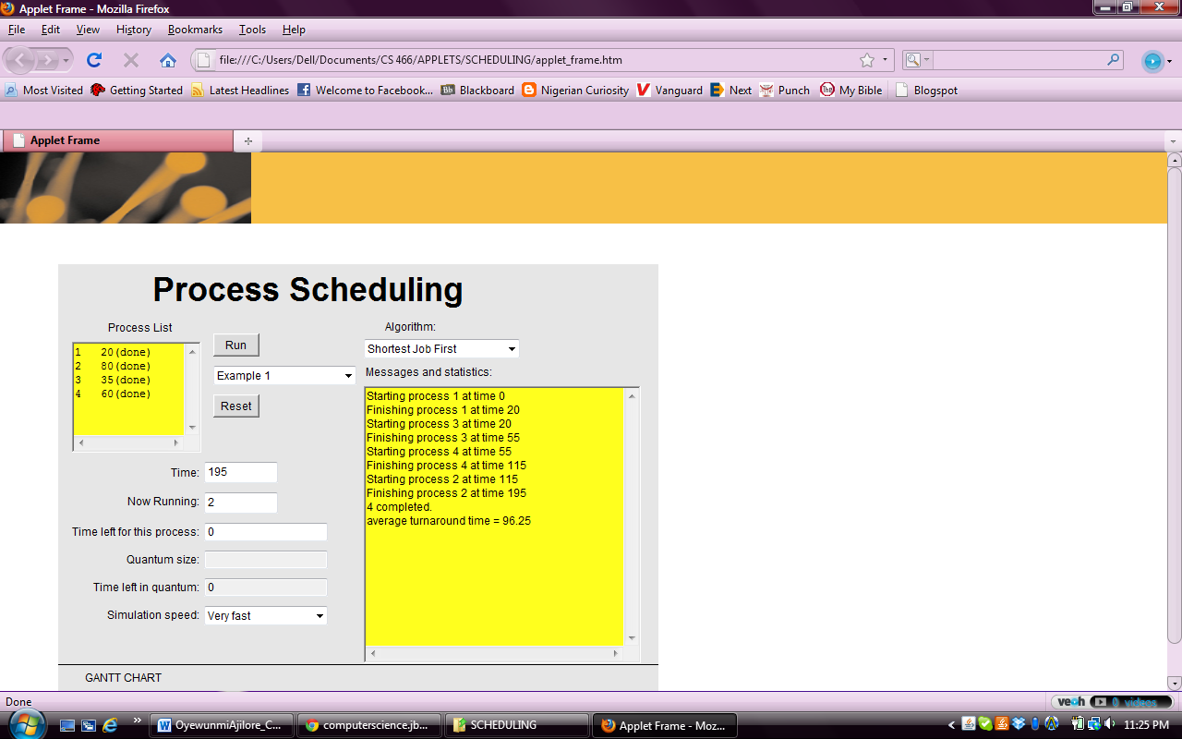

- Although the total time used is same, the average turnaround time compared to the other two is a lot more, but we cannot say this Algortith is not as good as the others.
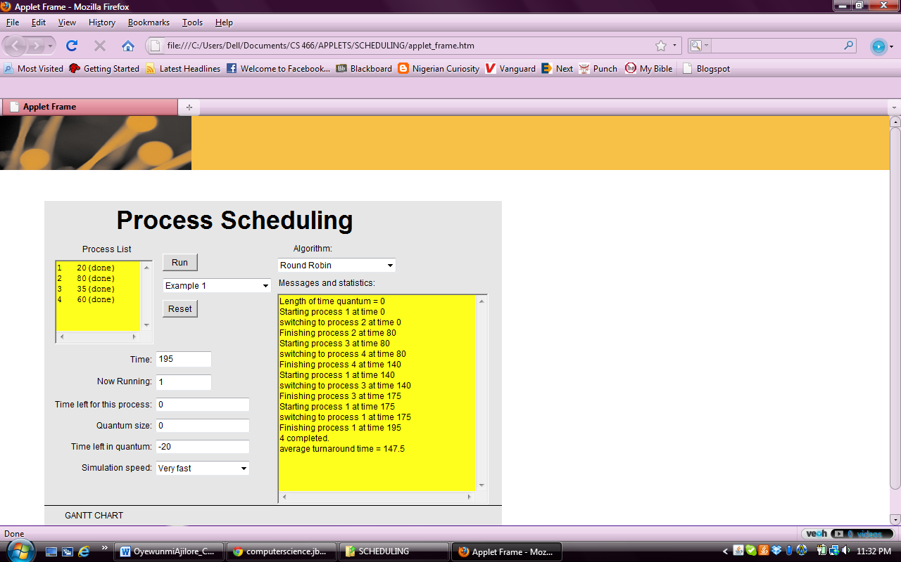

- The Round Robin algorithm is preemptive because it establishes a particular time slice which is the amouth of time each process receives before it is preempted and returned to the ready sate to allow another process to take its turn. Most computing systems would use Round Robin because it supports all kinds of jobs.

