NAME:
CHAPTER: Chapter 12
LAB: 12

For each chapter, you will complete a set of Animated Flashcards, Book exercises, and Lab exercises. Although you will have three different activities, you will submit them in one document. Use this document to record your answers for submission.

ANIMATED FLASHCARDS

In order to receive any point value for the Book and Lab exercises, you must submit your answers to the chapter’s Animated Flashcards, found on the textbook companion web site. Identify your responses with the Flashcard question numbers in this section.
- Database management system
- Table
- Cardinality constraint
- Cryptanalysis
- Database
- Confidentiality
- Spreadsheet
- Circular reference
- Key
- Encryption
- Digital signature
- Cell
- Decryption
- Risk analysis
- Field
- Caesar cipher
- Record
- Structured Query Language
- Public-key cryptography
- ER diagram
- Digital certificate
- Substitution cipher
- Transposition
- Cipher
- Cryptography
- Route cipher
- Information system
- Relational model
- Information security
- Integrity
- Availability
- Schema
- What-if analysis
- Query
- Range
- Spreadsheet function
- Entity-Relationship modeling
- BOOK EXERCISES

Refer to the chapter’s corresponding eLearning module or the course schedule for the assigned chapter exercises. Identify your responses to the exercises by including their numbers as they appear in the chapter in this section.

- False
- True
- True
- False
- False
- True
- True
- False
- True
- False
- True
- True
- False
- True
- True
- True
- True
- True
- False
- True
- True
- True
- False
- False
- True
- True
- True
- True
- False
- True
- True
46. A set of formulas that ultimately, and erroneously, rely on each other to compute their results. It is useful for solving implicit equations
48. What-if analysis is modifying spreadsheet values that represent assumptions to see how changes in those assumptions affect related data.
55. A database schema is a specification of the logical structure of the data stored in the database.
57. A Field is a single value in a database record.
60. One or more fields of a database record that uniquely identifies it among all other records in the table.
69. An ER is a popular technique for designing relational databases
73. One-to-one, One-to-many, Many-to-many
82. We first assume Claire and David have the public and private key pair. Claire gets David’s public key (which he gives to her) and uses it to encrypt a message, that way, only David can decrypt it with his pairing private key.
84. It’s in a form of a deceitful helpful program. It seems to be legitimate, even while running but causes problems when executed.

- LAB EXERCISES

The Lab Exercises are found on the textbook companion web site by clicking Explorations in Computer Science link, located in the left-side panel. Refer to the chapter’s corresponding eLearning module or the course schedule for the assigned exercises. Identify the Exercise and the activity’s number as you record your responses in this section.

12A

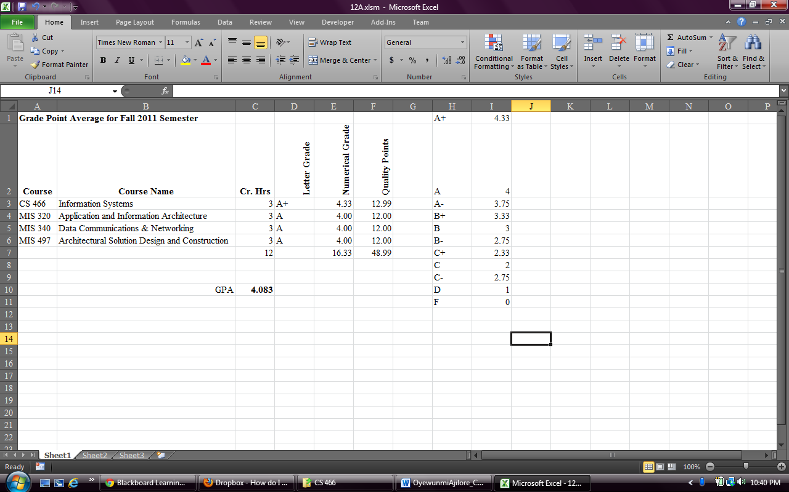

12B

select * from People where Age > 30

