NAME:
CHAPTER: Chapter 13
LAB: 13

For each chapter, you will complete a set of Animated Flashcards, Book exercises, and Lab exercises. Although you will have three different activities, you will submit them in one document. Use this document to record your answers for submission.

ANIMATED FLASHCARDS

In order to receive any point value for the Book and Lab exercises, you must submit your answers to the chapter’s Animated Flashcards, found on the textbook companion web site. Identify your responses with the Flashcard question numbers in this section.
- Knowledge-based system
- Artificial neural network
- Loebner prize
- Depth-first approach
- Weak equivalence
- Breadth-first approach
- Lexical ambiguity
- Natural language
- Chatbot
- Voice recognition
- Natural language comprehension
- Syntactic ambiguity
- Referential ambiguity
- Effective weight
- Strong equivalence
- Inference engine
- Training
- Turing test
- Phonemes
- Search tree
- Voiceprint
- Artificial Intelligence
- Semantic network
- Rule-based system
- Voice synthesis
- Expert system
BOOK EXERCISES

Refer to the chapter’s corresponding eLearning module or the course schedule for the assigned chapter exercises. Identify your responses to the exercises by including their numbers as they appear in the chapter in this section.

- Lexical
- Lexical
- Referential
- Syntactic
- Referential
- True
- True
- True
- True
- True
- False
- False
- True
- False
- True
- False
- True
- True
- False
- True
- True
31. The Turing test is used to empirically determine whether a computer has achieved intelligence based on whether a computer could fool a human into believing that the computer is human.
33. Weak equivalence is the equality of two systems based on their results and would be demonstrated by a computer that passes the Turing test. Equivalent in result but do not arrive at the result the same way.
34. Strong equivalence is the equality of two systems based on their results and the process by which they arrive at those results (process is usually similar).
38. A Graph
44. Depth-first approach is searching down the paths of a tree prior to searching across levels while Breadth-first approach is searching across levels of a tree prior to searching down specific paths.
54. A neuron
55. A pathway
56. It is strengthened or weakened according to the state of the neurons it passes through.
57. Dendrites
58. An Axon
59. They pick of the signals from the axons of other neurons.
60. A synapse
61. The chemical composition
62. Tempers the strength of its input signal.
63. It relates through the weight values. They correspond to the controlling effect of the synapse.
64. An effective weight is the sum of weights multiplied by the corresponding input values.
65. An output value is calculated by comparing the effective weight to the threshold value.
66. 1
LAB EXERCISES

The Lab Exercises are found on the textbook companion web site by clicking Explorations in Computer Science link, located in the left-side panel. Refer to the chapter’s corresponding eLearning module or the course schedule for the assigned exercises. Identify the Exercise and the activity’s number as you record your responses in this section.

13.1
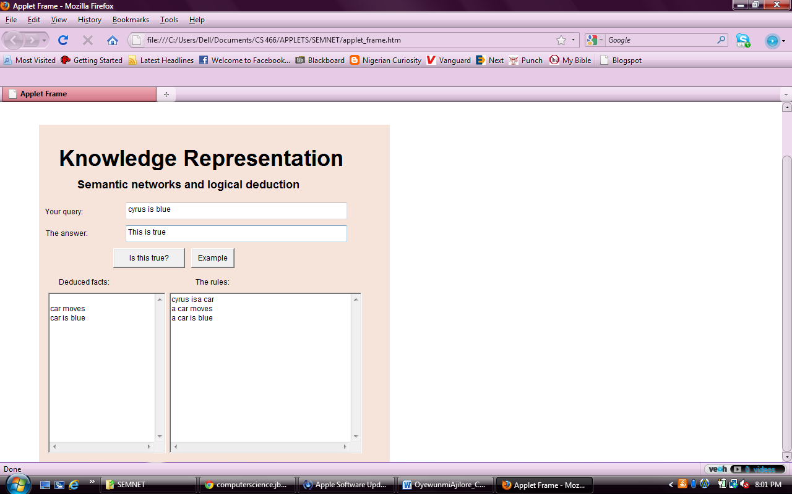

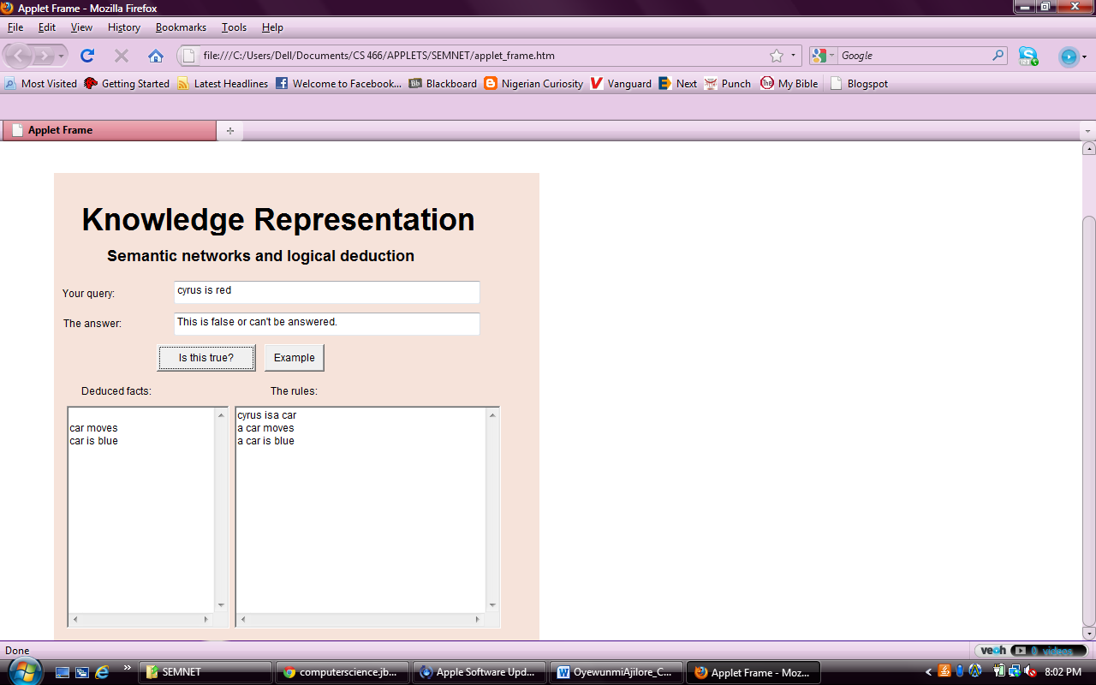

7. Because there are no rules that pertain to John and his skin, the computer cannot figure out what you might be referring to. So the answer is false/can’t be answered.

8. 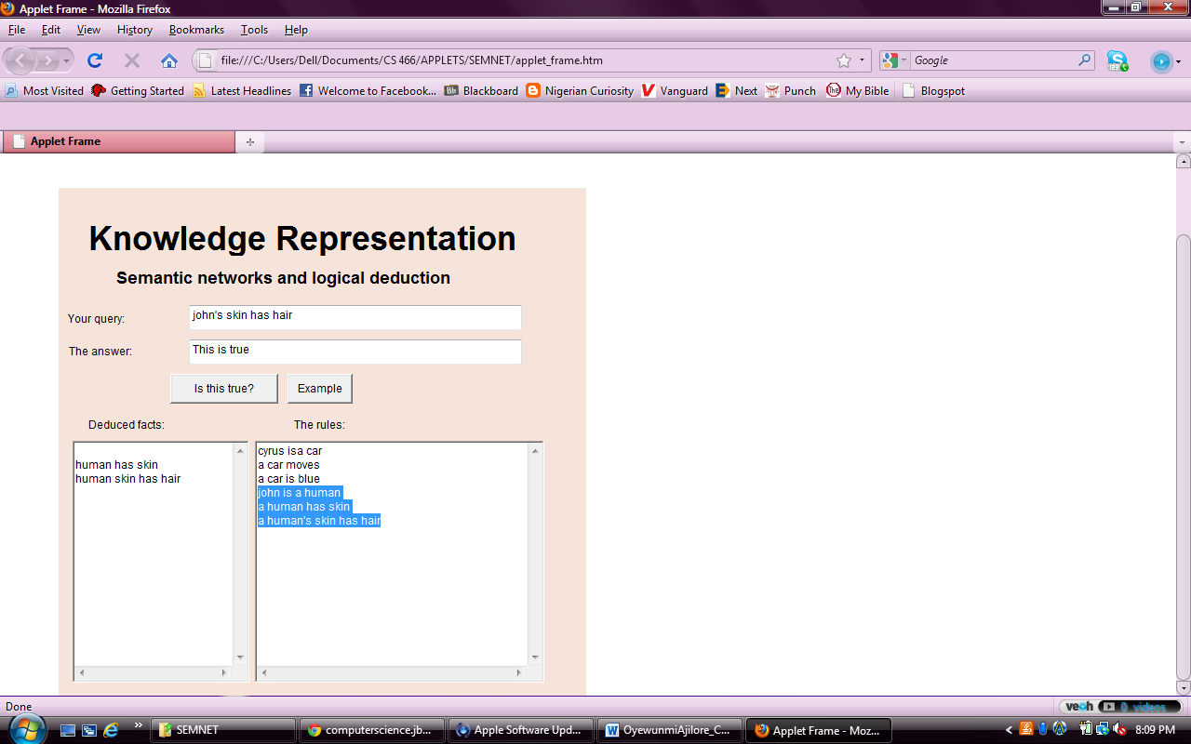

john is a human
a human has skin
a human's skin has hair

13.2

6.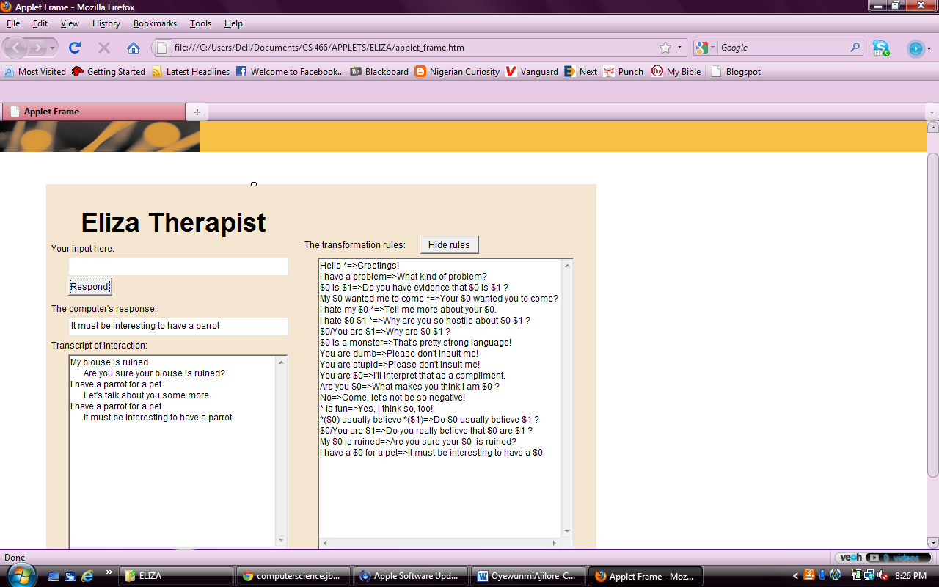

7.

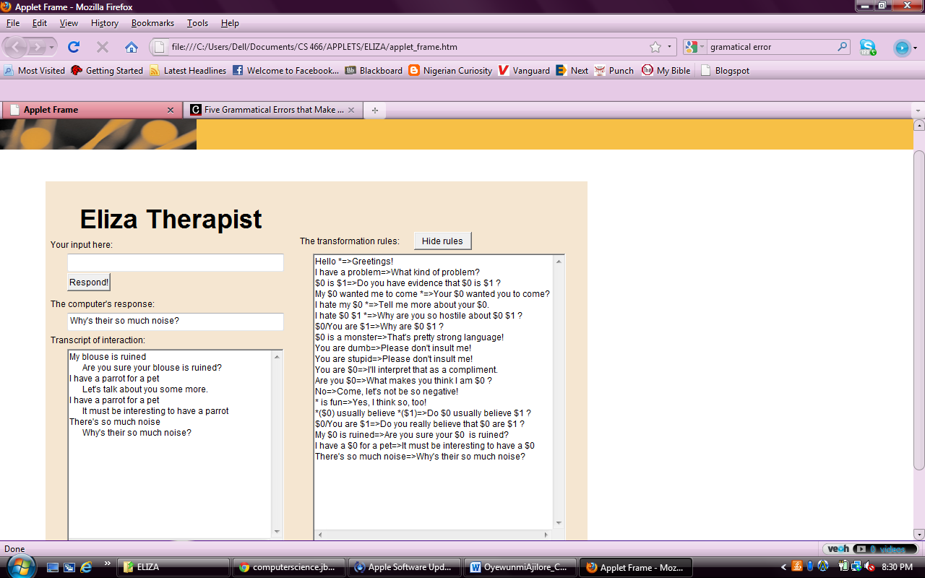

8.
