NAME
CHAPTER: Chapter 14
LAB: 14

For each chapter, you will complete a set of Animated Flashcards, Book exercises, and Lab exercises. Although you will have three different activities, you will submit them in one document. Use this document to record your answers for submission.

ANIMATED FLASHCARDS

In order to receive any point value for the Book and Lab exercises, you must submit your answers to the chapter’s Animated Flashcards, found on the textbook companion web site. Identify your responses with the Flashcard question numbers in this section.
- Biometrics
- Phishing
- Virus
- Simulation
- Buffer overflow
- Password guessing
- Gameplay
- Spoofing
- Back door
- Malicious code
- Computer gaming
- Electronic commerce
- Model
- Trojan horse
- Man-in-the-middle
- Smart card
- Password
- Worm
- Logic bomb
- Game engine
- Interactive system
- Authentication credentials
- Denial of service
BOOK EXERCISES

Refer to the chapter’s corresponding eLearning module or the course schedule for the assigned chapter exercises. Identify your responses to the exercises by including their numbers as they appear in the chapter in this section.

- A
- A
- A
- A
- B
- B
- A
- A
- B
- A
- A
- B
- B
- B
- B
- B
- B
- A
- A
- B
- A
- A
- A
- A
- Simulation is the development of a model of a complex system and the experimental manipulation of that model to observe the result. Examples: Which store will have the least wait time in line, which route will be best to take to work, determining weather, where is the best place to eat, who is offering the best sale.
- The essence of construction a model is to identify a small subset of characteristics or features that are sufficient to describe the behavior under investigation.
- Continuous simulation treat time as continuous and express changes in the terms of a set of differential equations that reflect the relationships among the set of characteristics, while Discrete-event simulations are made up of entities, attributes and events with some having to be explicitly defined.
- Choosing the entities to represent the system and correctly determining the rules that define the results of the events.
- The rules which must be sufficient to produce the results to be observed.
- Abstract model because the entities in the abstract model are object classes.
- The goal of a queuing system is to utilize the servers as fully as possible while keeping the wait time within a reasonable limit.
- The number of events and how they affect the system so we can determine the rules of entity interaction, The number of servers, The distribution of arrival times so we can determine if an entity enters the system and The expected service time so we can determine the duration of an event.
- It is referred to as luck. It generates a random number between 0.0 and 1.0. If the random number is between 0.0 and the arrival probability, a job has arrived or if the random number is greater than the arrival probability, then no job arrived in this clock unit.
- FIFO queue: the entity that receives service is the entity that has been in the queue the longest time. In Priority queues, each item in the queue is associated with a priority and when an item is dequeued, the item returned is the one with the highest priority.
- It introduced constructs such as classes and objects, inheritance and polymorphism.
- Of partial differential equations of fluid mechanics and thermodynamics.

- When objects move, there is a period during which their speed is increasing , called the ‘ease-in’ in animation.
- Bioinformatics, Computational biomodeling, Computational genomics, Molecular modeling, Protein structure prediction

- LAB EXERCISES

The Lab Exercises are found on the textbook companion web site by clicking Explorations in Computer Science link, located in the left-side panel. Refer to the chapter’s corresponding eLearning module or the course schedule for the assigned exercises. Identify the Exercise and the activity’s number as you record your responses in this section.

Exercise 1

- Configuration: O i
Took about 200 simulations

Exercise 2

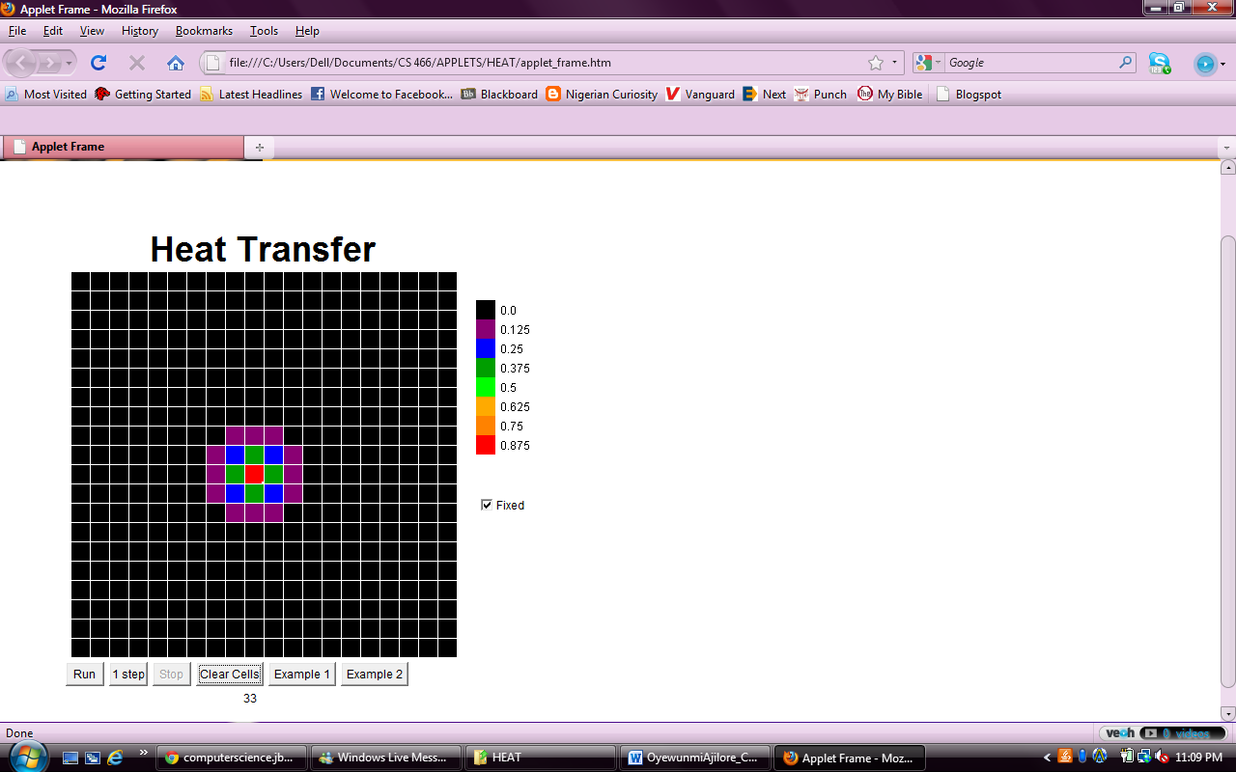

4) There are 4 different colors in a square like pattern.
5) Yes
6) If the coal is hanging in the air
7) The rate of change is gradual and represents what might happen in reality
8) The colors gradually disappear beginning with the red and the other colors closest to it. I don’t really know what’s going on.

