NAME:
CHAPTER: 6
LAB: 6

For each chapter, you will complete a set of Animated Flashcards, Book exercises, and Lab exercises. Although you will have three different activities, you will submit them in one document. Use this document to record your answers for submission.

ANIMATED FLASHCARDS

In order to receive any point value for the Book and Lab exercises, you must submit your answers to the chapter’s Animated Flashcards, found on the textbook companion web site. Identify your responses with the Flashcard question numbers in this section.
- Program
- Control abstraction
- Encapsulation
- Method
- Implementation phase
- Abstract step
- Identifier
- Filtering
- Top-down design
- Walk-through
- Class
- Object class
- Module
- Semantics
- Reuse
- Sort key
- Algorithm
- Base class
- Syntax
- Fields
- Assignment statement
- Pseudocode
- Problem-solving phase
- Desk checking
- Object
- Client
- Information hiding
- Scenarios
- Brainstorming
- Programming language
- CRC cards
- Sorting
- Maintenance phase
- Control structure
- Responsibility algorithms
- Data abstraction
- Heuristics
- Procedural abstraction
- Container class
- Inspection
- Concrete step
- Object-oriented design
- Problem solving

BOOK EXERCISES

Refer to the chapter’s corresponding eLearning module or the course schedule for the assigned chapter exercises. Identify your responses to the exercises by including their numbers as they appear in the chapter in this section.

- False
- False
- False
- False
- True
- False
- True
- True
- False

- True

- The realization that data and instructions to manipulate data are logically the same and could be stored in the same place. In essence, it can store, retrieve, and process data.
- Machine language must have addition, subtraction, reading, writing and storing
- Millions
- The Program counter contains the address of the next instruction to be executed while the Instruction register contains a copy of the instruction being executed.

LAB EXERCISES

The Lab Exercises are found on the textbook companion web site by clicking Explorations in Computer Science link, located in the left-side panel. Refer to the chapter’s corresponding eLearning module or the course schedule for the assigned exercises. Identify the Exercise and the activity’s number as you record your responses in this section.

- 0000000000000001, 0000000000000010, 0000000000000011, 0000000000000100

- 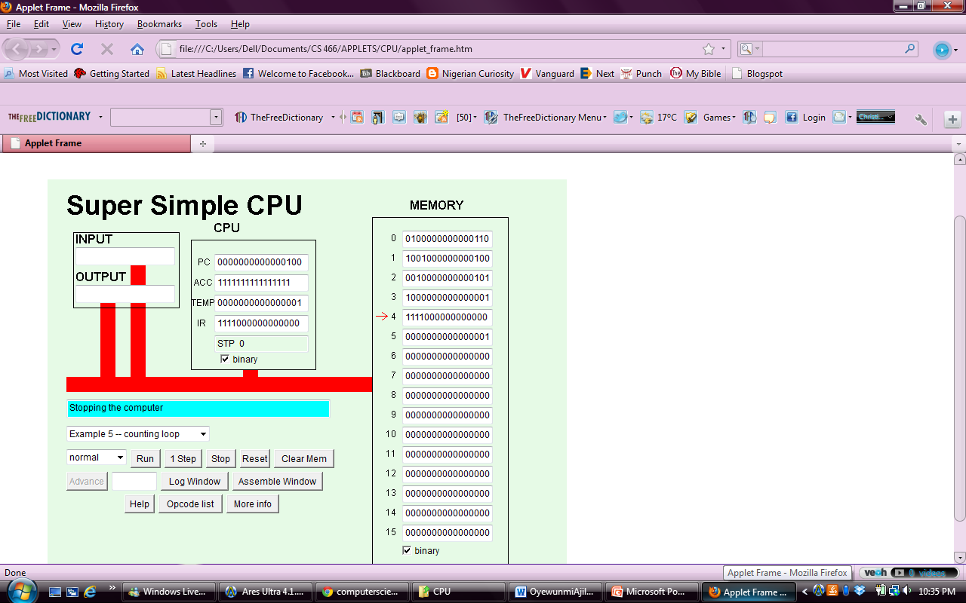
- Cell 0: LDI into cell 6
Cell 1: JNG Jump to instruction in cell 4 if accu<0
Cell 2: SUB Subtract operand from accu in cell 1
Cell 3: JNP Jump to instruction in cell 1
Cell 4: STP counter

Exercise 5
- 10000₂ and 11100₂
- 