- A hashed file has space for 70 records. Relative record numbers of 0-69 label each of the 70 record positions. In addition, there is space for several overflow (synonym) records. Draw a picture of the file and using the division-remainder method, store records with each of the following four digit keys, accounting for collisions as necessary:
  - 4000.
  - 5207.
  - 0360.
  - 1410.

- The record with key value 4000 is stored at record location 10.
- The record with key value 5207 is stored at record location 27.
- The record with key value 0360 should be stored at record location 10 but that location is already occupied. So, the record with key value 0360 is stored in an overflow record location and the synonym pointer at location 10 points to it.
- The record with key value 1410 should be stored at record location 10 but that location is already occupied. So, the record with key value 1410 is stored in an overflow record location. The synonym pointer at record location 10 still points to the overflow location at which record 0360 is stored. The synonym pointer at location 0360 now points to the location of record 1410.
0
…
10 | 4000
…
27 | 5207
…
69
70 | 360
71 | 1410
72
73
74

- Happy Cruise Lines.
  - Consider the Happy Cruise Lines Sailor file shown below. It lists all of the sailors on the company’s cruise ships by their unique sailor identification number, their name, the unique identification number of the ship they currently work on, their home country, and their job title.

 | Sailor  Number | Sailor  Name | Ship  Number | Home  Country | Job  Title
1 | 00536 | John Smith | 009 | USA | Purser
2 | 00732 | Ling Chang | 012 | China | Engineer
3 | 06988 | Maria Gonzalez | 020 | Mexico | Purser
4 | 16490 | Prashant Kumar | 005 | India | Navigator
5 | 18535 | Alan Jones | 009 | UK | Cruise Director
6 | 20254 | Jane Adams | 012 | USA | Captain
7 | 23981 | Rene Lopez | 020 | Philippines | Captain
8 | 27467 | Fred Jones | 020 | UK | Waiter
9 | 27941 | Alain DuMont | 009 | France | Captain
10 | 28184 | Susan Moore | 009 | Canada | Wine Steward
11 | 31775 | James Collins | 012 | USA | Waiter
12 | 32856 | Sarah McLachlan | 012 | Ireland | Cabin Steward
Sailor file

    - Describe the file’s record type. Simple Linear Index
    - Show a record occurrence. 00536, John Smith, 009, USA, Purser
    - Describe the set or range of values that the Ship Number field can take.
Integer
    - Describe the set or range of values that the Home Country field can take.
Text
  - Assume that the records of the Sailor file are physically stored in the order shown.
    - Retrieve all of the records of the file physically sequentially.
1 | 00536 | John Smith | 009 | USA | Purser
2 | 00732 | Ling Chang | 012 | China | Engineer
3 | 06988 | Maria Gonzalez | 020 | Mexico | Purser
4 | 16490 | Prashant Kumar | 005 | India | Navigator
5 | 18535 | Alan Jones | 009 | UK | Cruise Director
6 | 20254 | Jane Adams | 012 | USA | Captain
7 | 23981 | Rene Lopez | 020 | Philippines | Captain
8 | 27467 | Fred Jones | 020 | UK | Waiter
9 | 27941 | Alain DuMont | 009 | France | Captain
10 | 28184 | Susan Moore | 009 | Canada | Wine Steward
11 | 31775 | James Collins | 012 | USA | Waiter
12 | 32856 | Sarah McLachlan | 012 | Ireland | Cabin Steward
    - Retrieve all of the records of the file logically sequentially based on the Sailor Name field.
27941 | Alain DuMont | 009 | France | Captain
18535 | Alan Jones | 009 | UK | Cruise Director
27467 | Fred Jones | 020 | UK | Waiter
31775 | James Collins | 012 | USA | Waiter
20254 | Jane Adams | 012 | USA | Captain
536 | John Smith | 009 | USA | Purser
732 | Ling Chang | 012 | China | Engineer
6988 | Maria Gonzalez | 020 | Mexico | Purser
16490 | Prashant Kumar | 005 | India | Navigator
23981 | Rene Lopez | 020 | Philippines | Captain
32856 | Sarah McLachlan | 012 | Ireland | Cabin Steward
28184 | Susan Moore | 009 | Canada | Wine Steward

    - Retrieve all of the records of the file logically sequentially based on the Sailor Number field.
00536 | John Smith | 009 | USA | Purser
00732 | Ling Chang | 012 | China | Engineer
06988 | Maria Gonzalez | 020 | Mexico | Purser
16490 | Prashant Kumar | 005 | India | Navigator
18535 | Alan Jones | 009 | UK | Cruise Director
20254 | Jane Adams | 012 | USA | Captain
23981 | Rene Lopez | 020 | Philippines | Captain
27467 | Fred Jones | 020 | UK | Waiter
27941 | Alain DuMont | 009 | France | Captain
28184 | Susan Moore | 009 | Canada | Wine Steward
31775 | James Collins | 012 | USA | Waiter
32856 | Sarah McLachlan | 012 | Ireland | Cabin Steward

    - Retrieve all of the records of the file logically sequentially based on the Ship Number field.
16490 | Prashant Kumar | 005 | India | Navigator
00536 | John Smith | 009 | USA | Purser
18535 | Alan Jones | 009 | UK | Cruise Director
27941 | Alain DuMont | 009 | France | Captain
28184 | Susan Moore | 009 | Canada | Wine Steward
00732 | Ling Chang | 012 | China | Engineer
20254 | Jane Adams | 012 | USA | Captain
31775 | James Collins | 012 | USA | Waiter
32856 | Sarah McLachlan | 012 | Ireland | Cabin Steward
06988 | Maria Gonzalez | 020 | Mexico | Purser
23981 | Rene Lopez | 020 | Philippines | Captain
27467 | Fred Jones | 020 | UK | Waiter

    - Perform a direct retrieval of the records with a Sailor Number field value of 27467.
27467 | Fred Jones | 020 | UK | Waiter

    - Perform a direct retrieval of the records with a Ship Number field value of 020.
06988 | Maria Gonzalez | 020 | Mexico | Purser
23981 | Rene Lopez | 020 | Philippines | Captain
27467 | Fred Jones | 020 | UK | Waiter

    - Perform a direct retrieval of the records with a Job Title field value of Captain.
27941 | Alain DuMont | 009 | France | Captain
20254 | Jane Adams | 012 | USA | Captain
23981 | Rene Lopez | 020 | Philippines | Captain

  - Create a simple linear index for the Sailor file based on:
    - The Sailor Name field.
Prashant Kumar
John Smith
Alan Jones
Alain DuMont
Susan Moore
Ling Chang
Jane Adams
James Collins
Sarah McLachlan
Maria Gonzalez
Rene Lopez
Fred Jones

    - The Sailor Number field.
005
009
009
009
009
012
012
012
012
020
020
020

    - The Ship Number field.
16490
00536
18535
27941
28184
00732
20254
31775
32856
06988
23981
27467

    - The combination of the Ship Number and the Job Title fields.
005 | Navigator
009 | Purser
009 | Cruise Director
009 | Captain
009 | Wine Steward
012 | Engineer
012 | Captain
012 | Waiter
012 | Cabin Steward
020 | Purser
020 | Captain
020 | Waiter

  - Construct a B+-tree index of the type shown in this chapter for the Sailor file, assuming that now there are many more records than are shown above. The file and the index have the following characteristics:
- The file is stored on nine cylinders of the disk. The highest key values on the nine cylinders, in order, are:
Cylinder 1: 02653
Cylinder 2: 07784
Cylinder 3: 13957
Cylinder 4: 18002
Cylinder 5: 22529
Cylinder 6: 27486
Cylinder 7: 35800
Cylinder 8: 41633
Cylinder 9: 48374
- Each index record can hold four key value/pointer pairs.
- There are three index records at the lowest level of the tree index.
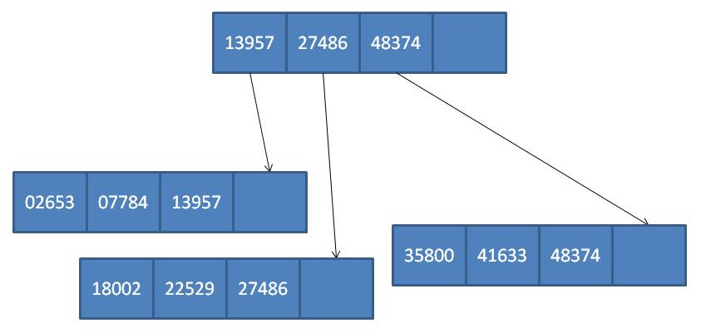

  - The same as part d above, but now there are four index records at the lowest level of the tree index.
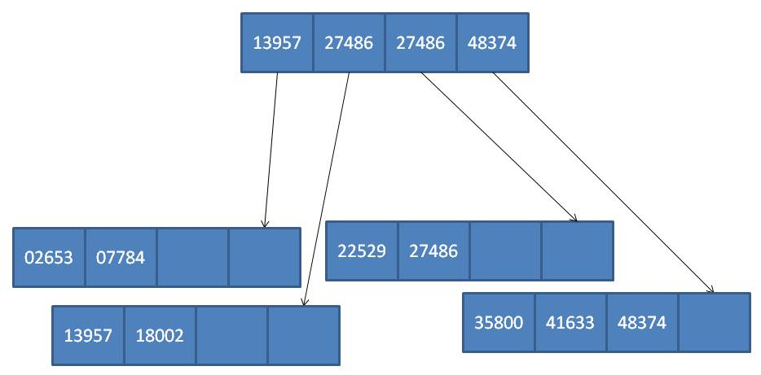

  - The same as part d above, but each index record can hold two key value/pointer pairs and there are five index records at the lowest level of the tree index.
