Draw an ERD for the following narratives:
Narrative # 1
Projects Inc., is an engineering firm with approximately 500 employees. A database is required to keep track of all employees, their skills, projects assigned, and departments worked in. Every employee has a unique number assigned by the firm, required to store his or her name and date of birth. If an employee is currently married to another employee at Projects Inc., the date of marriage and who is married to whom must be stored; however no record of marriage is required if an employee’s spouse is not an employee. Each employee is given a job title (e.g. engineer, secretary etc). An employee does only one type of job at any given time and we only need to retain information on employees current job title.
There are 11 different departments, each with a unique name. An employee can report to only one department. Each department has a phone number.
To procure various kinds of equipment, each department deals with many vendors. A vendor typically supplies to many departments. We are required to store the name and address of each vendor and the date of the last meeting between a department and a vendor.
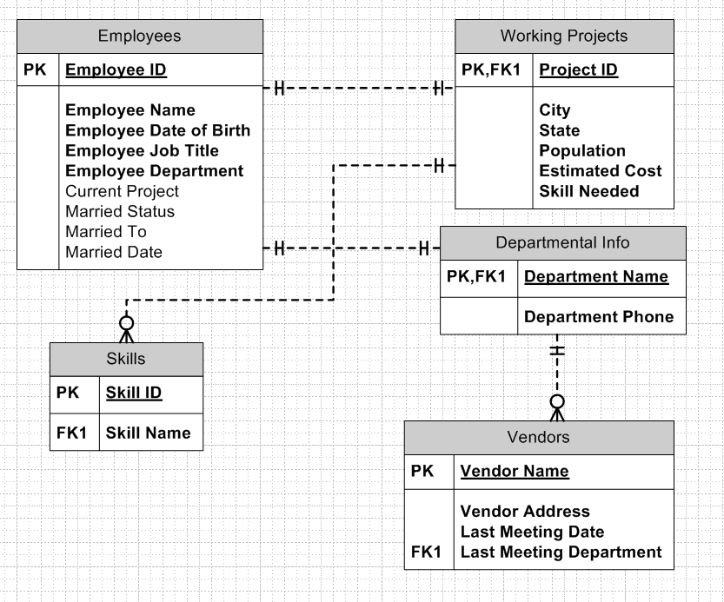
Many employees can work on a project. An employee can work on many projects but can only be assigned to at most one project in a given city. For each city, we are interested in its state and population. An employee can have many skills, but can only use a given set of skills on a particular project. Each skill is assigned a number, and we must store a short description of the skill. Projects are distinguished by project numbers and we must store the estimated cost of each project.

Narrative # 2.

The Super Baseball League wants to maintain information about its teams, their coaches, players, and bats. The information about players is historic. For each team, the league wants to keep track of all of the players who have ever played on the team, including the current players. For each player, it wants to know about every team the player ever played for. On the other hand, coach affiliation and bat information is current, only.
The league wants to keep track of each team’s team number, which is unique, its name, the city in which it is based, and the name of its manager. Coaches have a name (which is only assumed to be unique within its team) and a telephone number. Coaches have units of work experience, which are described by the type of experience and the number of years of that type of experience. Bats are described by their serial numbers (which are only unique within a team) and their manufacturer’s name. Players have a player number that is unique across the league, a name, and an age.
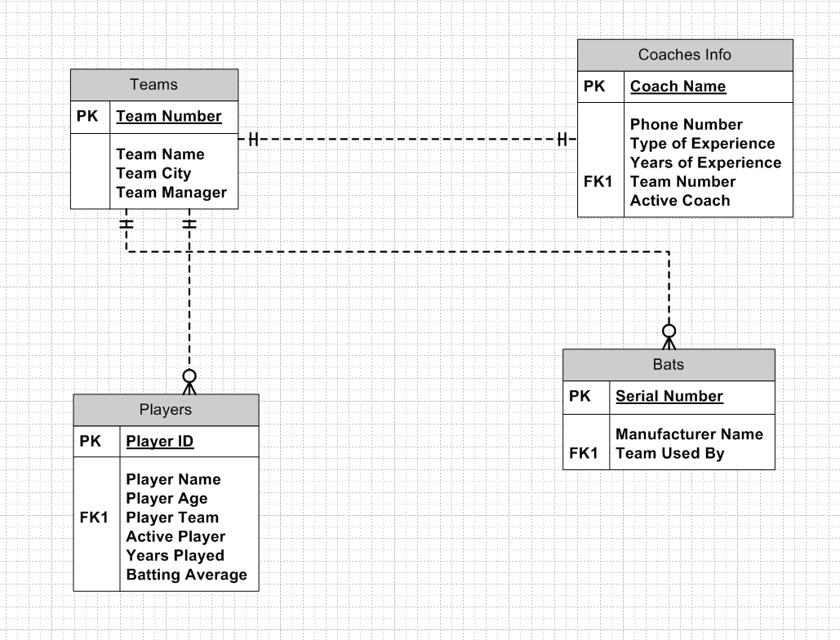
A team has at least one and usually several coaches. A coach works for only one team. Each coach has several units of work experience or may have none. Each unit of work experience is associated with the coach to whom it belongs. Each team owns at least one and generally many bats. Currently and historically, each team has and has had many players. To be of interest to the league, a player must have played on at least one and possibly many teams during his career. Further, the league wants to keep track of the number of years that a player has played on a team and the batting average that he compiled on that team.

