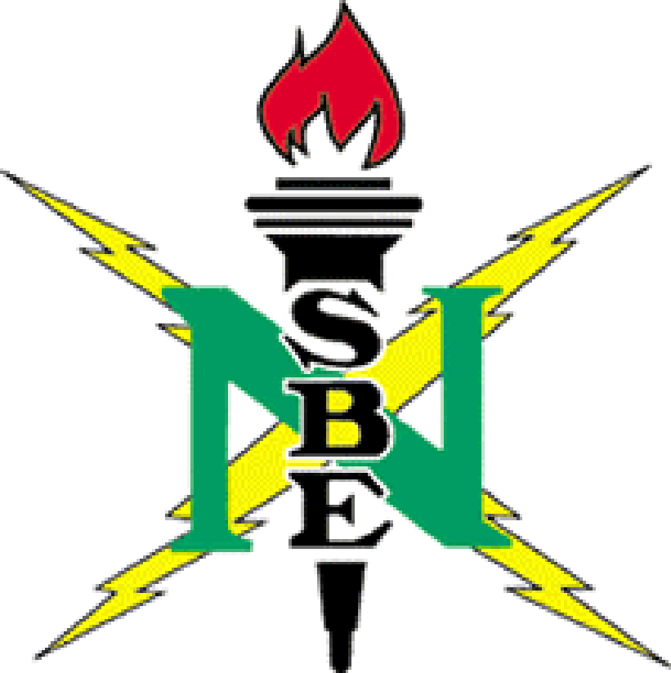

February 24, 2007

9:00 – 12:00 A.M.

Montgomery Public Library

Main Branch Auditorium

Refreshments will be served

For information, contact Jamie Foster of NSBE-MAE at
(334) 270-5687.

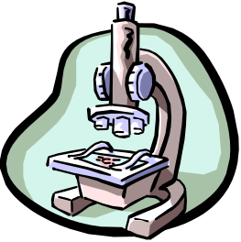


Take advantage of this free help to prepare yourself for the exit exam. Space is limited, so call ASAP to reserve your spot!



