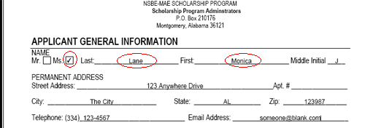
First download the PDF form to your local computer. Click inside any field in which you wish to enter information. If you place your mouse cursor over a field where information can be typed in, your cursor will change to a vertical line, similar to this: |
When the cursor changes to a vertical line, simply click your left mouse key and begin entering the necessary information.
Once you have filled out the form and printed it, sign the form and send it to the address listed on the application.

