**Digital Assignment – 1**

**Machine Vision**

Divyaansh Agarwal

20BPS1128

**Perform image manipulation techniques for images in MATLAB**

Code:

1. **Addition and Subtraction**

original4 = imread('img_01.jpg');

subplot(1,3,1),imshow(original4),title('Original Image')

%% addition

addition = original4 + 70;

subplot(1,3,2),imshow(addition),title('After addition')

%% subtraction

subtaction = original4 - 70;

subplot(1,3,3),imshow(subtaction),title('After subtraction')

**Output:**

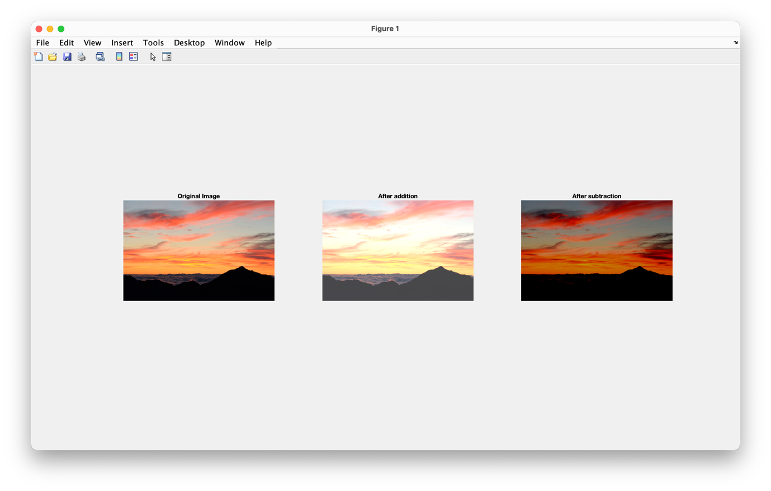

1. **Grayscaling and Edge Detection**

original1 = imread('img_01.jpg');

subplot(1,3,1),imshow(original1),title('Original Image')

%% grayscale

grayscale1 = im2gray(original1);

subplot(1,3,2),imshow(grayscale1),title('GreyScale Image');

%% edge detection using roberts method

e1 = edge(grayscale1,"roberts");

subplot(1,3,3), imshow(e1),title('Edge Detection');

**Output:**

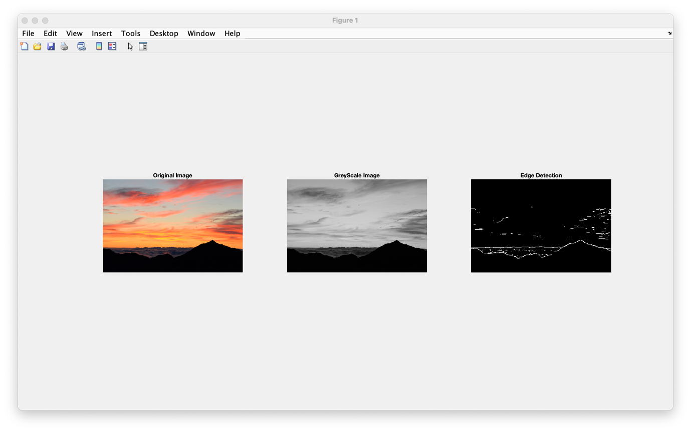

1. **Histogram Equalization**

original2 = imread('img_02.jpg');

subplot(3,3,2),imshow(original2),title('Original Image')

%% grayscale

grayscale2 = im2gray(original2);

subplot(3,3,4),imshow(grayscale2),title('Grayscale Image');

%% histogram of grayscale

subplot(3,3,6), imhist(grayscale2), title('Histogram of Image ');

%% constract enhancing using histogram equalisation

image1_contrast = histeq(grayscale2);

subplot(3,3,7), imshow(image1_contrast), title('Enhancing contrast of greyscale image');

%% histogram of equalised image

subplot(3,3,9), imhist(image1_contrast), title('Histogram of enhanced image');

**Output:**

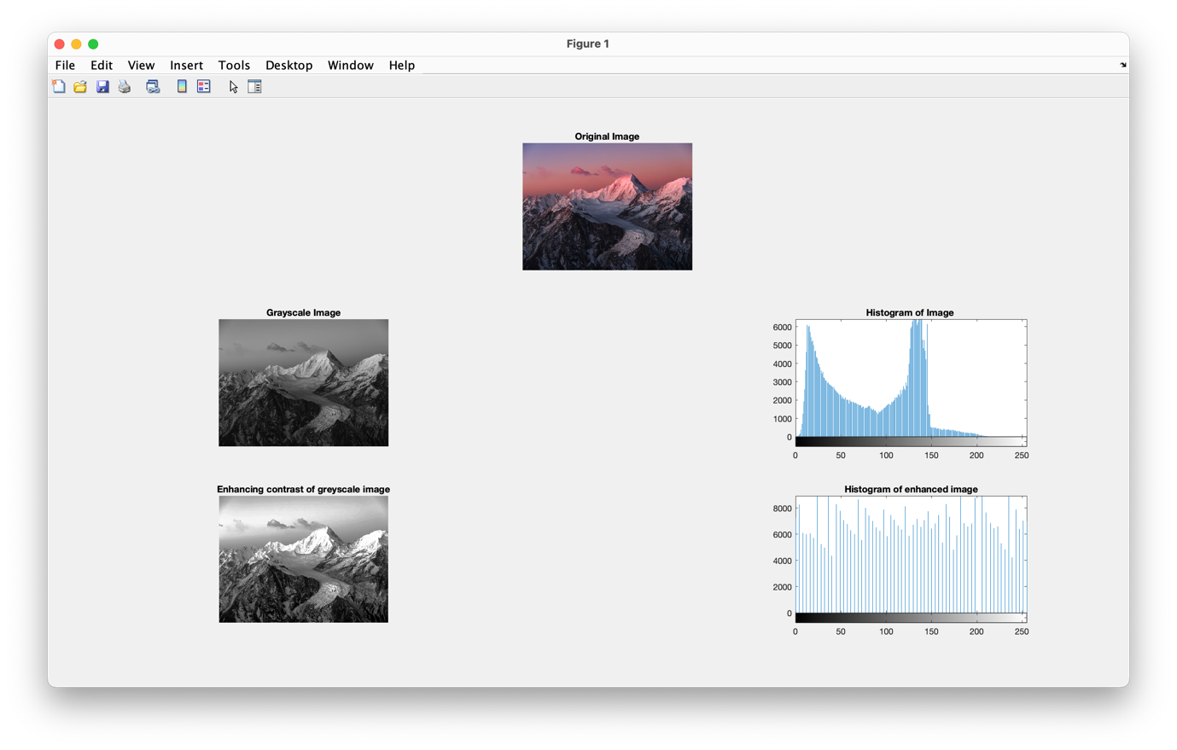

1. **Inverting Image**

original3 = imread('img_03.jpeg');

subplot(2,2,1),imshow(original3),title('Original Image')

%% grayscale image

grayscale3 = im2gray(original3);

subplot(2,2,3),imshow(grayscale3),title('grayscale Image');

%% compliment of coloured image

complement1 = imcomplement(original3);

subplot(2,2,2), imshow(complement1), title('Complement of colour image');

%% compliment of grayscale image

complement2 = imcomplement(grayscale3);

subplot(2,2,4), imshow(complement2), title('Complement of Grayscale');

**Output:**

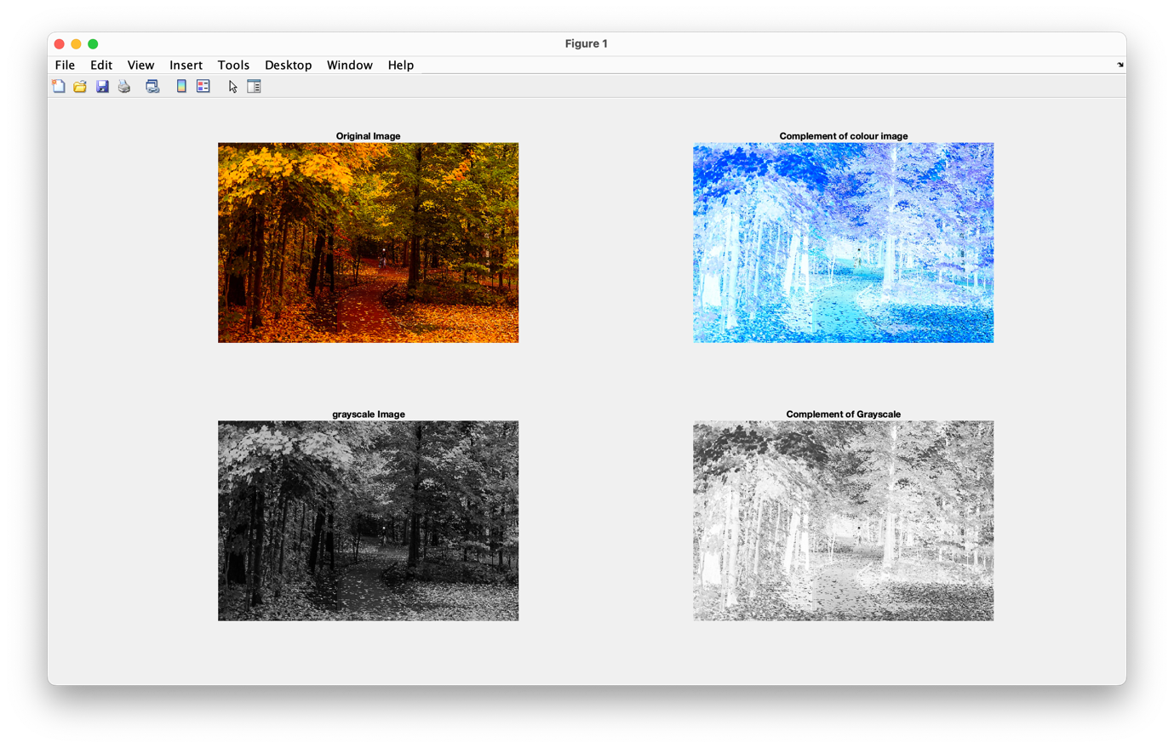

1. **Smoothing and Sharpening**

original5 = imread('img_03.jpeg');

subplot(3,3,2),imshow(original5),title('Original Image')

%% Smoothing using guassian filter at different sigma values

smooth1 = imgaussfilt(original5,2);

smooth2 = imgaussfilt(original5,4);

smooth3 = imgaussfilt(original5,8);

subplot(3,3,4),imshow(smooth1),title('gaussian smoothing sig2')

subplot(3,3,5),imshow(smooth2),title('gaussian smoothing sig4')

subplot(3,3,6),imshow(smooth3),title('gaussian smoothing sig8')

%% Sharpening image

sharp = imsharpen(smooth3);

subplot(3,3,8),imshow(sharp),title('sharpened image')

**Output:**

