鹤语袅袅

Mr & Mrs Crane Sing

江西为什么这样红？这片土地上承载着太多的红色记忆，这块山水中凝结着太深的红色文化。江西革命烈士多，开国将军多，革命旧址多，可谓县县有红色故事，处处有红色景区，在中国共产党的革命历史与精神谱系中占据特殊的重要地位。为了更好地继承发扬中华民族的优秀红色文化及其宝贵精神财富，华东交通大学外国语学院“鹤语袅袅 数融红赣创青春”项目组开展江西红色文化国际传播效能的调查研究与创新实践。

Why is Jiangxi so red? The land carries both so many red memories and so deep red culture. Jiangxi has a lot of revolutionary martyrs, founding generals and revolutionary sites, so there are red stories in red scenic spots everywhere. Jiangxi Red Culture occupies a special and important position in the revolutionary history and spiritual genealogy of the Communist Party of China. The project team of "Mr & Mrs Crane Sing:Empowering the Internationalization of Jiangxi Red Culture with Digital Technology " from School of Foreign Languages of East China Jiaotong University conducted an investigative research and innovative practice on the international communication effectiveness of Jiangxi Red Culture. It is of great significance to better inherit and carry forward the excellent red culture of the Chinese nation and its precious spiritual wealth.

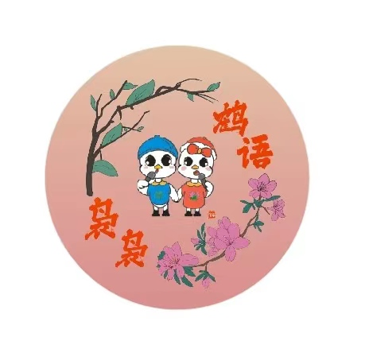

地址：中国江西省南昌市华东交通大学外国语学院

邮编：330013

电话：0791-87046375

网址：https://www.heyuniaoniao.com

二维码: 

ADD.：School of Foreign Languages, East China Jiaotong University, Nanchang, Jiangxi, China

P.C. ：330013

Tel. ：0791-87046375

URL: https://www.heyuniaoniao.com