Nat & Sami’s Rare Earth Metals
COSC 304, Lab Group 34
Nat Scott
Sami Almuallim

Mission statement
Our mission is to ensure every Canadian can get a pure sample of any rare earth metal on their doorstep within two days.

Executive summary
For a variety of cultural and logistical reasons, private citizens in need of rare-earth metals for reasons beyond the scope of this report continue to find them hopelessly inaccessible. Nat and Sami's Rare-Earth Metal Delivery Company seeks to bridge this gap by providing reliable, nation-wide two-day delivery of any of the 17 rare-earth metals, in any quantity, no questions asked. Our platform, hosted on Hetzner, implements user authentication routines, a shopping cart, an order fulfillment system, and an administrator dashboard to perform maintenance tasks without needing to dig into the database manually.

Features

Hosting
Our website is being hosted on a Debian VPS rented from Hetzner at https://cosc304.njms.ca

Main page
- You can search for products from the root page “/” and the main product directory “/listprod”
- By default (i.e. no search query) all products are listed on “/listprod”
- Most pages have a navigation bar fixed to the top which lists the username of the current user

Shopping cart
- You can add to the shopping cart from “/listprod” and “/product”
- You can view the shopping cart at “/showcart”
- You can increment/decrement an item’s quantity at “/showcart”. If the quantity reaches zero, the item is removed from the cart
- Items in the cart can be immediately removed by pressing the “Delete” link in “/showcart”

Checkout
- From “/showcart” you can follow a link to reach “/checkout”
- Once you enter your customerId and password, you can check out, registering your cart as an order in the database.

Product Detail Page
- Product details can be reviewed by following the link of the product’s name from “/listproduct” to “/product?id={product id}”.
- This page may retrieve the product’s image from the database as a blob and render it if applicable.

User Accounts
- A user’s profile is accessible at “/customer” when logged in
- New users can register at “/register”. This page implements HTML client side validation, and values are also checked against constraints enforced by the database (distinctness, not null)
- You can update all fields of your profile except for customerId
- Users are redirected to “/login” when not logged in. Users can log out at “/logout”, accessible from “/customer”
- All of a customer’s orders can be found at “/listorder”. If the current user is an admin, then all orders from all customers will be listed here.

Admin portal
- “/admin” can only be accessed if the user is an administrator
- “/admin/listCustomers” lists a table of all customers
- A table listing sales by day is available on “/admin”, along with a bar graph illustrating the data
- New products can be added at “/admin/addProduct”
- From “/admin/productDirectory”, the admin can delete and update products
- Orders can be shipped from “/ship”
- Photos can be added to products as files and directly in the database, from “/admin/productAddImage”, accessed from the admin product directory. This procedure uses AJAX.

Source list
- Express.js 4.x API reference. https://expressjs.com/en/4x/api.html
- mssql library documentation. https://www.npmjs.com/package/mssql
- multer library documentation. https://www.npmjs.com/package/multer
- Chart.js Documentation. https://www.chartjs.org/docs/latest/
- “How do I upload a file with the JS fetch API?” on Stack Overflow. https://stackoverflow.com/questions/36067767/how-do-i-upload-a-file-with-the-js-fetch-api
- “How to get the value of a selected radio button” on Stack Overflow. https://stackoverflow.com/questions/15839169/how-to-get-the-value-of-a-selected-radio-button

Walkthrough
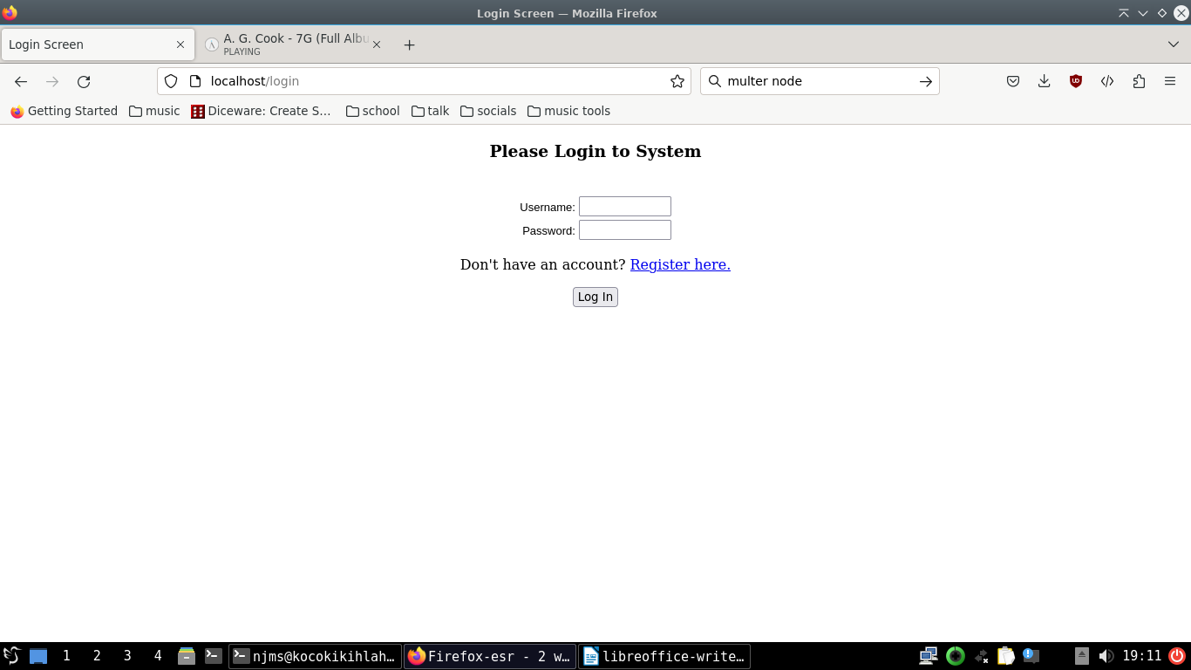
We start at the login page. We don’t have an account yet, so we can click “Register Here”
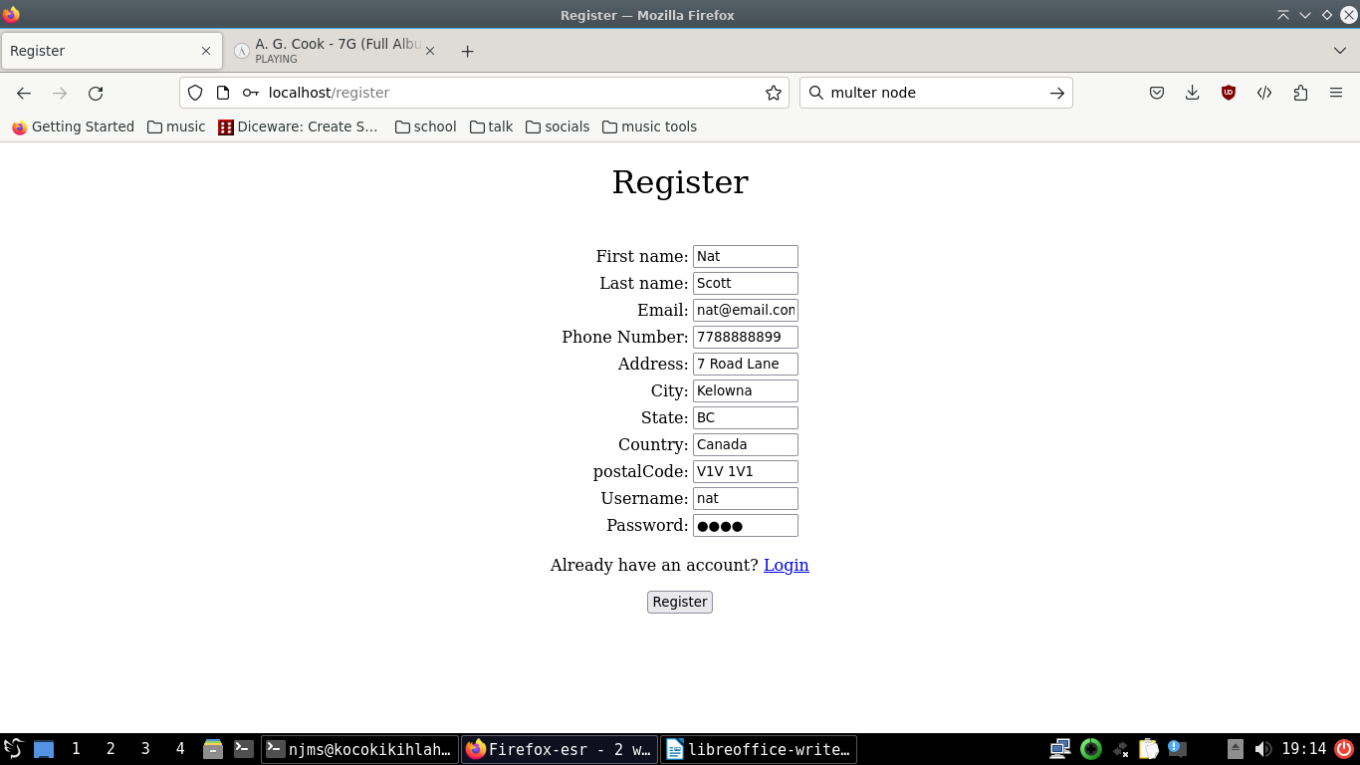
Filling out valid information and clicking “Register” brings us to the login page again. From here, we log in, and are brought to the main page.
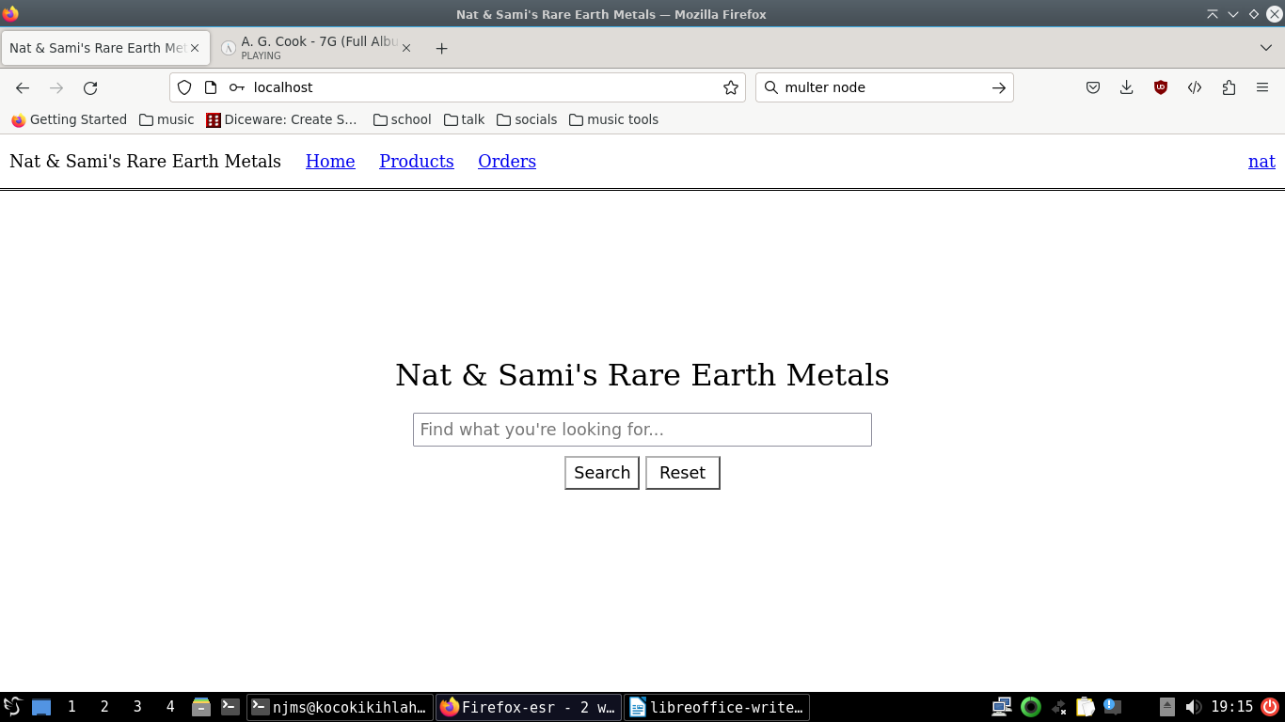
By searching from here, we can get to the product directory page, listing matching products
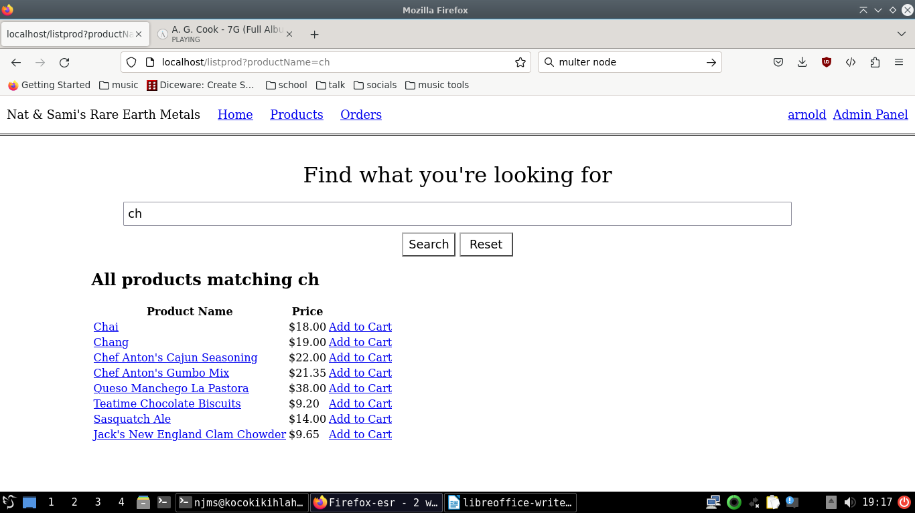
We can click the “Chai” link to see more information on this product.
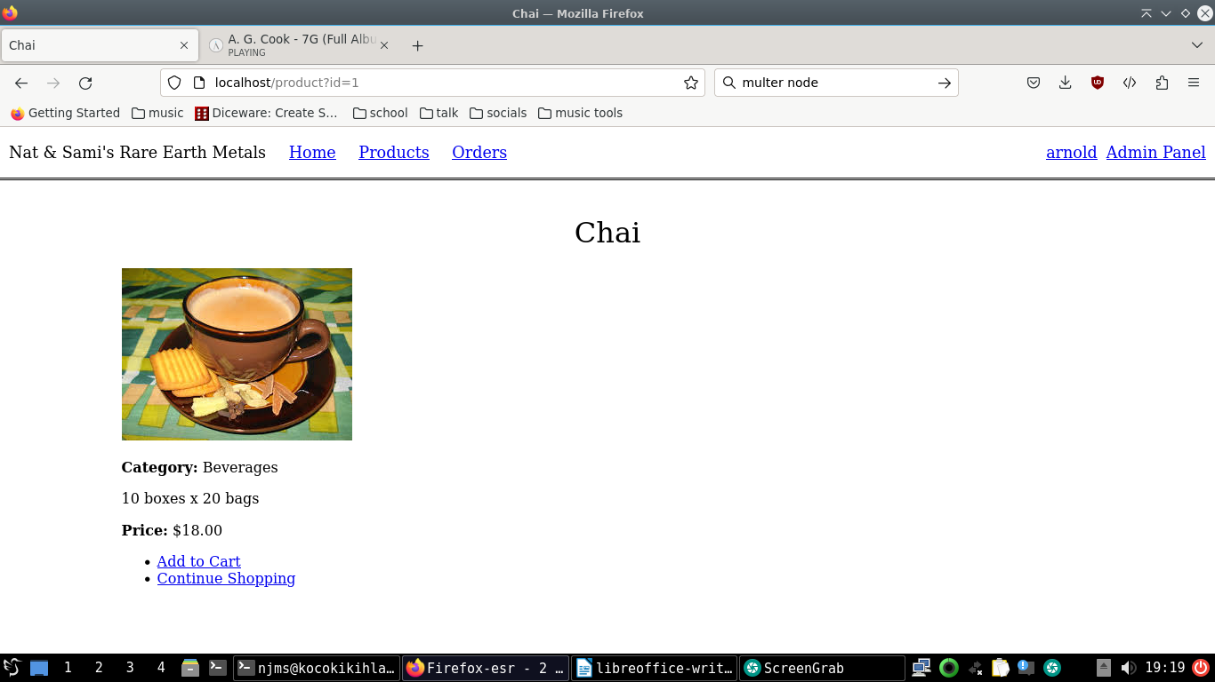
From here, we can add the item to our cart:
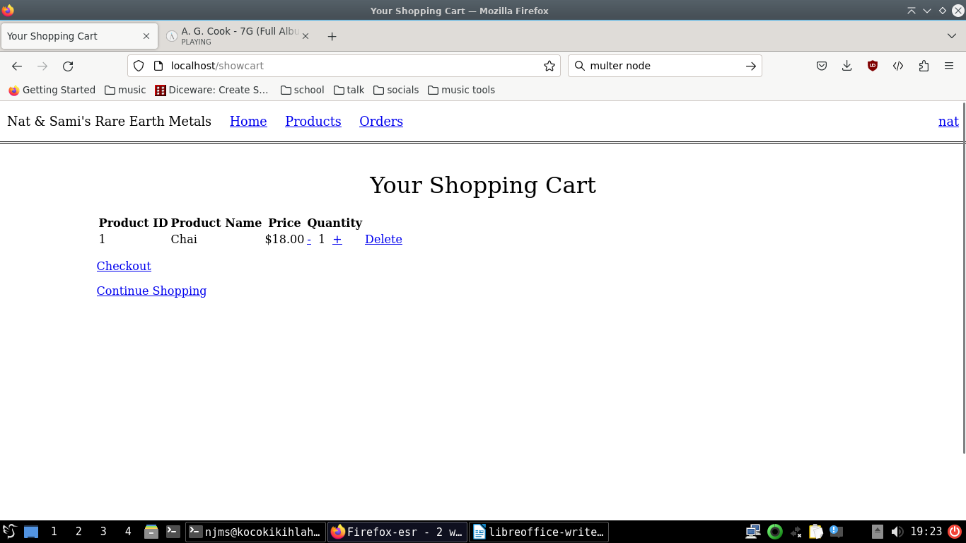
We’re also able to tweak the quantity from here. When we’re done, we can click “Checkout”. After verifying our credentials, we’ll get confirmation our order was recieved:
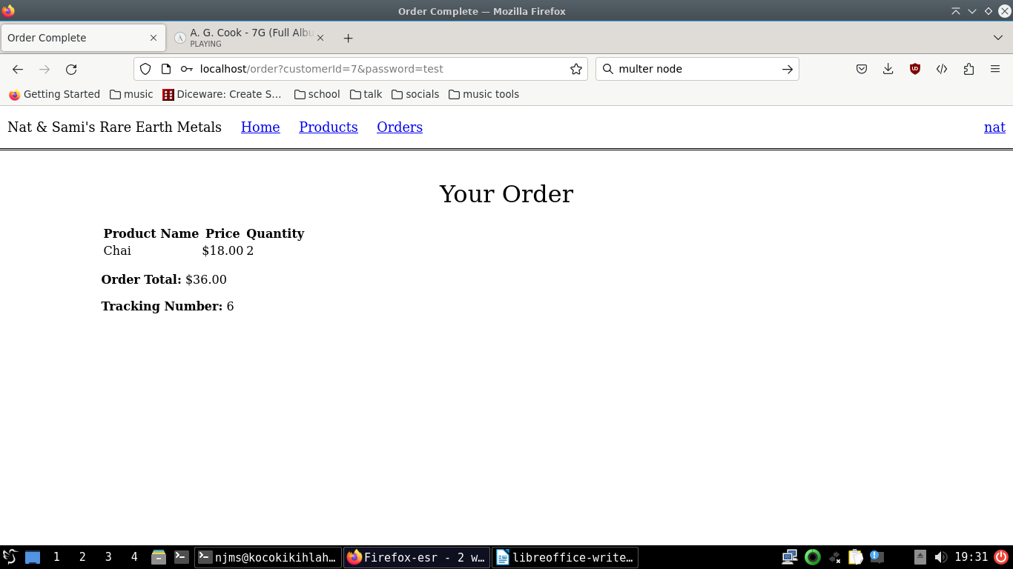
We can find a list of all our orders by clicking “Orders” in the nav bar:
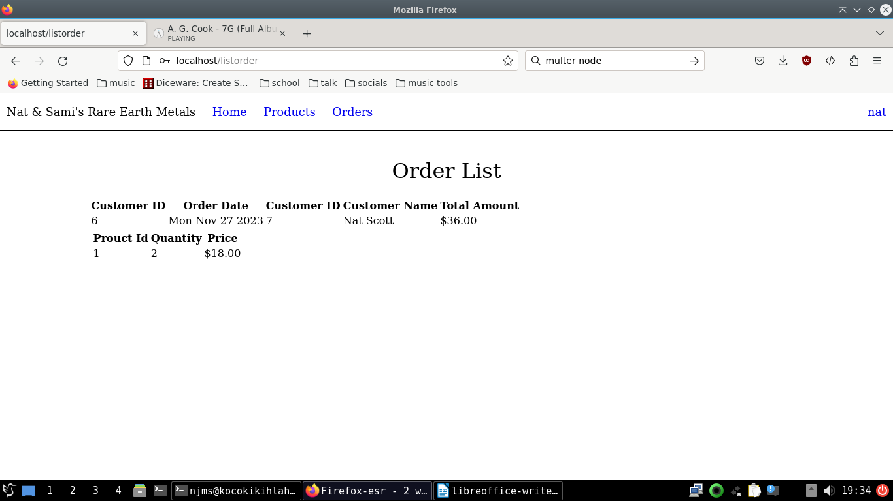
Next we click “nat” in the navbar to take us to the profile page:
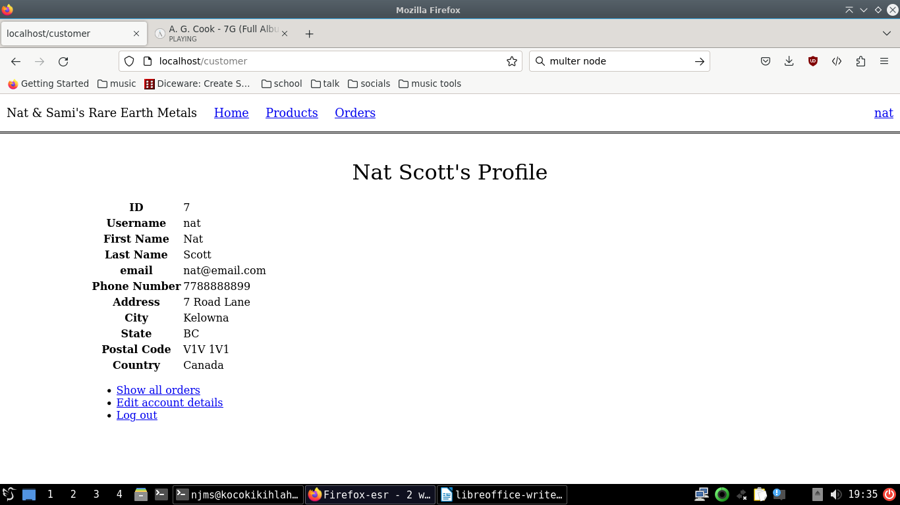
Now we can click “Log out”. Let’s log back in as “arnold”.
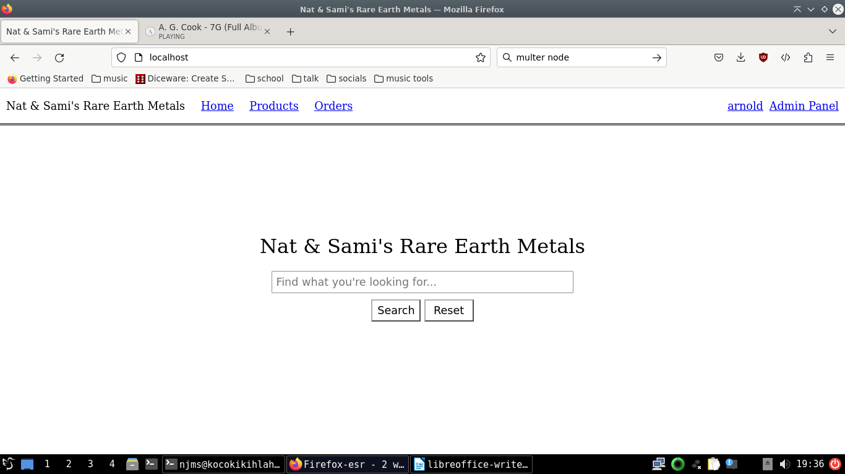
Next, click “Admin Panel” in the navbar.
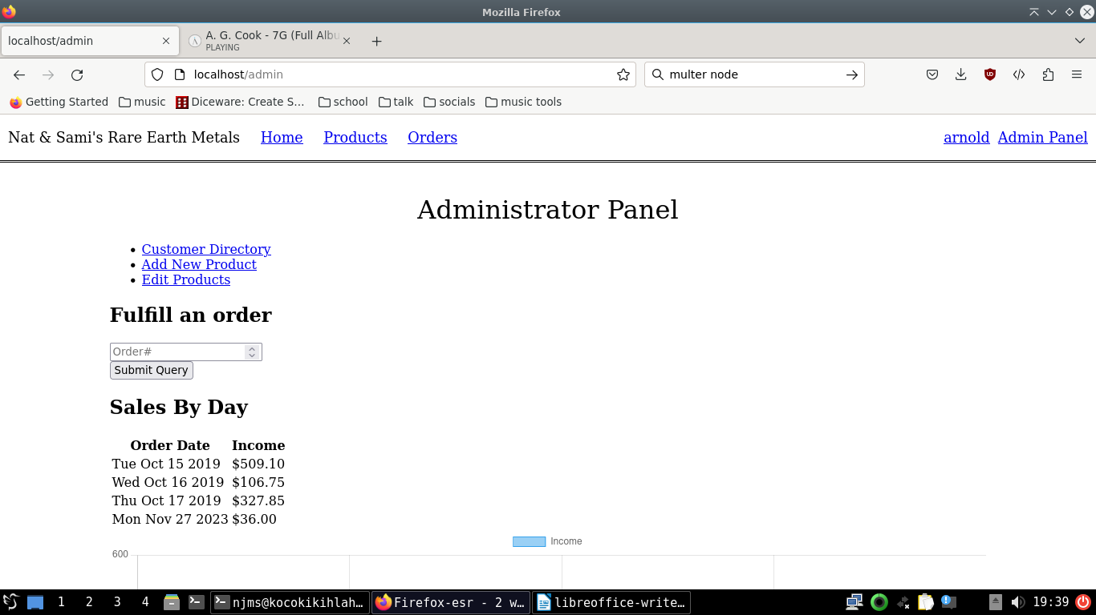
We know Nat’s order number was “6”, so filling that in, we can fulfill their order.
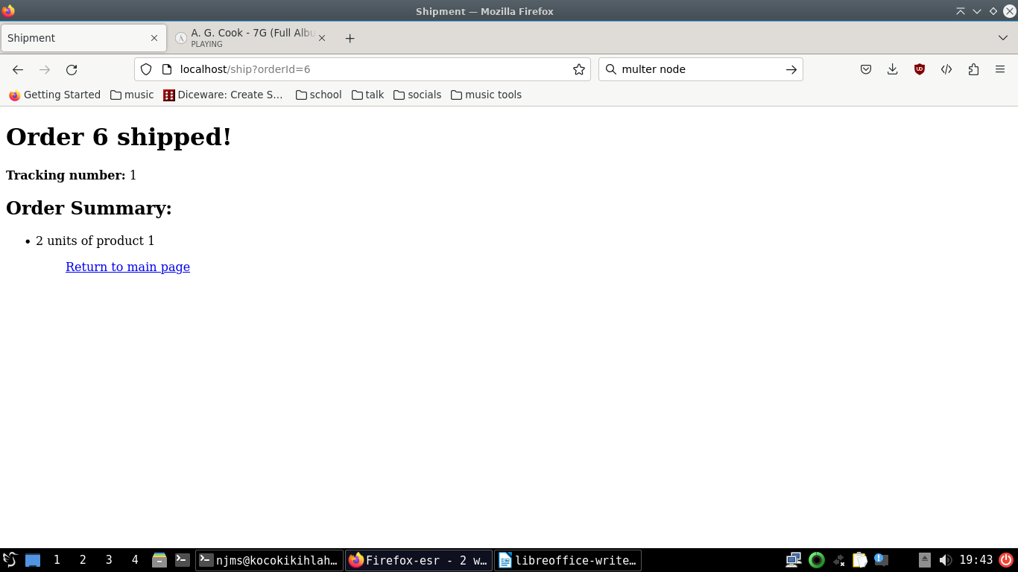
Clicking “Add a Product” from the admin panel takes us to this form:
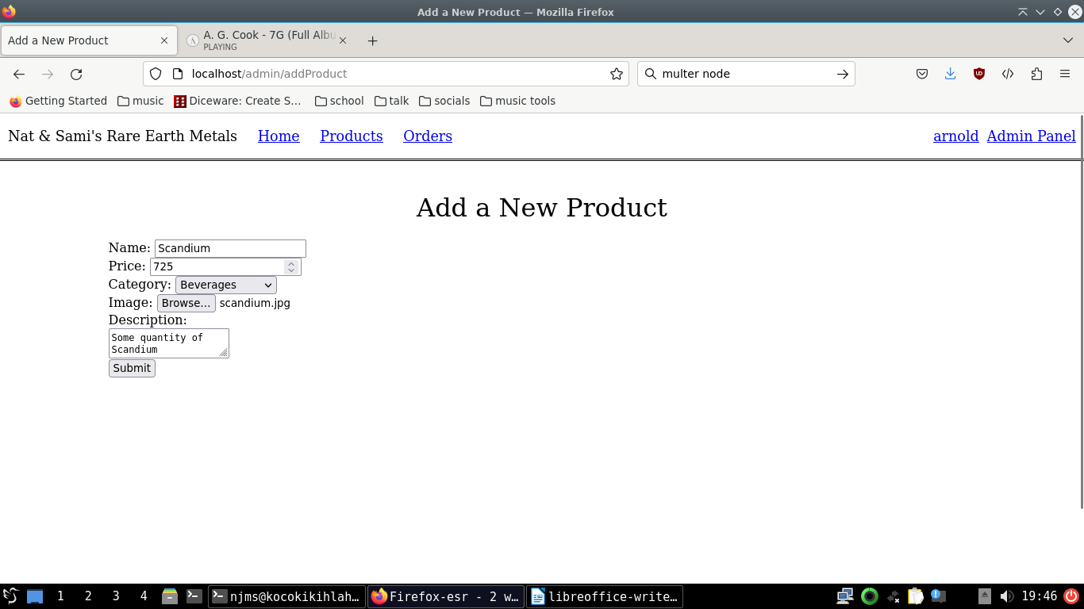
Clicking “Edit Products” takes us to the admin product directory, where we can update, delete, and add photos to existing products:
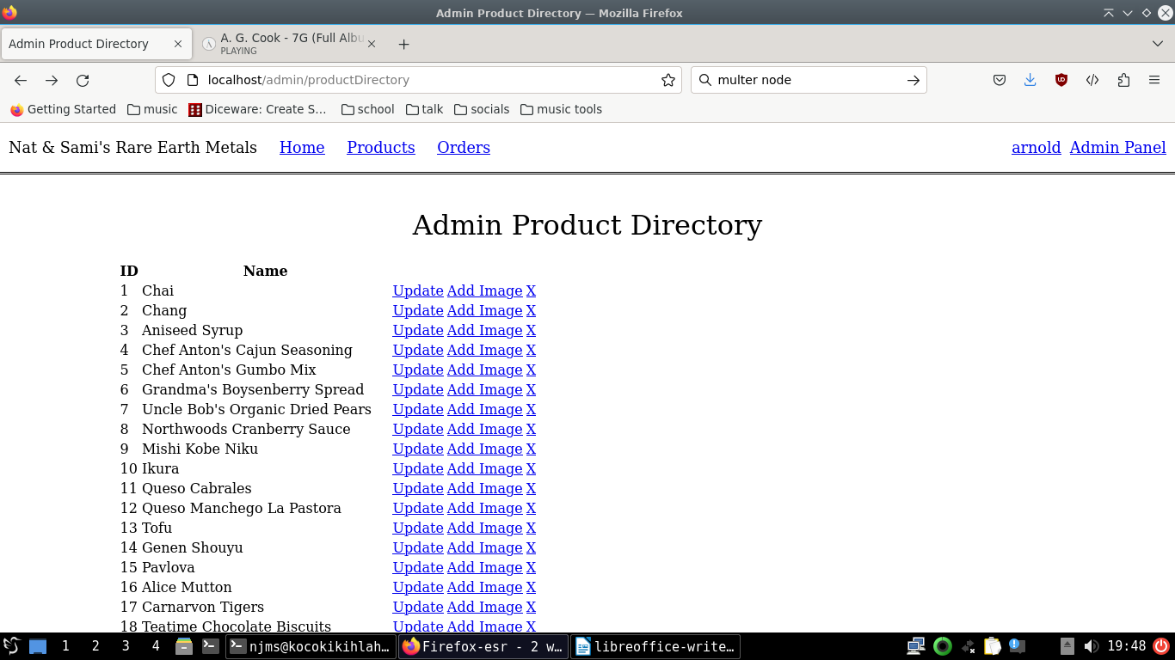
When you’re adding a photo to an existing product, you have the option of adding it as a file stored and served statically, or as a blob stored in the database:
